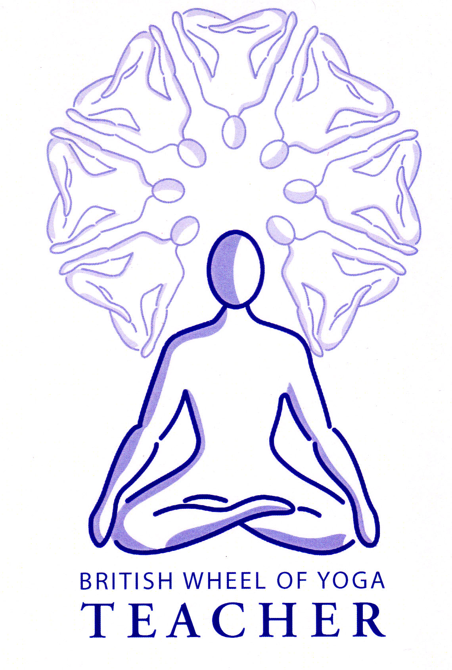**Viloma pranayama**

‘Viloma’ means ‘to go against the usual flow’ and in this pranayama we interrupt the in breath or the out breath, or both, meaning this pranayama is a great preparation for when we will use kumbhaka (breath retention) at a later stage. We must keep the breath smooth and easy throughout this technique, working as subtly as possible, so we are refining and relaxing the breath. We can perform this technique from a seated or lying position remembering to apply mula bandha at each pause.

1. ***Interruption of inhalation***

Here we inhale little by little, inhaling a little, pausing, then inhaling a little more, pausing and so on until the lungs are full, then exhale in one long continuous breath out. We continue in this way. If it helps we can imagine we are taking steps up to the top of a playground slide, inhaling and pausing at each step, then as we exhale we slide down in one continuous motion. Generally it takes between 3 and 5 pauses to fully inhale.

***Inhale Exhale***

1. ***Interruption of exhalation***

Here we inhale in one continuous breath in, then exhaling we exhale a little then pause, exhale a little more then pause and so forth. If it helps we can imagine we are effortless rising up on to a tall platform as we inhale, then as we exhale we are taking the steps down, one by one. Generally it takes between 3 and 5 pauses to fully exhale

***Inhale Exhale***

1. ***Interruption of inhalation and exhalation***

Here we inhale little by little and exhale little by little, pausing as we inhale and pausing as we exhale. Again generally there will be between 3 to 5 pauses for the inhale and the same number for the exhale. For this breath take a normal breath between each round of viloma to keep the mind and body relaxed.

**Benefits**

Viloma improves the elasticity of lungs, rests nerves and soothes the brain. It helps us to learn to breathe deeply and smoothly.

##### Prohibitions and Precautions

None apply except for those with high blood pressure & heart conditions who must take care & monitor their reaction.