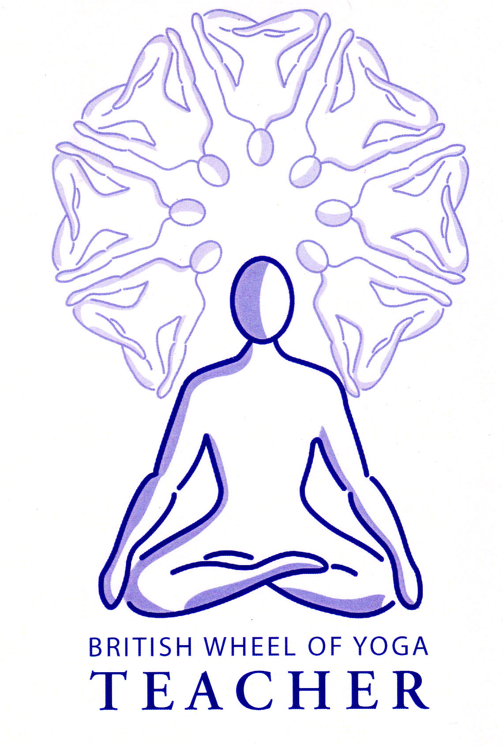
The principles for twisting asana

Benefits of twisting
When twisting we are basically compressing soft tissues along the axis of the twist, the axis being the spinal column. This is an everyday movement although in yoga we twist more consciously and to more of an extreme, moving the spine and the internal organs of the torso into compression so when the twist is released new energy is liberated. Indeed twists encourage us to breathe into different areas of the lungs with the inhalation feeling more restricted, but as we work we mobilize the ribcage and improve the lung capacity.

Twists help us to release tension held deep inside the structures surrounding the spinal column, the contraction of the muscles brings strength, and the release from our twists activates the tendon reflexes of all the compressed muscles producing a relaxation response releasing chronic tension and creating more length in the spine; meaning twists develop both strength and relaxation. This action also assists the nervous system as spinal discs are decompressed and the nerves stimulated and it greatly helps realign the body where there are structural imbalances and in particular back problems.

We are also literally massaging the body as we squeeze and release whether this done as we enter and leave the twist or as we stay and gently breathe creating subtle movement inside. Think of a sponge being wrung out as we release waste substances and then being soaked in new nutrients meaning twists rejuvenate all of the internal organs having both a cleansing and nourishing effect.

Finally, the twisting effect upon the appendicular skeleton is very beneficial, increasing the range of movement of the shoulders, the arms and hands, as we release the neck region and the brachial plexus supplying nerves the arms and hands. We can also improve the mobility of the hips depending upon the positioning of the twist.

We must however ensure we do not move too deeply into a twist at first, as for all asana we go more deeply over time keeping the body moving with an inner sensitivity and structural integrity. There are some general principles we can apply to twisting:

General principles for twisting

- If we look at the spinal column then each part of the spine possesses a different ability to rotate. From the skull to C1 there is no disk and so no rotation is possible but between C1 to C2 there is a peg like pivot joint allowing the head to rotate. Between C2 and C7 the neck can freely rotate and as we move downwards into the thoracic vertebrae T1 to T12 again there is great freedom to twist since the vertebrae are perfectly aligned for this action, allowing around 30 to 40º of rotation. Yet as we move into the lumbar region of the spine from L1 to L5 twisting become difficult as these vertebrae are primarily designed for support allowing for only 5º of rotation.

We begin by aligning the upper body, simultaneously feel the body weight being released downwards as you lift upwards through your crown.

Then as we rotate we must move with structural integrity bearing in mind how the spine is designed to move, meaning as we begin to twist we inhale consciously lengthening the spine and exhaling begin to twist from the abdominal area, then twisting in the thoracic region and finally the cervical region. Think of a corkscrew action occurring throughout the length of the spine. Twisting in this manner means we are not leading with the head, which can destabilize the spinal movement causing us to move the various areas of the spine differently rather than as a whole. As we work from the lower spine upwards it also means that we are not bypassing ‘stuckness’ in the thoracic region by working primarily in the cervical region of the spinal column.

- We need to maintain a level pelvis for standing and seated positions to alleviate pressure upon the sacroilliac joint which will require a slight anterior tilt. This means if seated if required we can place a block beneath the buttocks to create a little more space between the torso and thighs faciliating the anterior tilt, this is especially usefulwhen the hamstrings/adductors or low back are tight. The foundation of the twist needs to be stable, whether it is legs and pelvis when standing, pelvis when seated, shoulders and arms when supine etc. When seated some authorities also suggest that we work on a blanket rather than a sticky tapas mat so the buttocks can shift a little if needed, so avoiding placing potential strain upon the sacro-iliac joint.

- The spine must initially be placed in an aligned neutral spinal position, especially keeping the lumbar curve natural, allowing neither a flattened or exaggerated lumbar curve.

- We must keep shoulders level to maintain structural alignment and the shoulder blades can be depressed and retracted to open the chest.

- With focus upon the very top of the neck where it meets the skull is worth gently tipping the chin up and down until students find a head position where the neck feels long and open and the crown is rising effortlessly.

- Where the arms are involved we must also ensure we are not twisting through the action of the arms. Eventually they can be used as levers to stay in the twist but the twisting action must come from the inner body and the breath.

- Once we are in our twist make sure breathing has not been overly inhibited and stay and breathe gently awaiting the inner relaxation response or if we wish to work more actively we can gently contract the abdominals as we exhale so initiating another twisting action upwards through the spiral staircase of the spine. Always maintain an inner sensitivity recognizing if there is an excessive closing of the body or an opening of the body, if the body begins to close too much and the breath cannot be smooth and even, then we have moved too far compromising the integrity of the pose. Remember it is inner muscular effort and the breath creating the twisting action!

- We can teach simple twists at the start of a class and go on to teach more challenging twists later in the class, where using a short series of twists we can counterpose at the end with a symmetrical forward bend.

Good preparation for twisting
Generally lateral stretches are the best preparation for twists although good shoulder and chest mobilization is excellent as are hip mobilisers.

Areas for caution

Disc problems, especially in low back and spinal facet joint sprains | Avoid strong seated twists focusing upon gentle supported supine twists.
Hiatus hernia | No strong twists
Pregnancy and menstruation | No strong twists working only with open twists where the abdomen is not compressed
Inflammatory conditions such as crohns, ulcers, endometriosis etc. | Only twisting on remission not when inflammation is present
Asthma and other respiratory conditions | Gradually increase intensity as may initially feel anxiety as breathing capacity is restricted
Scoliosis | Use a support beneath the ‘easy’ side to keep twist symmetrical
Neck problems | May place in neutral having worked a little dynamically from side to side to give some mobilization
Knee | We must all ensure when we twist we maintain the alignment of the knees where pressure is placed upon them.
Hip problems | For hip replacement we must not adduct the leg i.e. cross the leg over the body on the affected side so may need to practice a simpler twist such as bharadvajrasana or a sukhasana twist, otherwise we can keep the affected leg in alignment.

