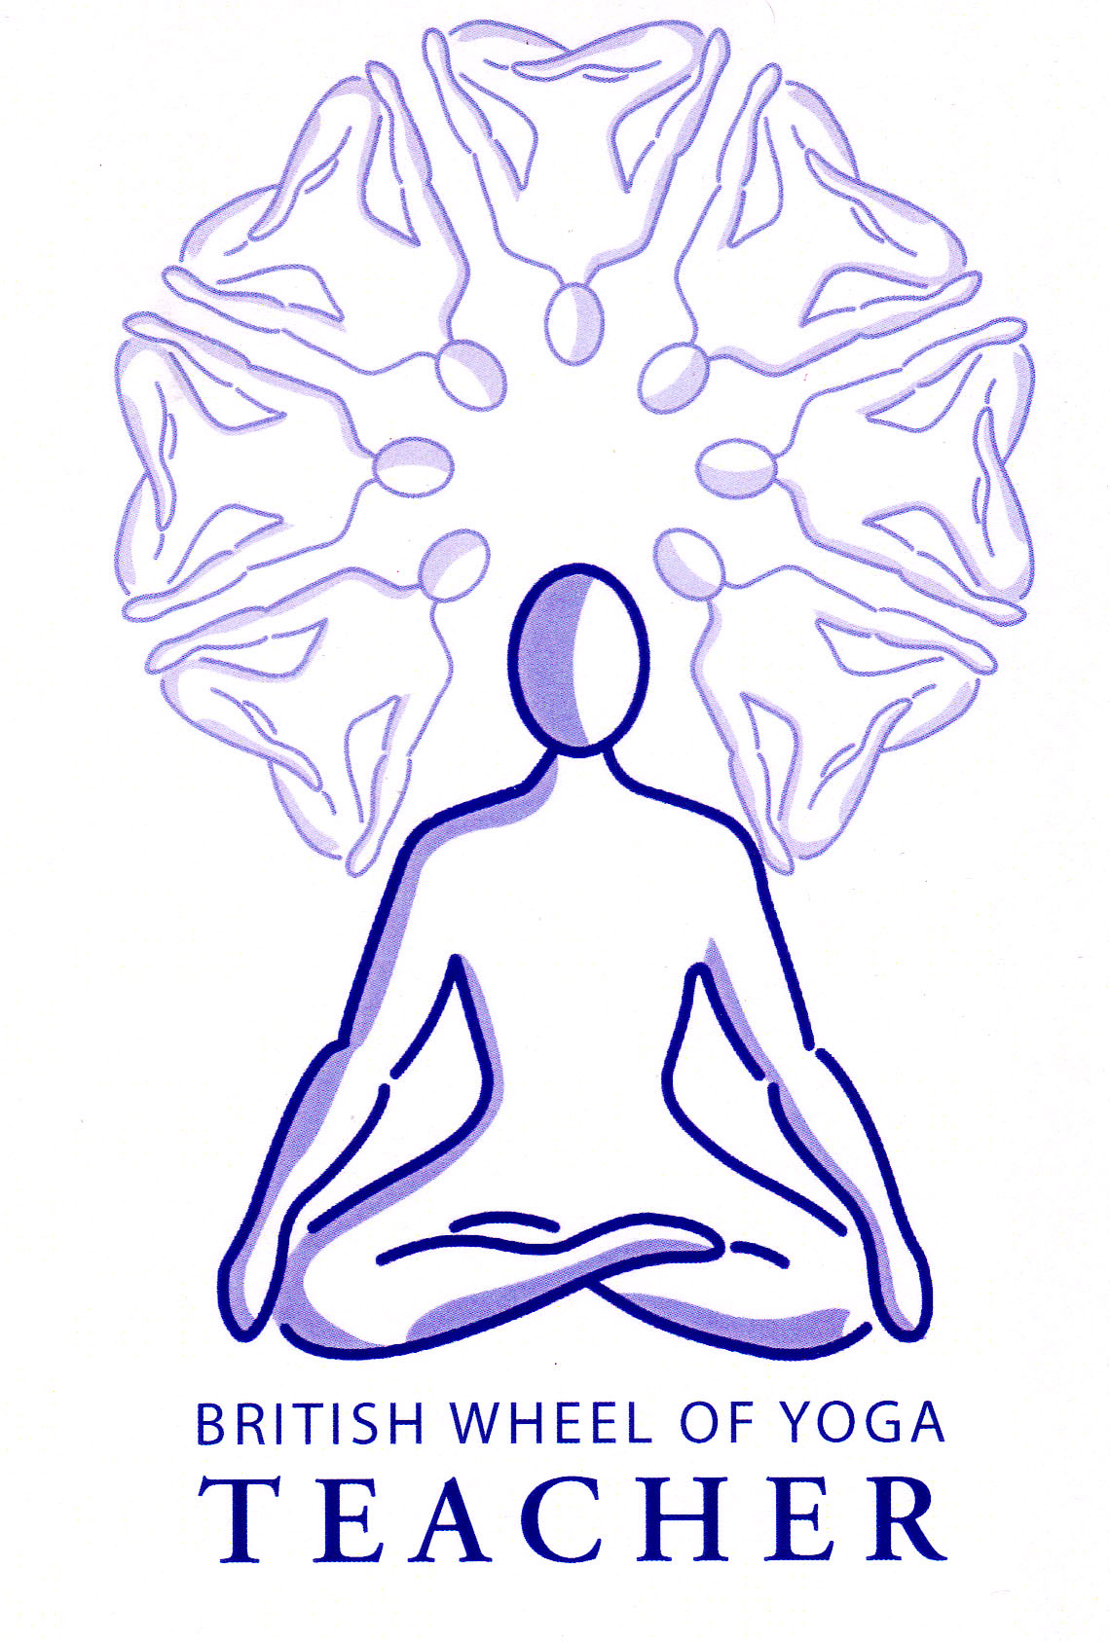
The principles for side bending asana

Generally speaking there is less information on side bending as they are fewer in number, as indeed is sidebending in everyday life.

There is a natural type of protection limiting side bending since at some point the bones of the body come against other bones within the body. For instance the pelvis will eventually come against the trochanter or head of the femur and the ribs will eventually come against the pelvis. All of these anatomical restrictions will naturally limit lateral flexion.

Indeed many authorities say we cannot have a true side bend since the vertebral column will rotate slightly above and below the main area of the bend meaning in fact many side bends are in fact a combination of side bending, rotation and forward bending!

There are however some general principles we can apply to those asana usually known as side bends.

General principles for side bending

- If we look at the spine then all areas of the spine allow for 20 to 30º of lateral flexion; there is 20º maximum at lumbar & thoracic regions and 35 to 45º maximum at the cervical region.

- When the feet are close together such as with palmyrasana (palm tree), sometime known as ardha chandrasana (half moon) little movement can occur at the hip joints but in those poses such as trikonasana (triangle) or parsvakonasana (lateral angle pose) where the legs are further apart there is more movement possible at the hips. But what is happening at the hip joints? Some students will have a great range of movement within their hips joints being able to abduct their legs, and medially and laterally rotate their legs with great ease, whereas others will have a structural restriction from doing so. These restrictions may be a case of immobility of joints and lack of flexibility of muscles and connective tissues or there may be natural limitations. This means for either situation when there is restriction we must avoid creating strain at the lower back and the sacroiliac joints, also that the front leg knee is not placed under undue pressure, especially of twisting medially. So it is best if we teach these types of asana by allowing the rear hip to fall forwards when moving deeply into these poses and when necessary encourage students to turn their front foot inwards so their front knee remains aligned with the front foot when bent.

- We must also maintain integrity within the spine as we enter a side bend, engaging the abdominal muscles and the superior lateral muscles as we mobilize the thoracic region of the spine. At all times we must avoid creating a deep arch within the spine, as deep extension will cause compression.

- Prior to entering a side bend we must lift and lengthen the spine when inhaling to help create ‘space’ within the spinal column, maintaining that internal lift as we move into the side bend. Do not lean outwards first in poses such as trikonasana (triangle) as whilst this can extend the spine it also diminshes the link between the pelvis and the spinal column causing potential strain upon sacroiliac joints and the low back; for some students this will be very important. It also ensures that we are moving more truly into a sidebend rather than folding forwards and twisting.

- We need to create a strong foundation within the lower body so the lower body is grounded and fully aligned, a good pada bandha (foot lock) and a gentle mula bandha (root lock) will help with this process, as will activating the adductors. In asana such as trikonasana other helpful teaching point is to draw the lead leg sitting bone backwards and down towards the rear leg heel as this aligns the hips in a sideways plane and also helps the pelvis and spine to move as one.

- Avoid hyper-extending the knee on the stretching side, maintaining a strong base by lifting upwards through the quadriceps. If necessary bend the knee to this side if discomfort is experienced.

- Do not allow yourself to relax the body by placing all of your weight into the lower hand, it may better not to practice sidebends where the lower hand is supported until we are able to support a pose using muscular effort alone.

- Do not go too deeply into the side bend unless you know you can use your muscular strength to lift yourself out again. Contract the muscles of the legs, thighs and hips before you lift then inhaling raise up and out. Where it is applicable we can bend the front knee to help us lift out.

- Do not attempt to go into a ‘full’ or ‘deep’ posture at first, always maintain a good degree of ease within the body, breath and mind. Eventually with practice the body will be able to comfortably adjust to new states of tension.

- Remember the stretch or line of energy needs to be experienced primarily on the top side of any side stretch, which will both open and strengthen those muscles, and if it feels as if the limiting factor is on the side you are moving towards than in all likelihood you have reached an impassable point of compression where bone meets bone or we are compressing muscle, tension and ligament.

Areas for caution

Back conditions | Ensure the spine stays lengthened working more gently, possibly placing a block or support under lower hand
Hypertension and heart problems, to include mature diabetic | If the upper arm should be raised keep it on the hip instead, avoiding working too strenuously
Neck conditions | Can keep looking forwards or downwards rather than upwards
Obesity & pregnancy | Work cautiously without placing too much pressure on the body, using a support for lower arm or moving into a gentle side stretch only
Osteoporosis | Take care not to work too strongly taking softer modifications where needed
Sciatica | Can stretch this nerve so if needed work gently and can place lower hand on a block or support, where both legs are straight can bend front leg to alleviate any tension

© S.Beck 2013

