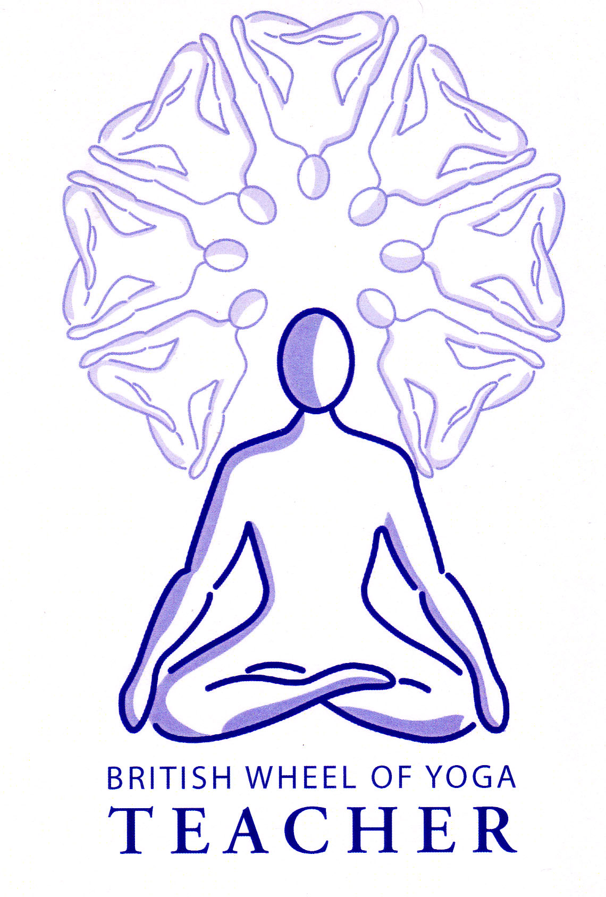**Benefits of balances**

The main benefit of balances is to the mind. When we enter a balance we must necessarily be mentally calm and centered in order to maintain the balanced state and as we learn to balance we are developing dharana, the ability to concentrate. We will also find balances create a grounding effect drawing us out of the head and into the body.

In addition there are other physical benefits to be achieved such as strengthening the feet, legs, lower back etc. and they are great for helping with developing an awareness of postural alignment and proprioception, the ability to know where the body is in space.

Balances are of many types, some are forward bends, some backbends, some twists etc. and so the principles which apply to each of these are relevant so for instance in natarajasana (dancer), a backbending asana, we also work according to the guidelines for backbends.

There are however some general guidelines to help us in our balancing poses:

**General principles of balances**

* Shift your weight within your feet so you have equal weight between the heels, balls of feet and little toes. (Although some authorities tell us natural weight distribution means the weight is directed downwards to a point just at the front of the heel with the toes being used for balancing purposes.)
* Ground down creating a good foundation and simultaneously lift upwards, feeling yourself lengthening between these two points. Here we are using a rebound effect where as we press down we are being lifted up out of the floor.
* We may find that adopting mula bandha is helpful whilst in the balance since this aids the grounding of a posture and the simultaneous lifting upwards. Also lifting the hyoid bone to engage the muscles of the front of the body can be valuable.
* Arm balances may be very challenging and so here long term preparation is usually required, especially working with strengthening the muscles of the shoulders, arms, back and core.
* Balances require a great deal of mental concentration so to help keep the eyes soft and focus them upon a fixed spot. 45º away. Allow the breath to be gentle and even and let the mind be peaceful.
* Always take your time to centre before entering the balance and enter slowly with attention
* If you are having a bad balancing day then be respectful of that making softer modifications such as keeping one foot the floor in tree or placing a hand to the wall for extra assistance.
* Be confident mentally saying to yourself that you can do this and if you topple over then always forgive yourself immediately!

Good Preparation for balances

Work extensively with tadasana (mountain pose) initially and then learn to balance in incremental stages, working from simple balances where there is more support to more challenging balances. Do not attempt the more challenging balances until ready because this will cause frustration and a lack of confidence within students. For example when teaching vrksasana (tree) we can start with the lateral hip opening with the upper foot being kept to the floor heel raised, then progress by placing the sole of foot to the inner calf of the standing leg, then to the upper thigh and finally place the sole to the top of the upper thigh with each student staying at the appropriate level.

## Areas for caution

|  |  |
| --- | --- |
| Anxiety | Where balance and confidence are adversely affected work with supports and gentler modifications |
| Ear problems | Where balance is affected work with supports and gentler modifications |
| Pregnancy | Where balance is affected work with supports and gentler modifications |
| Vertigo | Work with assistance from the wall, chairs etc. if needed |

© S. Beck May 2013