The vayus are the five ‘winds’ which move prana through the body. They exist within the pranamayakosha of the pancha koshas or five sheaths.

These are sub-divisions of Prana responsible for moving prana in certain directions through the body/mind complex ensuring the body/mind functions correctly. In a way we can imagine these to be like waves of vibratory energy running through the body.

They constitute vata dosha where the vayus move all substances and impulses through the body, co-ordinating all phsyiological systems and the functioning of the mind. For this reason the vayus must move prana in the right direction in the right way and if they move too fast, too slow, in an agitated manner or are obstructed then ill health will arise as the systems of the body are not being co-ordinated properly and cycles are disrupted. The vast majority of disease is created by the improper movement of the vayus i.e. by vata dosha so hopefully we can appreciate the importance of the vayus. It is for this reason that in yoga we calm the senses, perform sequences such as pawanamuktasana and so forth.

Each of these five winds has an area of influence as we can see from the illustration produced here, taken from the book Practical Yoga Psychology by Dr Rishi Vivekananda (page 29).

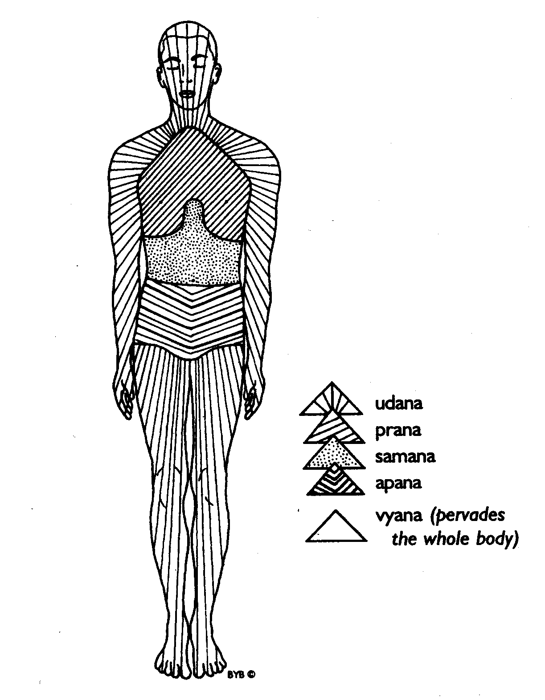**Prana** is located primarily above the diaphragm at the chest area and also has a special relationship with the heart and brain. It is generally considered to be an inward force governing all types of receptivity such as eating, inhaling, the reception of sensory impressions and mental experience. It provides the positive force for the other vayus and can sometimes be seen as moving upwards, this is because we can only receive prana when there is prana inside so to some extent prana also reaches upwards. **Apana vayu** is located in the lower abdomen and pelvis. It possesses a downward movement and is therefore responsible for all elimination and reproduction but also plays a considerable role in maintaining immunity. **Samana vayu** is located around the navel and is a centripetal type force helping us to regulate digestion and assimilation and is therefore very important for the regulation of our metabolism and homeostasis. **Udana** is a specialized form of prana having a particular upwards direction. It is located primarily at the upper chest, throat and head being responsible primarily for the ability to express oneself, to exhale and for our levels of enthusiasm and effort. Finally **Vyana** is the diffusive, centrifugal prana which starting at the heart moves prana throughout the whole body and although it pervades the whole body, it is especially important as the vayu bringing prana to the limbs, meaning it has a great affinity with the circulatory system.

These five vayus are functionally connected to all elements, koshas, organs and mental functions serving to energize and connect our activities on all our levels, with Prana being the ultimate energizing force linking us with the universe. See Prashna Upanishad Question III.

The table below gives us some of the most important connections:

|  |  |  |  |  |
| --- | --- | --- | --- | --- |
|  | Responsible for: | Connected to: | Particularly affiliated to: | For the koshas: |
| Prana vayu | Energization | Senses  Respiratory system  Nervous system | Nerve tissue | Energizes them all |
| Vyana vayu | Circulation | Circulatory system  Lymphatic system  Musculoskeletal system | Connective tissue | Circulates prana through them all |
| Udana vayu | Motivation/effort | Mental activity | Muscle tissue | Draws energy upwards from the gross to the subtle |
| Samana vayu | Digestion/nutrition | Digestive system | Fat tissue | Maintains the relationship between them |
| Apana vayu | Elimination | Urinary & Excretory systems  Reproduction | Bone tissue  Ojas | Draws energy downwards from the subtle to the gross |

So for example on the physical level prana is responsible for eating food, samana for digesting it, vyana circulates nutrients to the tissues, apana helps to eliminate waste material and udana allows us to use the energy derived from the food for physical work.

On a psychological level prana is responsible for taking in sensory impressions and ideas, samana digests them, vyana circulates these ideas, apana removes the waste material such as negative emotion or thoughts and udana enables us to perform mental work. The table below outlines the main ways in which the vayus are related to our mental faculties and how dysfunction manifests.

|  |  |  |
| --- | --- | --- |
|  | Governs | Dysfunction |
| Prana vayu | Our ability to receive positive thoughts and impressions. | Sensory overload, wrong impressions, negative thinking received, lack in energy |
| Apana vayu | Our ability to avoid negativity, the downwards force in the mind | Stagnation, depressed, negative thinking or ungroundedness, anxiety etc. |
| Vyana vayu | Our capacity to reach outwards mentally & physically | Isolation, agitation |
| Udana vayu | Our will and motivation | Inability to express oneself or conversely domineering |
| Samana vayu | Our ability to mentally digest | Lack of discrimination, lack of mental peace |
| Apana vayu | Our ability to avoid negativity, the downwards force in the mind | Stagnation, depressed, negative thinking or ungroundedness, anxiety etc. |

It is important to note that dysfunction in the mind creates dysfunction in the corresponding vayu and therefore once it is vitiated there will also be a dysfunction in its capacity to perform its physical functions; again we see how pranamayakosha bridges the manomayakosha and annamayakosha (the mind/body complex). For example a lack of mental peace can directly create digestive disorders, a feeling of being isolated or separated from others can cause circulatory or heart problems and when we overload our senses our nervous system becomes agitated and tense, and eventually fatigued

The three koshas relating to the mind, prana and body are always interlinked and interdependent and it is at these levels that dysfunction and therefore disease primarily occurs.

For us at this juncture we simply need to know that alterations in the activity of the vayus, as they direct the movement of prana through the vast system of nadis, can create mental and physical illness and that because of the subtle nature of this energetic system we can either work on a mental level to create harmony or we can also work on a physical level to create harmony so that for instance changing our perspective or working with asana can restore balance. Alternatively we can also work directly with the breath where there is a more direct effect upon these subtle energies and when working with the breath we can also use the mind as intention where we can consciously direct the breath and prana itself.

**Prana, Udana & Apana Samana & Vyana**

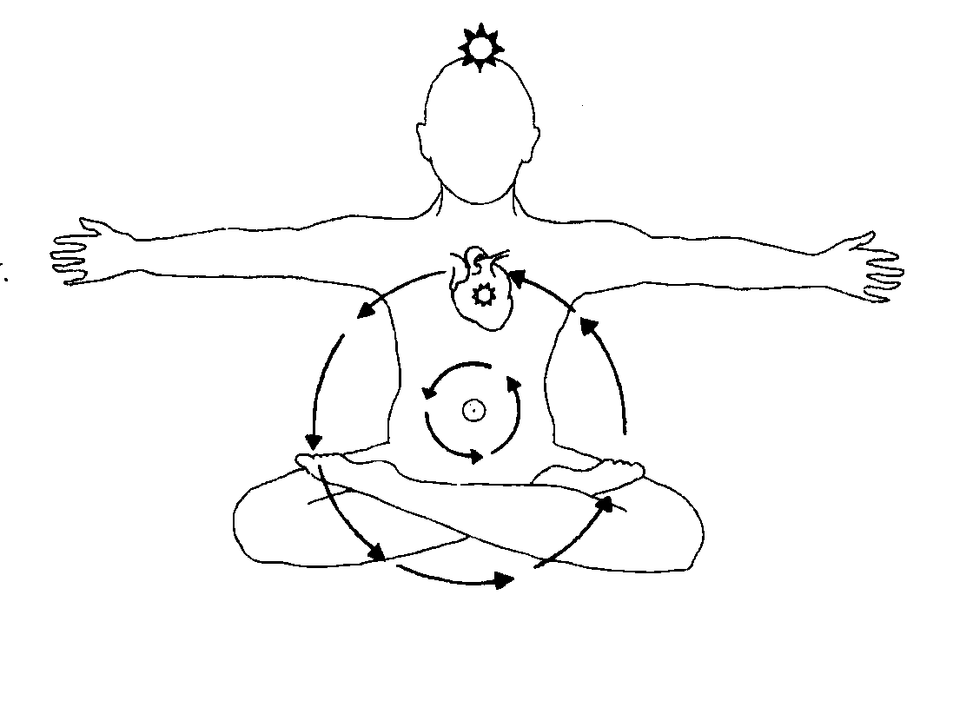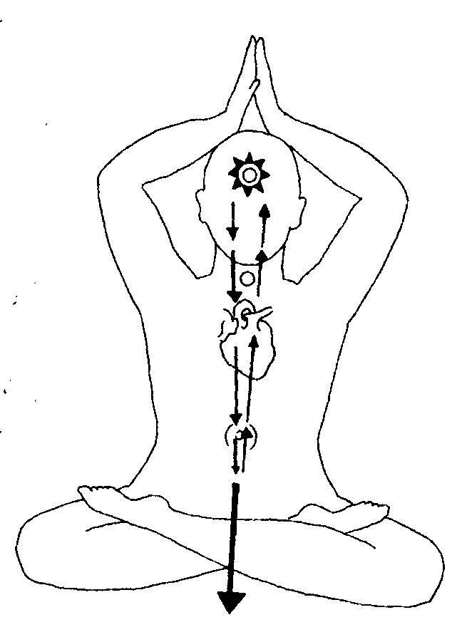

### Upa Pranas

There are also five subsidiary pranas:-

1) Naga gives belching & hiccups

2) Krikara gives hunger & thirst & sneezing

3) Devadatta gives yawning

4) Koorma is blinking or operating eyes

5) Dhananjaya maintains integrity of body

It is said that these should never be suppressed under any circumstances!

All of these types of prana are essentially forms of the innate intelligence of the body. Together they form the energy body ‘Pranamaya Kosha’. They are usually unconscious but through yoga can be brought under conscious control. In Hatha Yoga we endeavour to cleanse the system initially then direct the flow of prana.

Of these different types of prana, prana and apana are the most significant within yoga practice. In Hatha Yoga we are attempting to prevent the downward movement of apana and the upward movement of prana so that they can be united within samana vayu where prana is accelerated and drawn within the sushumna nadi so a change in consciousness can be experienced. This is why the kriyas, asana, pranayama, mudra and bandhas are used in Hatha Yoga.

References in the classical texts:-

* Hatha Yoga Pradipika Ch2 v3, Ch2 v17
* Prashna Upanishad 3rd & 4th Questions

Bibliography:

Vivekananda, Dr Rishi, (2005) Practical Yoga Psychology, Yoga Publications Trust: Bihar, India

© Sarah Beck 2013