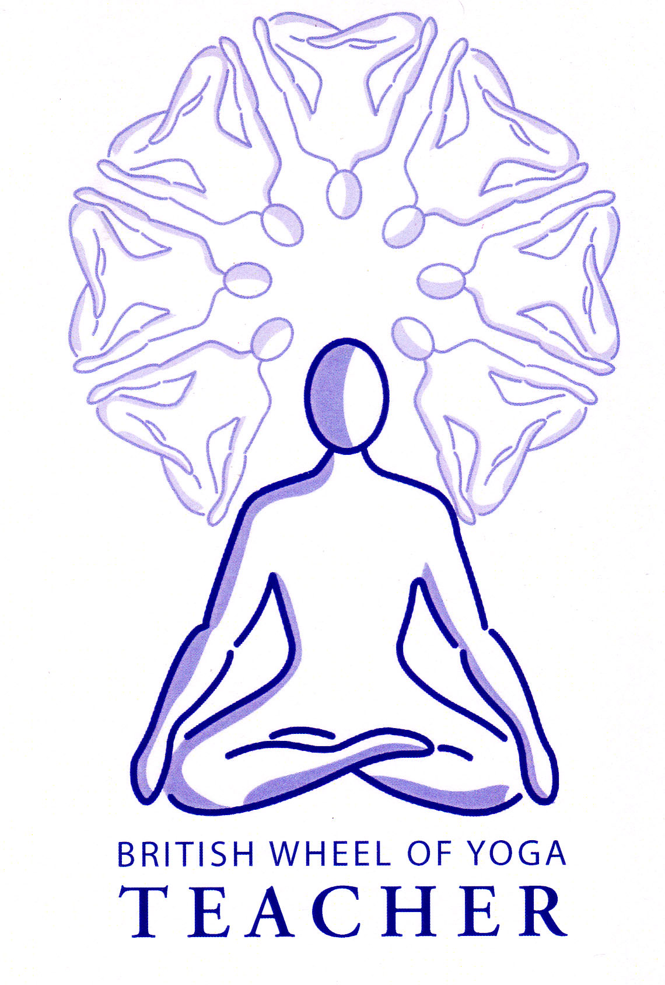

The Hatha Yoga Pradipika lists eight kumbhakas or pranayama techniques which are considered to be the main pranayamas we can practice. These are:

1. Surya bhedena
2. Ujjayi

[Remember we have already looked at viloma, nadi sodhana, anuloma & pratiloma pranayama & the kriya kappalabhati]

1. Sitkari
2. Shitali
3. Bhastrika
4. Bhramari
5. Moorcha
6. Plavini

**1) Surya Bedhana “The Sun Piercing Breath”**

The word ‘surya’ means the sun and relates to pingala nadi and ‘bheda’ means ‘to pierce’ indicating how with this technique we are activating prana within pingala nadi.

Puraka (inhalation) is always through the right nostril and rechaka (exhalation) through the left nostril. When we inhale through the right nostril we draw prana into the pingala nadi, retaining it adopting jalandhara bandha, (neck lock) and mula bandha (root lock) then releasing mula bandha then jalandhara bandha we exhale through the left nostril releasing impurities in ida pingala. We work in this way taking a few normal breaths between each round so that ida pingala is not closed off completely, practicing up to ten rounds.

Surya Bhedhana stimulates the sympathetic nervous activity, heating the body and removing toxins. It is said to relieve vata type imbalances, which helps to balance the whole body. Indeed some sources state it prevents old age and death, increasing body heat and awakening kundalini.

## *Precautions & Prohibitions*

*We should ensure we are not overly increasing heat within the body by practicing when pingala nadi is already activated (i.e. the right nostril is the more open nostril) or there are already signs of excess heat. This breath is of very limited use in classes and is better taught one to one where it is applicable.*

**2) Ujjayi “The Victorious Breath”**

Here the glottis, the region at the back of the throat is partially constricted so that as air passes through it creates a soft sonorous sound. It is said to promote relaxation and relieve mental anxiety since it is soothing to the nervous system. In its simple form it is thought to be good for heart conditions. Puraka (inhalation) is done through both nostrils and traditionally rechaka (exhalation) is either through both or through the left nostril. It is also excellent in developing an appreciation of prana since it heightens sensitivity.

## *Precautions & Prohibitions*

*This pranayama can be used at anytime and is safe for everyone although we must work cautiously with low blood pressure. Remember when used in asana practice it is great at lengthening the breath, concentrating the mind and is an excellent feedback tool to ensure we are working within our own capabilities.*

**3) Sitkari “The Hissing Breath”**

The word ‘see’ relates to the sound created by this breath and ‘kari’ means ‘that which produces’. Puraka (inhalation) is done through the partially opened mouth, where the lips are apart but the teeth are together, so as we breathe through the gaps between the teeth this creates a hissing sound. The rechaka (exhalation) is done through the nose. At first we work without retaining the breath but then once we are ready to work with breath retention we inhale between teeth, hold the breath as we apply jalandhara bandha (neck lock) and then mula bandha (root lock), then when ready to exhale we release mula bandha, followed by jalandhara bandha, lifting the head to then exhale slowly through the nose. Generally we can practice up to 20 rounds of sitkari.

Sitkari has a cooling effect upon the blood so should only be practiced in warm weather or after a heating breath such as bhastrika where we wish to bring balance. It is said to balance hormones, especially those related to the reproductive system making the practitioner virile and magnetically attractive without being lustful!!

## *Precautions & Prohibitions*

It is not to be performed when feeling cold internally or externally or there is a polluted atmosphere. Also this breath should be avoided if we are suffering from chronic constipation, which is indicative of increased vata, a cold inner energy.

**4) Sitali “The Cooling Breath”**

To perform sitali we need to able to curl the edges of the tongue inwards so the edges meet but this ability is genetically determined meaning in a class of 20 students you will always expect one or two students to be unable to do this. Where students cannot curl the tongue we always offer sitkari, the previous pranayama instead. To perform the technique we inhale through the curled tube of the tongue and then placing the tip of the tongue against the roof the mouth we exhale through the nostrils. Once we wish to incorporate breath retention we inhale though the tube of the tongue, then and adopt jalandhara bandha (neck lock) and mula bandha (root lock), then lifting the head upright, releasing jalandhara bandha and mula bandha we exhale through the nostrils. We continue in this way gradually building the number of rounds.

Sitali possesses the same benefits as sitkari being cooling and calming, although they each affect slightly different parts of the brain and the focal point for sitkari is upon the sound produced whereas for shitali it is upon the cooling sensations of the breath.

## *Precautions & Prohibitions*

Again it is not to be performed when feeling cold internally or externally or there is a polluted atmosphere. Also this breath should be avoided if we are suffering from chronic constipation, which is indicative of increased vata, a cold inner energy.

**4) Bhastrika “The Bellows Breath”**

The word ‘bhastra’ means ‘bellows’ which is indicative of how this breath fans the internal fire, bringing heat to the physical and subtle bodies. For this breath air is drawn in and out of the nose very quickly creating a bellows like action in which large amounts of stale air are expelled.

To perform this breath we need to sit upright and focus upon the movement of the abdomen. As we exhale we contract the abdominal muscles forcing the air out of the nostrils and as we inhale the abdomen relaxes and expands and the air is drawn into the nostrils. Very importantly the inhalation and the exhalation are of equal length unlike for kapalabhati where as a shatkarma the exhalation was the active part of the breath. At first we work for about ten breaths then take several ordinary breaths, performing around 3 to 5 rounds.

The rapid, rhythmic abdominal contractions are said to stimulate cardio-vascular and respiratory processes. The quickened blood circulation increases the rate of gaseous exchange for each cell producing heat and a cleansing effect as waste gases are removed more efficiently. Bhastrika also massages all of the viscera and is said to stimulate the production of cerebro-spinal fluid. This is a very dynamic and revitalizing pranayama that strengthens the nervous system and harmonizes our emotions.

Later as we are ready to incorporate breath retention we breath in through the left nostril and then perform bhastrika for 20 rounds, then on the last exhalation we breathe in slowly and perform Jalandhara Bandha (neck lock) & Mula Bandha (root lock), retaining the breath, releasing jalandhara bandha we lift the head to an upright position and exhale through the right nostril. We then perform another set this time starting by inhaling through the right nostril and finishing by exhaling through the left nostril.

Once we have worked with breath retention on the inhalation, later we start to work in just the same way with breath retention after the exhalation. As always we slowly build up the number of rounds for each new variation of bhastrika.

## *Precautions & Prohibitions*

*This is a heating breath which increases internal pressure so it should not be practiced if suffering from high blood pressure, heart disease, brain disorders, vertigo, stomach or intestinal problems, eye/ear problems or diarrhea (indicative of excessive internal heat). We must always desist if dizziness or the production of sweat is experienced. We must take care to avoid hyperventilation, which can happen if we not exhale sufficiently and never aim to make speed the principal aim.*

*After bhastrika a cooling breath such as sitali is necessary if the internal or external environment is particularly warm.*

**READ: Chapter 2, verses 59 to 67 on pages 226 to 231 in the Hatha Yoga Pradipka to gain a more complete account of the potential benefits of bhastrika.**

**6) Brahmari “The Humming Breath”**

This is an excellent breath that can be used as a pranayama but is also good as a preparation for mantra. It is named after the humming bee due to the sound produced which resembles that of the bee. The H.Y.P. says that brahmari on the inhalation is like the male bee and brahmari on the exhalation is like the sound of a female bee.

Both inhalation and exhalation is performed through the nostrils whilst producing a deep humming sound. It has a deeply calming effect on the mind and can reduce anger. It can also help to develop heightened sensitivity and is an excellent form of pratyahara or sense withdrawal especially when practiced when by placing the index fingers in the ear!

To perform this breath essentially we exhale whilst creating a soft deep humming sound and inhaling we purely breathe in through both nostrils. We continue in this manner for between 10 and 20 breaths. Once we are comfortable with this we can add the fingers, so as we inhale the hands are to the knees or thighs and as we exhale we place the index fingers in the ears as we hum the breath out, replacing hands to thighs again as we inhale.

Once we are practiced we can add breath retention on the exhalation, adopting jalandhara bandha and mula bandha. We can practice this for around 10 to 20 breaths taking several natural breaths as needed between the breaths.

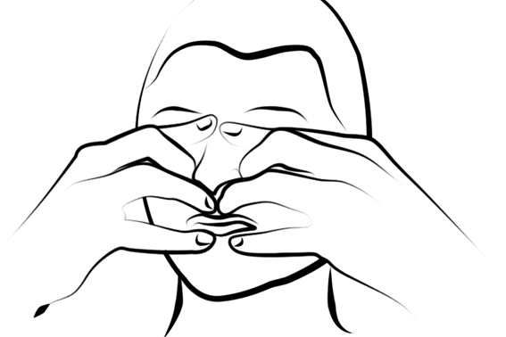Eventually we can adopt the full yoni mudra where after the inhalation we hold the breath and close the mouth with the little and ring fingers, the nostrils with the middle fingers, the eyes with the index fingers and the ears with the thumbs, This constitutes a very powerful form of pratyahara or sense withdrawal! When using yoni mudra we keep the fingers as directed simply lifting the nostril fingers to inhale, holding the breath, then lifting them again for the exhale as we hum on the out breath. When using yoni mudra we focus our attention upon inner vibrations.

It is possible to hum on both the in breath and the out breath, although humming smoothly on the inhale takes a little practice and can at first sound like a distressed bee!

## *Precautions & Prohibitions*

*Ideally it is practiced after more dynamic practices. There are no specific contraindications except those relating to the use of breath retention (kumbhaka).*

**7) Murccha “The Swooning Breath”**

‘Murccha’ means to swoon or faint! Here after the inhalation jalandhara bandha is practiced then attention is focused upon the ajna chakra, known as shambavi mudra. This breath retention is continued beyond the point of comfort then the bandhas are released and we exhale. By holding the breath retention beyond the point of comfort hypoxia or the reduction of oxygen within the blood is created producing a feeling of faintness. Although the chin lock provides a safety measure by regulating the heart rate through the reflex action of the carotid artery this practice should not be considered with the expert guidance of a teacher in an ashram situation!

## *Precautions & Prohibitions*

*Murccha is only advisable for advanced practice under the guidance of an experienced teacher. If any lightheadedness occurs then the practice must be stopped. It should never be practiced by those with high blood pressure, heart conditions or vertigo and essentially would only be a possibility in an ashram situation.*

**8) Plavini “The Air Swallowing Breath or Floating Breath”**

‘Plavana’ means to ‘float’. Here air is drawn into the stomach by swallowing. It is then retain there by resisting physical movement. Yogis in India can sometimes be seen floating on their backs with their legs folded in Padmasana whilst performing plavini. This technique is often used prior to entering prolonged Samadhi to increase the available prana in lieu of a food supply.

## *Precautions & Prohibitions*

*Again this would only be relevant in an ashram situation under guidance.*

© S. Beck (August 2103)