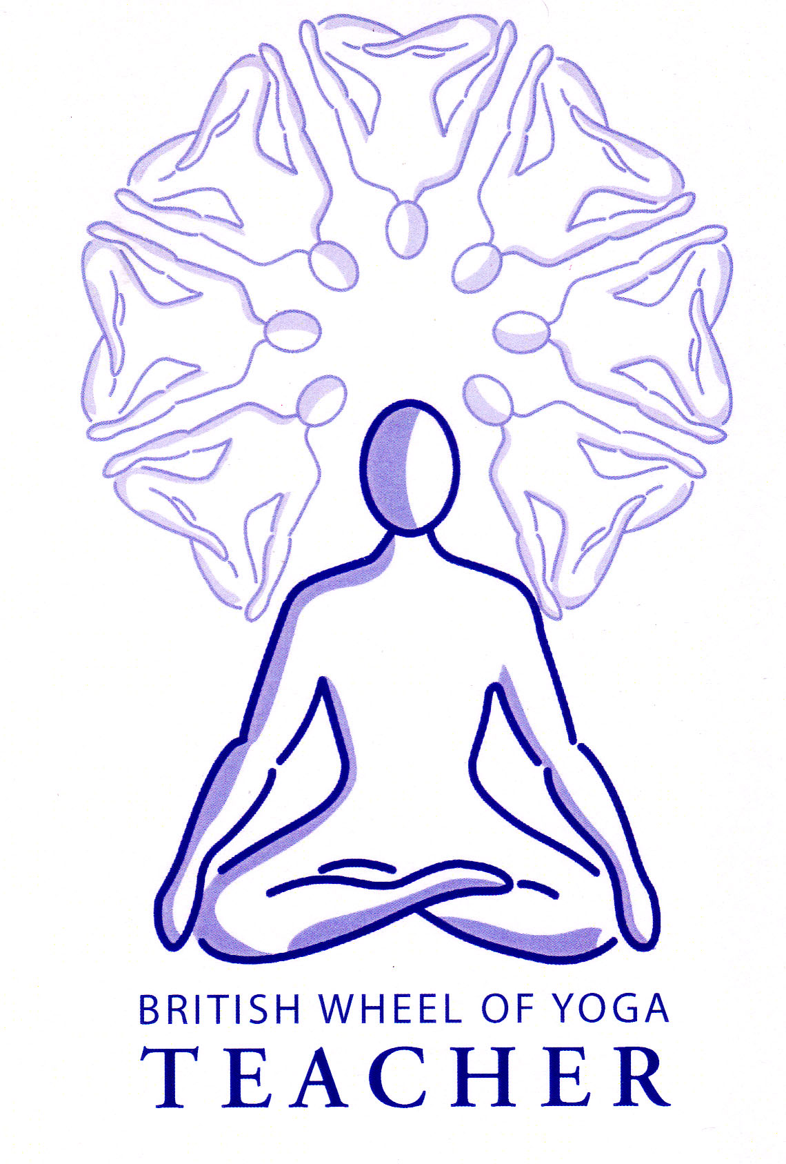When beginning pranayama there are several techniques to practice first. These are:

* Ujjayi
* Viloma pranayama
* Nadi Sodhana
* Anuloma pranayama
* Pratiloma pranayama
* Kapabalabhati

Please note that kapalabhati is primarily considered to be a kriya, used for cleansing purposes.

# Ujjayi Breathing

Ujjayi Breath is a very important breath. It can be used as a pranayama in its own right or within your asana practice where it has a very valuable effect.

‘Ujjayi’ can be translated as either ‘Victorious’, ‘Warrior’ or ‘Psychic’.

For ujjayi breathing the glottis is partially constricted creating a ‘sonorous’ sound. By partially constricting the glottis we are able to control the amount of air passing through the throat making the breath long and deep. This has many effects:

* It strengthens the respiratory muscles and the lungs themselves
* A greater amount of oxygen can be inhaled increasing energy levels
* Its smooth, rhythmic action promotes relaxation
* It decreases mental tension, being especially good for anxiety
* It facilitates deep diaphragmatic breathing meaning the heart is massaged more effectively, very good for heart conditions
* It has a heating effect, being excellent if we feel lethargic or congested
* It makes asana practice more meditative
* It helps us to become more sensitive to our energy
* It may help us to develop extra-sensory awareness of subtle energies

Ujjayi breathing is particularly beneficial for the following conditions:

Hypertension

Insomnia

Anxiety

Conditions related to the excessive production of mucous

## The technique

It can be difficult to master ujjayi breathing but there are several ways to try to learn the technique.

* We can imagine we are about to pronounce a hard ‘g’ as we would for the word ‘gate’. This is the shape we are making at the back of the throat. We can then breathe gently inwards and outwards as if we are sucking and blowing air through the partially close glottis at the back of the throat.
* Alternatively we can pretend we are misting a pair of glasses or a mirror, making the gentle sound of ‘aah’. Make this sound as you continue inhaling and exhaling. Eventually close your mouth and let the sound of ‘aah’ gently emanate from your throat.

In the early stages it may be helpful to imagine that your ujjayi breathing is mirroring the ebb and flow of the tide. Remember to make the breath very smooth and easy, never straining the breath. Also its effectiveness is increased if you lightly contract the lower abdominal as you inhale and more forcefully contract them as you exhale. This use of the abdominal muscles means there will be greater use of your diaphrgam.

When practicing pranayama keep the sound gentle never loud denoting force, although when used in asana sometimes to give us extra strength and focus it can become a little louder!

**Nadi Sodhana**

Nadi Sodhana translates as ‘cleansing of the nadis’ and is usually referred to as alternate nostril breathing. It is a very simple breath with far-reaching benefits; some might say it is the only breathing technique we ever need!

## *The technique*

Sit in a comfortable cross-legged position. Make a pincer with your right hand by pressing your right thumb against the ring and little finger. Curl the remaining two fingers into your palm, occasionally the spare two fingers are said to be placed against the ajna chakra, and this works well as a meditation technique where we are directing energy into this chakra, but if we wish to work with prana throughout the brain then the fingers should be curled inwards.

Place the pincer just beneath the bridge of the nose, thumb against the right nostril and two little fingers against the left nostril.

After a few natural breaths through both nostrils, inhale through the left nostril, exhale through the right, inhale through the right nostril and exhale through the left nostril. Continue breathing in through the same side and exhaling out of the other side keeping your breath relaxed. The breath should be very fine and quiet; we can imagine we are gently channeling a divine substance through each nostril, working with great attention and sensitivity. Ideally we must practice at least 12 rounds to create a beneficial effect. If at first you find it difficult to remain relaxed whilst working with this breath you could try holding your right elbow with your left hand or place your right elbow upon the right knee for support.

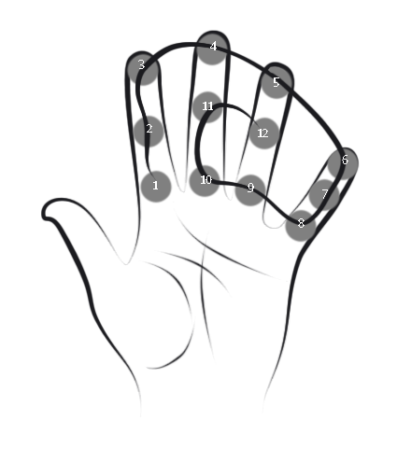This is a good point at which to learn to count when practicing pranayama. In order to count when using pranayama traditionally we use the fingers of the left hand. Here we place the left hand upon the knee or thigh with palm facing upwards and using the left thumb we start to count at the bottom pad of the index finger, moving the thumb pad by pad in a circular fashion as we count from 1 to 12. To see the sequence of thumb placements take a good look at the illustration.

This system of counting is very useful since we can focus upon the breath rather than numbers and whilst it is good to start it when practicing nadi sodhana where one round is inhale right ~ exhale left ~ inhale left ~ exhale right, later we can use it within any pranayama practice.

In addition when we count we can use a simple mantra to help us establish a rhythm so for instance we mentally count one-Om, two-Om, three-Om and so forth.

### The benefits of nadi sodhana

#### Nadi Sodhana creates a feeling of mental calmness being excellent as a prelude to meditation and can be used therapeutically when we are feeling agitated or nervous such as when we are about to give a presentation or take an examination of some kind!

This breath brings clarity to the mind and greater acuity to the senses as prana is increased and balanced.

Energetically it clears blockages within our subtle anatomy & physiology allowing prana to flow more easily. More specifically it balances ida and pingala nadis bringing our energetic state and therefore mental state into harmony; this is sometimes equated to the balancing of the sympathetic and parasympathetic sides of our nervous system. If there are imbalances within the physical or mental bodies this pranayama can always help to restore equilibrium. Eventually it is said this breath opens both sides of the brain.

**Prohibitions and Precautions**

There are no specific contraindications for nadi sodhana but it may be difficult to perform this breath if a student has a deviated septum or if the nostrils are congested in any way. In these situations we can use one of two variations instead. For the first variation we place both hands palms down on thighs or knees. Then imagining we are inhaling through the left nostril we turn the left palm up and then imagining we are exhaling through the right nostril we turn the right palm up as we turn the left palm down, imagining we are inhaling through the right we keep the right palm up facing then imagining we are exhaling out of the left nostril we turn down the right palm as turn the left palm upwards. We continue in this way turning the palms upwards and downwards as we imagine we are inhaling and exhaling. For the second variation we simply imagine the movement of the breath traveling through the nostril without moving hands.

**Anuloma Pranayama**

Anuloma means ‘with the grain’. For this technique we are working with both nostrils as for nadi sodhana but exhaling through alternate nostril as follows:

* Inhale through both nostrils and exhale through the right nostril
* Inhale through both nostrils and exhale through the left nostril

#### Benefits

It has a calming effect upon the body and mind.

#### Prohibitions and Precautions

As above for nadi sodhana.

### Pratiloma Pranayama

Pratiloma means ‘against the grain’. Again for this technique we are working with both nostrils as for nadi sodhana but this time we inhale through alternate nostrils and exhale through both nostrils as follows:

* Inhale through the left nostril and exhale through both nostrils
* Inhale through the right nostril and exhale through both nostrils

#### Benefits

This has a stimulating energizing effect upon the body and mind.

#### Prohibitions and Precautions

As above for nadi sodhana, also to ensure we do not over-stimulate our minds and bodies.

© Sarah Beck June 2013