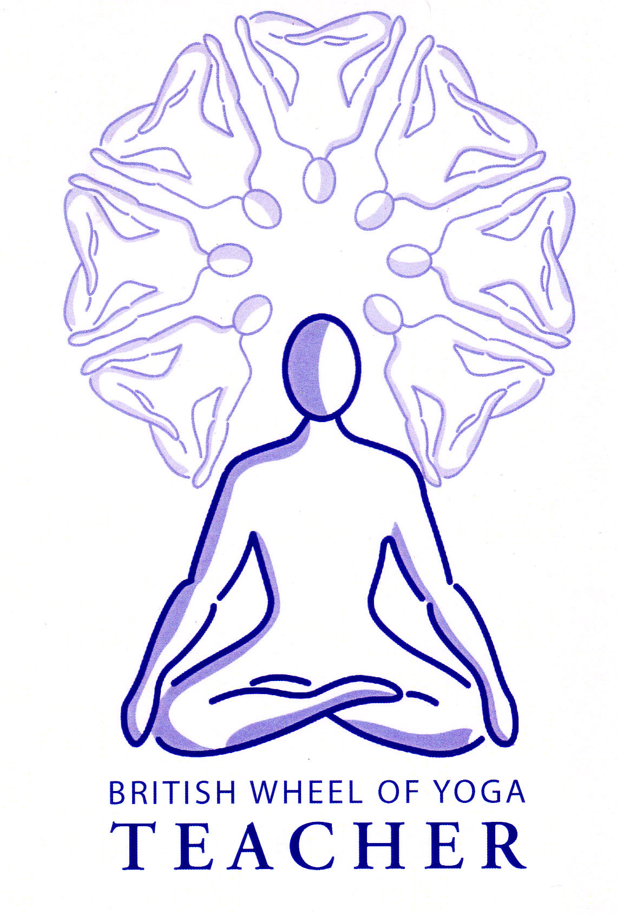

Benefits of forward bending
We must always work sensitively into forward bends, gradually releasing the muscles of the back of the body, in this way forward bends generally encourage a relaxed introverted state of mind where the exhalation is emphasized; all forward bends are calming and great for alleviating anxiety and a busy mind.

All posterior muscle tissue is stretched and the spine is lengthened, and by doing so the spinal vertebrae are opened as they decompress, improving the functioning of the spinal nerves and the circulation of spinal fluids; indeed the releasing of spinal muscles has a relaxing effect upon the sympathetic nervous system creating their calming and rejuvenating effect.

Forward bends also mobilize the hips, plus they will lengthen the hamstring muscles, which are attached to the pelvis at the ischial tuberosities.

For all of these reasons forward bends are very helpful to mentally and physically prepare us for the seated poses used in the quieter practices.

Additionally forward bends are great at massaging the abdominal organs and as such assist digestion and elimination plus they can be used when there are menstrual problems such a painful cramps.

However when resistance is physically experienced forward bends can also create mental frustration. In these situations they can be a great teacher as a vehicle for surrendering and consciously letting go, working with what is. We must also remember for some students forward bends will always be a great challenge in this way because their physical structure is such that they will experience compression either at the hip joints where structurally there is little rotation or they will meet compressed tissues at the front of the groin, here we must help students to recognize that if the limitations to stretching forwards is experienced at the back of the body then that is a sign they can work slowly over time to alleviate that tightness, as Paul Grilley calls it, this is tensile tension, but if it is experienced at the front of the body then that will be their structural limitation.

A guide for practicing forward bends

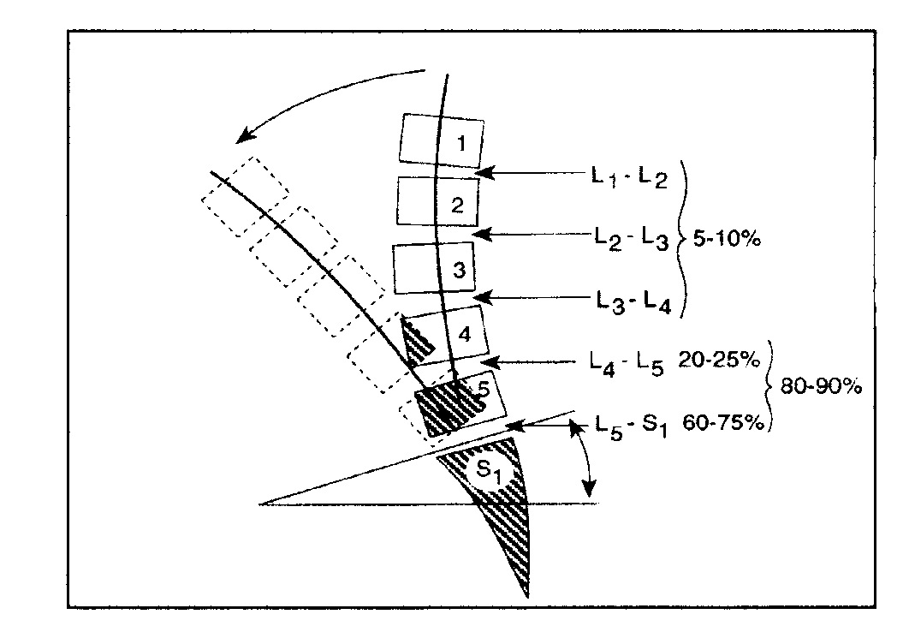
Work with an anterior or forwards tilt of the pelvis so you are primarily folding forwards from the hips rather than from higher in the spine itself. When the movement occurs at the hips this means we do not place the vertebral spine at risk by placing excessive pressure upon these areas. This is particularly important for the lumbar spine where most of the flexion in the spinal column occurs. Note that as you can see from the diagram opposite the lumbar vertebrae can only flex forwards for the angle of the natural lordosis (lumbar arch) so to fold the torso forwards we need also to rotate at the hips so the whole pelvis rotates forwards; now the entire length of the spine, from the tailbone to the head can move forwards safely as one length.

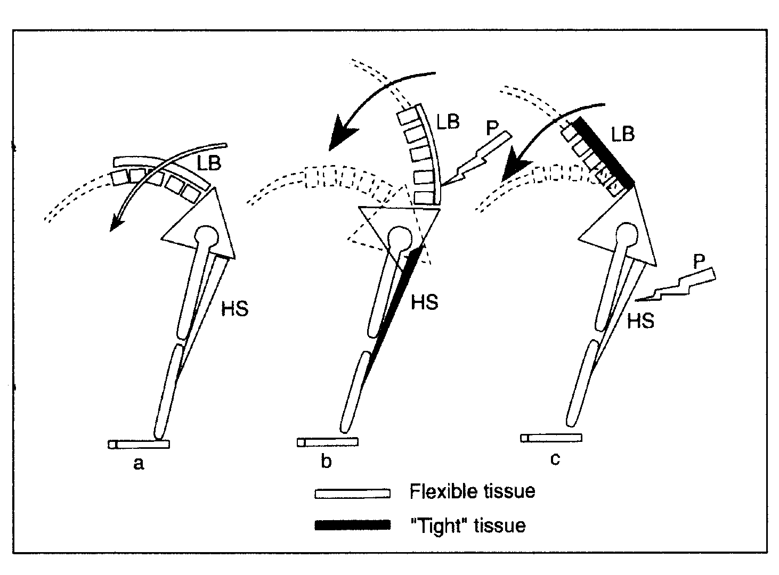
To practice forward bends we will need to mobilize the hip joints but also we will need to increase flexibility in hamstrings and adductors as these muscles are attached to the ischial tuberosities of the pelvis and if tight they keep the pelvis tilting backwards placing pressure on the lower back. Conversely if the lower back muscles are tight this can have an adverse effect upon the hamstrings potentially causing strain.

Meanwhile whilst the hamstrings, adductors and hips are still tight we can help assist proper forward movement by sitting on a block when performing a seated pose or we can bend the knees if performing a standing or seated pose, both of which help direct the primary action to the hips and avoid excessive pressure in hamstrings and the lower back.

We can use the breath, inhaling as we lengthen the spine and exhaling as we fold forwards. This is the way in which we enter the pose but is also the way in which we can work within the pose, using the inhalation to renew the length with the spine as we lift the chest and exhaling as we fold forwards again. This keeps the spinal column elongated throughout, avoiding excessive flexion between the vertebrae placing pressure upon spinal ligaments & discs. It also helps us to engage the abdominal muscles which must be utilized the help lengthen and support the back.

We must always keep the cervical spine long and neutral so avoid lifting the chin.

The legs must be placed symmetrically feet pointing forwards, knees aligned forwards. At all times we should be aware that for all forward bends we do not hyperextend at the knees and to avoid this we can lightly engage the thigh muscles. Hyperextension at the knees triggers the stress response where the nervous system tightens the body and can compress nerves and arteries behind the knee. Engaging the quadriceps has the secondary benefit that it will actually help to relax the hamstrings, this is known as reciprocal inhibition where for an antagonistic pair of muscles, such as the quadriceps and hamstrings, when one is contracted the other naturally relaxes and lengthens.

When choosing our form of forward bending we must also consider the weight of the arms, deciding whether to place hands at the hips, arms out sides or arms above the head etc. because these are progressively placing more pressure upon the spine. These variations in arm position can be used as developmental options gradually increasing the work upon the spine as the arms are place further away from the body.

At full flexion we can try to draw the ischial tuberosities apart utilizing the adductor muscles.

Good preparation for forward bending

All forward bends are best approached when the body is warm and awakened. We need to appreciate the quality of sukham or ‘ease’ to work with these asana.

As you may have realized already hip mobilisers, hamstring and adductor stretches all help to prepare the body for forward bending. We should also mobilise the spinal muscles. Some core strength is required, as is some thigh strength (quadriceps), and back strength. We must also be aware of the muscles of the feet and ankles especially in standing forward bends.

Specific considerations for forward bends

- As previously stated decide upon the placement of the arms, perhaps offering a couple of variations so students can choose the correct level of intensity.

- Always offer the option of bending knees and in seated forward bends always offer a block beneath the buttocks to aid the anterior tilt of the pelvis where required and know that sometimes a student can work with the back almost vertical, simply working to rotate the pelvis whilst placing a belt around the balls of the feet to create a dynamic circuit to work the hamstrings. We can also ask students to lift the tailbone and sitting bones to ensure the whole pelvis moves in alignment with the spine.

- Avoid overly using the arms creating by pulling the body into the forwards movement and remember to work with a lengthened spine, folding forwards from the hips with the whole spine moving as one.

Areas for caution

Abdominal problems, including hiatus hernia | Avoid excessive compression of the abdominal region. For hiatus hernia only work halfway with standing forward bends and do not move deeply into seated forward bends as they create acid reflux.
Asthma | Can help by enouraging breathing into the back and emphasizing the exhalation, which is often problematic for asthmatics.
Back conditions | Generally forward bends are problematic so with acute problems they need to be avoided. Thereafter go gently bending knees, blocks beneath buttocks when seated and it is often helpful place a small roll in the groin to create space in the hip joint. Avoid for at least 3 to 6 months for herniated disc.
Depression | May need to keep head and chest slightly raised and stay for short periods only as forward bends may be too introverting and quieting
Ear or eye conditions | Do not take the head lower than the heart, working with half forward bends when standing
Hamstring injury | Avoid any pain, bend knees to alleviate tension on hamstrings
Heart conditions, hypertension & mature diabetic | Do not keep the head lower than the heart, working with half forward bends when performing standing forward bends if holding the pose, can also place a support beneath the head when relevant.
Hip problems | For total hip replacement do not move into deep forward bends, when standing work halfway only, when seated use a block and belt staying upright For hip resurfacing work with caution.
Low blood pressure | Take care to move slowly between different heights e.g. from seated to standing etc. Can take extra breaths as move slowly upwards or downwards.
Osteoporosis | Work cautiously bending knees, as a deep forward bend can overly compress vulnerable joints, especially in the lower back.
Pregnancy | Work with legs apart if necessary, work with support if necessary, for standing forward bend going only half way using aids such a a chair if helpful
Sacro-iliac Joint Strain | Forward bends usually aggravate this condition, if acute may need to use an alternative, otherwise with caution bend knees & for seated pose sit on a block
Sciatica | Forward bends usually aggravate this condition so we may need to bend knees and if seated pose sit on a block to alleviate pressure on the sciatic nerve
Vertigo | May need to work very slowly when moving between different heights using supports where necessary

Note:
For all asana the stretch experienced must always be felt at the belly of the muscle not at the attachment and for forwards bend this especially means we should not experience the stretch at the sitting bones (the origin of the hamstrings) or at the knees (an attachment point for adductors and hamstrings). Nor should we experience any strain at the sacro-iliac joint or lumbar spine, and if these are already chronically present we need to modify our forward bends.

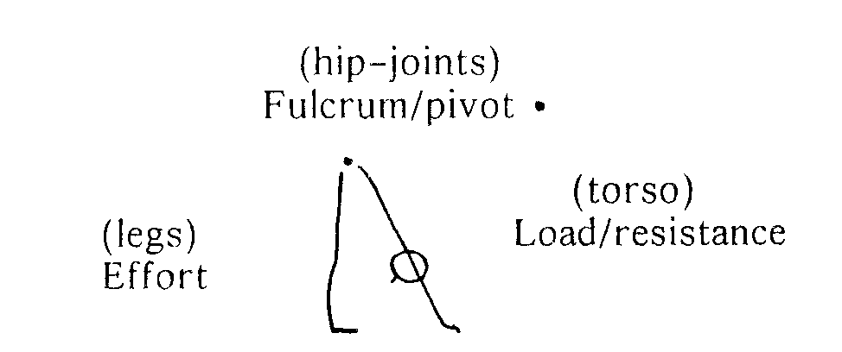
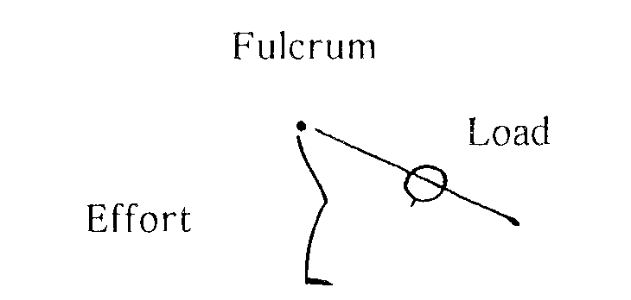
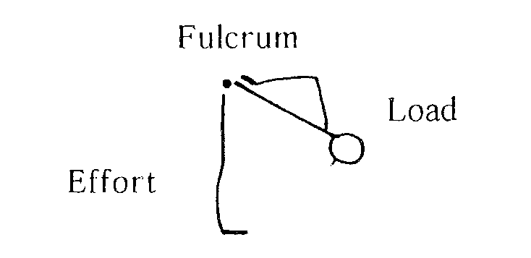
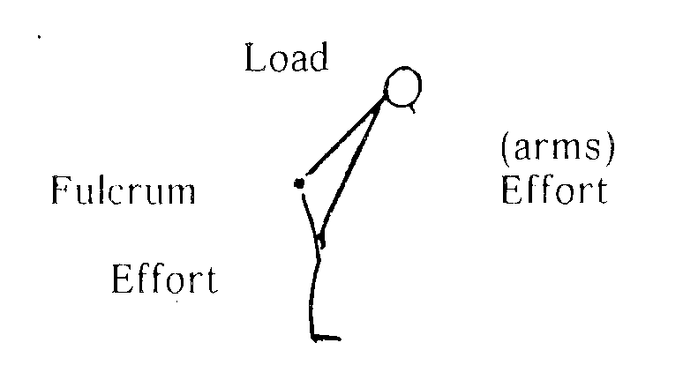
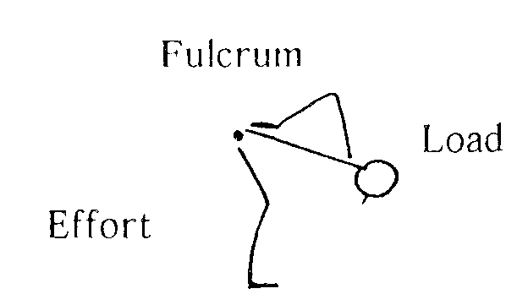
Applying the Principles of leverage to forward bends: Uttanasana
b) However if we bend knees then the effort has moved closer to the fulcrum making it easier to lift the load of the upper body
c) If we place our hands on the sacrum with elbows bent then this has greatly reduced the load to be lifted as the load has moved closer to the fulcrum
d) If we use the arms as levers then this decreases the load by increasing and spreading the effort
e) With bent knees and hands to the sacrum we increase
the effort and reduce the load simultaneously since both and the load are closer to the fulcrum
These principles will apply to all forward bends and we will need to consider how we teach forward bends to our students progressively, using modifications as necessary.

S

a) With straight legs and straight arms a great deal of effort is required from the legs to lift the upper body. The effort is a long way from the fulcrum, the hips, and the resistance is great since the load is far away from the fulcrum.

© S. Beck 2012

