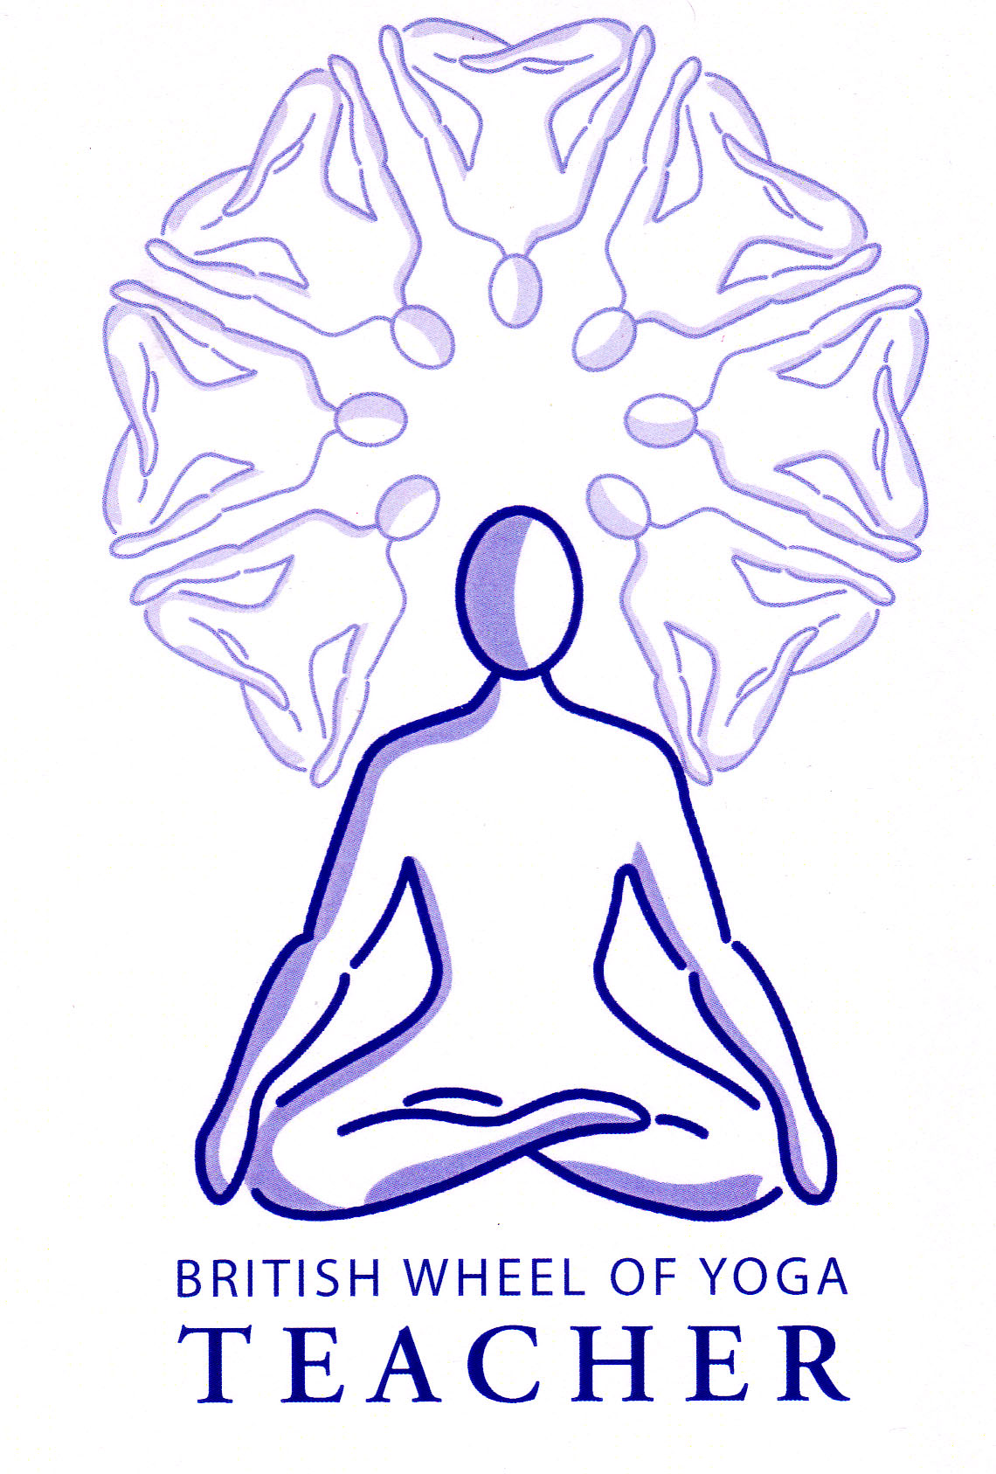**In our ‘introduction to Pranayama’ we looked at the following aspects of pranayama:**

* Benefits from the practice of pranayama
* The need to work with basic breathing techniques first
* General advice for practicing pranayama
* Possible positions for pranayama
* The correct use of the abdominals in pranayama
* The need to anchor the mind when practicing
* The fact that the breath must be smooth and never forced, with the relative time spent in each part of the breath being of prime importance, rather than the length of the breath
* The characteristics of the four parts of the breath (puraka, A.K, rechaka and B.K.)
* The format for the use of ratios
* That we always start with the A.K, first and can gradually introduce the B.K.
* The physiological benefits of the kumbhakas
* The cautions for working with kumbhakas

So let us continue our journey into pranayama….

**How to use ratios**

There are many permutations of ratio possible, with each permutation creating a different physical, mental or energetic effect.

In order to use ratios we must initially find our natural length of breath by counting a comfortable inhalation. Usually the ratio is expressed in its lowest numerical form to show the relative length of each part of the breath leaving it up to us to work out the actually number of counts.

At first we may find we can only inhale to a count of 4 so for us to double the exhalation to the length of our inhalation so for ratio 1:0:2:0 in reality our breath will be 4:0:8:0 or to perform equal length breath (samavritti) we will be working with the ratio 4:4:4:4.

As we grow in experience the capacity of our breath will increase so we may find we can inhale to a count of 6. So now, to double the length of the exhalation to the inhalation, the ratio will become 6:0:12:0 and our equal length breath will become 6:6:6:6.

It is the relative proportion of time spent within each part of the breath that is of most importance so we must never, never struggle or strain to increase the length of the breath beyond our capacities. The best advice is not to attempt to lengthen the breath forcibly but rather slow the breath, inhaling and exhaling more finely.

All pranayama techniques should create a feeling of lightness and well-being. If dizziness, disorientation, nausea, ear or eye discomfort are experienced then this indicates that the practice has either been incorrect or is contraindicated and we should desist from the practice. As for asana practice, we need to develop over time, using a vinyasa krama approach and commonsense should always prevail, meaning we should never exceed our current capacities where the breath becomes strained.

A good schedule is as follows:

* Initially perform basic breathing techniques
* Become adept at the full yogic breath
* Practice throat control through ujjayi so we can become more aware of the length of the breath and in particular learn to extend the breath without counting its length
* Practice finger control through nadi sodhana, gaining a more precise control over the flow of the breath through each nostril.
* We can introduce finger counting to count the number of rounds whilst working with simple nadi sodhana or ujjayi
* Work with viloma where we make pauses, interrupting the inhalation and exhalation
* Begin to practice using ratio once control over the length of the breath is possible with ease
* Start to work with 1:0:2:0 where the exhalation is twice the length of the inhalation which has a relaxing effect and ensures we are capable of a good exhalation
* Then with the ratio of 1:0:1:0 which is simple and balancing
* We can start to learn the bandhas (Mula Bandha & Jalanadhara Bandha) experiencing them separately at first, then applying them to pranayama as we continue
* We can begin to work with 1:1:1:0 antara kumbhaka, which has a rejuvenating effect.

This is often illustrated by using a triangle:

Hold the

Breath

Inhale

exhale

* Progress with antara kumbhaka using for instance 1:2:2:0
* Once students are comfortable with antara kumbhaka we can introduce bahya kumbhaka , which has a calming, introverting effect. Here we use the sama vritti (same length) ratio of 1:1:1:1 This is often illustrated using a square:

A.K.

Exhale

Inhale

B.K.

* For more advanced students the classic visama vritti (unequal length) ratio of 1:4:2:0 can be introduced
* In all cases the number of rounds is gradually built up, as is the time spent within kumbhaka. The breath must remain smooth and easy, remember the lungs are sensitive organs!

Finally to note once we are very experienced in pranayama there are ratios which are said to produce very specific effects such as:

4:2:4:2 helps asthma or convalescence

6:3:6:3 control emotions

8:4:8:4 strengthens, rejuvenates and cleanses

10:5:10:5 speeds metabolism

12:6:12:6 alertness, spiritual development

14:7:14:7 brings serenity

16:8:16:8 the Master’s Breath, giving health and longevity

Do not attempt these ratios now!!

**Practicing the Bandhas:**

**Jalandhara Bandha ‘The Chin Lock”**

“jal “= throat “dhara” = supporting

**Method**

Sit comfortably with your spine erect. Place hands on knees, arms straight. Inhale, hold the breath, drop the chin forwards and down onto the jugular notch, continue to retain the breath, lift the head, exhale. Ensure that you draw your shoulder blades together and keep your chest open. Can also swallow first to release neck tension and lengthen neck.

**Precautions & Prohibitions**

There are very few. Do not hold for more than 10 beats without also performing mula bandha. Do not build up counts if there is high blood pressure, heart conditions or pregnancy, or any other condition where the increase of inner pressure is contraindicated. There should be no pain felt in the neck. If short-necked roll a scarf under the chin to supply the pressure.

**Mula Bandha “The Root Lock”**

**Method**

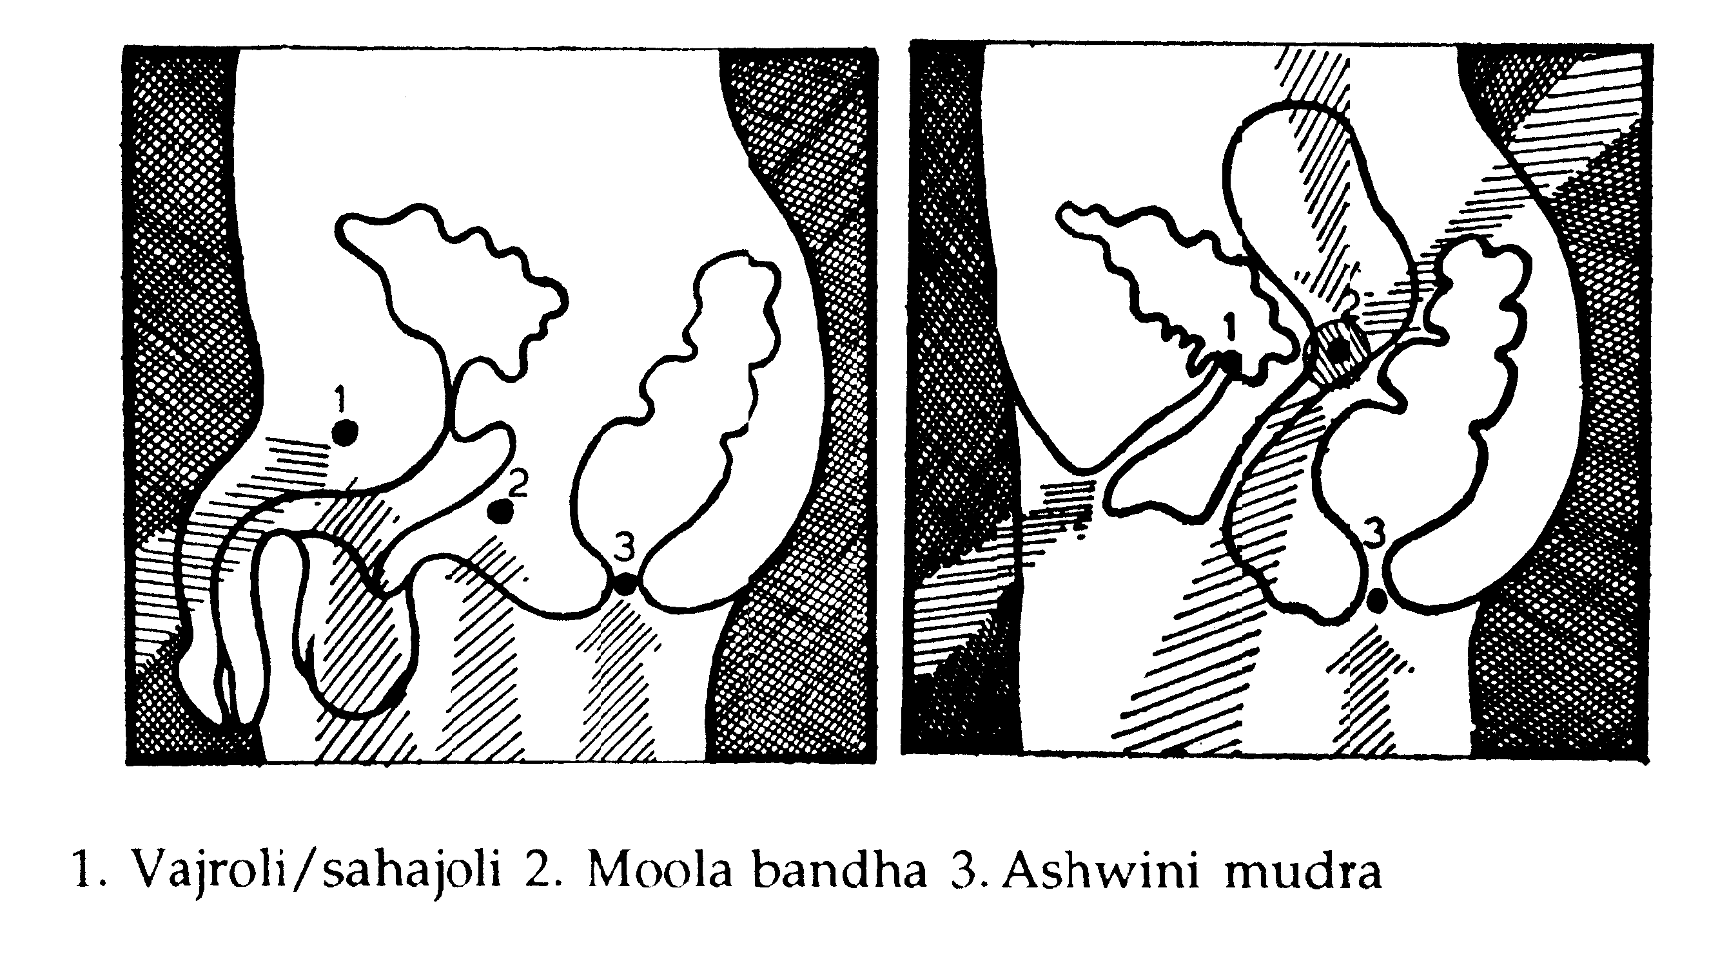

Practice general techniques to strengthen the pelvic floor first. Contract the rectal muscles repeatedly (Aswini Mudra). Contract the muscles around the pubis repeatedly (Yoni Mudra). Aim to isolate one movement from the other thenfinally when some control is experienced, practice the muscle lift into Mula Bandha on the central point, not the front or back. For men MB is located at the perineum whereas for women it is at the opening of the cervix. Performing the cat or shoulderstand can help you to locate this point.

**Precautions & Prohibitions**

Only for high blood pressure, so can use the slightest retention in this situation. It is an excellent practice for the elderly when done without retention. Everyone can lie down in a semi-supine position to practice pelvis rolling to locate the point in the perineum.

**General guidelines for working with kumbhaka**

As a general rule for breath retention:

* Before using kumbhaka we should always take several ordinary breaths and avoid taking a deep inhalation before breath retention as this is very unhelpful.
* We should always adopt mula bandha when working with breath retention and when holding the breath for more than 10 seconds we also must apply jalandhara bandha; these are very important because they act as safety locks
* Retaining the breath for 3 to 20 seconds is generally safe for all with the exception of the cautions already mentioned in the previous handout
* Retaining the breath for 20 to 90 seconds creates many prohibitions, both physical & emotional and requires slow progression
* Retaining the breath for 90 plus seconds is very advanced practice requiring great preparation and is beyond the remit of anyone working without expert guidance on a one to one basis.
* When working with A.K. we often find it helpful to inhale a very little after the breath retention before we exhale, this certainly helps to make a smooth continuous exhalation.
* At first we can perform 5 to 6 rounds of pranayama using kumbhaka after which we should take a few natural breaths and when we perform the next round we may find it is easier to perform the kumbhakas as the spleen will have been stimulated to produce more red blood cells.

**Teaching Pranayama to our students**

So how can we teach kumbhaka when some students in our class may be unready or it may be contraindicated for some students? Well we can work just as we did with asana by layering the practice. We can start the practice with natural breathing, then the pranayama technique without a ratio, then introducing a ratio without kumbhaka then go on to add a kumbhaka with those who should not perform kumbhaka staying with the previous ratio, for instance the students might be lead through the following stages:

1. Natural easy breathing (releasing, calming the breath)
2. Ujjayi without a ratio just getting used to the technique and establishing the length of breath
3. Ujjayi with a ratio of 1:0:1:0
4. Ujjayi with a ratio of 1:1:1:0 (M.B. on the A.K.) x 6 rounds

*[Note:use JB also if count is above 10]*

1. Natural Breathing
2. Ujjayi with a ratio of 1:1:1:0 (M.B. on the A.K.) x 6 rounds
3. Natural Breathing

This method means we prepare well for the more complex ratios and it also means students can stay at the correct level.

If a medical condition is present and you are in doubt about the suitability of using kumbhaka then always err on the side of caution and you may need to seek medical advice.

© S Beck February 2014