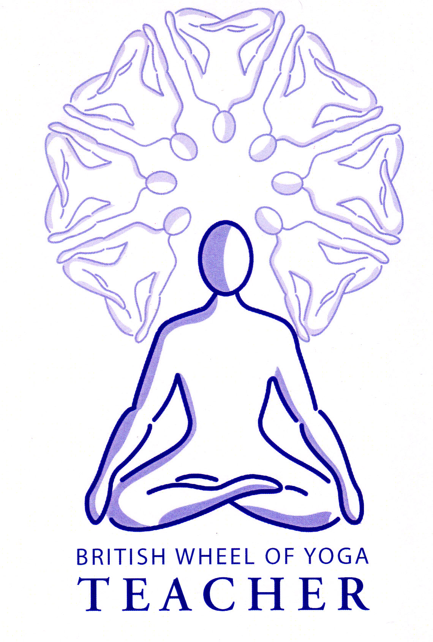Prana can be translated as ‘constant motion’ where ‘pra’ means ‘constant’ and ‘na’ means ‘movement’ denoting it’s nature. Some simple definitions of prana might be:

‘Vital energy’ Patanjali’s Yoga Sutras Bk 1 v34

‘The breath, the air, Life itself’ B.K.S. Iyengar

The energizing principle of the animate and inanimate world’ B.K.S. Iyengar

“All that vibrates in the universe is Prana; heat, light, gravity, magnetism, vigour, power, vitality, electricity, life and spirit are all forms of Prana. It is potent in all beings and non-beings and a prime mover of all activity. This self-energizing force is the principle of life and consciousness. It is the creation of all beings in the Universe. All beings are born through it and live by it, and when they die their individual breath dissolves into the cosmic breath. Prana is the hub of the wheel of life. Everything is established in it. It permeates life, creating the sun, the moon, the clouds, the wind, the rain, the earth; all forms of matter are permeated by it. It is both being (sat) and non-being (asat). Therefore, each and every thing including man takes shelter under it. Prana is the source of all knowledge and a unique energy.”

Sri Swami Satchidananda Yoga Today Magazine July 2001

‘Prana is the vital energy of the universe. Every living being is alive due to prana. Different traditions have different names for prana: the vital force, ki, chi., orgone, and simply energy. Whilst prana is often associated with breath, it is not the breath; prana rides on the breath, but is different from the breath. Prana enters and exits the body following the movement of the breath. That is the nature of prana: movement.

The name prana is Sanskrit; it means before (pra) breath (ana). Prana is neutral; its is pure energy without any qualities. This pure energy can take on any quality without losing its purity; just as by putting on clothes, we associate with a style of dress, still we remain the same person.

Prana can be used to facilitate meditation, sex, combat or healing. It gives vitality to the physical body and also gives us the power to think. Prana is both physical and mental energy: “Movement of thought in the mind arises from the movement of prana; and the movement of prana arises because of the movement of thought in consciousness. They thus form a cycle of mutual dependence, like waves and movement of currents in water.”(Yoga Vasistha p313)’

Atreya , Prana: the Secret of Yogic Healing page 3

A good way to conceptualize Prana is to think of Prana with a capital ‘P’ as being the undifferentiated power and energy of the universe with prana with a small ‘p’ as being all the manifested differentiated forces of prana.

“Thus Prana is undifferentiated universal energy, while prana is the differentiated energy revealed in every possible form. Magnetism is a manifestation of Prana, so are electricity and gravitation. Everything in the universe that moves is a manifestation of Prana; thanks to Prana the wind blows, the earth trembles, an axe falls, an aeroplane takes off, a star explodes, a philosopher thinks. We exist in an ocean of Prana where every living thing is a vortex. Yoga affirms that what characterizes life is its ability to attract Prana to itself, to store it up and transform it for influence upon both the inner and outer world…. According to the yogis, it is present in the air, yet it is neither oxygen, nor nitrogen, nor any other chemical constituent of the atmosphere. Prana exists in our food, water, sunlight, but it is neither vitamin nor warmth nor ultraviolet rays. Air, water, food , sunlight: all convey the prana on which all animal and vegetable life depends. Prana penetrates the whole body, even where the air cannot reach. Prana is our true nourishment, for without prana there can be no life. Vitality itself is no more than a special and subtle form of prana, which fills the whole universe. To make itself manifest on the material plane the spirit uses prana to animate the body and its organs…..[The Rishis} proclaim –and this forms the very basis of yoga – that prana can be stored in the nervous system, more particularly at the solar plexus. Furthermore, they emphasize this cardinal and essential idea that yoga gives us the power, through thought, of directing the current of prana at will. Yoga thus gives us conscious and voluntary access to the very source of life.” (Andre Van Lysbeth, p10)

“Everything in this universe is the manifestation of prana. In yogic terminology it is said that whatever is manifest is the sthula rupa or ‘gross form’ of the subtle cosmic energy, is prana. In yoga and tantra there is an eternal truth; the basis of existance depends on two forces Shiva and Shakti, or consciousness and energy. Ultimately they are not two forces but one; Shakti or prana, is the creative force of consciousness or Shiva. The purpose of hatha yoga is to realize Shiva or consciousness, by means of Shakti or prana.” Commentary on Hatha Yoga Pradipika, Ch 2, v1

*How can we experience prana?*

By its very nature prana is in perpetual motion, never resting. We can directly experience it in many ways for instance:

* During asana practice when there is a flurry of energy, rather like the feeling of electricity, moving through the body as the pathways of energy are altered to become more freely flowing.
* When we are feeling our energy levels lifting prana is increasing.
* Perhaps you may have experienced being drained by the company of another person where that person literally drains you of energy. Remember we do not exist as an isolated island, being more like the whirlpool of energy in a sea of energy, and like the weather system energy will flow from high to low pressure!
* You may have experienced distinct movements of energy or prana when receiving healing such as acupuncture, massage or the placing of hands.
* When you place your mind within a certain area of the body you may have felt the enlivening of that area, perhaps a feeling of heat, tingling etc. as prana follows the mind (energy follows thought).

Also note the important link between prana and the mind as Sri Swami Satchidananda stated:

“Prana (energy) and Chitta (mind) are in constant contact with each other. They are like twin brothers – the Prana gets focused where the mind gets focused; and where Prana is, the mind gets focused”

Yoga Today Magazine July 2001

Yoga makes much of this connection.

It seems in all indigenous societies there has traditionally been an animistic view of the world, with a special word denoting the ‘Life Force’ which is believed to be the spiritual force pervading all of their reality. In this way although the word varies from tribe to tribe in all of these societies this universally created a deep respect for all of nature and a sense of being connected to all of Life. This is a monistic view of the world where all is ultimately one.

Also see:

# Upanishads Kaushitaki Upanishad 3.2-3 p106

Prasna Second Question p68

Prasna Third Question p70 (all of this Upanishad is relevant)

Bibliography:

Atreya, Prana: The Secret of Yogic Healing, Samuel Weiser Inc: York Beach (1997)

Iyengar, B.K.S,

Van Lysbeth, Andre, Pranayama: The Yoga of Breathing, Unwin Paperbacks: Edinburgh, (2nd Edition 2007)

Sri Swami Satchidananda Yoga Today magazine July 2001

Swami Muktibodhananda Saraswati, Hatha Yoga Pradipka, Bihar School: Bihar (2nd Edition 1993)