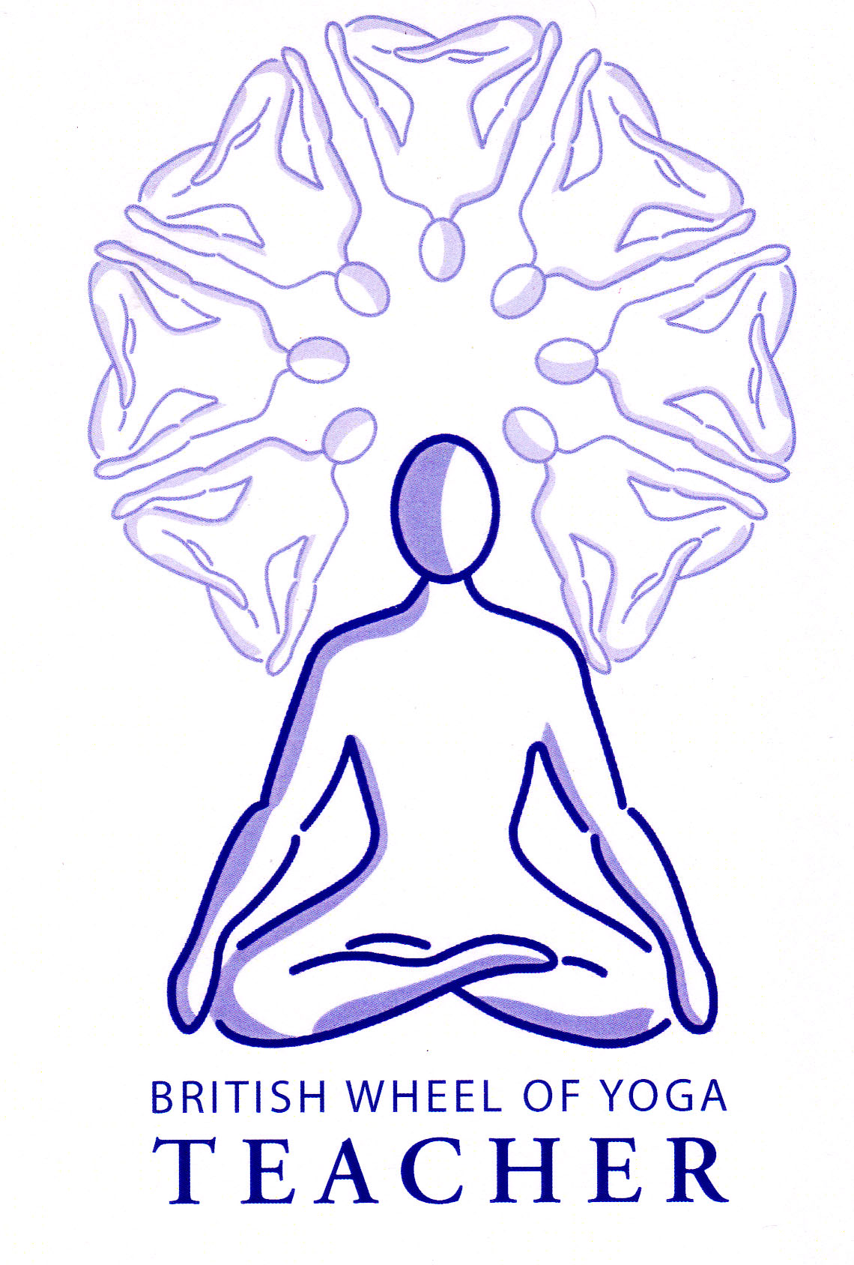The Six Kriyas or Shatkarmas

Both ‘Kriya’ and ‘Karma’ mean ‘action’ and ‘Shat ‘means ‘six’ so we are looking at the **Six Actions.**

These are six groups of purification practices traditionally kept secret and passed down from master to student. It was felt that these powerful techniques should always be taught by an experienced person and given according to individual needs.

Interestingly in the Gheranda Samhita they were seen as a necessary requirement for all practitioners of hatha yoga whereas in the Hatha Yoga Pradipika we see in ch2 v21 their use is suggested only if necessary, i.e. if the three doshas are imbalanced so there are signs of excessive wind, bile or phlegm. We also see in ch2 v37 that pranayama will remove impurities and therefore the shatkarma are unnecessary but here perhaps we can conclude that for mild imbalances of a certain kind pranayama will be enough whereas for more severe imbalances shatkarma becomes necessary.

Throughout the various texts of hatha yoga we find asana and pranayama in its mildest form is appropriate for all people but once we are retaining the breath for long periods and practicing intensively then this question of purification becomes important!

The key word for shatkarma is purification but what are we purifying and why?

The shatkarmas are not magical rituals, essentially they are simply cleansing techniques to maintain good health. They are designed to lead to the purification of the body so that prana can flow freely and our body, mind and senses can operate effectively without any disturbances. They increase our energy levels, leading us to a state of harmony and balance so that we can proceed with the other practices of hatha yoga.

Esoterically they help to purify the nadis, the channels of prana, weaving throughout the body.

Exoterically they can be seen as part of physical detoxification where they create internal health. They eliminate waste materials, toxins, impurities, assisting the natural processes by cleansing the mucous membranes, the kidneys, bowels, skin, eyes, lungs and parts of the digestive tract such as the tongue, esophagus, stomach etc. (see Ch2 v23).

You will see physiological imbalance spoken of in terms of excess wind, bile and phlegm or mucous, this being the traditional Yogic and Ayurvedic way of looking at health and disease. [Ayurveda is the healing branch of Yoga].

Wind, bile and phlegm relate to the three doshas of vata, pitta and kapha respectively. Doshas are intelligent bio-energetic forces responsible for every function of our mind and body. For instance vata (air & space) is responsible for all communication and cycles, for the movement of all substances around the body. Pitta (fire & water) possese a firery transformative function, governing cellular metabolism, enzyme reactions and so forth. Kapha (earth & water) is an anabolic force, building, repairing and secreting lubrication. However when the doshas become unbalanced due to factors such as the environment, our daily lifestyle, diet, stress etc. they begin to produce excessive quantities of wind, bile and phlegm, the waste materials of the doshas, respectively. These substances begin to accumulate in the body at first within the gastro-intestinal tract and there they begin to create uncomfortable symptoms for instance excess wind causes abdominal distention or pain, excess bile creates heartburn or ulcers, excess mucous causes feeling of nausea or heaviness.

Significantly the creation of these substances will interfere with our digestive capabilities, that is the power of our jathara agni or gastric juices. When wind, bile or phlegm accumulate our food begins not to be digested effectively creating ama or toxic undigested matter; excess wind causes the agni or digestive flame to burn intermittently so food is only partially digested, bile causes it to flare up burning food too much, and excess mucous causes our fire be put out so we do not have the power to digest. The ama produced sticks to surfaces inside the GI Tract creating a perfect place for pathogens to grow typically giving feelings of tiredness, heaviness etc. In time it will result in digestive problems such IBS.

The story continues as as this progresses our tissue formation becomes vitiated and as the unbalanced dosha moves through the tissues of the body it creates disease; for instance excess wind is absorbed by the colon, drying the surface membrane of the colon and inhibiting the uptake of minerals leading to osteoporosis or excess phlegm can create congestion deep inside the tissue forming cysts or fibroids etc.

Whilst the accumulation of excess doshas can affect us all we are often prone to the excessive accumulation of our own predominant dosha. This is because whilst we all possess all three doshas of vata, pitta and kapha there will be a particular mix of vata, pitta or kapha doshas for each us and if we are a vata type it is much easier for vata to accumulate and so on.

So we can see in this very basic way in yogic & ayurvedic terms the accumulation of the doshas i.e. wind, bile and phlegm needs to be addressed for good health and for increased energy levels so for the practitioner of hatha yoga this is a first consideration. The shatkarmas therefore are ways in which accumulated dosha can be cleared from the gastro-intestinal tract to purify the body and therefore the mind, and very importantly to increase our energy levels. Do note that our mind and emotions and even our senses are intimately tied to our physical health so in yogic and ayurvedic terms for instance excess vata (air & space) creates anxiety, excess pitta (fire & water) creates anger and irritation and excess kapha (earth & water) creates dullness or over-sentimentalism. In real terms the mind and body are the same, each intimately affecting the other.

The six kriyas are:-

1. Dhauti Cleansing of the Digestive tract
2. Vasti Colon Cleansing
3. Neti Nasal Cleansing
4. Tratak Therapeutic for eyes & mental functions
5. Nauli Intestinal Cleansing
6. Kapalabhati Purification & vitalization of the frontal lobes of the brain

In the commentaries we find most of the information since the Sanskrit verses are very short leaving a teacher to expand upon them. The Bihar School commentary is very good in this respect. (please read Ch2 v21 to v36)

# (1) DHAUTI meaning ‘to wash’

This is a series of cleansing techniques sub-divided into three main groups:-

A Antwar Dhauti or internal cleansing (further divided into 4 types)

B Hrid Dhatu or thoracic cleansing (further divided into 3 types)

C Sirsha Dhauti or head cleansing

# A Antwar Dhauti (internal cleansing practices)

These cleanse the alimentary canal from the mouth to the anus.

**1) Vatsara Dhauti (expulsion of air through anus)**

*The drinking of air through the mouth shaped like a crow’s beak, the forced through anus.*

Cleanses the intestines with air to stimulate the digestive system to work more efficiently, removing gas and wind, preventing hyperacidity and heartburn. Not to be used when there are stomach or intestinal ulcers, hernia, heart disease, high blood pressure or during menstruation.

**2) Bahiskrita Dhauti (washing the rectum in the hands)**

*Fill lower part of digestive tract with air, holding it for 90 mins then standing in water draw out large intestine and wash! Said to give a god like body “Deva-Deha’.*

Cleansing the rectum to cleanse the lower part of the digestive tract but not to be practiced during menstruation or with haemorrhoids.

3) Dhauti (rapid expansion & contraction of abdomen)

Sometimes called Agnisara the navel is pressed to the spine one hundred times – fire purification.

Activating the digestive fire to stimulate the functioning of the liver, spleen and pancreas. Toning abdominal muscles, alleviating constipation whilst creating heat in the navel area.

**4) Varisara Dhatu (empty water through bowels)**

*Drink water to the level of the throat then slowly move it through the stomach to be expelled through the anus. – water purification*

Cleansing of the intestines through an involved process so that the whole length of the alimentary canal is cleansed, including the digestive and eliminatory parts. It improves digestion, promotes proper functioning of the kidneys and urinary system and strengthens the immune system. It should not be practiced during menstruation or pregnancy. A shortened version is called laghoo shankhaprakshalana which is used by the Bihar School:

*Drink 16 glasses of salted water*

*Perform 5 asana 8 times*

*Drink 16 glasses of salted water*

*Perform 5 asana 8 times*

*Perform colonic irrigation and rest*

We also find the following practices that can be placed within the dhauti techniques.

**B Hrid Dhauti (thoracic or cardiac cleansing)**

## Vastra Dhauti or Cloth Cleansing

A 16ft long, 4 ft wide piece of cloth is swallowed whilst keeping hold of the end.

Releases excess bile and mucous, alleviating problems of the stomach and spleen and clearing the bronchial tubes and lungs. It should not be done during menstruation and is not for the faint hearted requiring the guidance of an experienced instructor.

**2) Vaman Dhauti**

The use of vomiting to clear the contents of the stomach.

**3) Danda Dhauti**

The insertion of a soft banana stem into the stomach!

# C Shirsha Dhauti

These are cleansing practices for the tongue, teeth, throat, ears, eyes and forehead. We can include:-

Danta Mula Dhauti Teeth cleansing

*Traditionally using neem twig or pure earth*

Jihva Sodhana Tongue cleansing

*Copper or steel scrapper used*

Karna Dhauti Ear cleansing

*Index or ring finger used*

Kapala Randhra Dhauti Sinus Cleansing

Rubbing thumb into depression on forehead near bridge of nose

# (2) VASTI

This is a general term relating to the lower abdomen, pelvis and bladder. There are two types of vasti:-

# Sthala or vata vasti

Here the colon is cleansed by drawing air into the body by placing a bamboo stick into anus whilst kneeling – rather like colonic irrigation

# Jala vasti

Here water rather than air is sucked into the anus.

These practices are used to cleanse the bowels, removing excess bacteria, old stools, threadworms and heat from the lower intestines. They are indicated for digestive disorders, constipation, urinary problems and also strengthen abdominal muscles. They should not be practiced if suffering from a fever, ulcers, haemorrhoids, high blood pressure, hernia or during menstruation.

1. **NETI (see additional handout)**

This is the practice for cleansing the nostrils and the sinuses. There are two main types:-

Jala Neti Nasal cleansing using water

Sutra Neti Nasal cleansing using a thread

Both of these techniques clear the nasal passageways and are beneficial for the eyes. They should not be practiced if one suffers from nosebleeds or lesions inside the nostrils. They should not be practiced just before going to bed.

1. **NAULI (see additional handout)**

In some ways nauli is considered to be a progression of uddiyana bandha. The Sanskrit word ‘nala’ or ‘nali’ means a tubular vessel, a vein, nerve or reed or hollow stalk, it is also the Sanskrit word for the rectus abdomini.

Nauli is the practice of isolating and rhythmically contracting and relaxing the rectus abdomini muscles. It massages and invigorates all the internal organs and brings a concentration of prana to the solar plexus. It helps to alleviate abdominal and chest disorders and stimulates metabolism. It should not be practiced with acute abdominal problems, during pregnancy or menstruation. The H.Y.P. considers it to be the most important of hatha yoga practices since it revives the digestive fire and removes sluggish digestion.

It is not always a good practice for women since there is intensive pummeling of the internal organs. It can be considered to be an advanced practice requiring strong abdominals. Agnisara (mentioned in G.S.) can be used instead where we flap abdominal muscles in uddiyana bandha or laulike (mentioned in G.S) where the abdominals are rolled from side to side.

1. **KAPALBHATI (see additional handout)**

In Sanskrit Kapala means ‘skull’ and bhati means to ‘shine’ so this can be translated as the practice of ‘skull shining’. It is a breathing exercise that purifies the nasal passages and lungs and helps the body to eliminate large quantities of carbon dioxide and other impurities. The increased oxygen enriches the blood and renews tissues. The movement of the diaphragm massages the stomach, liver and pancreas. It is similar to Bhastrika, the bellows breath, except that here the exhalation is emphasized and inhalation is a result of forcing the air out.

Kapalabhati stimulates the nerves and purifies the respiratory passage by keeping it free from impurities and mucous. The fast rate of breathing has a soothing and calming effect on the central nervous system and especially the autonomic nervous system. The circulation in the abdominal and pelvic region is also increased.

This kriya should not be performed if there is high blood pressure, epilepsy, hernia, gastric ulcers or lung disease. There must never be strain on the breath and it should be stopped if light-headedness occurs.

1. **TRATAK (see additional handout)**

The word trakak means to look or gaze. It is the final shatkarma and acts as a stepping stone between the more physically orientated practices and the mental practices which lead to higher states of awareness. It forms a bridge between hatha yoga and raja yoga. It is used to clean the eyes through gazing at an object without blinking. Tears tend to flow cleansing the eyes. It is a process of concentrating the mind and curbing it’s restless tendencies.

Tratak strengthens and cleanses the eyes, stimulating the nerve centers. It alleviates eye problems.

It should be practiced with a still flame and epileptics should not use this practice choosing instead a completely steady object. We must also advise that it is not to be used by M.S. and diabetes suffers for whom it may damage the retina.

Note tratakem can be used as a meditation practice but here the eyes can close when necessary since we are not trying to cleanse.

© S Beck November 2013