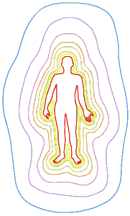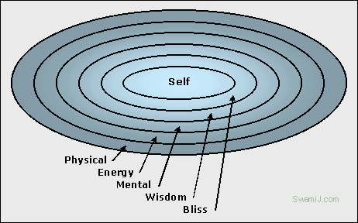

There are five subtle bodies:

Anna Maya Kosha

The body made of food

Prana Maya Kosha

The body made of prana

Mano Maya Kosha

The body made of the sense or desire mind

Vjna Maya Kosha

The body made of wisdom

Ananda Maya Kosha

The body made of bliss

Although the bodies are usually depicted as separate layers they are in fact interpenetrating existing as different levels of vibration.