Kapalabhati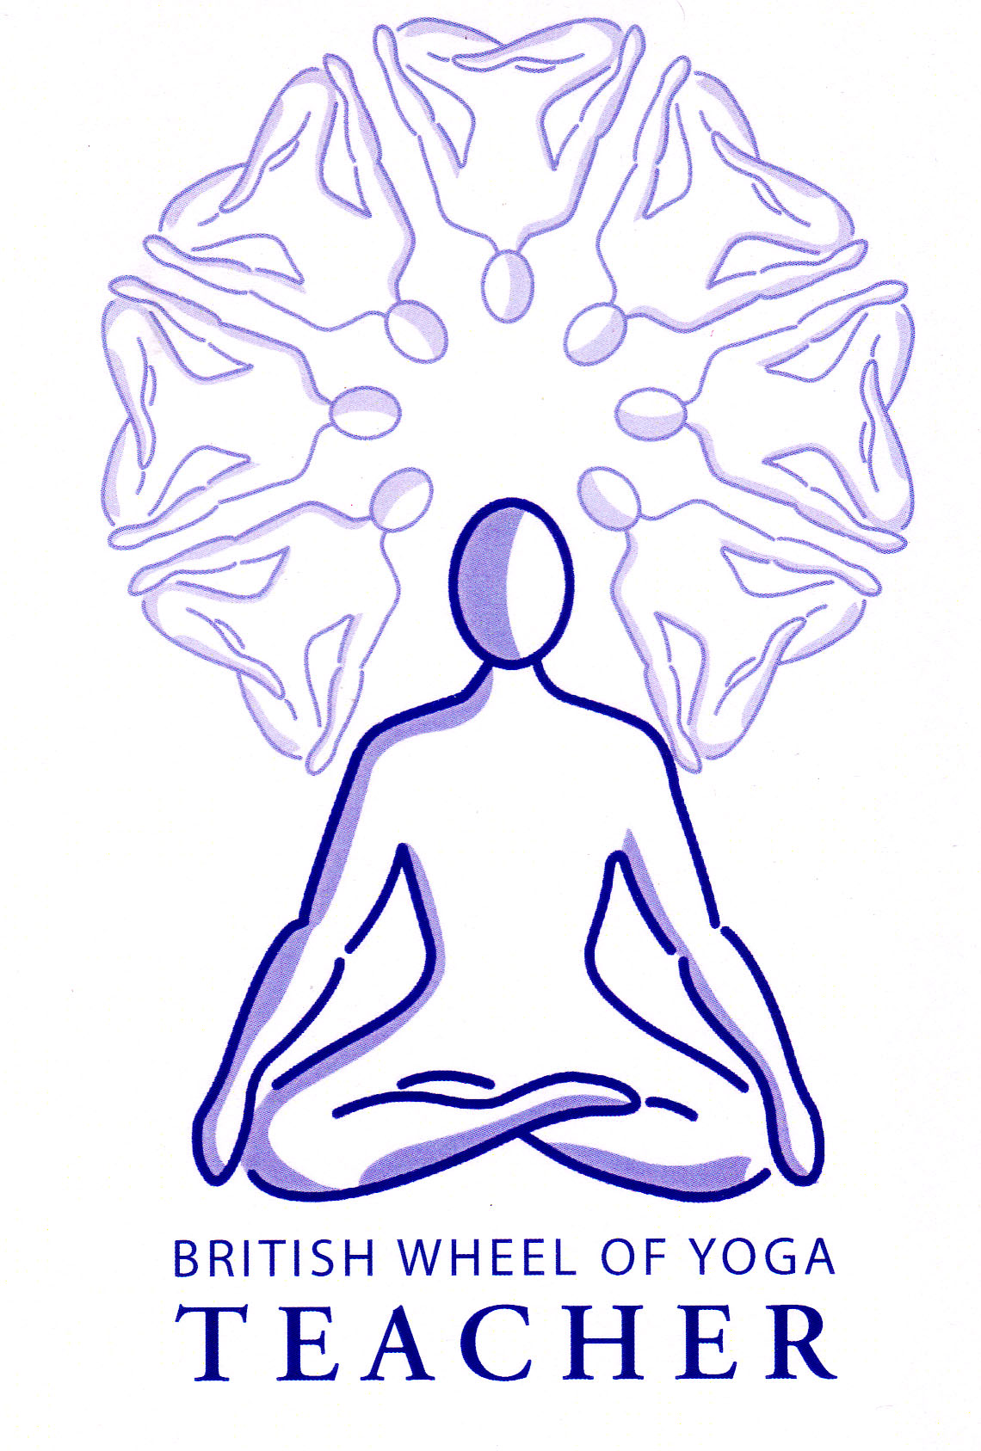

“skull shining”

kapala = skull bhati = shine, clean or light

**Technique**

There are many variations given on how to perform Kapalabhati. A good method is as follows.

**Posture**

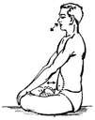Use any seated position where the spine is erect although for spiritual advancement Padmasana, the Lotus Pose is recommended. Hands are placed in Jnana Mudra. The center of gravity is located within the lower abdomen below the navel, with the abdomen relaxed so that it protrudes forwards, this is an unusual use of the abdomen compared to other types of pranayama. The thorax is held immobile with the ribs distended as if the chest has been expanded into the inhalation position. During the breath the thorax must be kept as immobile as possible although inevitably some of the lower ribs may move a little.

**Proceedure**

1. Inhale
2. Exhale by contracting the muscles of the abdomen sharply. We are particularly contracting the rectus abdominis muscles, located below the navel, as if they have been hit very hard. This gives a violent expulsion of air.
3. Immediately allow the abdomen to relax, letting it slowly expand as air enters the lungs. This is done passively and is a gradual release.
4. The expulsion will be around 2/10th of a second whilst the inhalation will be 8/10th of a second, although this will be dependant upon the rhythm. Essentially the inhale will be around three times slower than the exhalation.
5. The force of the exhalation is all important not the quantity of air expelled so there is no need to squeeze a little more air out or hold air out.
6. The nostrils will flare on the expulsion and should be kept flared during the inhalation.
7. Speed is not as important as the force but try to build up to 60 per minute in the first few weeks working up to 120 per minute.
8. It is a very vigorous breath and so we need to build up gradually. In the first week perhaps 3 x 10 exhalations, waiting 30 seconds between each round. Then adding 10 exhalations per week until we are working in groups of 120.
9. During the breath we need to ensure that:
   * The chest does not move
   * The shoulders do not lift
   * The exhalation is kept short and forceful
   * We do not push the abdomen out to inhale
   * We keep the spine straight and immobile
   * We concentrate upon the force of expulsion
   * We keep the face relaxed
   * We focus upon the area below the navel as much as possible

Eventually we can perform kapalabhati using the bandhas, which strengthen its effects. Note in kapalabhati as a kriya (cleansing technique) the emphasis is upon the exhalation whereas in bhastrika, the bellows breath the emphasis is equally upon the inhalation and exhalation.

This is a kriya that is generally to be performed after asana but before other pranayama and meditation; it is often performed after jala neti.

**Benefits**

Kapalabhati removes phlegm, particularly from the sinuses. It releases stale air and ensures good oxygenation of the blood; CO2 is released in greater quantities so that the absorption of O2 is increased. The metabolic conditions inside the body are altered slowing down respiration and giving the practitioner a greater control over his/her lungs. It quiets the respiratory center in the brain meaning that pranayama can follow with greater ease, essentially the strong stimulus from the respiratory center to take a quick inhalation and exhalation is reduced.

It has a massaging effect upon the abdominal viscera and also upon the brain where each forced exhalation reduces the pressure within the cerebro-spinal fluid and each inhalation increases it again. It is said to clear facial tension and generally possess an anti-aging effect. It is also said to awaken ajna chakra and our sensitivity to the subtle world.

Iyengar tells us it drains the sinuses, stimulates the liver, spleen and abdominal muscles. Improves digestion and gives a feeling of exhilaration and Hewitt says that it cleanses the frontal passages so is used prior to pranayama.

**Precautions & Prohibitions**

This breath should not be performed by anyone suffering from high blood pressure, heart disease, stomach ailments, ear or eye complaints, nosebleeds, during menstruation and pregnancy. It is also prohibited to anyone with abdominal disorders such as a hernia or recent hysterectomy plus for those who have poor control of their abdominal muscles or lung problems. Iyengar includes those with a weak constitution, poor lung capacity and women!!

Caution: if we become extremely light headed it indicates that we are not inhaling sufficiently and must slow down or stop the practice.

**Preparation**

Good preparation is essential to ensure that this breath is safe and effective. We need to use basic breathing techniques over time to give a good control of the respiratory muscles and improve the lung capacity. We also need to develop good control of the abdominal muscles so that they can be used without creating strain.

***See HYP chapter 2 v35 for more information***