Jala means ‘water’ and ‘neti’ means cleansing so this is the cleansing of the nasal passages using water. It is widely practiced within the yoga fraternity.

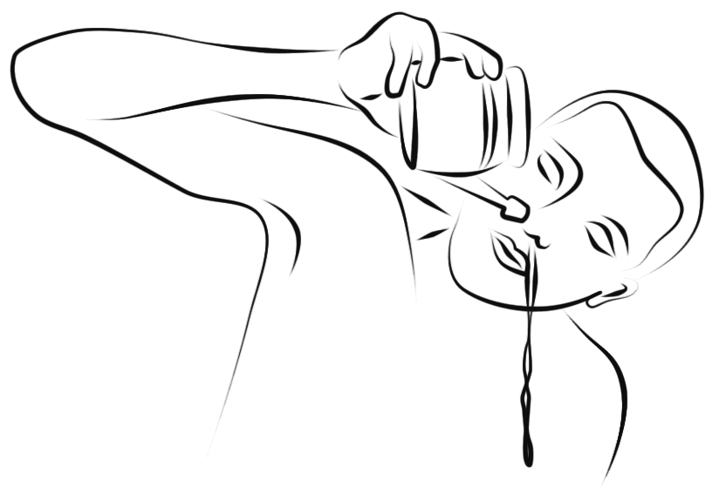
You will need to following equipment:

A neti pot

Lukewarm water (either well boiled tap water or plain bottled spring water)

Salt (non-iodised and without anti-caking agents, sea salt or bio-salt are fine but not table salt)

Some tissues!

The Method

- Mix around 1 teaspoon of salt to 500mls of warm water. You are aiming to produce an isotonic saline solution that is around body temperature and has a similar salt concentration as the body, around 0.9%.

- Fill the neti pot with the warm saline water.

- Test the temperature of the water by pouring a little on your arm and taste a little. It should not be a salty as sea water but be more like the saltiness of tears. This is important because it the water is too cold it will shock your system and if it is too hot it can burn you; if it is too salty or not salty enough again it will be very uncomfortable. With practice determining the correct temperature and salinity will become much easier!

- Now move to a sink, shower room or a garden

- Insert the nozzle tightly into the right nostril, keeping the mouth open for breathing. Ensure the nozzle is pointing directly along the nasal passage.

- Bend forwards so the tip of the nose is the lowest point, then tilt the head to the left and slightly back so the left nostril is now the lowest point of the nose. Allow the water to flow into the right nostril flowing out of the left nostril. At first the stream of water is likely to be intermittent but with practice it becomes one continuous flow. If the water flows down the throat then adjust the angle of your head until it is correct.

- Once around half of the pot has been used stop and gently blow any remaining water and mucous from the nostrils.

- Now repeat to the other side using the remaining solution.

- Finally the nose must be dried so bend forwards and let the head hang loosely allowing any remaining water to drain away. Then close each nostril in turn with the index finger and blow gently to thoroughly dry the nasal cavity.

- Finally we need to remove any residual water because as you will know if you have ever ducked your head under a wave in the sea an amazing quantity of water can enter the sinuses. Have a tissue ready and begin:

  - In a kneeling position block the right nostril and take a series of 6 breaths where the inhalations are through the mouth and when you exhale though the left nostril the exhalations are forceful by contracting your abdomen as you gradually lean forwards, folding over your thighs. Repeat this to the other side, then repeat again with both nostrils open.
  - Now roll up on to the top of the head and if there is any pressure within the area of the forehead this indicates water will soon drain out of the frontal sinus area.
  - Then returning to kneeling stretch both hands out at shoulder width, raising knees into adho mukha svanasana (down facing dog). Press the chin firmly down against the chest to help drain water from the sphenoid sinus area.
  - Finally coming to standing, take feet wide apart into prasarita paddottanasana (spread leg pose). With arms behind the back interlink fingers and exhaling fold forwards, bending knees if necessary and slowly turn your head to the rights side then drawing the head back to the central position so any water within the maxillary sinus area is drained. Return to an upright position then folding forwards again this time turn your head to the left side, then back to centre. Lift back up to finish

This can also be followed with Nadi Sodhana (Alternate Nostril Breathing) to enhance balance and clarity in the brain or we might elect to do more rounds of kapalabhati to lift energy levels.

Benefits

- Removes dirt and bacteria filled mucous from the nasal passages.
- Relieves frequent colds, sinusitis and sore eyes.
- Desensitizes hypersensitive nasal passages in nasal allergy e.g. hayfever, allergic reactions
- Alleviates inflammations of the upper breathing tract such as sore throats, bronchitis etc.
- Purifies most structures within the head.
- Has a cooling and refreshing effect, alleviating drowsiness.
- Helps asthmatics by removing the source of infected mucus & allergens
- Alleviates dry mucous membranes.
- Develops inner awareness and sensitivity
- Build up physical and psychological stamina, destroying blocks
- Increases our intake of prana which requires humidity to be absorbed into the body

Prohibitions and Precautions
Discontinue if an infection is present in the nose, usually evident by the presence of yellow or green mucous. Not to be performed by those suffering from chronic ear or eye complaints. Do not perform if prone to nose bleeds. Do not perform after a meal or go out into the cold afterwards. Avoid doing last thing at night in case of residue.

If possible try this technique remaining relaxed throughout!

