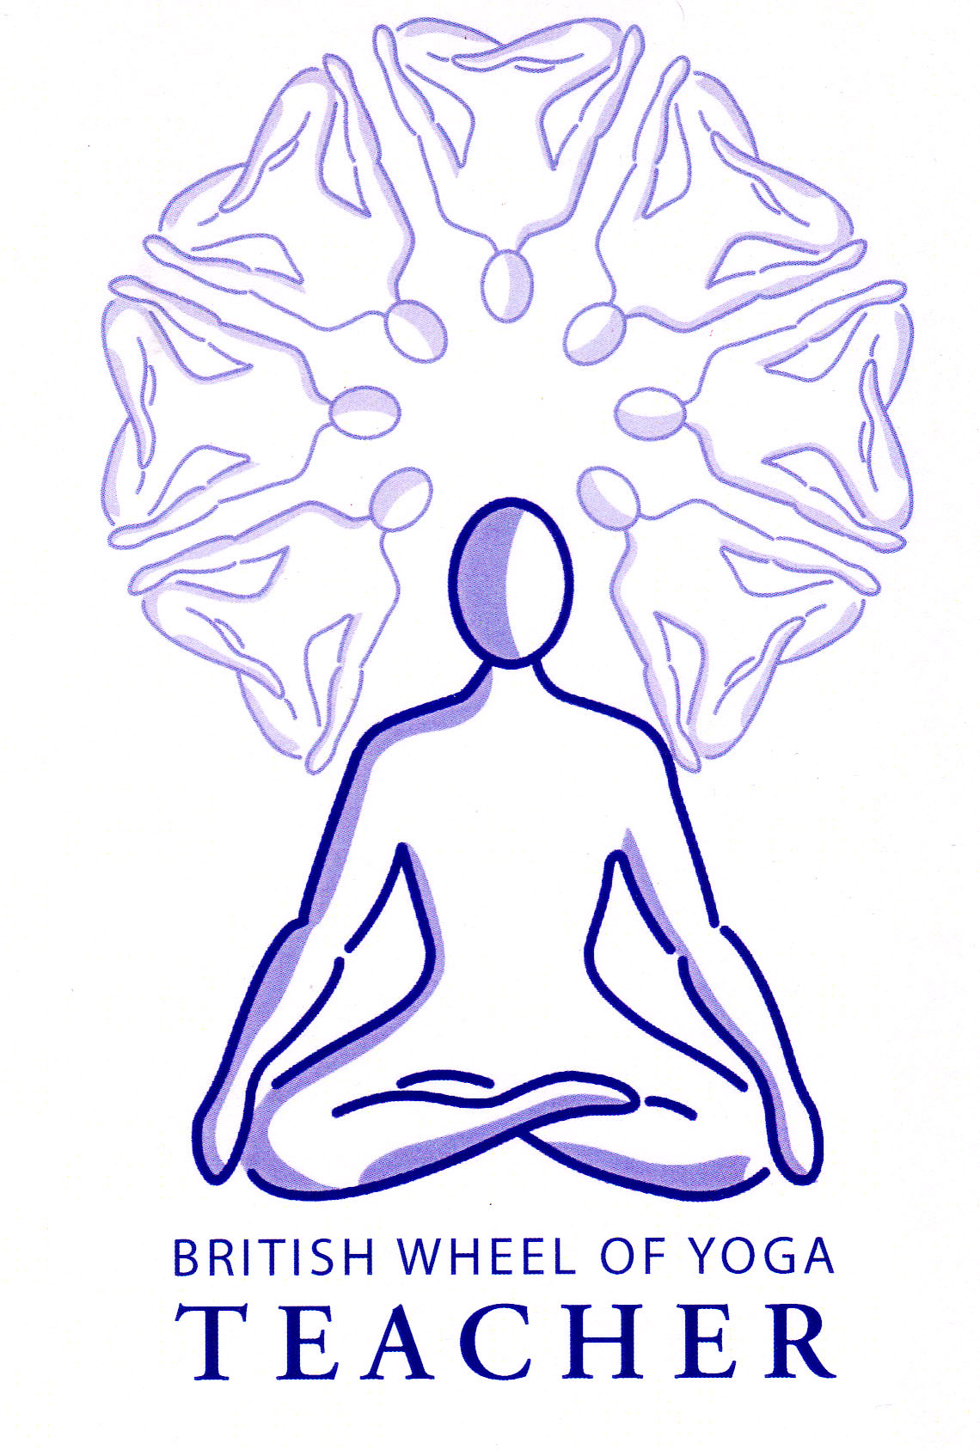
The Purpose of Pranayama

At first there are many benefits to be achieved on a more mundane level:

The practice of pranayama:

Cleanses and balances the body and mind of impurities.
Develops mental & emotional stability (as energies are balanced).
Relaxes body and mind (as mind releases tension so does the body).
Gives us the ability to control the nervous system so we are more in charge of the relaxation response i.e. the activation of the sympathetic branch of the autonomic nervous system.
Increases general energy levels.
Creates greater sensitivity and acuity of senses.
Develops capacity for concentration.
Creates inner clarity.
Healing occurs using increased prana (some authorities state if not practicing kriyas then all new prana used for healing purposes but if kriyas are used then new prana can be used for growth).
Promotes feelings of well-being.

Later the practice of pranayama:

Leads us to meditative states
Activates suhumna nadi when ida and pingala nadis are balanced and the mind becomes still, and with the application of the mudras & bandhas it awakens kundalini transforming consciousness
Releases fear of death
Leads us to Samadhi

So there are exoteric and esoteric purposes for pranayama with the ultimate aim of pranayama being a practice to lead us to the state of Union or Yoga.

Indeed we could say it re-integrates the human being and then with fervent practice it re-integrates the human being with All That Is.

Starting Pranayama

All of the yogic texts warn against the premature or inappropriate practice of pranayama, advising that an experienced teacher should be sought before embarking upon the breathing practices of hatha yoga.

Initially students should become well versed in the full yogic breath and the preparatory stages of ujjayi breathing. This means that there is a natural efficient use of the lungs and the use of sound enhances rhythm and concentration.

All pranayama techniques should create a feeling of lightness and well-being. If dizziness, disorientation, nausea, ear or eye discomfort are experienced then this indicates that the practice has either been incorrect or contra-indicated.

As for asana practice, commonsense should always prevail; the breathing must never be forced in any way.

General Advice for Pranayama
For all pranayama we must:

- Practice on an empty stomach waiting at least three to fours hours after a meal nor should we eat immediately afterwards.
- Generally practice after asana and before meditation, although it is possible to intelligently practice techniques at other times once we are aware of their effects
- Find a comfortable position where the spine is effortlessly erect and the diaphragm is able to freely move
- Find a well-ventilated, clean and unpolluted place to practice
- Ensure there is no strain within the breath at any time
- Avoid practice if smoking tobacco, cannabis etc.
- Seek expert guidance for intensive pranayama practice since diet and lifestyle must be supportive, this is also true of the higher practices of pranayama where we are really lengthening the duration of the kumbhaka

Positions for pranayama
Since the diaphragm is the most important muscle for good breathing practices we must adopt an upright and open posture where the diaphragm can contract and relax to aid inhalation (puraka) and exhalation (rechaka). A cross-legged position is the most stable but if it is difficult to lower the knees to the floor then the spine cannot extend and the abdominal muscles lose tone and cannot assist the back muscles in keeping the body upright. So if this is the case blocks can be placed under the buttocks to help to tilt the pelvis forwards so freeing the spine and abdominals. We also need to avoid excessive lordosis by tucking the coccyx under and extending the back of the neck.

If the hand is being placed at the bridge of the nose then the arm can become very heavy and the body may become increasingly uncomfortable. Here the other hand can support the elbow or we can place the elbow of the raised arm on the knee, ‘the thinkers statue’.

Alternative positions can include Vajrasana, the kneeling position where a block or cushion can be placed between the buttocks and thighs to release pressure on the kneecaps and ankles. We can also use the Friendship Pose where we sit on a chair but keep the back away from the back of the chair, if the back is against the chair then this may reduce the free movement of the diaphragm.

Essentially the pose assumed must be comfortable for a period of time, enable the spine to remain upright and allow the free movement of the diaphragm.

The correct use of the abdominal muscles in pranayama
There has been much controversy regarding how we can best utilize the abdominal muscles when performing pranayama especially because we can find two opposite ways of working. Some students allow the abdomen to expand fully in an inhalation such as we work with when performing the complete yogic breath and some students breathe like a gymnast where they hold the abdomen rigid and only work with thoracic and clavicular breathing yet neither of these creates the right internal response for pranayama. It is best to work between these two extremes where the diaphragm still descends fully but the there is also some resistance within the abdominal muscles so abdominal organs are massaged and the venous return to the heart is assisted.

So as we perform pranayama we must retain active abdominal control where as we inhale the area beneath the navel remains contracted, but not rigid and the area above the navel slightly yields. Then as we exhale the abdominal muscles contract more completely.

The need to anchor the mind when practicing pranayama
It is always important that we find a focal point for the mind when working with pranayama because once we have become familiar with each technique it then becomes too easy to allow the mind to wander. The focal point can be any element of the practice such as being aware of the quality of the inhalation and exhalation, the counting of the breath, the sound we are creating and so on. There is no one anchor for the mind for any technique but you must be aware of giving an anchor for the mind as you teach a technique.

The use of ratio and breath retention in pranayama
Pranayama involves the use of ratio and breath retention (kumbhaka) and indeed these elements separate the practices of basic breathing from the practice of pranayama. We must work with ratios and kumbhaka in a progressive way, starting simply and gradually increasing our capacities. It is very important to note that when we start to work with ratios many students believe that to progress they must hold the breath for increasingly longer periods of time but this is not the case and this belief both inhibits growth in pranayama and can be potentially dangerous. It is actually the rhythm of the breath which is the most significant factor i.e. the proportion of time spent in each part of the breath and secondly it is the quality of concentration which is also very important. If we do not recognize this right from the start then we will be working against our own body and mind, rather than creating health, rejuvenation, mental peace and focus.

So what are ratios within pranayama?
We often think of the breath as possessing two parts, the inhalation and the exhalation, yet yoga also recognizes the pause, known as the kumbhaka, which can occur after the inhalation and also after the exhalation giving us four parts of the breath to work with.

When we work with ratios we are consciously deciding how long we are staying in each part of the breath with different ratios creating differing effects.

Ratios are written as:

Inhalation | Retention | Exhalation | Retention
Puraka | Antara Kumbhaka (A.K.) “Full pot” | Rechaka | Bahya Kumbhaka  (B.K.) “Empty pot”

So to show we must exhale for twice the length we inhale we can write this as:

1: 0: 2: 0

Meaning if we take this ratio then first we must find our current natural length of breath by simply watching and counting the breath and if we can easily count in for 4 then we will be practicing inhaling for 4 and exhaling for a count of 8. If however our natural length of breath is 6 counts then we inhale for a count of 6 and exhale for a count of 12 and so on.

We must always spend time with our natural breath before beginning any pranayama technique as this enables us to determine the quality of our breath before proceeding.

What are the characteristics of each part of the breath?
Each part of the breath possesses distinct characteristics:

The characteristics of the inhalation (Puraka)
The inhalation must be smooth and usually through the nose rather than the mouth, exceptions to this include sitkari and sitali, techniques we shall encounter later in this section. Inhalation should never be forced with the thorax expanding naturally until the chest is comfortably full. Taking the breath up to the collarbones is a safe guide, never into the throat.

Psychologically, inhaling reflects our capacity to fully participate in life; our ability to draw deeply upon that which life has to offer us.

The characteristics of the exhalation (Rechaka)
Exhalation should be smooth and slow. Exceptions to this would include bhastrika and kapalabhati where the exhalation is short and dynamic. The quality of exhalation should be smooth and quiet and if this is not possible then we are not ready for pranayama, mentally or physically.

This is because in yoga we are seeking to eliminate impurities and avidya (ignorance) and the exhalation is vitally important because it transports impurities and makes room for prana to enter. Indeed a rough exhalation is often indicative of current or future illness. Psychologically our ability to exhale reflects our ability to let go, releasing internal pressures and emotional tension; allowing us to make the space for change or internal transformation.

Therefore it is always important that students learn to exhale effectively for all pranayama, which is why we always start our journey into pranayama with the ratio 1:0:2:0 because without this ability the student will remain mentally and physically closed and any further progression into pranayama will only cause internal strain.

The characteristics of breath retention after the inhalation (A.K.) and exhalation (B.K.)
In sanskrit ‘kumbhaka’ means ‘pot’ with 'antara' translating as ‘full’ and ‘bahya’ as ‘empty’ so it follows ‘antara kumbhaka’ translates as ‘full pot’ where the lungs are full of air and ‘bahya kumbhaka’ translates as ‘empty pot’ where the lungs are empty.

Psychologically we can only enter the breath retentions when we are relaxed and have surrendered.

The A.K, creates a stimulating enlivening effect. It is sometimes symbolized as “holding the Lord in the form of universal energy”. Whereas the B.K. creates a relaxing, introverting effect. It is sometimes symbolized as “surrender to the Lord by merging with universal energy”.

There are two forms of kumbhaka:

- Sahita means there is a deliberate pause after the full inhalation or complete exhalation.

- Kevala means there is a spontaneous pause, an absolute pause. This is an advanced form of kumbhaka “a state of absolute surrender” which is the aim of pranayama.

Initially we will always be working with sahita kumbhaka because it will be a consciously created pause, when the breath is stilled whereas if we are lucky at some point as we continue working with pranayama the breath will be stilled naturally without any conscious will or effort on our part.

Also note that Sahita pranayama is further divided into Sagarbha, using a mantra and Nirgarbha, without mantra. We do not find Sagarbha in the HYP but it is found in the Gherandha Samhita. Mantra directly affects inner vibration and deep levels of the chitta (mind space or consciousness) making this a profound addition to the practice of pranayama.

Why is the practice of kumbhaka so important?
The practice of kumbhaka is so significant because as the breath is stilled so is the mind; as we retain the breath, nerves impulses are inhibited and mental agitation is stopped.

Physiologically when more time is given for the exchange of gases at the level of the cell there is a kind of atomic reaction occurring at the level of the cell as intracellular breathing is stimulated. This means kumbhaka revitalizes the body. Normally when we inhale the air contains approximately 21% oxygen of which we normally only absorb around 6%, yet within breath retention as the length of contact between the air and the pulmonary membranes is lengthened much more then 6% of oxygen can be absorbed!

Also as we perform kumbhaka we are consciously controlling the medulla oblongata, the centre located at the base of the brain, which normally automatically responds reflexively to any changes in levels of carbon-dioxide, the PH level of the blood etc. which can be caused by alterations in blood circulation, muscular movement or even our emotional state. As such this centre is linked to the nervous system and particularly the pneumogastric or vagus nerve that is responsible for activating the parasympathetic responses of many muscles and the majority of organs including the heart. Hence when we take conscious control of the medulla oblongata we can regulate the parasympathetic nervous system creating a relaxation response within the body, for instance the heart slows, blood pressure drops etc. Indeed in extended kumbhaka yogis can even recreate what is known as the immersion reflex where the heart is slowed to just a couple of beats per minute as the body uses stored oxygen and stored sugars to produce energy in a state similar to hibernation. Indeed you may of heard of yogis who are said to be able to be buried alive or slow their heart rates down!

Ultimately by using kumbhaka as the prana within the body is increased and the bandhas (energy locks) are applied prana is heated accelerating prana to a higher vibration, and eventually latent universal prana or kundalini is stimulated causing its awakening. For most of us however, without intensive hatha yoga training, we can still reap the benefits of pranayama using kumbhaka meaning we can still experience the stillness it inspires and the transformative effects it has upon our nervous system, our mind and general wellbeing.

What is the precautionary advice for practicing kumbhaka?
Whilst individual contraindications apply to specific techniques, and you will find them given later when we look at the different techniques, there are some general contraindications associated with the use of kumbhaka. These include the following:

- Generally we must not retain the breath if we have high blood pressure or heart disease as this raises the inter-gastric pressure, increasing heart activity and exacerbating internal pressure. It is also prohibited for cases of an enlarged thyroid gland and students who are suffering from glaucoma and detached retina conditions are also advised to avoid breath retention.
- Certain respiratory conditions are also contra-indicated for prolonged breath retention here we can include emphysema and certain forms of asthma where the student feels the breath is being strained.
- We should not retain the breath after exhalation for long periods in the case of low blood pressure. Retention with empty lungs reduces the inter-gastric pressure and can exacerbate the condition causing dizziness or loss of consciousness.
- We must avoid breath retention in cases of pregnancy, multiple sclerosis epilepsy, inner-ear discharge and recent surgery.
- Do not use kumbhaka if you are suffering from severe psychological conditions such as depression or anxiety. It is better to use pranayama without retention until we have become more balanced. Remember pranayama works on both physical & psychological levels and one of the reasons to start with asana is that emotionally/mentally it is not as likely to provoke a strong reaction. Indeed we need to watch for strong reactions such as powerful emotions or movements of energy and allow these to surface and release; pranayama directly effects the mind and the subtle energies of the body with one of the main purposes of pranayama being to encourage ‘stuckness’ to be freed. As inner metabolism is accelerated we may begin to experience these internal forces, remember how we studied the metabolism of emotion in section 7.4 and how pranayama literally stirs up stuck emotions that will rise into consciousness to be digested! Note that often these experiences may arise some time after our practice where for example students may experience lucid dreams about earlier forgotten events or experience unaccountably strong emotions.

So we must tread carefully when teaching kumbhaka and fully prepare students, taking account of the contraindications. It is never a beginners technique but can be slowly introduced to those who have been practicing yoga for several years and have already established a firm foundation of basic breathing and of practicing pranayama without using breath retention.

© S Beck November 2013

