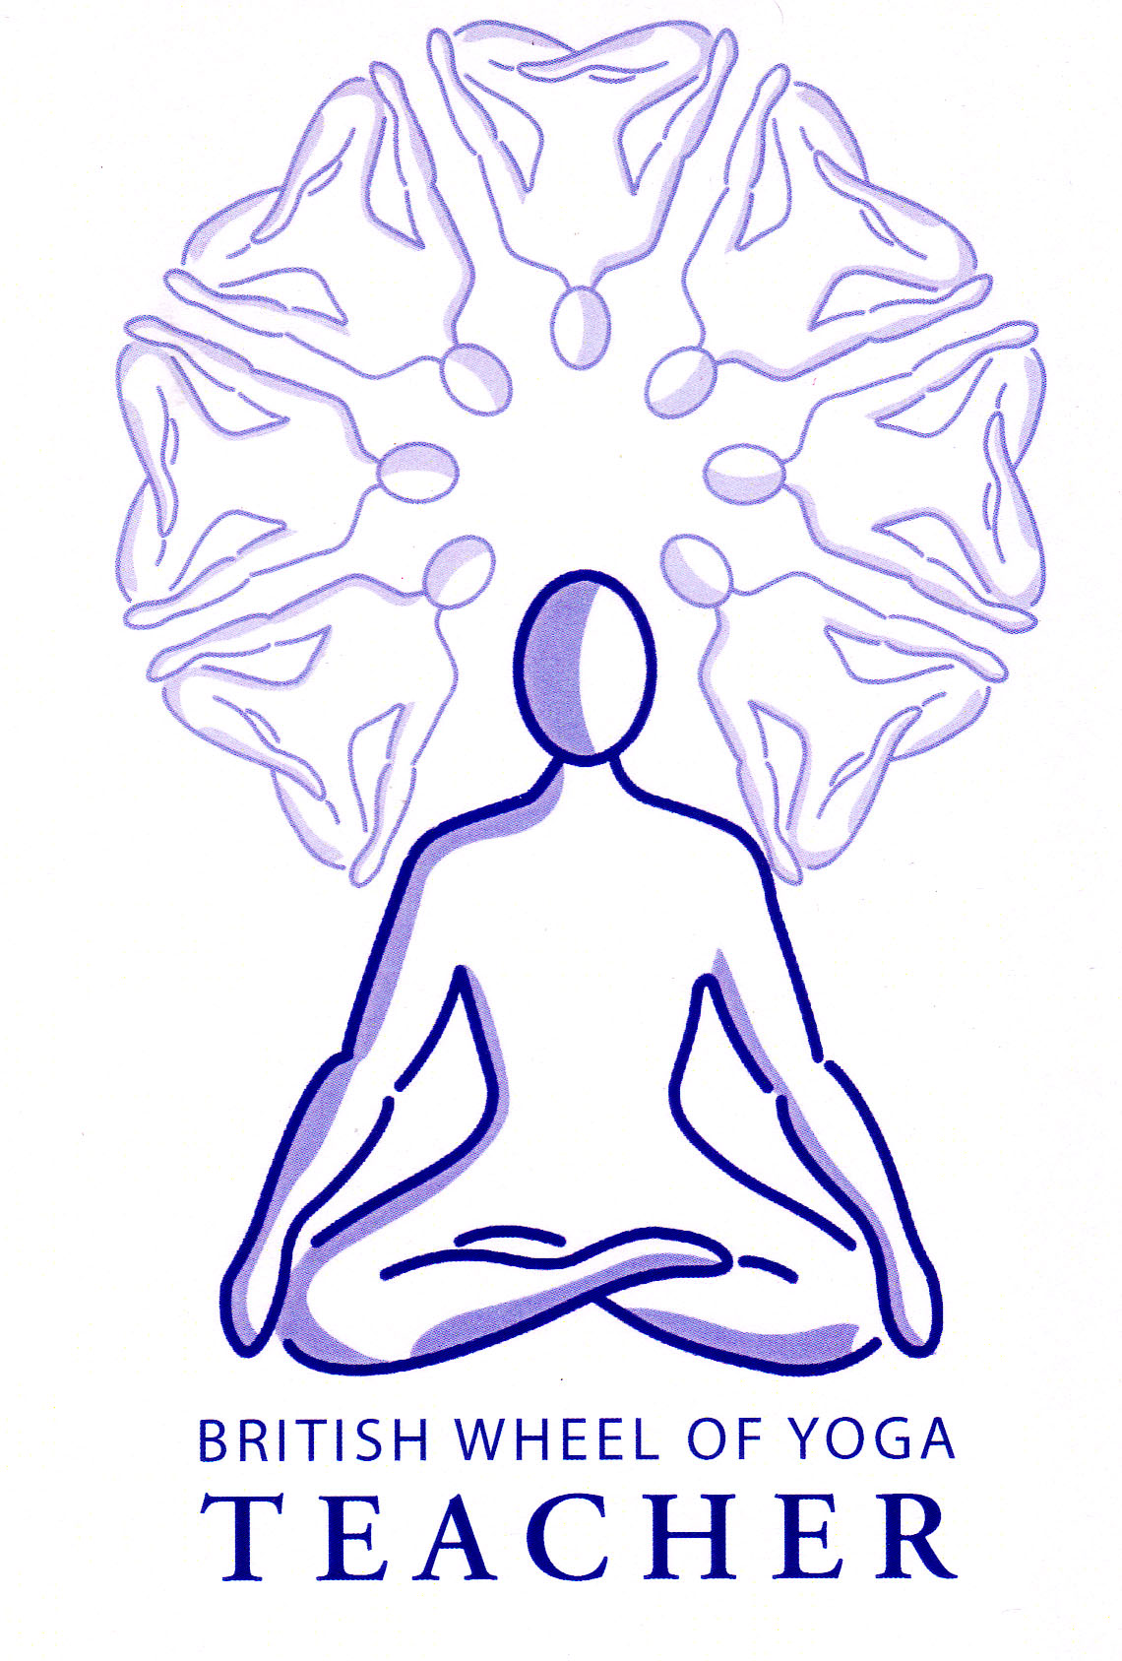

This month’s tasks:

* 2.2 Basic Breathing & Relaxation Teaching Practice: Mark to complete his final draft for his lesson plan to be ready to teach in April.
* 50 minute asana teaching practice: Alison to teach in our April meeting.
* Everyone to complete writing a lesson plan for the 50 minute asana teaching over this next month, referring to the guidelines given at our last meeting. **Do not leave this until later** because if you leave it until nearer the time you have to teach it there will be other assignments needing to be done making it extremely difficult for yourself. Once it is written over this month then you can make small changes nearer to the time of teaching if you wish.
* Everyone to read through the pranayama handouts from today’s meeting and if you have not read the former handouts on pranayama then please do so. They can be found in the website at <http://www.yoga-ayurveda.co.uk/pranayama.html> and remember the website password is Smile.
* Our next meeting is on 6th April we shall start at **11am and finish at 6pm**
* Have a great month!

Remember you are free to contact me at home if you have any questions. Although please note that I shall be in India between 7th & 23rd March.

Yr Ogof

Mynydd Mechell

Isle of Anglesey

LL68 0TE

Tel: 01407 710347 (home)

Mobile: 07757 914089 (not always a good signal in my study!)

Email: [sarah.deva@yahoo.co.uk](mailto:sarah.deva@yahoo.co.uk)