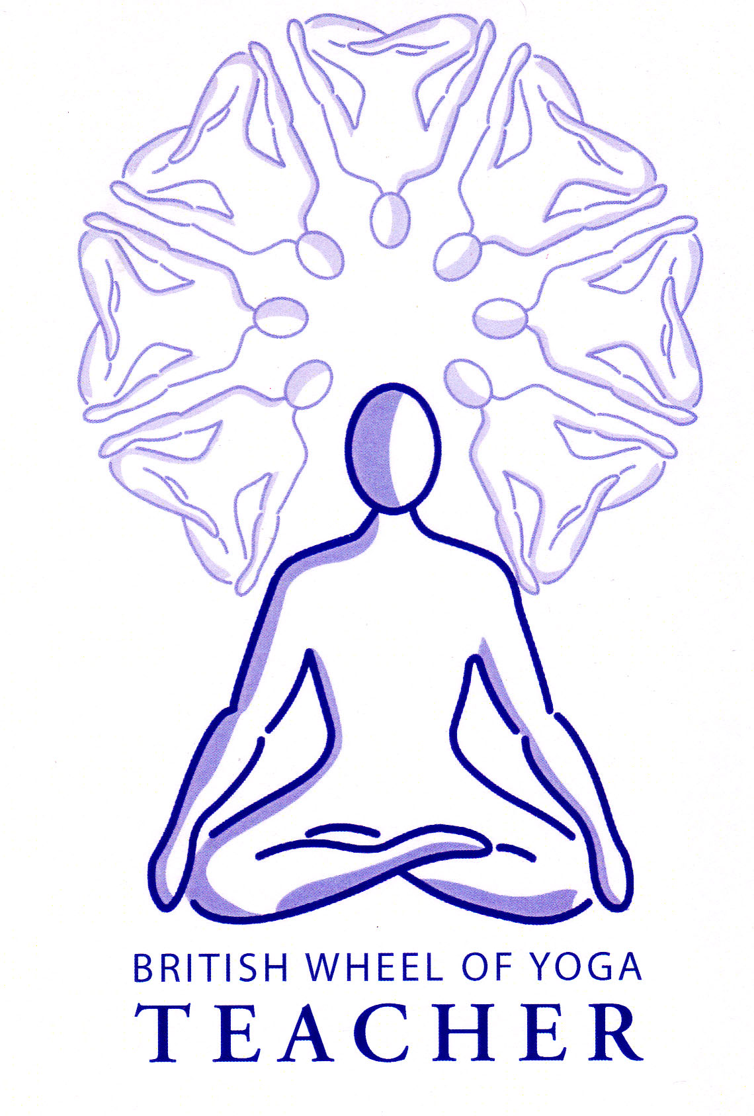

This month’s tasks:

* 2.2 Basic Breathing & Relaxation Teaching Practice: Mark to complete his final draft for his lesson plans and scripts to be ready to teach in March. Anita to also teach her practice in March.
* 1.1b Lesson Plans for Micro-teaching of asana: Phil & Gina to be ready to teach their asana lesson plans to be taught at our March meeting, sending me their final drafts of the lesson plan when it is done.
* Everyone to write a lesson plan for the 50 minute asana teaching practice for Part 2, referring to the guidelines given at our last meeting. Please do this over the next 2 months whilst there is time to do it, be aware if you leave it until nearer the time you have to teach it there will be other assignments needing to be done making it extremely difficult for yourself.
* Everyone to **read the introduction to the HYP.**

Remember you are free to contact me at home if you have any questions. Emailing me is always best when possible.

Yr Ogof

Mynydd Mechell

Isle of Anglesey

LL68 0TE

Tel: 01407 710347 (home)

Mobile: 07757 914089

Email: [sarah.deva@yahoo.co.uk](mailto:sarah.deva@yahoo.co.uk)