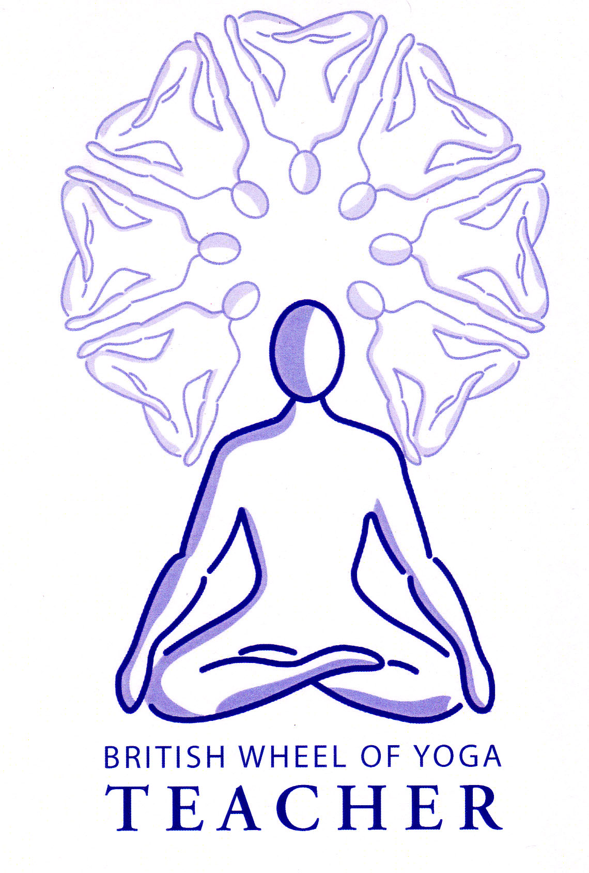

This month’s tasks:

* 2.2 Basic Breathing & Relaxation Teaching Practice: Anita & Louise to complete their final drafts for their lesson plans and scripts to be ready to teach in February.
* 1.1b Lesson Plans for Micro-teaching of asana: Phil to be ready to teach his asana lesson plan for sarvangasana (shoulderstand) to be taught at our February meeting, sending me the first draft of the lesson plan when it is done. Please remember that one aspect to be assessed is the demonstration or explanation of a use of an aid so do make this explicit, for instance use of a belt, block or blanket etc. David you are welcome to start your lesson plan for utkatasana (squat) just as soon as the posture profile is complete, your teaching practice to be also done in our February meeting.
* Everyone to make a **simple handout of a sequence you have enjoyed.** This can be a version of Surya Namaskara (Sun Salutation), Chandra Namaskara (Moon Salutation) or any other sequence you might teach to a class. These will be explored in either meeting 15 or 16.
* Everyone to **research the concept of ‘Prana’** and make notes for a discussion next time. You will need to create a sentence or two which for you best describes what prana is if you were to be asked by a student. **Please write this clearly on a plain piece of paper and bring it along next time**. It will also be helpful for the future if you note down any good quotations encountered as you do your research and also include any personal experiences of prana in your notes.
* Everyone to complete their **Student Development Profile and Part 1 Course Evaluation Questionnaire**. Electronic copies will be sent to you by email and once completed please email them back to me. Please remember to add addditional comments as indicated, and here questions you have can also be raised.
* Have great time over the christmas holidays and see you again in February 2014!

Remember you are free to contact me at home if you have any questions. Emailing me is always best when possible.

Yr Ogof

Mynydd Mechell

Isle of Anglesey

LL68 0TE

Tel: 01407 710347 (home)

Mobile: 07757 914089

Email: [sarah.deva@yahoo.co.uk](mailto:sarah.deva@yahoo.co.uk)