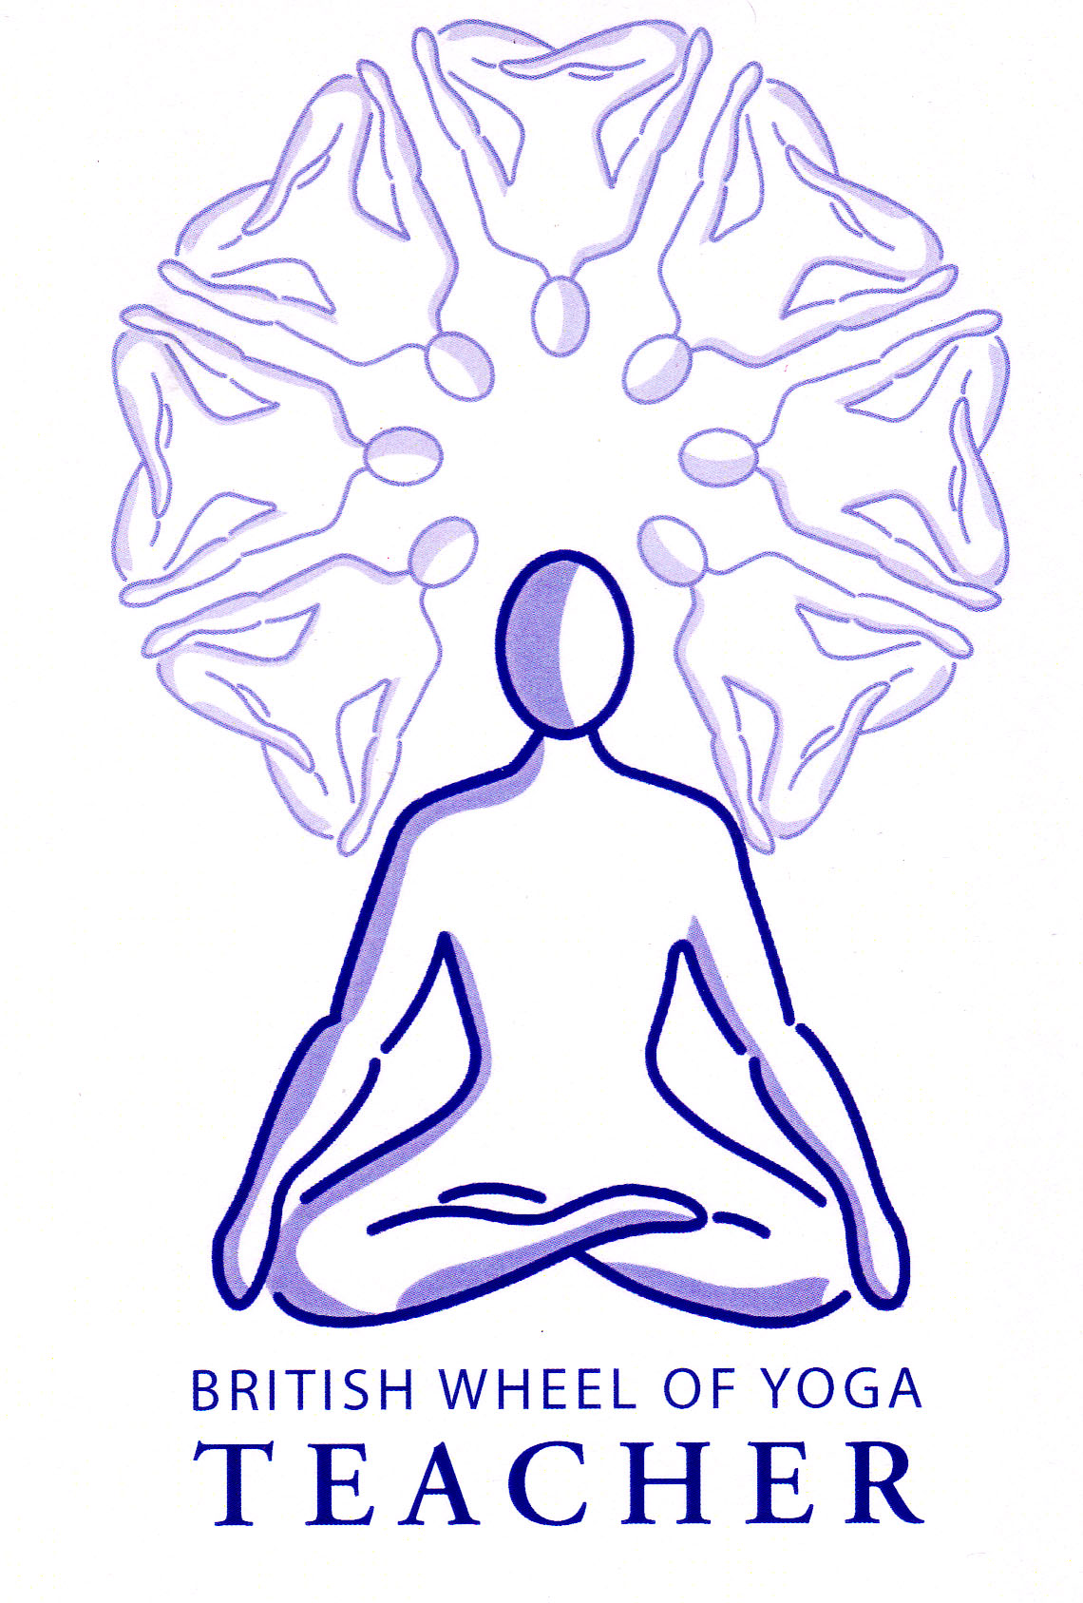

This month’s tasks:

* 2.2 Basic Breathing & Relaxation Teaching Practice: Anita & Louise to complete their first drafts for their lesson plans and scripts to be sent to me by our December meeting. Please remember to check with me regarding the types of practices you would like to do before you begin. You will eventually be teaching your session in our February meeting.
* 2.2 Basic Breathing & Relaxation Teaching Practice: Anne & Mark are due to teach their practices next time we meet in meeting 14 in December so please ensure your lesson plans have been sent to me as soon as possible so any revisions can be made in time.
* 1.1a Posture profiles: Phil to complete his posture profile for Sarvangasana (Shoulderstand Pose) and start his lesson plan for the December meeting. The lesson to be taught in February next year. David to start his posture profile to Utkatasana (squat pose), the first draft to be sent to me before our next meeting in December.
* 1.1b Lesson Plans for Micro-teaching of asana: Pippa, Gina & Mandy to be ready to teach their asana practices at our December meeting, sending me their final lesson plans as soon as possible. Please remember that one aspect to be assessed is the demonstration or explanation of a use of an aid so do make this explicit, for instance use of a belt, block or blanket etc.
* Complete any final revisions to your written assignment 2.1 on Stress & Relaxation remember this was due at our last meeting so please do this a.s.ap.
* Everyone to read pages 27 to 30 on the Evolutionary Forces & Chapter 14 on the Gunas in The Bhagavad Gita as translated by Eknath Easwaran.
* Also everyone to read through the Ayurvedic Dietary Guidelines handout. This month raise awareness of your own habitual eating habits and the foods you regularly eat, especially noticing the effects of your choices upon your mind, body and energy. See if there are any ways you can make beneficial small changes to your diet and eating habits. Please bring your thoughts on the Gunas and your diet to the next meeting for a brief discussion.
* Finally for those of you who have not as yet given me your records of Yoga Events Attended, Yoga Classes Attended and Classes Taught please email me them or bring them along next time. Also please let me see a scan of your first aid certificate, you can email it or bring along a copy for next time.

Remember you are free to contact me at home if you have any questions. Emailing me is always best when possible.

Yr Ogof

Mynydd Mechell

Isle of Anglesey

LL68 0TE

Tel: 01407 710347 (home)

Mobile: 07757 914089

Email: [sarah.deva@yahoo.co.uk](mailto:sarah.deva@yahoo.co.uk)