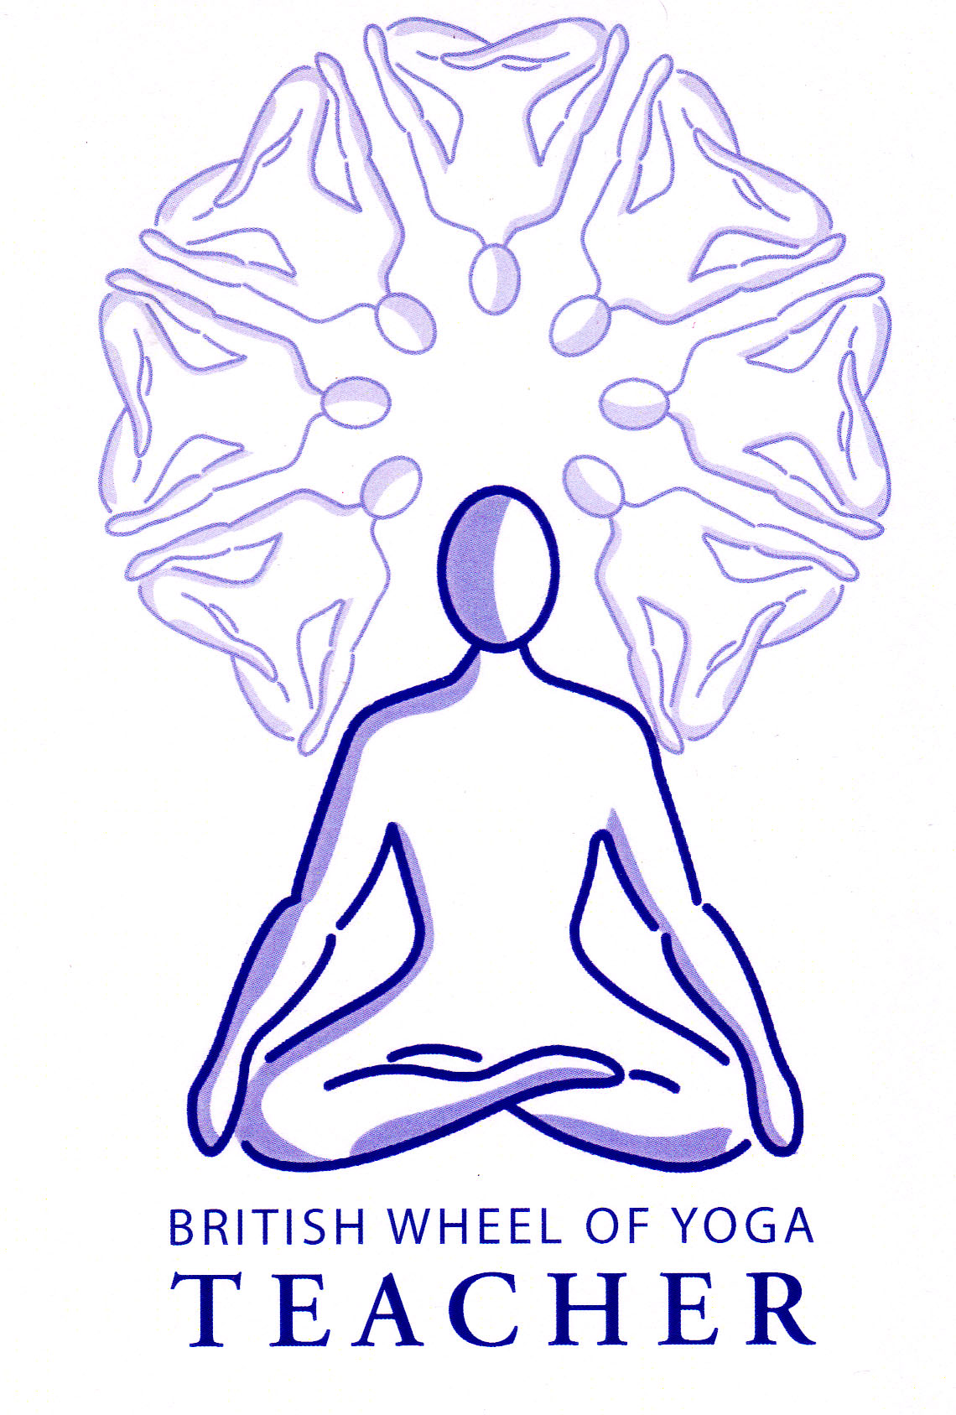

This month’s tasks:

* Please study all handouts from our last meeting making additional notes as needed.
* 2.2 Basic Breathing & Relaxation Teaching Practice: Anne & Mark to complete their first draft of lesson plans and scripts to email to me by our next meeting, meeting 13 in November. Please remember to check with me regarding the types of practices you would like to do before you begin. You will eventually be teaching your session in our December meeting.
* 2.2 Basic Breathing & Relaxation Teaching Practice: Elizabeth & Imogen are due to teach their practices next time we meet in meeting 13 in November so please ensure your lesson plans have been sent to me as soon as possible so any revisions can be made in time.
* 1.1a Posture profiles: Phil to complete his posture profile for Sarvangasana (Shoulderstand Pose). Scans for the pose will be emailed to you soon to help with this. Please email your posture profile to me before next time we meet so I can give you my comments and any changes can be made before you start on your lesson plan.
* 1.1b Lesson Plans for Micro-teaching of asana: Donna & Cheryl to be ready to teach their asana practices next time in meeting 13 in November, sending me their final lesson plans as soon as possible. Please remember that one aspect to be assessed is the demonstration or explanation of a use of an aid so do make this explicit, for instance use of a belt, block or blanket etc.
* 1.1b Lesson Plans for Micro-teaching of asana: Gina to complete her lesson plan for Navasana (Boat Pose) Mandy to complete her lesson plan for Virabhadrasana II (Warrior 2 Pose) and Pippa to complete her lesson plan for Baddha Konasana (Cobblers Pose). Please carefully refer to the guidelines given to you on this assessment and remember to closely examine the assessment criteria so you know what we be assessed. You will need to email your lesson plans just prior to meeting 13 at the latest so you will be able to make any necessary adjustments before the teaching practice in meeting 14 in December.
* Complete any revisions to your written assignment 2.1 on Stress & Relaxation and email me your next draft before meeting 13 note that **this final due date is non-negotiable so best to start on this sooner rather than later**. To help you please refer to the 2.1 Essay Guidance Notes given, also check out the emailed set of assessment criteria so you can see what you will assessed upon. Finally use the Essay Writing Standards Handout to help you structure the assignment. Note that the word count should be between 1500 and 2500 words.
* Also please start to get your class attendance sheets, events attended form and classes taught record together as Rosemary would like to see them soon. If you do not have these forms best get in touch with me very soon to have some sent to you to be filled in – although do remember everything is on the website – including all of our class hand outs. Indeed if you have had trouble filing all of our paperwork it is all filed here for you!!

Remember you are free to contact me at home if you have any questions. Emailing me is always best when possible.

Yr Ogof

Mynydd Mechell

Isle of Anglesey

LL68 0TE

Tel: 01407 710347 (home)

Mobile: 07757 914089

Email: [sarah.deva@yahoo.co.uk](mailto:sarah.deva@yahoo.co.uk)