Hatha Yoga comes from the Tantric Tradition where after the proliferation of Buddhism in India in around 6th CE there was a movement by yogis such as Goraknath and Matsyendranath to establish a new system of self-realization based soley upon the purification of the body. Unlike previous paths, where the body was seen as seem as something intrinsically impure and to be transcended, now in Tantra the body was seen as divine, as a manifestation of the One. Indeed Tantra is a system which considers all of Nature to be different manifestations of the One Great Spirit (Brahman, Paramatman, Pure Consciousness etc.) meaning that we can rejoice in our inner and outer worlds; this is markedly different from other systems where the aim was to transcend this world and leave behind the suffering it engenders.

They refined previous tantric practices, removing the aspects of meditation and ritual, so that the expansion of consciousness became a physiological possibility, although, like all yogic paths, hatha yoga leads us to raja yoga where the mind becomes one-pointed and samadhi becomes possible.

Hatha Yoga works directly with our subtle pranic energies, bringing them into balance, so that our innate store of Kundalini Shakti can be awakened and consciousness can be expanded beyond it’s usual limitations. In it’s entirety is a very intensive, forceful path requiring special guidance however there is much to be learnt from it’s study especially with regards to our subtle pranic anatomy & physiology and we can most certainly benefit from it’s most accessible practices.

The Hatha Yoga Pradipika, written by Swatmarama in around C13th to C15th, is perhaps the most complete and accessible text on Hatha Yoga where Swatmarama effectively compilied the entire wisdom of Hatha yoga within its pages. We shall study the HYP with a commentary by Swami Muktibodhananda Saraswati but we can visit other commentaries as we wish.

The Hatha Yoga Pradipika:

- is largely a technical formula on how to achieve Liberation or Moksha, the realization of the Transcendental Self, so is concerned primarily with the evolution of consciousness.

- works directly with our pranic energies because it was felt that working directly with the mind was much more difficult.

- removes the emphasis upon the yamas and niyamas or external and internal observances of earlier traditions, such as found in Patanjali’s Eight Limbs of Classical; this is because in Hatha Yoga it is felt that trying to follow these guidelines would only create internal mental and physical tension.

- Within Hatha Yoga we must first purify the body and so it can be called a Science of Purification.

  - Shatkarmas: cleansing the psycho-spiritual forces (doshas)
  - Asana: bringing strength & lightness, good health
  - Pranayama: regulating & increasing prana via the breath

- Through these practices the doshas which enable our minds and bodies to function are harmonised, and in particular the endocrine and nervous systems are brought into balance. On a more subtle level the vayus, nadis and chakras are brought into a state of balance and certainly we can say that Hatha Yoga can be also called the Science of Subtle Energies as the theory behind the practices is firmly rooted within our pranic system.

- Then once purification has been achieved the final practices of mudra and bandha, i.e. pranic seals and locks, are employed within Hatha Yoga to create deep states of meditation i.e. to move into raja yoga, and if grace favours us kundalini shakti may rise leading us to our goal.

- “The main objective of hatha yoga is to create absolute balance of the interacting activities and processes of the physical body, mind and energy. When this balance is created, the impulses generated give a call of awakening to the central force (sushumna nadi) which is responsible for the evolution of human consciousness. If hatha yoga is not used for this purpose, its true objective is lost.” Page 6 HYP introduction

- That said we can all practice hatha yoga according to our own capacities and there will always be great benefits to be receieved!

There are four chapters within the HYP:

Chapter One

Asana

Salutations to primal Guru Sri Adinath

All yogic texts begin with honouring those who gave inspiration & knowledge

Environment for practice & six causes which destroy yoga & six causes to bring success in yoga

Asana - giving steadiness and lightness of body and mind, a state of health, relaxed state, increase in freely flowing prana & vibrational rate of prana; different asana regulating different organs & systems, through balancing of different vayus & chakras

Asana for seated practices – siddhasana/siddha yoni asana (adept’s pose), padmasana (lotus pose), simhasana (lion’s pose) and bhadrasana (gracious pose)

Diet for practice

Chapter Two

Shatkarma (a.k.a. Kriya) & Pranayama

First the body must be regulated by asana and a moderate diet taken

The movement of prana creates movement in the mind, benefit of kumbhaka

The Vayus, the five winds pervading the body, Nadis, the subtle pranic channels & Chakras, the pranic pumping stations

Pranayama: nadis require purification, practice nadi sodhana

The practice & benefits of pranayama

Shatkarmas: are six cleansing practices used before pranayama when the doshas are unbalanced, i.e. there is an excess of wind (vata), bile (pitta) or mucous (kapha). If the dosha are balanced then they are unnecessary but if they are unbalanced and nothing is done disease will follow and our spiritual journey will be curtailed.

Shatkarma: Dauti
Basti
Neti
Trataka
Nauli
Kapalabhati

Pranayama: The eight kumbhakas: Suryabhedena – sun breath
Ujjayi – psychic breath
Seetkari – hissing breath
Sheetali – cooling breath
Bhastrika – bellows breath
Bhramari – bee breath
Moorcha –swooning breath
Plavini – gulping breath v39 to 70

Chapter Three

Mudra & Bandha

Kundalini

Is the support of all practices
When awakened the kundalini pierces granthis (psychic blocks)

Mudras & Bandhas:

Maha Mudra – the great attitude
Maha Bandha – the great lock
Maha vedha mudra – great piercing attitude
Khechari mudra – attitude of dwelling in supreme consciousness
Uddiyana Bandha – abdominal lock
Mula Bandha – perineum lock
Jalandhara Bandha – throat lock
Viparita karani mudra – reversing attitude
Vajroli mudra – thunderbolt attitude
Sahajoli mudra – attitude of spontaneous arousing
Shakti chalana mudra – attitude of moving energy

Chapter Four

Samadhi

Sama = equal
Dhi = reflection

The elimination of death and the experience of the bliss of Brahman, Supreme Consciousness.

Enlightenment or illumination beyond the body, mind, emotions and senses. Moving beyond Samsara, the Cycle of Death & Rebirth, beyond time & space

Achieving Moksha or Liberation.
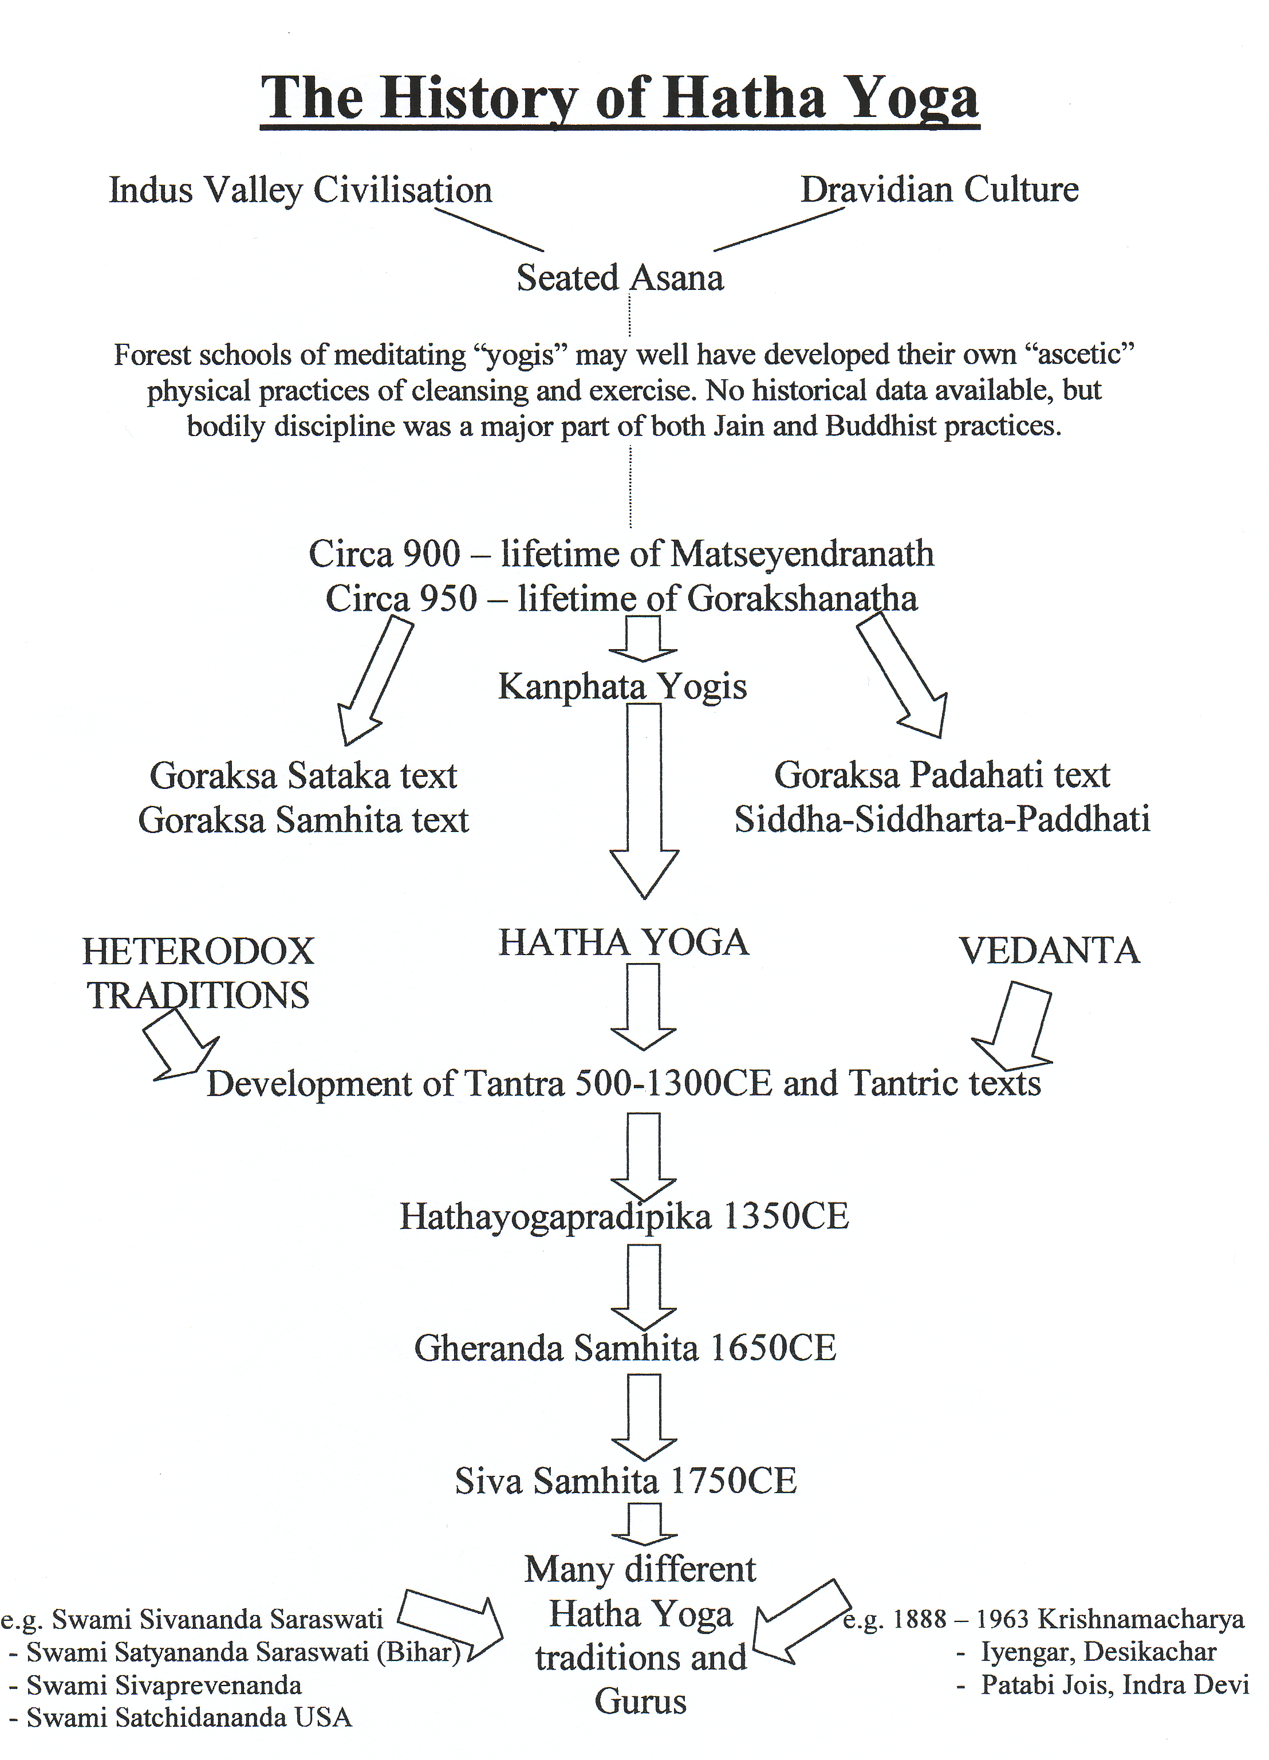

© S Beck 2013

