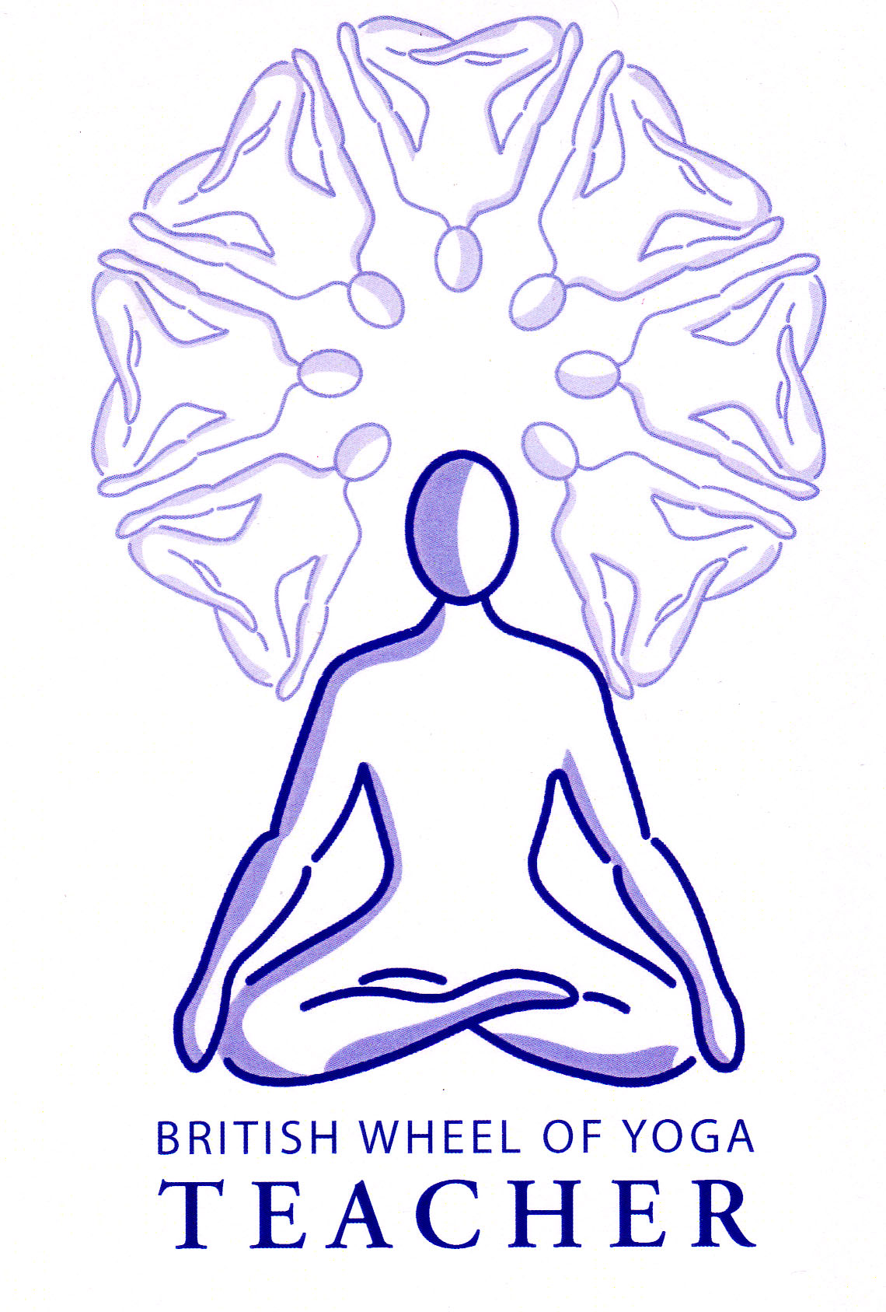

This month’s tasks:

* **2.2** **Basic Breathing & Relaxation Teaching Practice**: **Alison** to complete her lesson plan and script sending these to me by the next meeting, practice to be taught in meeting 8. Please remember to check with me regarding the practices you will be teaching, and I will gladly give you some ideas if needed.
* **1.1aPosture profiles**: **Louise** to start her posture profile for Jathara Parivritti, Revolving Stomach Pose, **Elizabeth** to start her posture profile for Bharadvajrasana, Pose of Bharadvaj and **Mark** to start his posture profile for Chataranga Dandasana. I will send some useful scans for your postures soon. Please email your first drafts of the posture profiles to me before next time we meet so I can give you my comments and any changes can be made.
* **1.1b Lesson Plans for Micro teaching of asana: Sue** to complete her lesson plan to Parsvakonasana, Lateral Angle Stretch, emailing me this before the next meeting.
* As always carefully **read through all of the handouts** from meeting six, making additional notes as needed.
* **Everyone to complete the final kinesiology worksheet on vulnerable areas of the body,** by referring to the handout on ‘hot spots: vulnerable areas of the body’ as given to you in meeting 5, plus where necessary the ‘principles of forward bending, backward bending, sidebending etc. handouts. as given to you in the last few meetings. This information will be invaluable for you in the future!
* **If possible try to teach some basic breathing techniques to friends and family**, making a note of how you experienced this as personal reflective account of your teaching. Do add these sessions to your teaching record but remember you will need to fill in the post lesson reflective evaluation form or make your own notes for any teaching sessons to count towards your total number.
* Finally, begin your final **mindfulness meditation** as outlined overleaf. Please take this opportunity to really immerse yourself in the different activities as they can teach us a great deal! If it does become too uncomfortable to spend time with these practices then feel that you can omit them.

Remember you are free to contact me at home if you have any questions. Emailing me is always best when possible. Yr Ogof

Mynydd Mechell

Isle of Anglesey

LL68 0TE

Tel: 01407 710347 (home)

Mobile: 07757 914089

Email: [sarah.deva@yahoo.co.uk](mailto:sarah.deva@yahoo.co.uk)

Mindfulness Meditation

For these final four weeks please undertake the following practices:

**Week One**

Everyday spend approximately 10 minutes sitting in a comfortable upright position and simply notice what your mind is doing; do not censor your thinking in anyway, just allow thoughts to rise and fall away as they wish. If you find that you have allowed yourself to be taken along by your thoughts, becoming immersed in them, then that is perfectly alright just bring yourself back to being aware of your thoughts. Within this practice you are just becoming more aware of the nature of your mind without seeking to change anything – please treat this an inner exploration only!

**Week Two**

During your everyday life wear an elastic band upon your wrist and see if everytime you have a negative thought you can snap the band. This can be a very interesting way to start to see how your mind habitually works. As aways if judgments arise within you about how good or bad you are let them fall away treating this just as an exploration to see how things are. Be kind to yourself!

**Week Three**

Everyday spend approximately 10 to 15 minutes sitting in a comfortable upright position and focus upon your breathing. See if you can happily stay with each new breath as it rises and falls away this practice requires surrendering to the simple act of breathing. However do not try to stop your thinking and if thoughts arise just note them and let them pass onwards without becoming involved with them, and if you do become involved with thoughts as soon as you notice gently return to your breathing. As always let there be no judgment on your practice just willingly stay with the breath and come back to the breath as needed.

**Week Four**

Return to one of the earlier practices.