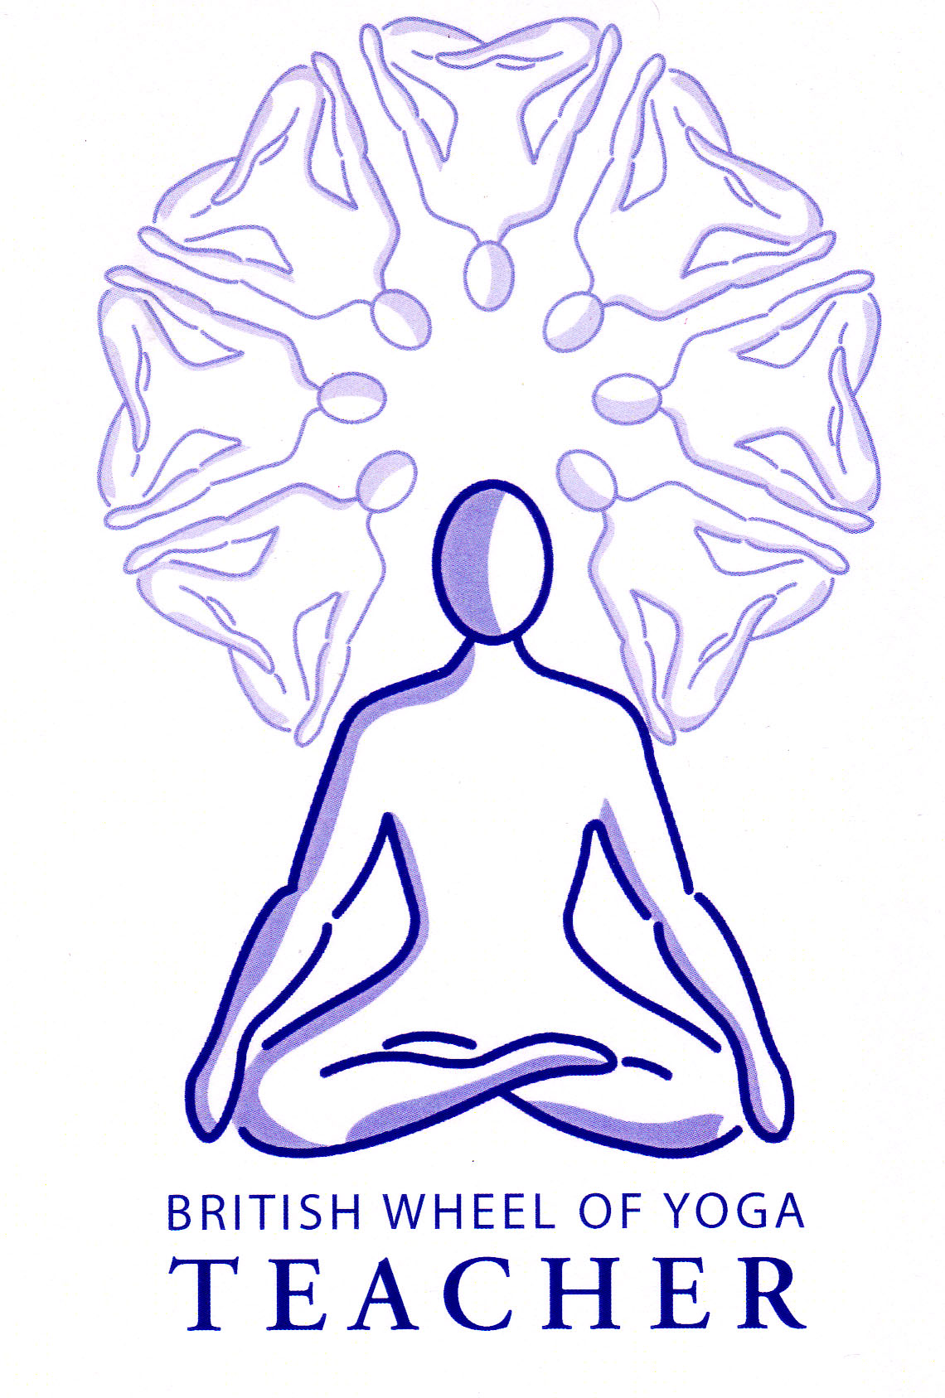

This month’s tasks:

* 2.2 Basic Breathing & Relaxation Teaching Practice: Mark to complete his final draft for his lesson plan to be ready to teach at our next meeting on 1st June.
* Louise to create her final draft of the lesson plan for her 6.3 Pranayama Teaching Practice for next time we meet in June, her session to be taught in our July meeting. Therese & Imogen to create their first draft lesson plans for 6.3 for our next meeting in June, they will teach at the 3rd August meeting. Please use the usual proforma lesson plan and refer to the guidelines given already for this 6.3 teaching practice.
* Everyone to complete your Lesson Plans for a 50 minute class teaching practice to your specified asana: Please carefully read the guidelines sheet so you will know how to orientate yourself to this task. Please complete the first draft done now as there will more work to be done over the coming months. I do not need to see this plan now and you can always make small changes nearer the time of teaching but at least the bulk of the work will have been done. It can be sent to me whenever you are ready, and certainly at least two weeks before you are due to teach your class. Therese to teach the asana practice leading to Dhanurasana for our next meeting on 1st June.
* Everyone to read the web article emailed to you and see what points or questions it raises for you. Are there points with which you wholeheartedly agree or disagree? Areas which seem confused or controversial? Please bring your considered thoughts to our next meeting.
* For those who have the time you can read two sections of the Upanishads on OM and the Four States of Consciousness. These are Brihadaranayaka Upanishad: Chapter 4 and the Mandukya Upanishad. We shall be looking at this next time we meet and it would be good if you have the time to contemplate upon these verses from the Upanishads beforehand.
* **Next time we are meeting on 1st June we are creating our Scheme of Work and Course Plans for our 10 week courses so please do everything you can to be present on the day as it will be mcuh more challenging to do by yourself!**
* Most importantly have a great month!

To find new copies of forms and especially guideline sheets you can always visit my old website at www.yoga-ayurveda.co.uk and the password is Smile.

Remember you are free to contact me at home if you have any questions. Emailing me is always best when possible.

Yr Ogof

Mynydd Mechell

Isle of Anglesey

LL68 0TE

Tel: 01407 710347 (home)

Mobile: 07757 914089

Email: [sarah.deva@yahoo.co.uk](mailto:sarah.deva@yahoo.co.uk)