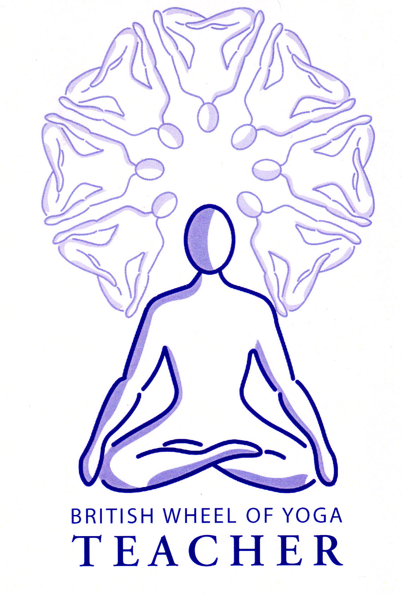
The Pranic System: Chakras & the Nadis

The pranic system has its roots in ancient India where there are references to the chakras within the Vedas, thought to be written over 4000 years ago, there are also later references within the Upanishads and Patanjali’s Yoga Sutras. The main source of references surrounding the pranic system however can be found within Tantra and it’s off shoot of Hatha Yoga where we are primarily working with the pranic system to create transformation. Indeed Hatha Yoga, our area of study, can be called the ‘Science of the Subtle Body’.

Hatha Yoga works primarily with the body in order to transform the pranic body so that our consciousness can evolve. Here we are not expected to be able to control the mind, rather we can practice asana, pranayama, mudras and bandhas, performing the shatkarmas (cleansing techniques) as needed, to influence the pranic system directly. In essence we are correcting dysfunction within our psycho-physical being and thereby becoming a better and more balanced conduit for the life force, eventually accessing our inner potential for the evolution of consciousness. Indeed it is believed that one can reach enlightenment within one lifetime through the intense practice of Hatha Yoga!

In the HYP there is a great deal said about the nadis and the vayus although little is said about the chakras however we are told “When all the nadis and chakras which are full of impurities are purified, then the yogi is able to retain prana” ch 2 v5. This points to two important facts, the first is that we must cleanse & balance our pranic system and the second that we must accumulate prana.

So let us explore the chakras.
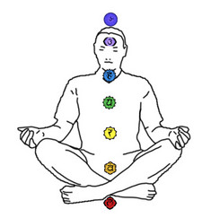
‘Chakra’ translates as ‘wheel’ or ‘disk’ which is very apt as they are spinning vortices of bio-energetic or pranic activity. There are many chakras within the body but the main seven chakras concerned with evolution of consciousness are situated along the spinal column. Each chakra is a confluence of energy at a different level of vibration. The lower chakras are slower moving, possessing a lower vibratory frequency and as we move upwards the chakras move ever faster, possessing higher vibratory frequences. This becomes clear when we examine the different correspondences for each chakra, where for example the root chakra corresponds to the slower moving earth element, and the throat chakra to the faster moving more subtle element of ether or space. Or the way in which the chakras are awarded colours where each colour is also of a different vibratory frequency or wavelength.

As a centre of resonance each chakra governs the functioning of different aspects of our being such as the:

- Organs of the body: esp. endocrine organs
- Systems of the body: respiratory, circulatory etc.
- Senses
- Mental & emotional concerns: both perception & expression

Also each chakra also corresponds to different elements, colours, bijja mantras and so forth which can be used to create balance within the chakras. This is because these are ways in which to create resonance with the different levels of vibration which can affect the functioning of the chakras, and thus its associated organs, systems, senses and psychological concerns.

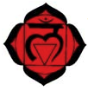
Muladhara Chakra ‘Root Place’
Root chakra
Located between the sacrum and coccyx this chakra is primarily concerned with our basic animal urges such as the need to survive & for security. It relates to the coccygeal plexus, the adrenals, the autonomic nervous system, the skeletal system, the lymphatic system and elimination. It relates to the element of earth, the sense of smell, colour red, 4 petals and the bija mantra Lam.


Svadisthana Chakra ‘Place of the Self’
Sacral chakra
Located between L5 and the sacrum this chakra is primarily concerned with our emotional identity and our need for sensual experience such as our appetite for food and for sex. It relates to the sacral or lumbar plexus, adrenals, liver, reproductive organs, pancreas, spleen, digestive assimilation. It also relates to the element of water, the sense of taste, the colour of orange,
6 petals and the bija mantra Vam.

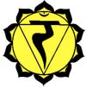
Manipura Chakra ‘Jewelled City’
Solar plexus chakra
Located between T12 and L1 this chakra is concerned with will power and self definition. It relates to the solar plexus, the muscular system, adrenals, pancreas and digestive system. It also relates to the element of fire, the sense of sight, the colour of yellow, 10 petals and the bija mantra Ram.

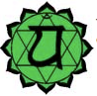
Anahata Chakra ‘Unstruck’
Heart chakra
Located between T4 and T5 this chakra is concerned with our ability to relate to others and integrate ourself. It relates to the cardiac plexus, thymus gland, respiratory system, circulatory system and immune system. It also relates to the element of air, the sense of touch, the colour green, 12 petals and the bija mantra Yam.

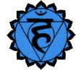
Vishuddhi Chakra ‘Great Purifier’
Throat chakra
Located between C7 and T1 this chakra is concerned with communication. It relates to the cervical plexus, the thyroid & parathyroid, metabolism and growth. It also relates to the element of space, the sense of hearing, the colour of pale blue, 16 petals and the bija mantra Ham.

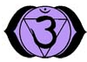
Ajna Chakra ‘Place of Command’
Third eye chakra
Located at the juncture where a line from tops of ears meets the point directly above the nose this chakra is concerned with concentration and creativity. It relates to the ciliary plexus, the pineal gland and the endocrine
system. It also relates to the sense of intuition the colour of indigo or deep
purple, 2 petals and the bija mantra Ksham or Om.

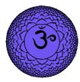
Sahasrara Chakra ‘To Multiple by a Thousand’
Crown chakra
Located at the juncture of the fontanels this chakra is concerned with transcendental consciousness. It relates to the brain, the pitituary gland and the nervous system. It also relates to the colour violet or white, 1000 petals and the bija mantra Om or indeed silence.

As part of pranamayakosha the chakras are centres of organization which receive the life force, assimilate it and express it. In everyday terms the chakras are concerned with physiological and psychological processes. Through the practices of Hatha Yoga where we are releasing constriction and blockage, purifying & strengthening them, we will find that there will be beneficial changes on both a mental and physical level, bringing more vitality and balance to the functioning of our body, mind, emotions and senses. If you remember the pranamayakosha is the bridge between the annamayakosha and manomayakosha, i.e. the vital force, prana affects both the body and mind; indeed we could say body & mind are not separate but two sides of the same coin.

Please note that in the HYP we are not led to work psychologically, rather as Sw. Muktibodhananda Saraswati says on page 16 in the initial introduction to the text “The psychic and mental diseases which human beings are suffering from are nothing but a state of disharmony in the energy system” i.e. when we bring harmony to the pranic system mental unease and disease will be resolved. That said there are many contemporary books which do help us to identify our psychological patterns through the lense of the chakras with self-awareness and the use of many yogic techniques, amongst others, being among the ways in which to restore balance to the psyche.

Once the chakras are balanced, i.e. are neither nor deficient or excessive in activity, then we will experience health, be emotionally balanced, mentally astute and creative, functionally well within this world. A great deal is said about opening chakras however this is not a normal function of the chakras rather it is part of spiritual development where when the chakras are purified and balanced and there is enough prana accumulated they will open like a lotus flower, an often used symbol of this process. The chakras are part of a much higher energy system than the physical body and we are told that it takes double the amount of prana that maintains the body and brains’ functions to activate each of the chakras, and that as we move through the chakras it takes double the amount of energy to open each of them. As the chakras become energized & purified, opening, it is only then that the higher functions of the chakras becomes evident, awakening the subtle sensory and motor organs to which they relate, giving us the experience of the subtle worlds & higher states of consciousness. There follows an absorption of the astral body into the causal body and eventually into pure consciousness itself.

The Tri Sharira:

Sthula Sharira or Physical Body:
Root chakra: Annamaya kosha
Sacral chakra: Subtle annamaya kosha (hormonal system)

This the densest field of prana comprised of the five elements subject to both time & space. At death it disintegrates.

Sukshma Sharira or Astral/Subtle Body:
Solar plexus chakra: Pranamayakosha or pranic sheath
Heart chakra: Manomayakosha or emotional sheath
Throat chakra: Vijnanamayakosha or mental sheath lower aspect

A dancing ever-moving ‘electrical or pranic field’ moving with the fluctuations of the sense organs, motor organs and the mind. It possesses the same form as the physical body but is more of an impression, giving vitality to the physical body primarily through the respiratory & nervous systems. At death the subtle body functions just as in dreams and sleep revealing impressions, experienced in our life, once revealed they are withdrawn and the causal body comes to the fore.

Karana Sharira or Causal Body
Third Eye Chakra: Vijnanamayakosha or mental sheath higher aspect
Crown Chakra: Ananadamaykosha or bliss sheath

This is the unmanifest form of the subtle body which exists as formless states of awareness. It does not live or die but holds our deepest life thoughts & perceptions, our vasanas and these samskaras founded upon our kamas or desires. Once revealed and exhausted this leads us to another birth where the causal body creates a new astral body which creates a new physical body – The Cycle of Samsara.

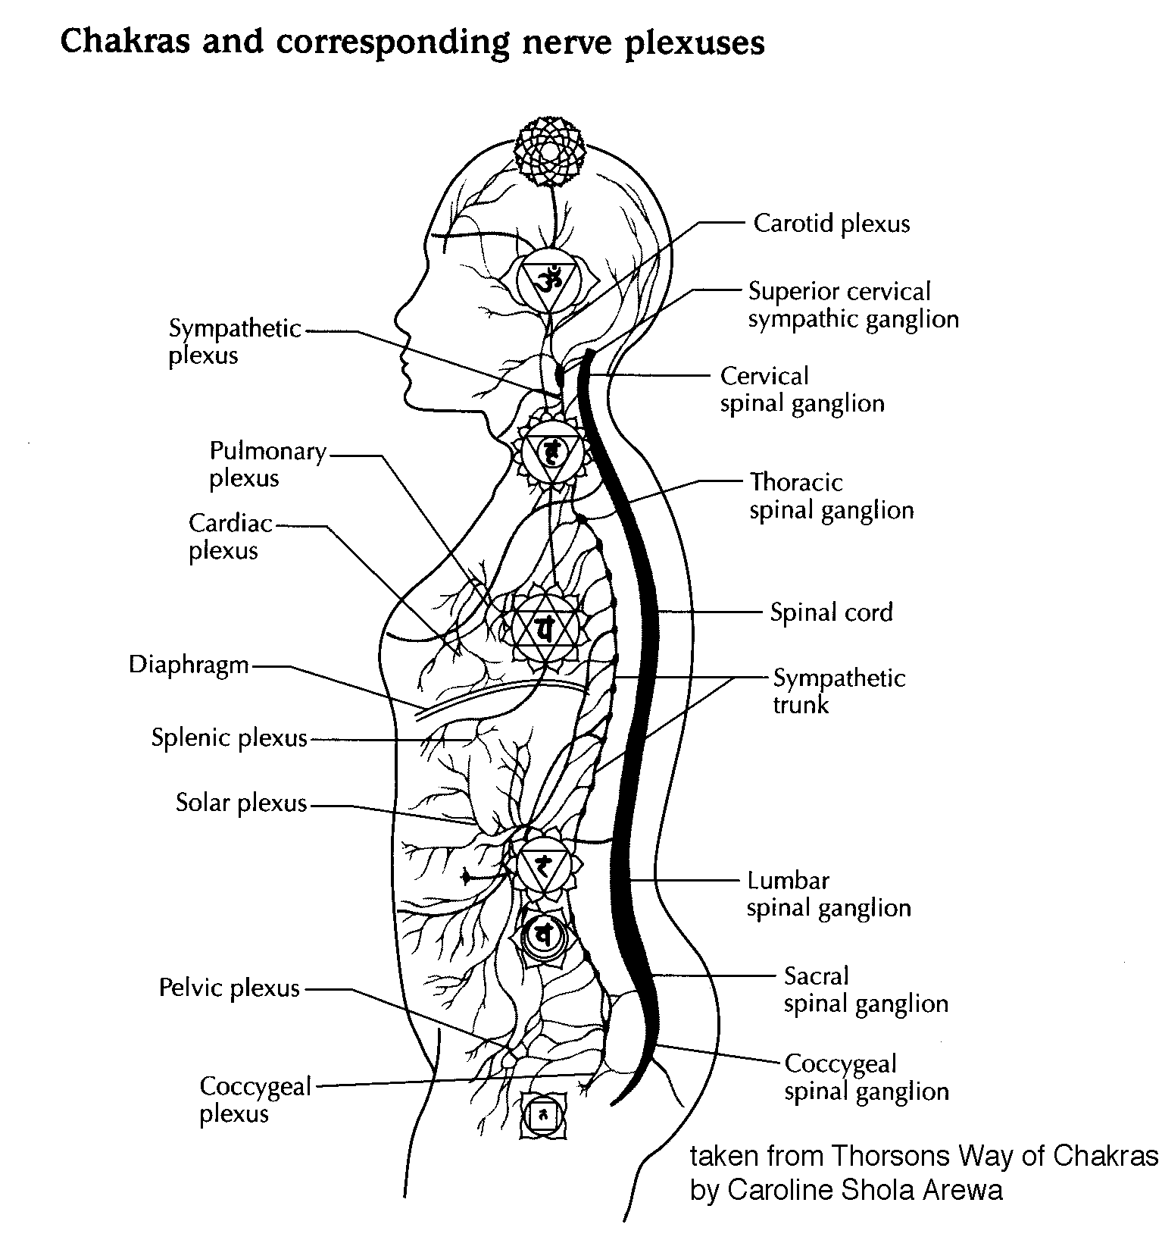
In essence we can live well with chakras closed but will remain spiritually ignorant (avidya). And for yogis the evolution of consciousness is everything!

Finally, it is interesting to look at the possible correlation of the chakras and the nerve plexuses and to some extent there does seem to be a relationship between the two although we must never forget that the chakras are part of pranamayakosha, our subtle anatomy, whereas the nervous system is primarily part of annamayakosha. The two are however interdependant.

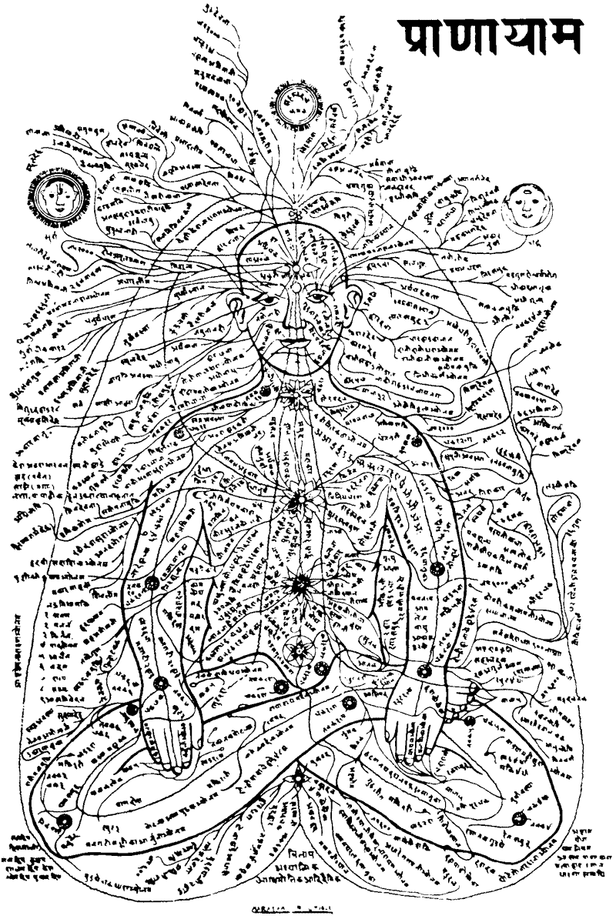
‘Nad’ translates as ‘to flow or duct’, the nadis being the channels of the life force, prana, flowing through our subtle pranic body taking energy to our physiological systems. They also relate to other parts of our subtle A & P, starting at the various chakras and being directed by the pancha vayus.

The system of the nadis is shown opposite in a rather busy diagram by David V. Tansley, Subtle Body - Essence and Shadow, (1977, Art and Imagination Series, Thames and Hudson, London).

The number of nadis is so vast it differs in various texts with the Hatha Yoga Pradipka and Upanishads stating there are 72,000 in total. Of the 72,000 there are fourteen major nadis and of these three are the most important for spiritual unfoldment i.e. Ida, Pingala and Sushumna Nadis.

Ida and pingala nadis are opposite energies with each possessing attributes of opposite qualities. For instance Ida is equated with the moon and pingala with the sun; Ida is cooling and Pingala is heating; Ida is the female passive principle and pingala the male active principle. Ida activates the PNS and pingala the SNS. (See HYP Ch3 v4 for table).
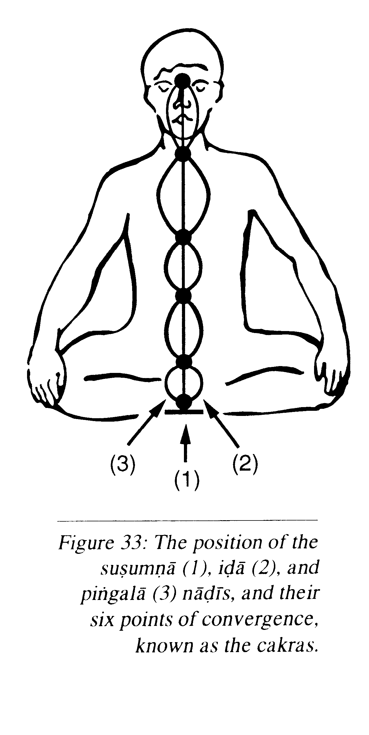
Significantly ida carries manas shakti or mental energy and pingala carries prana shakti or the dynamic force of prana meaning that whichever nadi is predominant will dictate our state of mind and physical vitality. Generally we find that approximately every 90 minutes the predominance of ida and pingala changes and we can see which is predominant at any time by checking which nostril is open. In essence this indicates which hemisphere of the brain is currently active so when the left nostril is open, ida nadi and the right hemisphere is active, whereas the alternative is true when the right nostril is open. This is the normal cycle where at the time of switching over there will a one to four minutes when both are equal and sushmuna nadi is activated. We are told, especially in Swara Yoga, The Tantric Science of Brain Breathing, that we can use this knowledge and perform activities which are aligned with our predominant nadi at any time so for instance we can study and be mentally creative when ida is active and perform physical tasks when pingala is active.

Ida nadi begins at the left of the root chakra and pingala at the right of the root chakra and from here they weave around the spinal column crossing over at the chakras as they ascend to meet at the third eye, ajna chakra. (note: some texts tell us they cross between the chakras). Ida controls the left hand side of the body and right brain, and pingala the opposite, the right body and left brain.
From: Heart of Yoga by T.K.V
Desikachar

The sushumna nadi, often called the channel of fire, emerges from muladhara chakra and travels along the central spinal column to unite with ida and pingala at the ajna chakra. Another name for this nadi is ‘brahman nadi’ since it is the channel which when traversed leads us to an experience of Brahman, the One. There are three layers to the sushmna where just inside the outer layer is the vajra nadi meaning ‘thunderbolt’, deeper still is the citrini nadi meaning “giver of immortality’ or ‘shining’ with the innermost layer being the brahma nadi.

Normally sushumna nadi is dormant being a vertical neutral energy field, with our pranic energy travelling upwards through either ida or pingala nadis; here sushumna acts almost like the neutral or earthing part of a plug. Sometimes however a little prana will flow through sushumna as in deep meditation or in highly charged activities such as going into battle, climbing a mountain and so forth when there will be a very productive awakened state experienced as both hemispheres of the brain become activated. This however is not long lived and is not the ultimate potential which lies with the activation of sushumna.

Through the practices of Hatha Yoga we are working towards the opening and activation of sushumna nadi through which the spiritual force of kundalini shakti can ascend through sushumna nadi to ajna chakra. At this point it is said that Hatha Yoga hs been attained. From there it can enter sahasrara chakra allowing us to experience our Transcendental Self, (Paramatman or Brahman) and now this is the attainment of Raja Yoga.

As we have seen this process requires purification from the practices of the shatkarmas, asana and pranayama all of which purify, strengthen and balance the chakras and nadis so there can be an unimpeded flow of prana and the accumulation of prana. Then there is the application of the mudras and bandhas to consciously alter the flow of the vayus so that kundalini can awaken. More on kundalini later as we explore the practices of mudras and bandhas!

In summary a modern analogy might be that we can imagine our pranic system to be rather like an electricity power station where the pressure of fast flowing water rotates great turbines creating powerful magnetic fields where electricity accumulates. The structures must be strong and capable of withstanding great forces and all obstacles to the flow of water must be removed!

HYP: references to chakras
Ch 2 v5

HYP: references to nadis
Ch2 v4, Ch2 19 & 20, Ch3 v4, Ch3 v123 & 124

Bibliography
Arewa, Caroline Shola, The Way of the Chakras, (2001), Thorsons: London, p14
Desikachar, T.K.V, The Heart of Yoga (1995), Inner Tradition International, Rochester: Vermont, p136
Tansley, David V., Subtle Body - Essence and Shadow (1977) Art and Imagination Series, Thames and Hudson: London, page unknown

Nadi Sodhana & the Bija Mantras

Right nostril relates to Ram: pingala nadi: SNS

Left nostril relates to Vam: ida pingala: PNS

Inhale R nostril: mentally chant Ram (Fire) Increase fire burn ama - heating

Exhale L nostril: mentally chant Yam (Air) Dry kapha/mucous & ama - lightening

Inhale L nostril: mentally chant Vam (Water) Cooling & soothing

Exhale R nostril: mentally chant Lam (Earth) Cooling & consolidating

The use of bija mantras helps to purify and open nadis, strengthen tissues since they relate to th elements, engages mind, creates heating/cooling effect

The bija mantras for each chakra
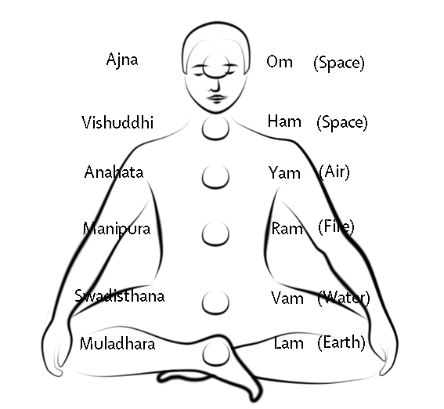

Please note when toning the bija sounds the ‘m’ is actually pronounced as ‘mng’ i.e. it is nasalised. So:

Lam is Lamng Ham is Hamng
Vam is Vamng Om is Omnnn
Ram is Ramng Silence
Yam is Yamng

Summary:

The knowledge of pranic anatomy & physiology is at heart of Hatha Yoga

Chakras & nadis are part of pranamayakosha

We need to purify chakras and nadis so prana can move freely

We need to accumulate prana (includes lifestyle – look later at this)

Traditionally we need not need to address the psyche directly

Normally chakras are closed but can be better balanced and enlivened through the practices of Hatha Yoga so we can function optimally physically & mentally

As chakras open they enable us to access their spiritual function, more aware of sukshma sharira, subtle body and karana sharira, causal body

Simultaneously ida and pingala have become balanced and prana can enter sushumna nadi, and when all is ready from muladhara chakra Kundalini Shakti can arise passing through opened
S S. Beck March 2014

