**Virabhadrasana III (Warrior balance pose)**

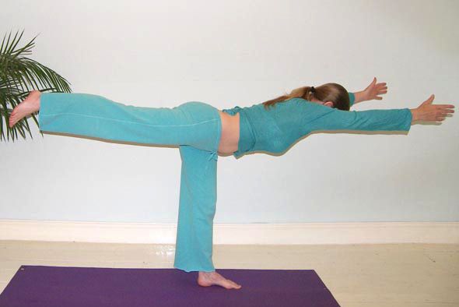

# *Pronounced veer-ubh-huh-draah-suh-nuh guh the word vira means hero or warrior and can also be translated at strength or fortitude, guh means third in Sanskrit.*

This balance is one of the warrior series of asana. It is especially good at building strength and developing endurance.

**Teaching Points:**

* Start in tadasana (mountain pose) taking the weight of the body into the left foot, spreading the toes well, creating a good pada bandha
* Inhaling raise both arms to the ceiling, lengthening whole body, and engaging abdominals and mula bandha. Keep lower ribs tucked in rather than flaring. Concentrate on keep hips facing forwards and level
* Now exhaling focus first upon raising the right leg and as the leg lifts the upper body will naturally be drawn forwards, go just as deeply as possible, keeping arms, toros and raised leg extended until eventually the upper and lower body are parallel to the floor.
* Keep reaching outwards through the back foot and forwards through the fingers, can look slightly up or downwards as the body folds forwards. Ensure the shoulders remain down away from ears, hips are level.
* Stay here for a few breaths maintaining the length of the body ensuring the hips are level. Do not over use the gluteus maximus, the buttock hip extensor.
* To exit, inhaling, using the strength of the hips, legs and back, lower the back leg as the upper hands are lifted to the ceiling and then exhaling lower arms to the sides of the body.

**Note:**

Most of the different versions of this asana differ according to the hand placement. Of course the back must work more strongly when the weight of the arms is greater so at first we may choose a softer alternative and they are also very good for general weakness. We can also alter the experience of the pose by how we enter and leave the pose.

**Benefits:**

Tones ankles and knees

Strengthens legs, arms and posterior shoulders

Strengthens hamstrings and other hip extensors

Strengthens abdominal muscles and the spine

Increases flexibility in hips and groin

Develops concentration

Creates feeling of confidence and independence

Increases stamina and energy levels

#### Good preparation

Poses developing **good abdominal control and strength & back strengtheners** as these must work together to maintain natural spinal curves (if abds are weak there will be a deeper lumbar arch); **hip extensors (hamstrings & gluteus maximus) strengthening** and **& hip flexor stretches (iliopsoas)** as need to keep raised leg parallel to floor; **strengthing of deep hip rotators** as needed for stability; **hamstring stretches** as the the standing leg side is flexed at 90º; **Shoulder stretches into flexion** for flexibility & strength (release serratus anterior/latissimus dorsi for arm flexion & strengthen shoulderblade stabilisers (pects, rhomboids, trapezius).

**Counterposing**

Need to release spine, especially the lower back

#### Cautions & possible modifications

* Balance problems, vertigo, pregnancy **place hands to back of chair, wall, partner**
* Back conditions & general weakness work with modified version

#### Other simple versions and modifications

###### :::warrior 3 pp.tifHands in prayer pose, back leg flexed (flamingo)

Place hands in prayer pose and bend right leg keep hips forwards. Could stay here but to go further start to lift the right thigh as the upper body is pivoted forwards from the hips. At some point it may feel right to straighten the bent leg. Remember to keep the neck in alignment with the whole spine and do not fold at the hips.

***Reach hand out at shoulder height***

Come to a raised warrior pose where you are on the toes of the back foot. When you are ready to move start to reach forwards with both hands as the weight is transferred into the front leg. Continue to move forwards, reaching forwards with both hands straightening the front leg as the lower leg lifts. This is a sweeping forwards action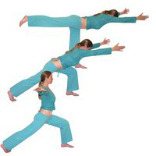 where the weight of the arms is lessened by reaching forwards from the shoulders.

###### Flying bird balance

Here we start with arms out at shoulder height, palms facing forwards. Then as we begin to lift one leg we allow the upper body to pivot forwards from the hips. We can stay at any stage but ensure you keep the standing leg strong and your chest open. Here again the weight of arms is reduced and the arms help a little with balance.

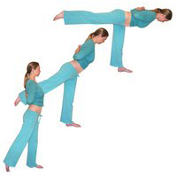**Developments & Variations**

###### Hands placed in reverse namaste position

Here we place hands in reverse prayer position. Lift one leg and as the leg continues to lift we start to allow the upper body to pivot forwards. Keep the neck in line with the spine and stop wherever necessary. This placement of the hands helps to keep the chest open and the spine long.

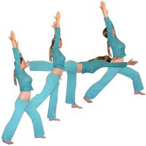***Warrior 1 to warrior 3 to warrior 1***

Here we work in a sequence where we move from warrior 1 into warrior 3 and from warrior 3 we return to warrior 1. This is a great way of entering warrior 1 more deeply as we step back from the balance pose.

#### Adjustments

If the hip of the raised leg side of the body is lifted higher than the other hip then we can gently place a hand on the elevated side instructing students to lower it until both hips are level. To help students whose arms are too low we can place our hands under the forearms and gently lift them and if necessary helping the arms to slightly externally rotate at the shoulders.

© S. Beck October 2014