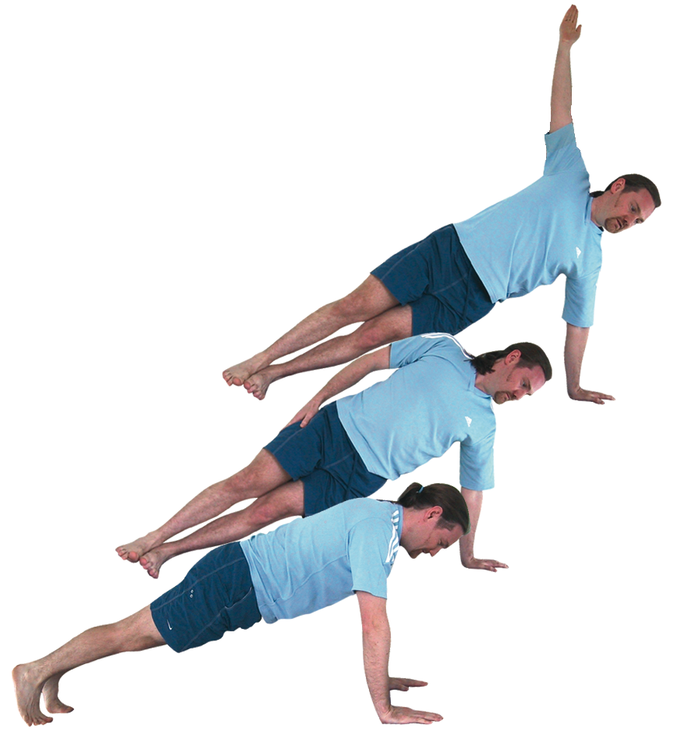**Vasisthasana (side plank pose)**

# *Pronounced vuhs-eesht-aah-suh-nuh vasistha is the name of a well-known sage in Sanskrit.*

This pose builds strength and poise. Note that we should not perform this pose on a soft surface as this decreases the angle between the forearm and palm.

**Teaching Points:**

* Start in plank pose as shown opposite with wrists beneath shoulders, body at 45º, if needs be can take wrists a little further forward to reduce pressure upon wrists
* Now roll onto the side of left foot, stacking the right foot above the left foot as the right arm is placing along the right side
* Keep fingers straight and the weight evenly across the bones of the palm, shifting weight forwards away from the heel of the hand, could stay here
* If possible raise the right arm to the vertical position, lifting out of the lower arm up into the upper arm, broadening the chest, could stay here
* If feeling steady look up along the vertical arm.
* Keep both legs active, core engaged, hips aligned with shoulders and knees
* To exit lower back down into plank and work to other side.

**Benefits:**

Strengthens the body, especially the abdomen,

shoulders, arms, wrists and legs

Also stretches the wrists and chest muscles

Improves concentration

Develops balance

Increases endurance

Gives energy

#### Good preparation

Shoulder, arm and wrist strengtheners; core & leg strengtheners

**Contra-indications & possible modifications**

* For heart conditions and un-medicated high blood pressure work within limits and keep the upper arm to the top hip if staying
* For balance problems, wrist problems or general weakness we can place the top foot in front of the back foot instead of stacking the feet or work with one of the modifications given below

#### Simple versions and modifications

#### *Lower arm bent*

We can work by bending the lower arm, fingers pointing forwards away from the body. Although here we must ensure we keep both shoulders and the chest open as reach the upper arm vertically.

#### *:::side cat balance.tifCat balance*

A good modified version, which also be used for preparation is where we start in cat pose on all fours then straightening the left leg place the instep in front of the right toes, making a triangle shape with the legs. Then if steady we can arc the left arm up to a vertical position.

*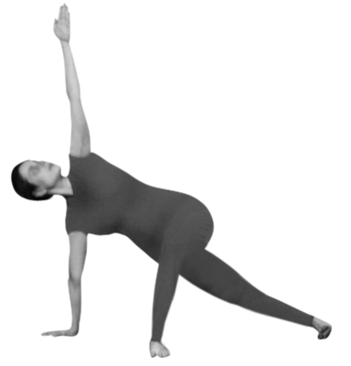****Top foot over lower leg***

If the full pose is too intense we can bend the top leg and place the leg over the lower leg, foot pointing forwards.

***Lift the heel of the wrists or use fists***

Place hands on a wedge, folded towel etc. to increase the angle between the palms and forearms, fingers sloping downwards. Can try placing hands on blocks to transfer some of the weight into legs, with fingers either in the block or over the side.. Can use fists instead to avoid pressure into the wrist area.

**Developments & Variations**

*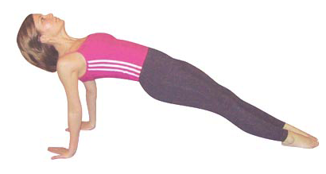****Rotating round and round***

We can practice the pose by lifting the right hand into vasisthasana from plank then moving into purvottanasana (east stretch), returning back to vasisthasana where the left hand is raised, moving into plank and so forth.

*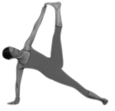****Hand to big toe***

To develop this pose we can externally rotate the hip of the top leg at first placing the foot to the side of the lower thigh, working the top knee backwards (as in tree) then we can wrap the middle finger around the big toe of the raised foot as the leg is straightened out to the side.

**Adjustments**

If the hips are too low then we can gently lift the hips upwards, or at least place a hand lightly at the lower hip suggesting the direction the hips must lift.

© S. Beck January 2015