**Utthita Parsvakonasana – Extended Lateral Angel Pose**

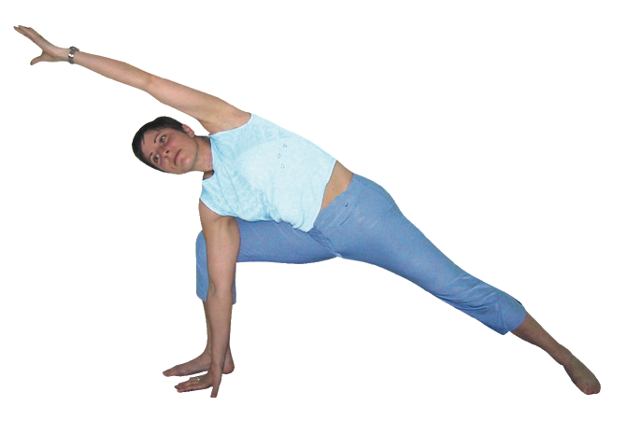 *Pronounced oot-t-hee-tuh-paarsh-vuh-kohn-aah-suh-nuh utthita means extended, parshva means side or flank and kona is angle in Sanskrit.*

This pose is taken to be a side stretch because we create a great line of effort along one side of the body although in reality there is a considerable twisting action necessary to perform this pose.

**Teaching Points:**

*Stage one*

* From tadasana abduct feet for approximately one legs length apart, then raise arms out to sides at shoulder height drawing feet apart until the ankles sit beneath the wrists. One you have placed the feet lowering arms to sides.
* Turn the right leg 90º to right side and the left leg approximately 45º inward so a line from the front heel runs directly into the arch of the back foot
* Inhaling raise both arms out to the sides at shoulder height and exhaling lower the right forearm on to the right thigh (as shown below). Using the lower arm to draw the right thigh backwards as the top shoulder is simultaneously drawn backwards so the chest is opened. Keep the knee stacked upon the ankle, aligned with the front foot. Could stay here keeping the spine long and open, shoulders open, placing the lower hand in chin mudra where the forefinger and thumb touch, palm facing upwards.

##### Stage two

* To go deeper into the pose lunge more deeply, lowering the hips placing the lower hand to the floor just in front of the front foot. Press gently against the front leg keeping the leg aligned as you rotate the chest upwards, keeping it open, shoulders back. You could raise the top arm vertically and work here

##### Stage three

* To move into the final stage inhale and exhale draw the top arm over head at 45º, looking under the arm towards the ceiling.
* To exit inhaling straighten both legs, reaching out to sides from whichever position has been adopted and exhaling lower arms to sides, feet forwards. Then working to the other side.

**Benefits:**

Stretches the whole side of body

Increases circulation to heart and lungs

Opens chest and shoulder muscles

Alleviates discomfort around the hips and low back caused by lack of mobility due to conditions such as arthritis or structural imbalance

Opens groin muscles

Can help with sciatica

#### Good preparation

Lateral stretches, adductor stretches and hip mobilizers. Simpler asana such as warrior 2

**Contra-indications & possible modifications**

* For un-medicated high blood pressure & heart conditions keep the upper hand to the top hip when staying statically and only work for short briefer periods, without strain.
* Knee problems take great care with alignment working with feet closer and hips higher if the intensity must be reduced.
* Sometimes students have small lengths of arms proportionate to the length of legs so here students may sometimes benefit from keeping the lower arm at a higher point, perhaps on a block or brick placed on the floor in front of the front foot or even on the thigh as shown above. Otherwise these students will find if they place their lower hand to the floor this will actually compress the torso meaning they are unable to rotate the chest.
* For neck problems keep the head turned forwards

Take care to:

* To keep the front knee aligned with the knee stacked over the ankle at 45º and the knee aligned with the front foot to avoid twisting at the knee. If the knee is a little misaligned try lifting the toes of the front foot, which magically realigns the knee then keeping the knee still lower toes once again. At the same time keep the arch of the back foot lifted.
* Ensure a student who has stiffness in the hips and inner thigh muscles or sacroiliac strain allows the top hips to drop forwards.
* We may need to turn the front foot inwards a little or allow the rear hip to drop if the adductors or hips are tight, otherwise the front knee may be twisted placing pressure upon the medial collateral ligaments and uneven weight upon the bursae & cruciate ligaments.

#### Modifications

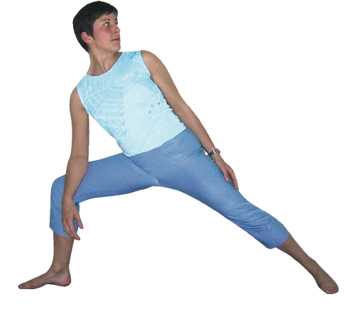**Lower arm to thigh**

Here we stay at stage one possibly keeping the upper arm to the side of the body.

**Alternatively** it maybe possible to position the lower hand upon a block or brick so we are midway between the thigh and the floor.

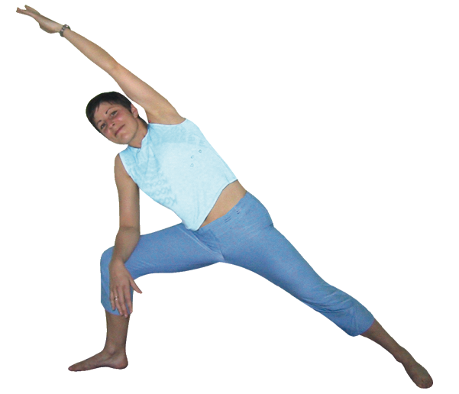**Lower arm to thigh, top arm raised overhead**

We can raise the upper arm to create a line of intensity from the lower foot to the top fingertips.

**Variations**

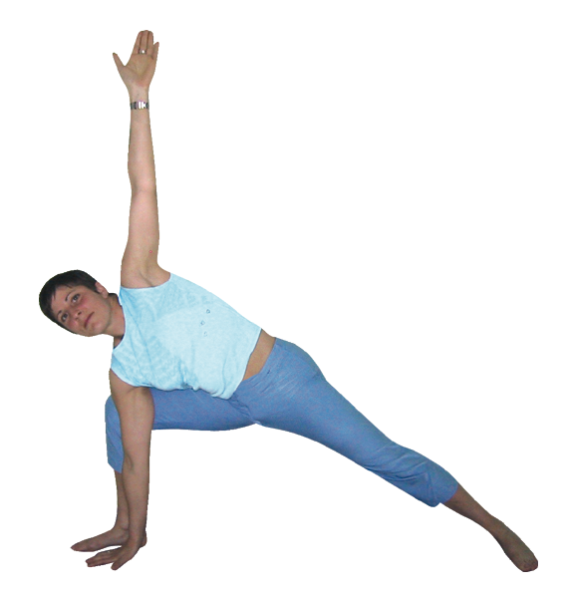

**Top arm vertical**

By taking the top arm to a vertical position we are really working to open the shoulders and chest as well as the hips and inner thigh muscles. This is a great variation!

Some schools of yoga teach that the lower hand is to be placed behind the front leg. This is a variation we can use although it does not help us to keep the front leg aligned and is therefore sometimes unhelpful.

**Developments**

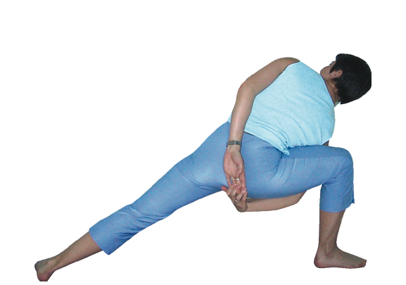**Bound parsvakonasana**

To increase the strengthening effect of working the lower body we can interlock fingers behind the back then work to keep the front knee back and the shoulders opening as we rotate the ribcage slightly upwards.

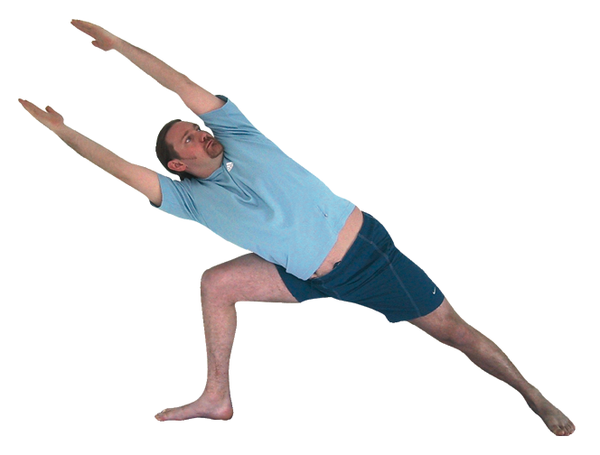

**Unsupported parsvakonasana**

We can also increase the strengthening effect upon the upper and lower body by raising arms past ears. Good alignment must be maintained!

#### Adjustments

There is often misalignment in this pose and mirroring to individual students often works very well.

A common mistake is often students do not bend the front knee enough so the hips remain too high so we can help them to bend the front knee more and perhaps move the front foot a little further forwards if needed to maintain the 45º angle of thigh to lower leg.

Sometimes it is useful to carefully re-position the upper arm, gently extending the arm to create the line of intensity through the side of the body. Also it is possible to gently roll the top shoulder backwards as you use your knee to stabilize the pelvis and your lower hand holds the top of the upper thigh, although we must take care not to attempt to excessively open the groin areas as this can de-stabilize the hips.

For more experienced groups we can also re-iterate the teaching instructions and then ask students to watch each other practicing this asana, offering verbal guidance. This is a great way of working so students actually learn the main teaching points by teaching them and is very useful for large groups.

© Sarah Beck September 2021