Summative Assignment 3 Posture Profile

Name of Student Teacher:  BWY Number: |  | Date of submission of profile:
Asana Sanskrit Name | Uttanasana ( Pronounced oo-taahn-aah-suh-nah)
Common English Name | The Intense Pose or Standing Forward bend  [The Intense Pose: the word ‘ut’ means intensity and the word ’tan’ to lengthen or strengthen in Sanskrit]
Diagram or Picture
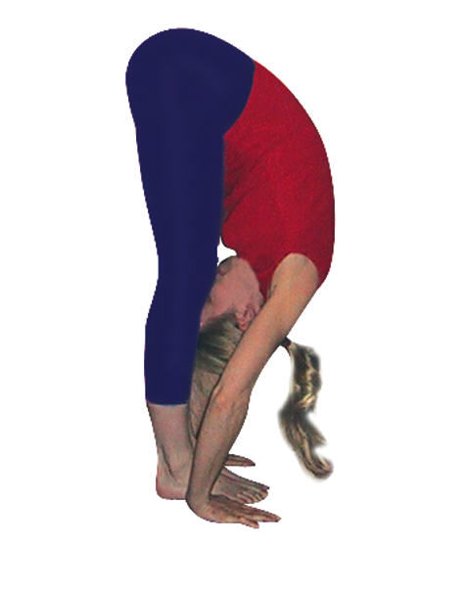
(own photo) Note: you will need to give a source for any image copied and pasted from the internet in the bibliography of this profile.
Note: Please check with me as to your choice of the peak asana as there are often different versions.

Starting Point/ Position
This can be very simple indeed but please do give a sense of taking a few moments to attune to the body and breath.
- Centre in Tadasana, Mountain Pose, with feet hip width apart, feet aligned forwards.
- Find Pada Bandha, the foot lock, by balancing the weight of the body equally through all four corners of the feet
- Ensure pelvis stays in a neutral position where spine feels relaxed and open, natural lumbar curve
- Adopt a gentle Mula Bandha becoming aware of rooting downwards as you lift upwards through the crown.
- Attune to the breath.

Key Joints and their Actions
Choose the key joints only. Give the movement and the articulation using your handouts & notes on The Anatomical Terms of Movement and The Major Joints of the Body
- Flexion of arms at shoulders (humerus articulating with the glenoid cavity of the scapulae)
- Flexion of torso at hips, along with a slight internal rotation (the head of the femur articulating with the acetabulum of the hips)
- Extension of whole length of the spine with small amounts of flexion between vertebrae (vertebrae articulating with one another)
- Extension of the lower legs at the knees (femur articulates with the tibia), may need to have some flexion at knees

Key Muscles and their Actions
Here describe the main key muscles; remember fixators are muscles that help to stabilise another part of the body as it moves or is held & synergists are muscles that assist the prime mover (agonist) or neutralise undesired movement. You will find more information on fixators and synergists in the information sent to you on your posture.
1) Extension of legs at the knees
Key muscles contracting: Quadriceps
Key muscles stretching: Hamstrings (& also adductors attached to sitting bones)
Fixators & Synergists: When in the asana the muscles of legs and feet will generally contract and relax as needed to maintain balance, to include the gastrocnemius, and anterior & posterior tibialis of the lower legs. The lower leg calf muscles, especially the gastrocnemius must also be stretched if tight.
Also, the adductors help to stabilise the pose, as do the hamstrings and iliopsoas.
Controlling movement (eccentric contraction): Gravity does most of the work where the posterior lower body muscles must simply relax to enter the pose, with muscles at the back of the body (i.e. the hamstrings and gastrocnemius) acting as brakes to slow the movement against gravity as needed i.e. eccentric contraction where some muscle fibres stay partially contracted as the muscle lengthens slowly.
2) Flexion of torso at hips
Key muscles contracting: Iliopsoas, rectus femoris (the quadriceps muscle that crossing both the knee & hip joints) & rectus abdominis create the movement of flexion and gravity plays the main role of lowering the body
Key muscles stretching: Spinal muscles especially the erector spinae, the spinal extensors; also the gluteus muscles, especially the gluteus medius and minimus and the deep external hip rotators
Controlling movement (eccentric contraction): Gravity does most of the work where the posterior upper body muscles must simply relax to enter the pose, with muscles at the back of the body (i.e. the erector spinae, gluteus muscles and external hip rotators) acting as brakes to slow the movement against gravity as needed i.e. eccentric contraction where some muscle fibres stay partially contracted as the muscle lengthens slowly.

Limiting Factors: Cautions, Modifications
When detailing ‘Limiting Factors’ consider muscle strength/flexibility, joints, body geometry.
Key Limitations:-
Tight hamstrings, tight back muscles and tight hip rotators. Also, possibly tight gluteal muscles.

Some students may find there is a structural limitation for forward flexion and where this is experienced at the front of the body, e.g., at the front area of the hips then this will be a natural limitation, when it is experienced at the back of the body then overtime students will be able to flex more deeply as their muscles relax and lengthen. Also, some students may find their legs are proportionately long relative to the torso and/or arms and this may mean they will not be able to easily touch the floor or work by binding hands to feet.

Vulnerable Areas: Cautions, Modifications
Vulnerable Areas to include everyday yoga class issues: ‘Blood Pressure, Neck, Shoulders, Wrists, Lumbar, Knees, Hip Replacement, Pregnancy’. Not all will be applicable. For areas of cautions refer to our handouts on Principles of Forward Bending, twisting etc. and also to handouts on Cautions all of which will be given soon. Many of the same cautions apply for different asana so other profiles may also be useful.

Cautions for: -
Hamstring injury or stiffness: Bend knees or can practice halfway (Ardha Uttanasana) with straight/bent legs
Heart conditions, Hypertension & Mature Diabetic, Eye and Ear ailments: Do not keep the head down below the heart; can stay in Ardha Uttanasana, half forward bend.
Herniated discs: Avoid forward bends for at least 3 to 6 months, take an alternative pose

Hiatus Hernia: Practice halfway only (acid reflux), can use a chair as support for hands
Hyperextension of knee: Keep a micro bend in the knee and keep weight distributed through whole foot.
Low Back conditions, Sciatica & General Discomfort: Bend knees or can practice half forward bend; hands to chair if needed for support
Low blood pressure: Take care moving between different heights, may need to take several breaths working downwards and upwards or stay at half forward bend
Osteoporosis: Practice cautiously with knees bent as can overly compress spinal vertebrae
Posterior hip replacement: Practice to halfway only, can use a chair for support for hands
Pregnancy: Practice with caution, halfway with hands to chair can be helpful – no prolonged stay
Sacro-iliac strain: Limit flexion, practicing with bent knees

Vertigo: Take care moving between different heights, may need to take several breaths working downwards and upwards or stay at half forward bend
So main modifications will include:
- Bent knees
- Stay Halfway
- Support for hands
- Different arm placements i.e., hands to hips/arms to sides/hands clasped behind/arms forward
- Not staying statically in pose ‘just visiting’
- Taking time to lift and lower

Specific Preparations
Here you will need to explore preparation for mobilising joints, stretching or strengthening specific muscles or muscle groups; note that sometimes muscles will need longer term preparation and in the shorter term we are simply raising an awareness of them.
Hamstring & Gastrocnemius stretches: such as Supta Padangusthasana (lying hand to big toe pose) or Adho Mukha Svanasana (Down facing Dog Pose)
Mobilise hip joints: hip opening exercises such as Supine hip circling, Baddha Konasana (cobblers pose) and Chakki Chalasana (stirring the pot pose), also poses showing forward pelvic tilt at hips such as cat pose
Gluteus stretches such as Gomukhasana (cow’s head pose) & Jathara Parvritti (revolving stomach pose)
Adductor stretches such as Upavistha Konasana (wide angle pose) and Anantasana (pose of bliss)
Adductor strengtheners: Dwi Pada Pitham (Two Foot Support) or Ukatasana (squat) with blocks between knees
Quadriceps strengtheners: Ukatasana (squat), Utthita Anjaneyasana (intense lunge pose)
Mobilise spine: Majrasana (cat pose), Jathara Parvritti (revolving stomach pose)
Core strengtheners: such as Navasana (boat), Majrasana (cat balance)
Back strengtheners: such as Shalabhasana (locust) & Bhujangasana (cobra pose)
Mobilise shoulder joints: Shoulder circles & Universal pose

Also, useful to spend time:
- Exploring the anterior pelvic tilt, possibly in Tadasana or in cat, Majrasana. In cat if an anterior tilt is not possible when the hamstrings are relaxed then the student will need to explore whether there is a problem with the hip joints.
- Experiencing pada bandha, the foot lock, in Tadasana, Mountain Pose so we are aware of keeping weight distribution throughout the whole feet in the full pose.
- Placing blocks between thighs to encourage a slight adduction whilst relaxing external hip rotators and the gluteus muscles of the buttocks, to help with a small amount of internal rotation of legs as flex at hips

Teaching the Posture in Stages
When ‘Teaching the Posture in Stages’ the stages act as modifications. Check each area of caution (included earlier) to see if a stage can act as a suitable modification.

Stage 1. Hands to hips lifting & lowering to hip height, knees bent
Useful for: learning to flex at the hips, with an anterior pelvic tilt, without the weight of arms and the need to straighten legs.
Stage 2. Take hands to a support such as back of chair and explore Ardha Uttanasana (Half Forward Bend), knees bent or legs straight if possible
Useful for: learning to go a little deeper into the forward bend and staying a little longer; learning to flex at the hips and keep the whole spine extended throughout
[Stay at the halfway stage using support for: More acute back conditions, HBP, Heart Conditions (CAD), Eye & Ear conditions & Mature Diabetic, Hiatus Hernia (acid reflux,) Hip Replacement or problems, Pregnancy Keep knees bent for: General inflexibility, Lower back conditions, Osteoporosis, Sacro-iliac Strain, Sciatica, Tight hamstrings]
Stage 3. Arms lifted and then lowered through abduction (i.e., out to sides), lowering hands to the floor, can bend knees
Useful for: Developing strength, especially in the back and abdominal muscles; many teachers teach this as the main pose as there is less strength needed in the body to lift and lower than for stage 4.
[Keep knees bent & may need to stay at this stage for: General inflexibility, Lower back conditions, Osteoporosis, Sacro-iliac Strain, Sciatica, Tight hamstrings]
Stage 4. Arms lifted and lowered through elevation (forwards) and lowering hands to the floor
Useful for: Developing more strength and body awareness
Teaching Points
Give teaching points for the asana as we stay and explore the pose.

- Allow the abdomen to rest along the thighs and there is any discomfort in the back or legs, or the torso is away from the thighs, then bend the knees; remember the stretch needs to be experienced in the belly of the muscle not at the points of attachment at the knees or sitting bones.
- Let the head be heavy, neck long and relaxed.
- Sitting bones ascend as the crown of the head descends, aligning hips above ankles if legs are straight.
- Maintain the foot lock where weight is spread evenly throughout the feet, especially if subject to hyperextension at the knee joints.
- Engage the thigh muscles and draw the legs as if together, to help create slight internal rotation, as if the sitting bones are being drawn apart

- Use the breath to subtly move the body, with each inhalation subtly lifting and lengthening the spine and each exhalation lowering the spine, until you reach a point when you wish to stay still and relax.

- We can picture the spine to be like a waterfall cascading downwards from the top of the pelvis, breathing in with awareness flowing up the back of the legs and exhaling down along the spine releasing.

Variations
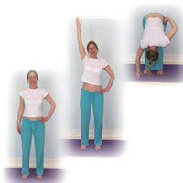
1. An interesting variation is to lift and lower only one arm. This however needs to be taught only after students can work symmetrically. It can be very good for scoliosis where students work twice to the weaker side.
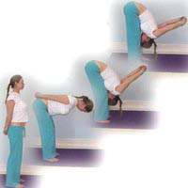
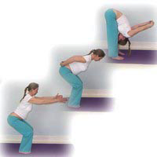
2.We can clasp hands behind us which helps to lift and lower the upper body with less effort.

3.We can also enter the pose from a different position such as to straighten legs from a low squat with arms around the legs or entering the pose from a squat position with arms overhead.
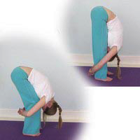
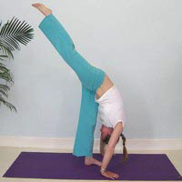
4. We can also alter the way of staying in the asana by placing hands in various positions. For instance, we can hold our wrist around the outside of legs, draw arms overhead, place palms under soles, or hold big toes.
5. There are many ways of developing the pose for those who require more intensity such as lowering down with hands in reverse namaste or by lifting into Eka Pada Uttanasana (one foot forward bend)

Exiting Posture
- i) Establish a stronger connection with the feet and legs, bending knees if wished, firming the muscles of the abdomen, then inhaling lift arms out to sides to shoulder height, opening the chest and lifting the upper body to the vertical position, and exhaling lower arms back down to sides
- ii) Inhaling sweeping arms forwards to sides of ears as lengthen spine & lift upper body to the vertical position as one unit, exhaling lowering arms to sides.

Counter pose
These should be gentle and not require their own preparation or counter pose

- Arms to ceiling in Tadasana, i.e., Urdhva Hastasana, raised arm pose
- Balasana, Apanasana

Key Benefits and Effects
Key benefits and effects must be referenced, if not factual.

- Quiets the mind
- Calms the systems of the body, especially the cardiovascular and nervous systems
- Floods the brain with blood providing a sense of calm and clarity
- Rejuvenates the spinal nerves
- Tonifies internal viscera, especially the liver, spleen and kidneys
- Stimulates the digestive system, eliminating gas, constipation & indigestion
- Lengthens hamstrings, tones back of legs
- Gives suppleness to the spine
- Alleviates menstrual pain

Bibliography/ References
Use the following format for your reference materials as given in your handout ‘Student Written Assessment Guidelines’:
For texts:
The author(s) name (date of publication including edition if not 1st), Title, Publishing House: City of Publication, page numbers
e.g. Stiles M. (2000) Structural Yoga Therapy, Weber: York Beach, p13
For websites (note must be a recognised authority):
Author if known (Date of publication if known) Title, (Type of media), Electronic address, date you accessed
e.g. Swami Jnaneshvara Bharati , Yoga Sutras of Patanjali: The 196 Sutras, (Online),
http://www.swamij.com/yoga-sutras-list.htm (accessed on 9 Oct 2012)
For journal or magazine articles:
The author(s) name (Year of Publication) Title of Article, Title of Journal/Magazine, additional info such as
the volume and issue number, page number(s)
e.g. Clark R. (2012) ‘Warm-Up and Mobilisation: Yoga Warm-ups’, Spectrum, Autumn 2012, pp. 15-19

Brown, Christine (2003) The Yoga Bible, Godsfield Press: Hampshire p310 to 311
Coulter, H. David (2001) Anatomy of Hatha Yoga, Body & Breath Inc: Honesdale,PA p240 to 247
Hately Aldous, Susie (2004) Anatomy and Asana, Eastland Press: Seattle p65 to 72
Kaminoff, Lesley (2007) Yoga Anatomy, Human Kinetics: Leeds p42 to p43
Kappemeir, Kathy Lee & Diane M. Ambrosini (2006) Instructing Hatha Yoga, Human Kinetics: USA p88 to 90
Lasater, Judith Hanson (2009) Yoga Body, Rodmell Press: Berkley p25, p26, p106
Long, Ray (2008) The Key Poses of Yoga, Bandha Yoga Publications p58 to 59
Saraswati, Swami Satyananda (1969) Asana, Pranayama, Mudra, Bandha, Bihar School:Munger p199 to 200
Schiffman, Erich (1996) Yoga: The Spirit and Practice of Moving into Stillness, Pocket Books: New York p107 to 117

Posture Profile: Notes for Guidance:

Diagrams may be used for explanation but must be correctly referenced.

When detailing ‘Muscle Action’, include what is stretching and contracting. When relevant consider eccentric and concentric muscle action when moving into and out of a pose.

When detailing ‘Limiting Factors’ consider muscle strength/flexibility, joints, body geometry.

Vulnerable Areas to include everyday yoga class issues: ‘Blood Pressure, Neck, Shoulders, Wrists, Lumbar, Knees, Hip Replacement, Pregnancy’. Not all will be applicable.

When ‘Teaching the Posture in Stages’ the stages act as modifications. Check each area of caution (included earlier) has a suitable stage which acts as a modification.

Props to be included where relevant under modifications for ‘Limiting Factors’, ‘Vulnerable Areas’ and ‘Stages’.

Remember that counterposes are simple and do not require their own preparation or counterpose.

Key benefits and effects must be referenced, if not factual.

All areas of the profile must be covered as relevant to the specific posture; some aspects will be more applicable than others, depending on the posture.

