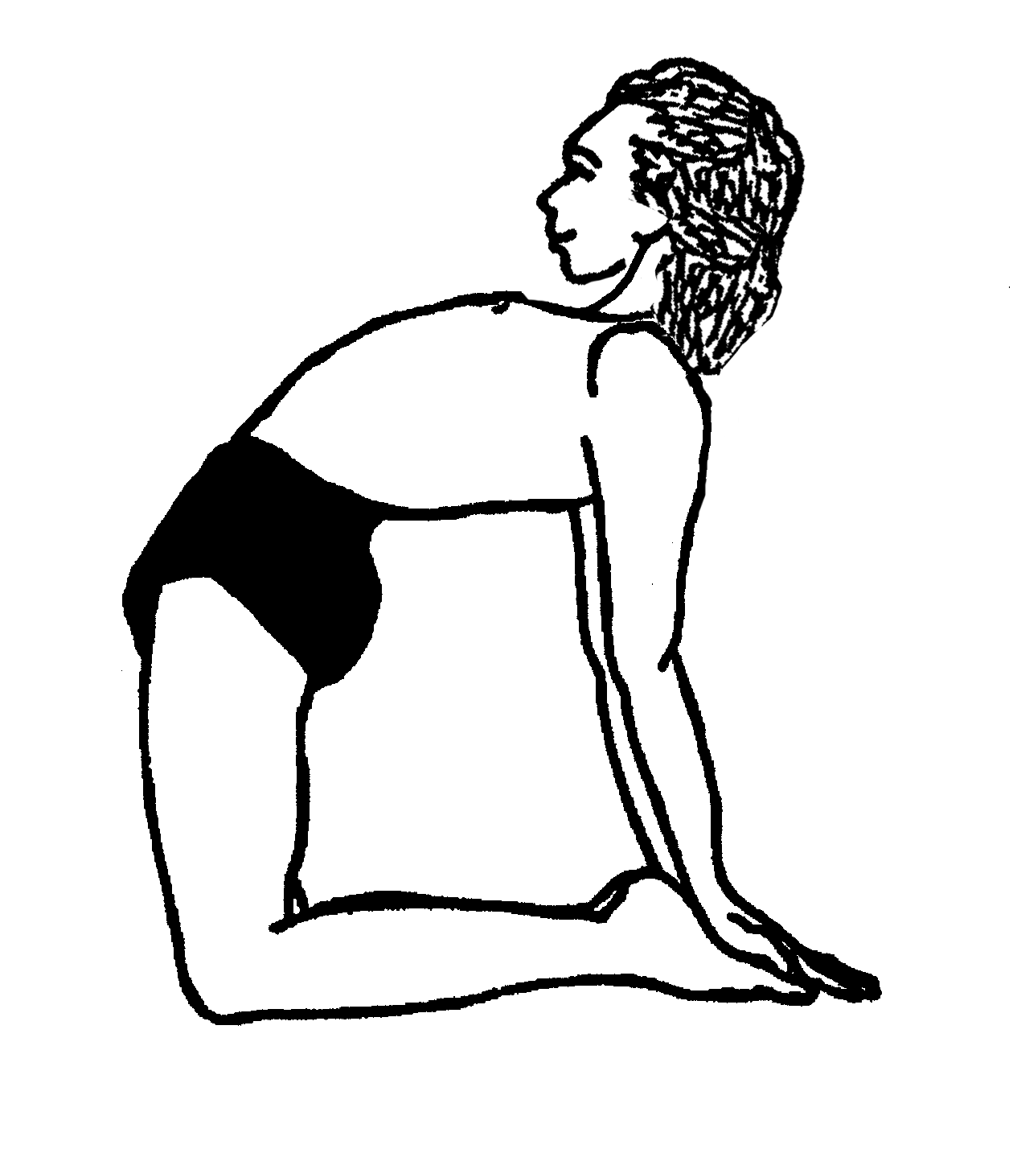
Ustrasana (Camel Pose)

As a backbend there are many benefits to be derived to include:

- Counteracting slumping and tendencies towards kyphosis
- Building strength in the muscles at the back of the body
- Stretching and strengthening muscles at the front of the body, in particular opening the pectorals and intercostals, promoting a freely moving ribcage
- Increasing our capacity to inhale, stretching the diaphragm
- Improving circulation by stimulating the heart and lungs
- Promoting good lymphatic drainage especially through stimulating the lymph nodes at the throat, armpits and groin
- Improving digestion by massaging and stimulating the digestive organs
- Increasing the flexibility of the spine, once the pose is released there is more space between the vertebral bodies
- Stimulating the lumbar and thoracic nerves so stimulating the sympathetic nervous system and if intense also possibly stimulating the flow of adrenalin from the kidneys & adrenals meaning it removes mental and physical lethargy
- Removing a sense of vulnerability so increasing confidence
- Backbends are extroverting and energizing

Esoterically backbends:
Increase prana vayu (open chest), increase vyana vayu (heart/lungs better cirulate to periphery of body), increases samana vayu (promote digestion)
Stimulate anahata chakra (heart) increasing capacity for love & compassion, stimulate manipura (navel) increasing personal power, confidence and courage and stimulate vishuddhi (throat) increasing capacity for self-expression and communication.

1) Which vulnerable areas are contained within this asana?
Knees, low back and neck are potentially vulnerable so we must ask students to be especially aware that these areas are comfortable and make adjustments as needed

2)Which principles of backbending do we need do we need to give in our teaching points for this asana?
Whilst we can differ in the way we give our teaching points they must cover:

- Extend throughout the entire spine, reaching outwards and upwards
- Distribute the curve evenly along the whole spine
- Initiate the backbend by lengthening and lifting the thoracic area of the spine, drawing shoulderblades down and against back, engaging abdominals and lifting the sternum, maintaining the depth of the backbend according to the extent of the thoracic movement. This ensures we do not jam the spine at the hypermobile joints of C7-T1, T12-L1 and L5-S1
- Press down into the ground with knees and hands, lifting upwards (rebound effect)
- Place knees hip width apart
- Perform a slight medial/internal rotation of the legs to engage the adductors
- Press hips forwards and chest upwards, keeping thighs vertical
- Can adopt mula bandha and/or keep the tailbone towards the floor to keep the lower back open
- Turn fingers to point to toes to maintain external rotation of the arms at shoulders
- Keep hyoid bone gently lifted and tucked in to engage muscles at front of body, so at first keep neck in neutral. Later as head drops then keep extension in neck muscles, lifting chin
- Lengthen on the inhalation and open on the exhalation
- Keep the face relaxed!

3) Good preparation?
Movements to promote good external rotation of the shoulders
Movements to open the chest muscles i.e pectorals
Movements to give extension of legs at hip i.e. using hip extensors gluteus maximus and hamstrings, opening the hip flexors i.e. primarily the iliopsoas, rectus femoris
Other simpler backbends done just prior without counterpose
Simple poses to teach some of the teaching points ahead of time

4) Possible counterposes?
Gentle twists
Forward bends, especially adho mukha svanasana, down facing dog, especially those which stretch out the legs again
Neutral quiet poses

5) Contraindications?
Caution for:
Unmedicated high blood pressure & heart problems – do not work too strenuously, do not stay
Neck problems – keep neck in neutral
Low back condition: softer modification if needed e.g. hands at low back, on chair seat or blocks
First days of menstruation – may need softer backbend
Knee problems: padding under knees, along shins or work seated/standing
Pregnancy, Osteoporosis, Recent abdominal surgery, Inflammatory abdominal conditions e.g. colitis, ulcers etc.,Spondylosis (degeneration/thinning of discs and facet joints) in low back, Spinal injuries, operations: can take softer modification i.e. hands at hips, on chair or blocks, focus on opening chest and shoulders

6) Possible modifications, variations and developments

To modify: hands to hips
hands to tall blocks
hands to chair seat
backbend from dandasana or on chair seat

Avoid placing asymmetrical pressure on spine by lifting one arm up and one hand to foot
To vary: start from below, lifting hips, then placing hands to heels into full pose work with hips touching a wall to emphasize drawing hips forwards

To develop: arms overhead against a wall or lower head
Palms along soles of foot

© S Beck 2013

