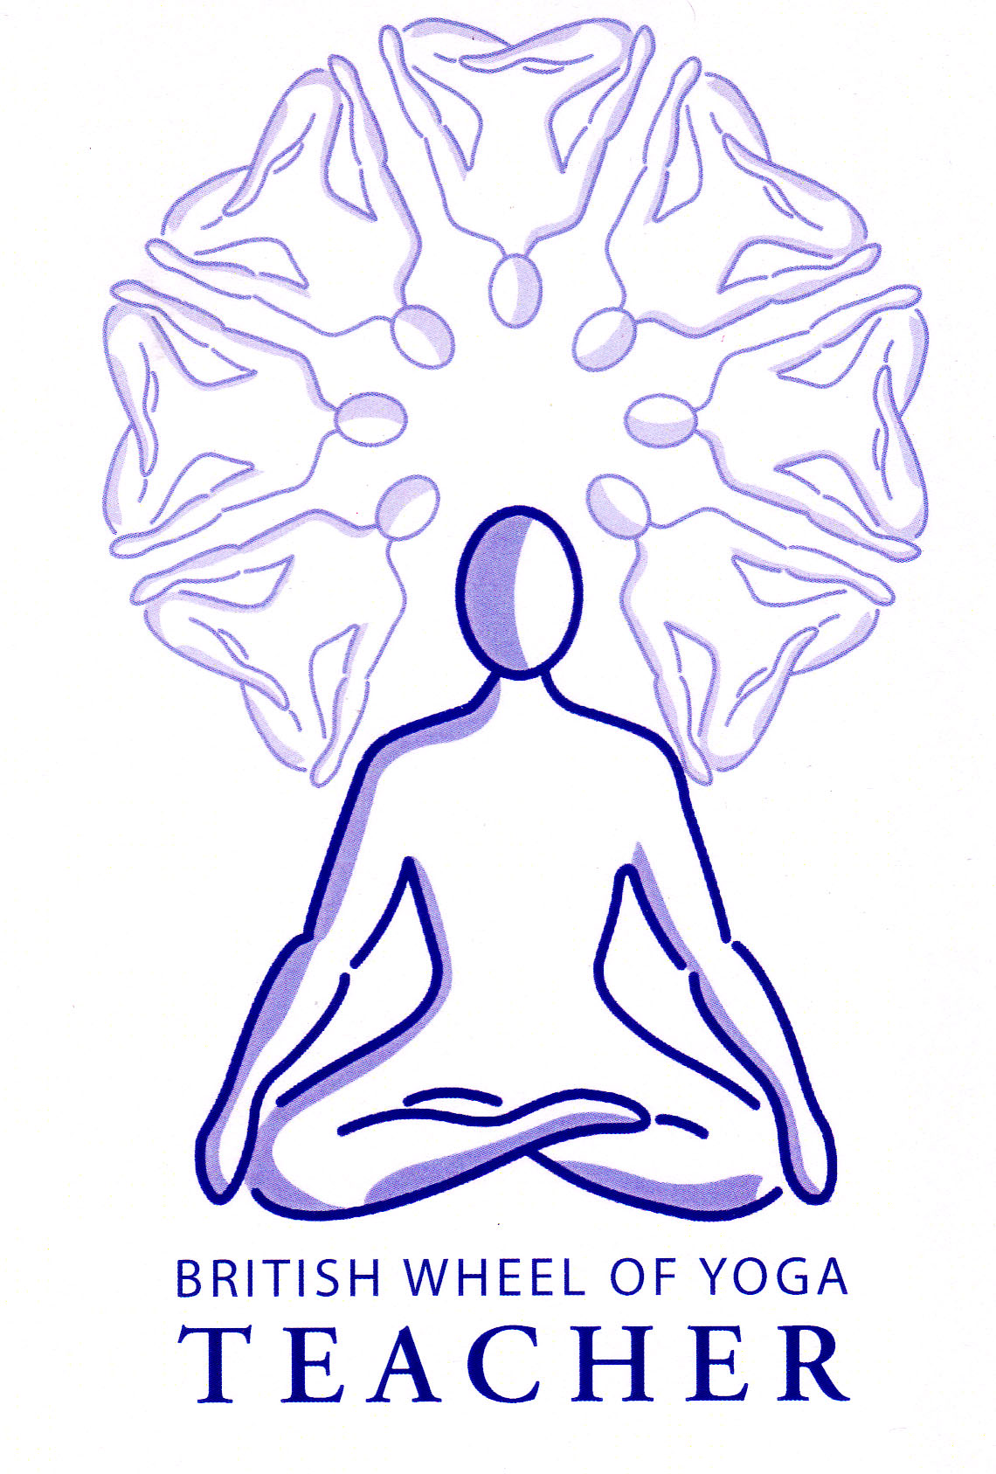
Dirga Swarsam (‘Deerga’) Yogic Breath, ‘The complete Yogic Breath’
This is the breath which is usually taught first to students and lays the foundation for all breath work. ‘Dirga’ translates as ‘slow’, ‘deep’, ‘long’, or ‘complete’ and ‘swarsam’ as ‘breath’. It is also known as ‘the three-part breath’ where the ‘three parts’ are the abdomen, diaphragm, and chest. Within this breath the lungs are completely filled on the inhale and reversing the flow, air is completely released on the exhale.
Benefits: Breathing more completely has countless benefits for us such revitalizing the entire body with prana (i.e. the essential life force). It benefits the vital organs, which can easily become stagnant, constricted, or fraught with emotional and physical tension. The complete breath refreshes the mind, and activates the parasympathetic nervous system, encouraging a calmer, more balanced state of being overall. Significantly it also helps to correct unhealthy breathing patterns.
This technique can be engaged at any time, but it is especially beneficial when practiced intently for five to fifteen minutes every day—preferably on an empty stomach. It is also very useful as the initial technique for our daily practice, helping us to settle and connect with the breath prior to asana.
“Prana and mind are intricately linked. Fluctuation of one means fluctuation of the other. When either the mind or prana become balanced the other is steadied.” Ch2 v2 Commentary from the Hatha Yoga Pradipika p150, Swami Muktibodhananda

Cautions: Please stop the practice if you feel any dizziness, and never strain the breath or try to breathe too deeply, keeping breathing easy and smooth at all times.

The Technique:
Take a comfortable semi-supine position, placing a block behind the head if this is more comfortable and it prevents the chin from lifting. Indeed, we can practice this breath in any pose where the spine is straight and the abdomen is free to move, although it is usually best to start in semi-supine and later practice seated in Sukhasana or in Supta Baddha Konasana, (Supine Cobbler Pose).
1. Gently close your eyes and take a few moments to settle. Scan down through your body, making sure it feels comfortable and relaxed, making adjustments if needed. If possible close your mouth and breathe only through your nostrils. Begin by simply observing the natural flow of your breath. Let go of any thoughts and allow yourself to arrive completely in the present moment just noticing the quality of the breath. As we progress through the complete breath remember to keep your breath smooth and easy throughout, practicing without any strain at all.
2. Now place hands over the abdomen and inhale slowly into your hands, allowing the breath to fill upwards towards the navel and exhaling feeling the belly gently fall; continue in this way your hands gently rising and falling as you breathe into the abdomen. Notice how the belly expands outwards in all direction, upwards, sideways and even backwards. Do this several times with ease….
3. Now placing the hands either side of the lower ribs, once the lower abdomen has filled completely, continue the inhalation by filling the mid-torso in a similar manner. Continue to draw the breath upwards, from the navel to the ribs, allowing the breath to gently expand the abdomen and then the ribs, then exhaling and releasing; each time your ribcage expands into your hands notice how it moves in all directions, forwards, sideways and even backwards, exhaling and releasing. Repeating several times breathing slowly, and as smoothly and easefully as you can….

4. Now placing hands lightly over the upper chest fingertips facing either side of the upper breast bone, as you continue to breathe slowly and easefully once the abdomen, then the ribcage feel full, complete the inhalation by drawing the breath into the upper chest, feeling the upper chest area lift and broaden slightly……, exhaling and releasing…. Repeat several times as smoothly as you can, this time focusing upon any sensations experienced at the upper chest….

5. And finally, drawing everything together now, observing the complete yogic breath, dirga swasam, where inhaling the abdomen swells, then the ribcage expands and finally the upper chest broadens, and exhaling release and relax. Focusing upon making this as smooth as possible, like a wave passing through the whole torso, one long continuous breath
Both the inhalation and the exhalation should feel fluid and continuous; at no point should either one cause any strain whatsoever. Keep in mind that it may take some time to develop a relaxed relationship with this type of breath work, especially if it is new to you; it is no accident that this is referred to as a practice. What’s important is the intention to develop our capacity for moving the breath intentionally, fluidly, and yet without tension or struggle.

6. After several rounds of Full Yogic Breath allow your breathing to return to normal for a minute or two before gently opening your eyes and bringing your practice to a close. Then, before you move on to your next activity, pause briefly to notice how you feel. Are you more refreshed, awake, and relaxed? How did your practice affect or benefit you today?

As you become more comfortable with the practice of the Full Yogic Breath, you can integrate this style of breathing more and more throughout your day-to-day activities.

Bibliography:
Muktibodhananda, Swami (3rd Ed. 2012) Hatha Yoga Pradipika, Yoga Publications Trust: Bihar

