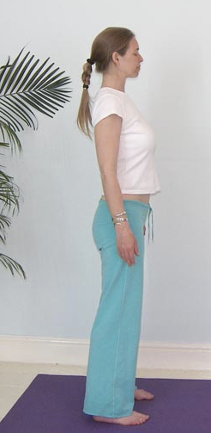*Pronounced taad-aah-su-nuh the word ‘tad’ means mountain in Sanskrit*

This pose is named mountain pose because it develops the feeling of absolute stillness and stability. It is the foundation posture for all standing poses and is often used at the start of a practice to direct our attention inwardly before we begin to move the body.

**Teaching Points:**

* Place feet hip width apart, arms to sides with palms slightly turned forwards to open the chest, check the inner edges of the feet point straight ahead and the toes are spread wide.
* Check the weight of the body is equally distributed within the feet, to accomplish this establish the foot lock, pada bandha where equal weight is placed between all four corners of the feet, beneath the big toes, little toes and the centre of the heels.
* Allow the legs to be straight but without locking the knees
* Gently check the position of the pelvis, creating a neutral pelvis, if necessary touching fingers lightly to the crease at top of legs, lifting and lowering the tailbone until the correct position is found, where there is medium intensity felt under finger tips.
* Lengthen your spine, lifting upwards through the crown of the head, as if a golden cord attached to the top of the head is drawing you upwards, as simultaneously release weight downwards.
* Allow the sternum to lift, feeling the upper region of the back move gently forwards helping the chest to expand, let there be more space between the pelvis and the ribcage with the abdominal muscles slightly contracted.
* Slide the shoulders down and back and feel a little energy down through the arms into the hands, hands facing slightly forwards or possibly facing towards the thighs.
* Keep the head aligned, chin parallel to the floor.
* Let the feet and the head move away from one another, creating a feeling of both being grounded but also buoyant
* Close eyes if possible or lower the gaze to 45º and breathe smoothly and easily, relaxing and feeling the body becoming more expansive inside.
* See if you can simply focus upon your gentle breath and be still like the mountain.

**Benefits:**

Aligns the body teaching good posture

Develops a refined sense of balance

Calms and concentrates the mind

Can be performed after practicing asana(s) to experience & assimilate the effects

**Contra-indications & possible modifications**

* For pregnancy may need to stand with feet wider apart
* With weakness or balance problems hold the back of a chair or stand with back to a wall
* For lordosis (excessive lumbar curve) carefully neutralize the pelvis dropping the tailbone towards the heels
* For kyhosis (excessive backwards thoracic curve) must carefully draw shoulders back opening the chest

**Adjustments**

It is best to teach tadasana verbally so students can make slight internal adjustments.

However we can place students against a wall, standing with heels a few inches from the wall, placing buttocks, shoulders and back of head against the wall. This helps if shoulders are rounded. Alternatively we can lightly place hands on the shoulders drawing them back and down if necessary

We can lightly place a hand at the back of the head lifting gently upwards to help lower the chin if a student cannot find the correct position for the head.

Remember never push or pull when physically adjusting, the placing of a hand is enough to awaken an area of the body.

© Sarah Beck May 2013