**Surya Namaskar ‘The Sun Salutation’**

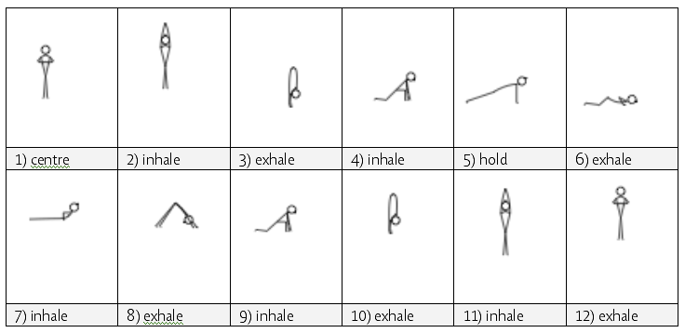

*With praying hands I face the sun, feeling love and joy in my heart.   
I stretch up my hands and let the sun fill me with warmth.   
I bow before the sun's radiance and place my face to the ground with humble respect.   
I lift my face to the sun and then remember, to achieve such heights I must be as the dust of the earth.   
I stretch up towards its light trying to reach the greatest heights and again surrender.   
I stand tall as I remember the true sun is within me.   
  
-- Ancient Verse, author unknown*

**Our relationship to the sun**

The sun has been worshiped by all ancient cultures as the source of all life, for without the sun there can be no light, heat, food or life as we experience it here upon the earth.

Esoterically, if all matter contains consciousness, as Vedic thinking believes, then the body of the sun is a magnificent being with a special relationship with the earth and all that lives upon it.

**“The Sun is the soul of the world.”**

– Rig Veda 1.115.1

The sun is a beautiful metaphor for the Consciousness or Pure Awareness within each of us, where on one level the sun is the light of our perception whereby our world comes in being.

This ‘inner sun’ has many names including, the Seer, Shakshin, Witness, Purusha, that which in yogic experience is beyond time and space, never changing, our eternal spirit or pure state of Being; that beyond thought. In vedanta this is sometimes called Sat-Chit-Anananda, the state of Being-Consciousness-Bliss.

* This is a sequence traditionally performed with the sunrise and sunset, the times of Brahma Muhartha
* Some authorities say it was traditionally performed with sound for up to 20 mins, performed to each direction 12 times making a total of 48 times, others that the ideal number of repetitions is 108!

There are a multitude of benefits to include:

* Synchronising breath and movement, harnessing the mind
* Stimulating nerve pathways and subtle pranic pathways & centres
* Stimulating the respiratory system
* Mobilising major joints and softening & toning major muscles, for instance:
  + Tadasana: balancing, stabilizing
  + Hasta Tadasana: lengthening whole body, mobilize shoulders
  + Uttanasana: stretching whole posterior body
  + Ashwa Sanchalasana: stretching hip flexors, quads
  + Kumbhakasana: strengthen arms, shoulder girdle, legs, core
  + Bhujangasana: strengthen erector spinae, stretching anterior body
  + Adho Mukha Svanasana: stretch posterior body, strengthen core, shoulders, arms

The sequence can be practiced in many ways, it can be a:

* warm up when suitable modifications are provided
* cardio-vascular workout when practiced dynamically with many repetitions
* way to calm energries, reducing vata when staying for a few breaths in the poses
* meditation on the breath to focus the mental energies
* practice with a mantra for focus and the benefits of the vibrational forces of mantra
* meditation when focusing upon different chakras
* prayer when performed with a bhavana of surrender or devotion………..

To teach the sequence we can:

1. Teach individual poses first
2. Teach transitions between different asana
3. Teach moving with breath in short sequences
4. Teach whole sequence
5. Teach whole sequence with breath
6. Teach whole sequence building up repetitions
7. Teach whole sequence with mantra
8. Teach whole sequence with chakra focus

**Potential modifications:**

Generally:

HBP/Heart conditions/Mature Diabetic: go slowly, rest as needed

LBP: go slowly between bases, take pauses as lift and lower as needed

*Hasta Tadasana to Uttanasana*

Less strength: lower arms out to sides

HBP/Heart conditions/Mature Diabetic: do not stay

*Uttanasana*

Back conditions/Sciatica/Tight hamstrings: bend knees

HBP/Heart conditions/Mature Diabetic: do not stay

*Ashwa Sanchalasana*

Knee problems: padding beneath knees

*Stepping into kumbhakasana (plank)*

Wrist conditions: knees to floor /wedge/fists

*Kumbhakasana through Asthanga Namaskara to Bhujangasana*

Back conditions/general weakness: to cat, or cat to sphinx, or cat to cobra

Wrist/shoulder conditions: as above

Abdominal conditions, pregnancy: as above to cat

*Adho Mukha Svanasana*

Sciatica/back conditions: bend knees if necessary

Wrist/shoulder conditions: can sit back into extended child’s pose

HBP/Heart conditions/Mature Diabetic: do not stay

*Adho Mukha Svanasana to Ashwa Sanchalasana*

General inflexibility: look up soon as can to create more room, can lift front hand closest to forward moving leg and step rear leg forwards with control

Knee problems: padding beneath knees

*Uttanasana*

Back conditions/Sciatica/Tight hamstrings: bend knees

HBP/Heart conditions/Mature Diabetic: do not stay

*Uttanasana to hasta tadasana*

Less strength: lift arms out to sides

**Consider:**

Which individual poses can be taught initially, with suitable modifications given as needed?

Which transitions can be explored, with suitable modifications given as needed?

Which asana or transitions can be developed?

