Stress & the Art of Relaxation

**Finding a definition of ‘stress’......**

Melissa Conrad Stoppler (Medicinenet.com 2018) states “Stress: In a medical or biological context [stress](https://www.medicinenet.com/stress/article.htm) is a physical, mental, or emotional factor that causes bodily or mental tension. Stresses can be external (from the environment, psychological, or social situations) or internal (illness, or from a medical procedure). Stress can initiate the ‘fight or flight’ response, a complex reaction of neurologic and endocrinologic systems.”

**‘Good and Bad’ Stress**

There are however two types of stress as coined by the endocrinologist Hans Selye in 1936 in his model ‘The General Adaptation Syndrome’. These are: -

Eustress = Positive Stress (from the Greek word ‘eu’ meaning good)

Distress = Negative Stress (from the Greek word ‘dis’ meaning bad)

This can be visually described using the human performance curve as shown below. This illustrates the Yerkes-Dodson Law stating that performance will increase with increased mental and physiological arousal (stress) until it reaches a point where level of stress become too high, becoming overwhelming, whereby performance lowers and fatigue, sickness and eventual burn out can follow.

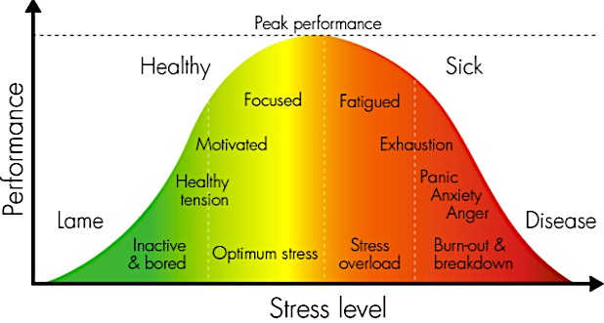

Image 1

So here we are being shown that we all require a certain amount of stress in order to feel happy and fulfilled, and this is known as ‘eustress’, as shown in yellow, being often referred to as creative stress. Then when we feel there is too much stress we move from being stretched to being strained, and into a state of distress, as shown by the orange and red colouring. Or to put it another way........

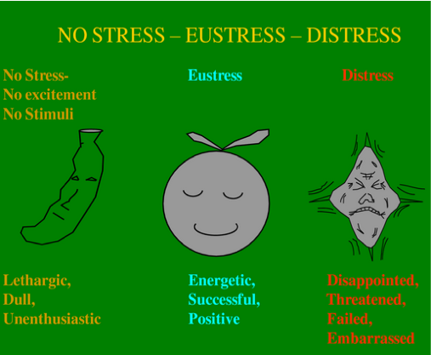

Image 2

Interestingly there is a relatively new term being cited where the phrase ‘Rust Out Stress Syndrome’ (ROSS) is being used to denote how it is also possible to create distress through understimulation where a person would like to more fully engage with the world but for some reason cannot. They can feel disengaged with work or personal life, feeling that their potential is not being realised. In this situation a person may also experience a high alert stress response that may become chronic. This is often set against situations where excessive pressure can lead to distress and a possible ‘Burn Out Stress Syndrome’ (BOSS) We can see these terms being discussed in many contemporary magazines and papers, and a good version can be found by Madanat Tripathy , a Human Resources Specialist at https://selfrejuvenation.wordpress.com/2015/05/29/rust-out-stress-syndrome-ross-managerial-disease-of-a-different-hue/

**The Stress Response**

When we move into a stress response the body begins to produce stress hormones such as Noradrenaline and the Sympathetic Branch of the Autonomic Nervous System will be activated creating what is commonly known as the ‘Fight or Flight Response’ where we are physically put on red alert so we are prepared for fighting or running away. [See the handout on the Autonomic System examining the activation of the Sympathetic branch]

However, it is significant to remember that in addition to our physical and energetic capacities to withstand situations this response will ultimately depend upon our own personality and our perspective of what is stressful and also how much stress we believe is good for us, so that the same situations will necessarily elicit a different response in different individuals. Oftentimes the measure of control we percieve ourselves to have is an important factor.

Note that we can also include the option of Freeze to the ‘Fight or Flight’ response where we shut down completely when there is seemingly no hope of fight or flight and in humans this is often seen as a response to overwhelming trauma; it can be connected to the way in which sometimes an animal who has been cornered freezes with a dropping of blood pressure and so forth so that when a predator loses interest in what does not seem to live prey the animal may have an opportunity for escape. No doubt this has saved humans from bear attacks, and enables gazelles to escape from attack from large cats with minimal injury once they appear lifeless. These days counsellors working with Post Traumatic Stress Disorder recognise this situation, seeing that it can also lead to flashbacks and small pieces of memory surfacing. (see more later on this)

Traditionally it was seen that to counteract the fight or fight response once the threat had passed the parasympathetic branch of the autonomic nervous system would be activated returning us to the ‘rest and digest’ response. [See the handout on the Autonomic System examining the activation of the Parasympathetic branch]

**New research: The Polyvagal Theory by Stephen Porges (1994)**

There has recently been a movement away from the traditional focus upon the twofold sympathetic and parasympathetic branches of the autonomic nervous system, which create the stress (fight or flight) response and relaxation (rest & digest) response respectively, towards a more refined threefold system where the parasympathetic branch i.e. the vagus nerve is divided into two distinct parts, the ventral and dorsal branches of the vagus nerve. [See the handout showing the vagus nerve] So now we have three distinct neural circuits where we have for the sympathetic aspect the spinal sympathetic chain, and for the parasympathetic aspect we have both the ventral branch of the vagus nerve and the dorsal branch of the vagus nerve.

Both branches of the vagus nerve start in the cranium, they do not travel downwards through the spine rather they travel down through different pathways traversing through the middle of the body, wandering through facial features, organs and connective tissues; the ventral and dorsal branches each possess different functions, giving an added dimension to the ANS. Very significantly, this threefold system is no longer simply related to the regulation of inner organs but also takes into account emotions and behaviour.

1)**Ventral branch of vagus nerve:** This is believed to be a later development in mammals which relates to positivity, joy, communication and connection to others. It is the capacity for immobilisation or relaxation allowing social engagement, a feeling of health and a vibrant energy where we are not under or overwhelmed. Activation of the ventral branch always requires a feeling of safety or security to be functional. (parasympathetic response 1)

2)**Spinal sympathetic chain**: Here a series of chain reactions helps to mobilise us to meet a challenging situation, which could be emotional, mental or a physical challenge. This can be a temporary positive enhancement of our performance when activated along with the ventral vagus nerve meaning we feel friendly and safe such as in a sporting context or can be a more heightened intense response to a situation which is creating fear or anger etc. (sympathetic - response eustress or distress respectively)

3)**Dorsal branch of vagus nerve:** As a more ancient response here immobilisation or relaxation when feeling safe and secure helped animals to conserve energy e.g. for hibernation, and for us this enables us to rest and recuperate, and when activated in connection with the ventral vagus nerve it enables a positive vulnerability where we can curl up with someone, hold or be held. Conversely, when we feel threatened and fearful and cannot fight or flee to avoid something for the short term, the dorsal branch of the vagus nerve comes online creating an immobilising response where we may shut down, withdraw, disassociate etc. from the situation. This latter circumstance is often referred to trauma. Sometimes persistent dorsal vagal activity can remain where a person finds they cannot disengage and activate either the spinal sympathetic chain of action or the social engagement of the ventral vagus nerve. This can be experienced as apathy, numbness, depression, anxiety, withdrawal, disassociation or shutdown. In this situation once we are able to access the spinal sympathetic chain we are able to access our energy and act, and once the ventral and dorsal vagus nerve becomes active again without any sense of fear we are able to find intimacy and close relationship with others again. (parasympathetic response 2)

**Faulty Neuroreception**

In polyvagal theory ‘neuroreception’ is a term coined by Stephen Porges which describes how our neural circuits determine whether a situation is safe. This is largely an on-going unconcious process where the ANS monitors incoming information from the environment and body. However, neuroreception can be faulty so that the link between perception and behaviour is inappropriate, making it difficult to distinquish what is actually safe, threatening or dangerous. Faulty neuroreception can occur due to a strong emotion such as anger, jealousy or even falling in love, a trauma, a physical feeling such as being tired or unwell, or having chemical altering substances such as medicines, drugs alcohol etc. within our system. For all of these reasons, and more, it is possible that a circumstance we encounter means we enter into a state of distress where we will need to rebalance our system, so that we need a flexible nervous system which is able to appropriately adapt to each situation.

**Types of Stressors**

According to Mark Greener (2003) of Which Magazine there are three types of stressor:

**i) Micro Stressors** – everyday hassles such as journey to work, queues at post office etc.

**ii) Mezzo Stressors** – life events such as moving house, having a baby, getting divorced, receiving an award - noticing some are ‘good’ but still create stress!

**iii) Macro Stressors** – socio-economic-poliitical circumstances affecting large groups such as war, tax changes, bad weather etc.

[See the handout: **The Levels of Stress caused by Life Events** where we can see many of the common stressors we may encounter]

**Moving through the stages from short term to long term chronic stress**

Based upon work by Dr Udapa (1977), there are four main stages as stress accumulates and leads to disease

**Stage 1**

**Psychological Stage**

Initially there are psychological changes such as irritation, anger, insomnia, weeping, anxiety etc. This stage may last from days to months and if we can address it now then we do not need to progress to the following stages. We can measure this stage chemically by the levels of acetylocholine found within the blood and if observant we can all recognize the psychological and emotional signs!

**Stage 2**

**Psychosomatic Stage**

Now distinct physical signs of stress manifest such as high blood pressure, elevated heart rate, tremours, palpitations etc. Here the homeostasis of the body is beginning to be effected.

**Stage 3**

**Somatic Stage**

If this state of hyper-arousal continues more profound physical or biochemical imbalances occur, symptoms are now more fixed and there may also be some organ dysfunction, although at this stage symptoms are likely to be still prodromal, i.e. non-disease specific. The sites of the physiological effects of stress are largely dependant upon genetic or environmental factors, usually moving into our most vulnerable areas. This stage can be measured by the levels of adrenalin, or noradrenaline in the blood.

**Stage 4**

**Organic Stage**

Disease fully settles into a particular organ. Now we are experiencing chronic problems and organ destruction can begin. We can find the signs and symptoms of a specific clinical condition eventually requiring medical intervention such as surgery or medication.

**What are the common signs & symptoms of stress?**

Note: A **symptom** is subjective i.e. from the person’s point of view whereas a **sign** is objective i.e. it can be seen or measured by another person.

[See the Handouts: **How Stressed Are You?** & **Where are You on the Burn Out Scale?** which provide a good summary of potential signs & symptoms of stress]

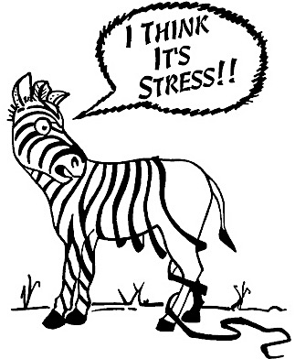

**Q From your own insight can you name some physical, emotional, energetic or behavourial signs/symptoms of stress, particularly relating this to your own patterns?**

Image 3

**Q Can you think of some of the long terms effects of chronic stress?**

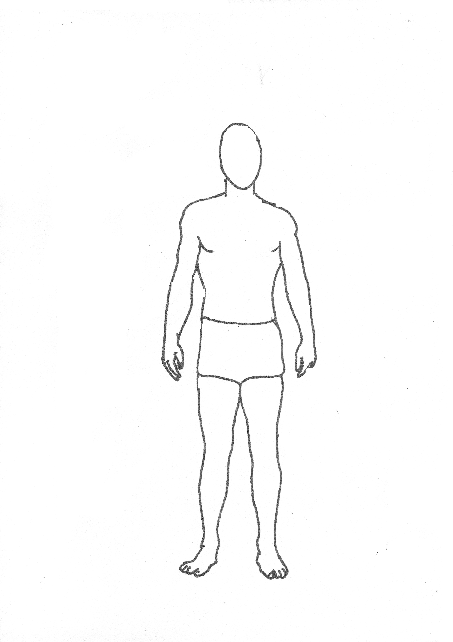

**How can we stop the stress cycle?**

When the Fight or Flight or Freeze response has been activated what can we do?

Conscious Response

Steps taken to counteract stress response

Maladaptive Coping Mechanisms e.g. alcohol, work

Chronic hyperarousal or hypoarousal continues

For instance:

* Alleviate pent up energy such as taking regular exercise e.g. yoga asana
* Change our perspective e.g. through a better understanding of a situation e.g. insight meditation
* Consciously create the space to sit with the emotions, feelings & sensations, creating a spaciousness around the experience giving us a choice of how to respond
* Directly initiate the Relaxation Response e.g. meditation, yoga relaxation technique

Unconscious Reaction

e.g. Supression, denial or confrontation

So, in Yoga we can utilise breathing techniques, relaxation techniques and meditation to enable us to consciously regulate our autonomic nervous system. To counteract stress this can be seen as evoking the relaxation response, a term which was coined by Herbert Bension in 1974, where we purposefullly activate the parasympathetic branch of the ANS. Or, more recently it could also be seen in terms of moving into vagal tone to return to a balanced state of self-regulation. It might also be possible to see this in terms of moving from tamas or rajas to a more sattvic state.

For more information on how breathing techniques can help us counteract stress see the information on the breath. Although it is worth mentioning here that breathing is one of the few ways we can directly affect the functioning of the ANS as whilst it is an automatic function there is also the potential for voluntary function.

Relaxation is a very significant part of yoga where we can learn to elict the relaxation response or re-establish vagal tone. There are many types of yoga relaxation techniques we can offer to include:

* Progressive neuro-muscular relaxation (PNR) i.e. squeeze & release
* Passive muscle relaxation i.e. imagining muscles are relaxed
* Autogenic i.e. using specific thoughts to relax body i.e. my body is warm & heavy....
* Journey e.g. creating a relaxing safe haven
* Visualisation: creating soothing, rejuvenating positive imagery
* Sensory relaxation e.g. through sound, colour  etc.
* Breathing relaxation e.g moving the breath, extending the exhale etc.
* Scanning the body i.e. taking attention to the body
* Yoga nidra: deep physical and mental release & planting of a positive sankalpa as a seed within the unconscious

Meditation is another excellent way to counteract the negative effects of stress.

**Q How does relaxation, conscious breathing and meditation reduce the negative efects of stress, with examples?**

**Q How might breathing and relaxation techniques need to be adapted for different individuals?**

Some ways we can find vagal tone:

* Exposure to cold
* Cold water on the face, stimulating facial nerves
* Deep slow breathing, where the exhalation is longer than the inhalation
* Singing, humming, chanting, stimulating vocal cords and muscles at back of throat
* Playfulness, especially if spontaneous, being creative and exploring the unknown, yet staying within realms of safety
* Meditation, staying present, witnessing
* Exercising, going with what feels good
* Massage
* Yoga asana
* Spending time in nature, synchronising with nature's rhythms
* Spending time with friends, laughing

**Bibliography:**

Conrad Stoppler, Melissa (2018) Stress (Online) Available at <https://www.medicinenet.com/stress/article.htm#stress_facts> (accessed 21.07.18)

Greener, M (2003), ‘The Which? Guide to Managing Stress’. Which? Consumer Guides.

Udupa, K.N., "Pathogenesis and Management of Stress Disorders", Quarterly Journal of Surgical Sciences, Banaras Hindu University, Vol. 13, no. 2, June 1977

Benson, H (1974) The Relaxation Response, Harper Collins Publishers: New York

Rosenberg, S (2017) Accessing the Healing Power of the Vagus Nerve, North Atlantic Books: Berkley CA

Images

Figure 1: <http://www.haleo.co.uk/wordpress/whats-stress-got-to-do-with-it/> (online: accessed 31.07.18)

Figure 2: <https://www.tes.com/lessons/dd7eKpMREh4HQg/understanding-stress> (online: accessed 31.07.18)

Figure 3: <https://www.ebay.com/itm/METAL-MAGNET-Zebra-Losing-Stripes-I-Think-Its-Stress-Humor-MAGNET-/302440769197> (online: accessed 31.07.18)

S Beck August 2021