For this inquiry you will need a straw and also any aids to help you maintain a comfortable seated position.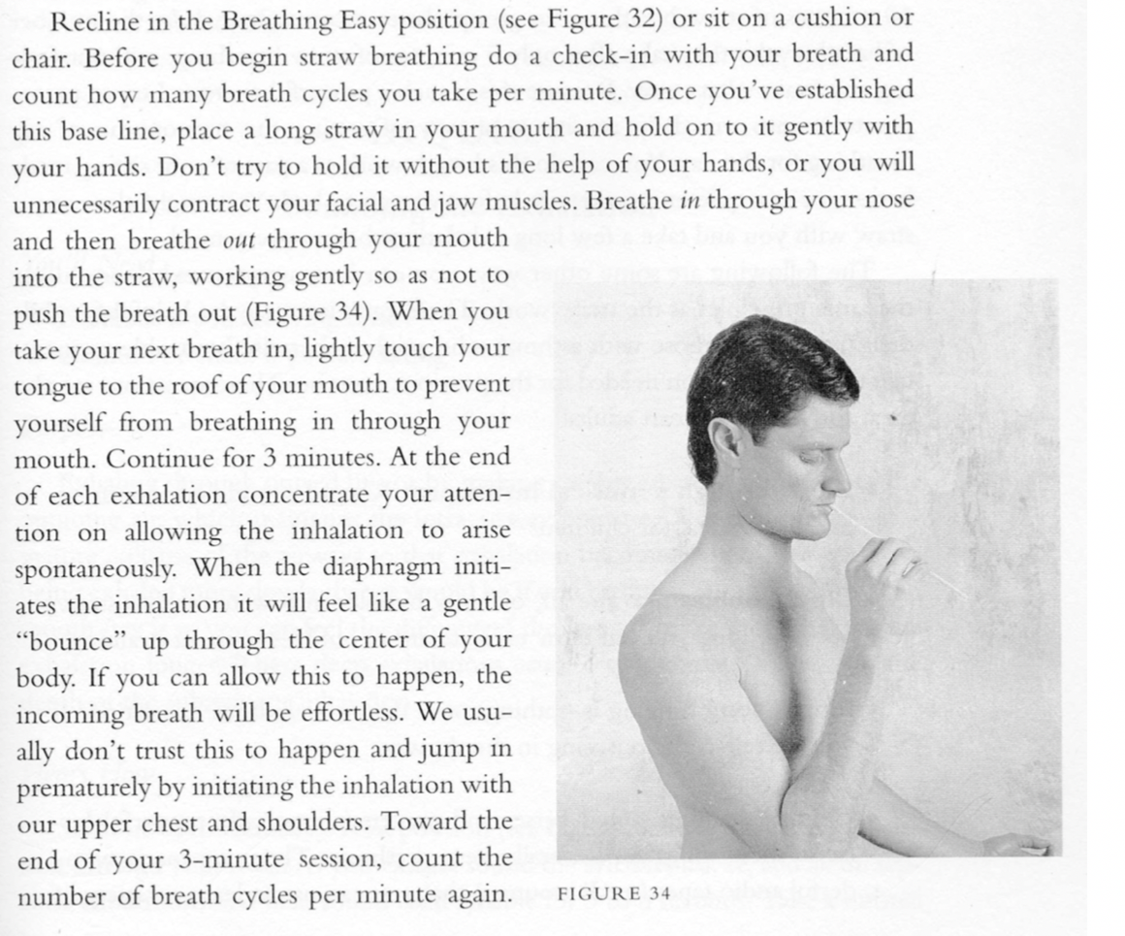

Cautions: Take care to remain relaxed throughout and if necessary, just stop and take a few natural breaths, resuming if possible

Benefits: This breath can dramatically lengthen the inhalation and exhalation, and the movement of the diaphragm can become much smoother and more complete. It can also calm the mind. It is particularly useful for those with asthma or any other lung disorder where there is difficulty exhaling fully. 