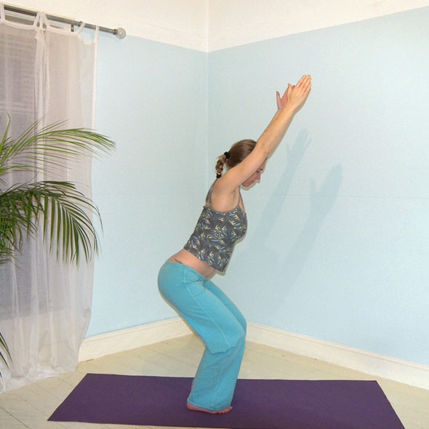**Utkatasana (Fierce Pose or Squat)**

# *Pronounced oot-kuht-aah-suh-nuh the word ‘utkat’ means ‘ fierce or powerful’ in Sanskrit.*

This pose is known as the fierce pose because it focuses upon the strength of the thigh muscles traditionally linked to the power of a warrior in Indian mythology.

**Teaching Points:**

* Stand in tadasana (mountain pose) with feet hip width apart or feet and ankles together, weight evenly distributed between the feet, pada bandha activated
* Inhaling, raise arms to the ceiling or to shoulder height, arms shoulder width apart, palms facing
* Engaging mula bandha
* Keeping shoulders down away from ears, shoulder blades tucked down and in towards the back.
* Exhaling bend knees keeping knees just behind the toes, folding forwards from the hips so the torso and arms are at 45º, the same angle as the shinbones.
* Check the pelvic tilt employed keeps the lower back comfortable, if there is compression or an excessive lumbar lordosis then increasing the posterior tilt, i.e. tucking tailbone under may help
* Keep the thighs parallel, avoiding twisting inwardly at the knees
* Keep the lower back long and open by stretching the tailbone & sits bones downwards, creating space between the ribcage and pelvis, reaching outwards through fingertips.
* Maintain length through the neck, only dropping the head backwards when the neck is comfortable to do so.
* Bend the knees just as deeply as there is absolute alignment and the work is challenging.
* To exit, inhaling straighten the legs as the arms lift up vertically and exhaling lower both arms to sides.

**Benefits:**

Strengthens thighs & arms

Releases ankles

Rehabilitates knees

Stimulates heart & diaphragm

Increases endurance

Gives energy

Creates feeling of being grounded

Increases sense of purposefulness

#### Good preparation

Shoulder and ankle mobilisers, shoulder and upper back strengtheners , thigh strengtheners

**Contra-indications & possible modifications**

* For heart conditions , high blood pressure & mature diabetic work dynamically or if static keep arms at shoulder height only.
* For knee problems ensure the student does not squat too deeply, focusing upon maintaining absolute alignment. Overtime strength with the thigh muscles will increase and it becomes possible to squat more deeply.
* For balance problems or pregnancy we can take feet wider apart or use a support such as a chair or wall where students can either place hands upon the support or position their backs to a wall. In late pregnancy do not squat too deeply.

#### Possible staging:

1) Squat with arms forwards at shoulder height (check alignments here)

2) Squat with arms flexed above the head

or

1) Dynamic lifting & lowering to arms at shoulder height

2) Dynamic lifting & lowering to arms fully flexed

3) Stay with arms either at shoulder height or fully flexed

#### Variations

*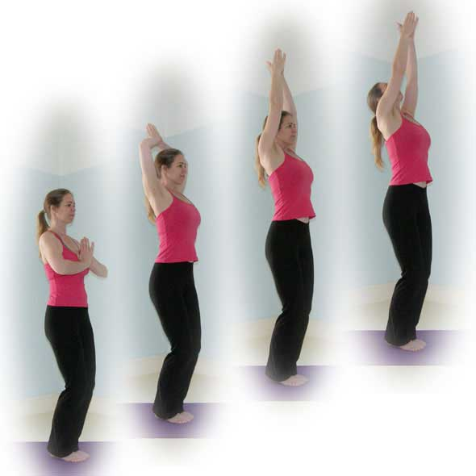****Ankle Squats***

We can work with the back vertical so essentially as we bend knees we can drop into the ankles placing hands into prayer position. This squat is good for all students and there is still strengthening of thighs and the development of balance. If students can work more deeply then we can position arms above the head, elbows wide, then to progress we can straighten arms, finally if applicable looking upwards. To exit we look fowards and inhaling straightening both legs as we reach upwards, exling lowering both arms.

***Squat to forward bend***

Another good variation is to perform squat then inhaling lift upwards as the legs straighten immediately folding forwards into uttanasana (standing forward bend). This works well as the squat engages the quadriceps and so releases the hamstrings preparing the body for the forward bend!

**Developments**

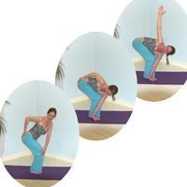***Kneeling twist***

Once in a kneeling position we can exhale twisting to the right, placing the right hand upon the right hip and the left hand upon the outside of the right knee. Shoulders should remain down away from ears, the chest open. To work more intensely we can slide the left hand down to the outside of the right foot, lifting the right arm vertically as you work shoulders back, chest open.

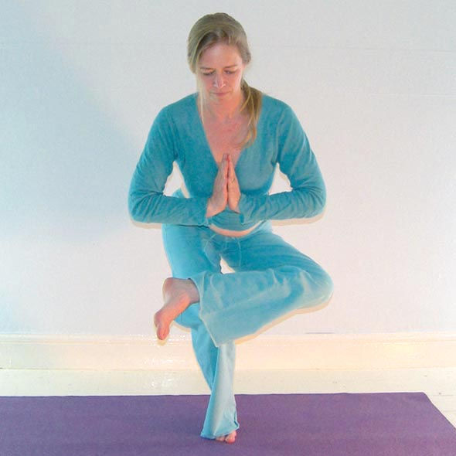***Half lotus squat***

If the hips are able to sufficiently externally rotate we can place the outside of the top ankle against the other thigh. We must be able to keep the standing leg knee stable and the lower back long, with the tailbone dropping down to the floor.

**Adjustments**

We need to ensure good alignment is maintained and if the knees have traveled inwards we can lightly tap just above the knees although verbal instruction may be preferable. We can also place hands lightly upon the shoulders if the shoulders have been raised. If toes are lifted can place hands on feet. We may also have to ask students to work less deeply if alignment has been lost.