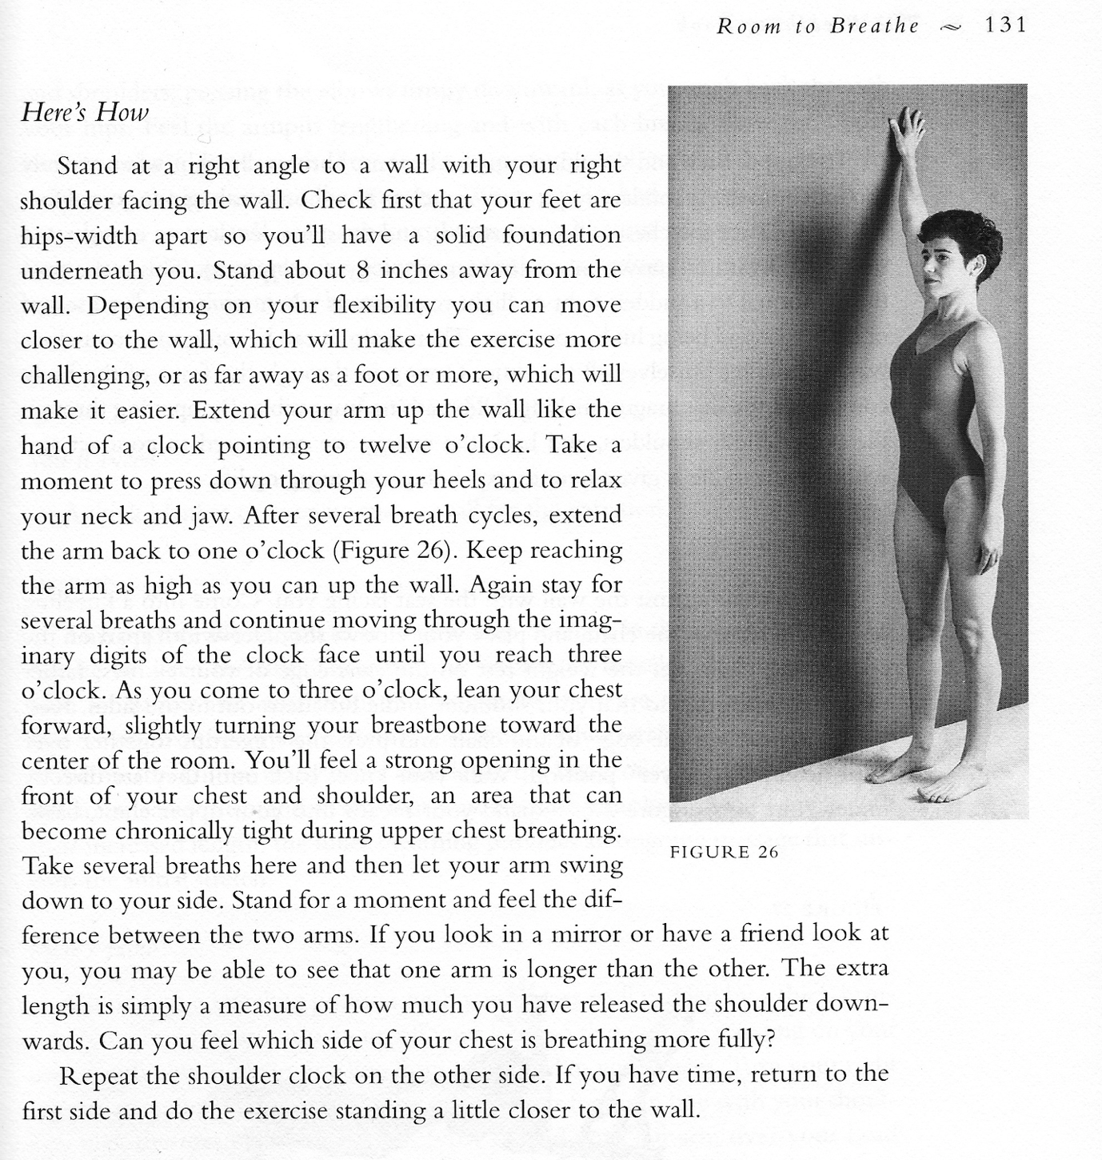

Cautions: care with shoulder injury

Benefits: The release of tension and constriction in upper chest and shoulders which can restrict breathing.