1)Why do we encourage students to place padding (folded yoga mats, blankets, blocks) beneath the upper back?

2)How do we know how large must the padding used must be?

3)What main teaching point(s) relate to the head and neck whilst in the pose?

4)What action(s) do the shoulders make and what is the alignment needed for the elbows?

5)Why do we ask students to bend their knees close into the body when exiting?

6)What guidance would we give to the following students who have: heart conditions, unmedicated HBP, medicated HBP if older than 30 years, mature diabetic?

7)Name other conditions for which the same advice is true?

8)What is reflexive hypotension, and which cautionary advice is useful?

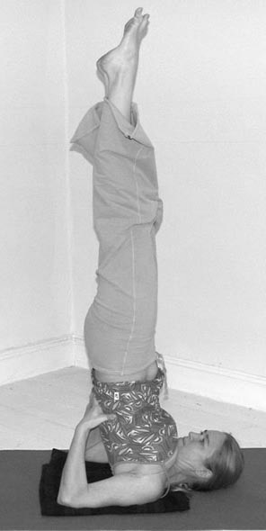

9)Is it true to say that because the pose is static where many muscles are activated to hold the pose, both systolic and diastolic blood pressure readings are increased meaning blood flow must be increased to force blood through the smallest capillaries?

10) Can pregnant students practice Salamba Sarvangasana?