**Salamba Sarvangasana (Supported Shoulderstand)**

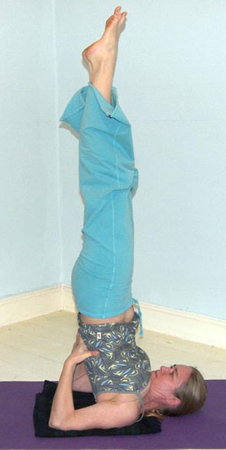

# *Pronounced saah-lum-buh sahr-vaahng-aah-suh-nuh, the word ‘sa’ means ‘with and ‘alamba’ means support, ‘sarv’ means ‘all' and ‘anga’ means 'limb' or 'member' so salamba sarvangasana translates as 'supported all members pose' in Sanskrit.*

The shoulderstand is the queen of all asana meaning it possesses very many benefits for the whole of the body, often being described as a panacea for all ailments! But it is also a pose requiring good preparation over time and has many associated contraindications.

The shoulderstand is simultaneously active and passive requiring whole body muscular effort to hold whilst we evoke the relaxation response.

**Teaching Points:**

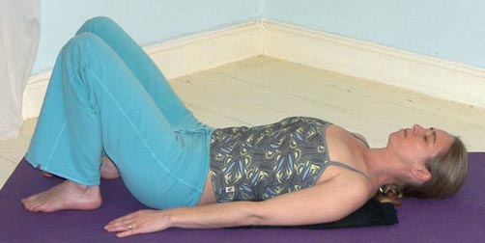

* Start in a semi-supine position with a folded blanket beneath the upper back, the top aligned with the top of the shoulders
* 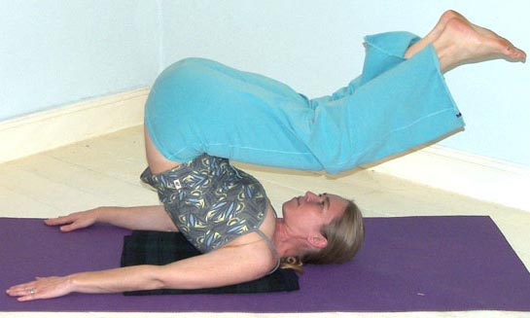When ready roll up onto the upper back using the momentum of your legs and your arms, by pressing the arms downwards against the floor.
* 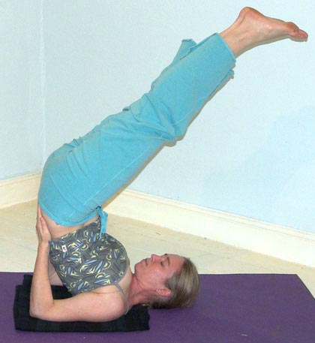Place hands either side of the lower back, thumbs pointing towards the belly and fingers pointing towards the buttocks. Gradually adjust the position if necessary drawing the elbows in line with the shoulders, opening the chest as the shoulders externally rotate.
* With legs angled at 45º this is ardha sarvangasana (half shoulderstand). We could stay here.
* 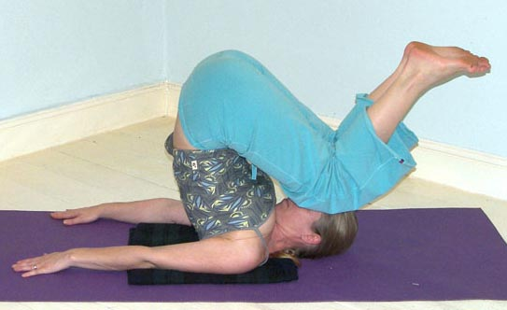If possible continue to straighten the torso, opening the chest and rotating shoulders backwards so the hips are positioned above the shoulders as the spine lifts upwards into a vertical position. Begin

to tuck the tailbone under as the hips are opened forwards, toes pointing upwards towards the ceiling. This is now the full shoulderstand sometimes known as the candlestand as shown above.

* To exit the pose bend the knees so the centre of gravity is low then straighten one arm along the ground then the other arm along the ground. Gradually curl the spine to the floor whilst pressing down with both arms and hands to curl down with absolute control.
* After releasing down take a few moments of stillness in a position which feels right, this could be savasana (corpse pose), supta baddha konasana (supine cobblers pose) or whatever feels the right thing to do.

**Drishti:** gaze towards the toes.

**Benefits:**

Promotes proper functioning of the thyroid and parathyroid glands and therefore the functioning of the hormonal system

Aids the venous return to the heart promoting the circulation of blood to the chest and head

Promotes the functioning of the parasympathetic nervous system so calming our mind and nervous system and releasing tension, being very good for all ailments where stress is a central factor

Increases the action of the bowels, so alleviating constipation and releasing toxins from the body

Reactivates the proper functioning of the abdominal organs

Assists in alleviating insomnia

Can be therapeutic for asthma and sinusitis

Can be therapeutic for infertility

Increases energy levels

Invigorates the brain

#### Good preparation

Abdominal and back strengtheners, shoulder and wrist mobilisers. Ideally students will be able to perform salamba setu bandhasana (supported bridge pose) where the neck is relaxed and does not touch the ground. This tells us a student is ready to perform shoulderstand, i.e. they are able to produce a firm foundation for the pose. In particular we need to develop strong abdominal and back strength so students can lift and lower with control.

**Cautions & possible modifications**

There are different contraindications given by various authorities and this may be a little confusing, especially when one authority states we must avoid the shoulderstand if we have a particular condition whereas another authority states the same pose will actually help that same condition. So as always we must note the available advice and then apply our knowledge and commonsense; in addition we must always teach our students to observe their reaction to a pose both during the asana and afterwards.

It is also very helpful to practice softer modified versions of the shoulderstand and over time make our way to the stronger versions of the shoulderstand, staying at first for a few seconds only then gradually building up the time spent. In this way we can monitor our responses to the pose.

This pose is prohibited if a student is suffers from:

* heart conditions or un-medicated high blood pressure
* severe eye conditions such as detached retina or glaucoma
* ear or nose problems
* an overactive thyroid
* un-medicated epilepsy
* severe kyphosis

Also avoid this pose if you are currently experiencing:

* migraine or headache
* high temperature
* flu or cold symptoms
* excessive gas or mucous
* pregnancy (unless very well practiced and able)
* menstruation

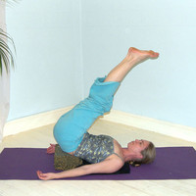

For any of these conditions we can adopt a version of **viparita karani** (reversed position pose) as shown opposite where a student lies supine and lifts the hips, sliding two blocks beneath the sacrum. The legs are then lifted one by one until they are straightened. This pose gives a soft inversion ideal for those for whom shoulderstand is contraindicated. If blocks are unavailable we can adopt the modification by lying supine and placing hands, palms facing downwards, beneath buttocks. Alternatively we can place legs up against a wall if a wall is available to be used.

We also need to take care if suffering from the following conditions:

* diabetes
* lower back conditions
* osteoporosis
* neck problems
* mild kyphosis
* wrist problems
* vertigo

For all of these conditions we must monitor how a student responds and they can if necessary adopt viparita karani as shown above or only stay within the pose for a few moments.

#### Simple versions and modifications

Viparita karani is great as a general modification giving the benefits of a partial inversion where the nervous system is rejuvenated, the back is relaxed and congestion in the legs is released

Ideally we will teach shoulderstand in a progressive manner:

1. Starting by working with salamba setu bandha (supported bridge) so a good foundation is established.
2. Then we can introduce virparita karni for everyone so students begin to experience partial inversions.
3. Now students can learn to lift the hips off the blocks from viparita karani into ardha sarvangasana (half shoulderstand) where the legs are positioned at 45º
4. Finally we can teach students how to lift safely into and out of ardha sarvangasana and at this point student can, if applicable, straighten legs vertically, drawing a straight line between shoulders, hips and ankles.
5. Once students can perform a well aligned and relaxed version of salamba sarvangasana then students can progress to practicing the developments.

Two useful modifications are:

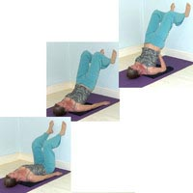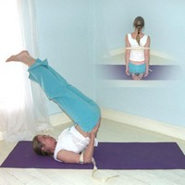

Placing a belt around the upper arms to keep the arms at shoulder width.

Performing a supported shoulderstand against a wall gives a good feeling if being inverted. Although we should avoid lifting away from the wall as this can cause injury. If we need to use the wall to lift then we are not ready to work into a support free shoulderstand!

Note: Please remember we should always treat this posture with respect particularly in relation to the safety of the neck.

**Developments & Variations**

There are many different developments we can practice.

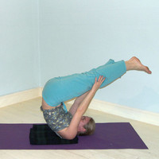***Pose of tranquility***

This is a very useful alternative to shoulderstand, especially for those who do not wish to place pressure upon the neck. Here we lift up as for half shoulderstand but then balancing upon the upper back we place hands to legs. This pose calms the mind.

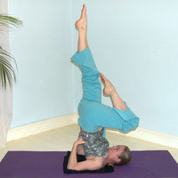

***One leg sarvangasana***

We can alternately lower one knee then the other, although this must be performed slowly so we do not disturb the neck.

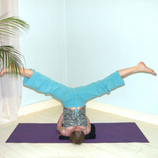***Spread leg sarvangasana***

We can move into spread leg shoulderstand, although we must ensure the back remains vertical with hips above shoulders.

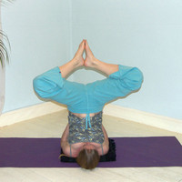***Cobbler sarvangasana***

We can bend knees and place soles together, keeping knees pointing upwards so the thighs are not parellel to the floor. As before we must ensure the back remains vertical with hips above shoulders.

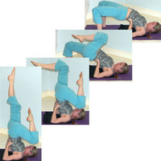

***Supported shoulderstand to supported bridge***

Here we can move into supported bridge by lowering one leg to the floor as the other is drawn inwards as a counterbalance. This movement requires flexible wrists and the ability to keep the hips raised as we lower into bridge. We must also be able to keep the elbows aligned with the shoulders, maintaining the lift of the chest. To exit ideally we lift back up to shoulderstand by drawing one knee inwards.

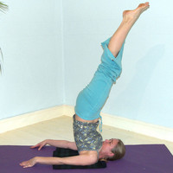***Nirlamba shoulderstand***

We can release the hands and move into unsupported shoulderstand where muscular effort maintains the posture. Here we endeavour to gradually straighten the legs, drawing ankles above hips, hips above shoulders. We can also hold arms along the body as opposed to along the ground.

**Adjustments**

Always check that students do not have a block or padding beneath the head, remember the padding is for the upper back and back of shoulders. Students need to prevent the chest from collapsing so ensure those students with a collapsed chest and rounded upper back are using modifications and have made use of the padding beneath the upper back and shoulders to help them to extend and straighten the back so hips are positioned above the shoulders. If students continue to work in this way then in the longer term it will compromise the neck. We can if necessary stand behind the legs, holding the legs with both hands, pressing one knee against the back gently straightening the back as the legs are lifted upwards; as always however we must never work forcefully and this option is only acceptable when a student is considered capable of moving into full candlestand!