**Salamba Sarvangasana (Supported Shoulderstand)**

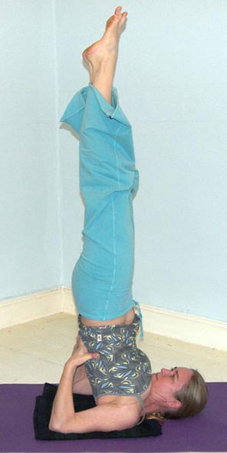

# *Pronounced saah-lum-buh sahr-vaahng-aah-suh-nuh, the word ‘sa’ means ‘with and ‘alamba’ means support, ‘sarv’ means ‘all' and ‘anga’ means 'limb' or 'member' so salamba sarvangasana translates as 'supported all members pose' in Sanskrit.*

The shoulderstand is the queen of all asana meaning it possesses very many benefits for the whole of the body, often being described as a panacea for all ailments! But it is also a pose requiring good preparation over time and has many associated cautions.

The shoulderstand is simultaneously active and passive requiring whole body muscular effort to hold (i.e. all members/limbs pose) whilst we evoke the relaxation response. At first we will find there is more effort required for the ‘stay’ then with practice this will decrease; this is a pose requiring both good strength & flexibility.

**Teaching Points:**

**Note: the use of Padding beneath the upper back and shoulders**

Before entering shoulderstand we must have taken the time to explore the use of padding beneath the upper back and shoulders. Here five blocks can be used or a folded blanket can work very well. Remember students must make the padding wide enough that both of the upper arms can be placed on the padding and also the padding is positioned along the along the top of the shoulders and does not extend under the neck or head. You will need to scan your group to ensure that no-one is using their padding as a pillow for the back of the head as this will actually increase the amount of flexion of the neck, causing more compression, rather than giving new space for the neck to be free!

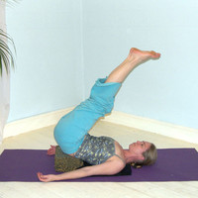**Stage 1: Viparita Karani (Reversed Position Pose)**

* From semi-supine place one or two blocks beneath the buttocks
* Straighten legs out to 45º, allowing the rest of the body to relax
* Here many of the benefits associated with having legs inverted will be gained e.g. the nervous system is rejuvenated, the back is relaxed and congestion in the legs is released
* Here there will be no pressure upon the upper back and cervical spine: Could stay here.

It is possible at first to see if we can lift up into half shoulderstand from this raised

position, although to do this we will need to have placed padding beneath the upper

back and shoulders to alleviate any adverse pressure upon the neck.

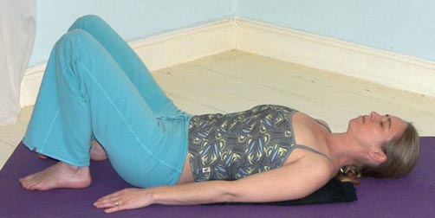**Stage 2: Ardha Sarvangasana (Half Shoulderstand)**

* Start in a semi-supine position with a folded blanket beneath the upper back, the top aligned with the top of the shoulders

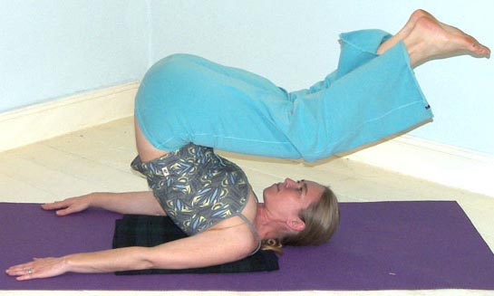

* When ready roll up on to the upper back using the momentum of your legs and your arms, by pressing the arms downwards against the floor. Keep both knees bent.
* 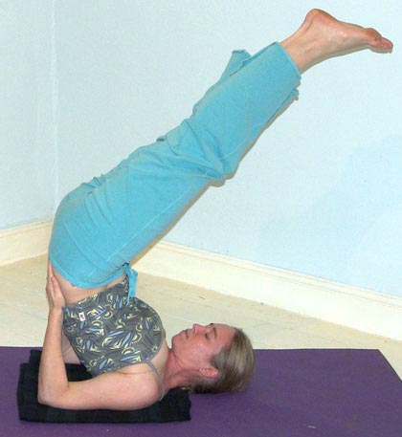Place hands either side of the lower back, thumbs pointing towards the belly and fingers pointing towards the buttocks. Gradually adjust the position drawing the elbows in line with the shoulders, opening the chest as the shoulders externally rotate.
* Keep the head & neck aligned resisting the temptation to look around
* With torso & legs angled at 45º this is Ardha Sarvangasana (Half Shoulderstand). We could stay here.



**Stage 3: Salamba Sarvangasana (Supported Shoulderstand)**

* If possible continue to straighten the torso by walking hands ‘up’ the back towards the ground
* Ensure the elbows remain aligned with shoulders, chest open, until the hips are positioned above the shoulders, feet pointing upwards, feet above hips
* This vertical position ideally has the spinal column fully extended and here check that the neck & head remain still and remain comfortable
* This is often known as the candlestand and here we can stay using our muscular effort to remain still whilst relaxing as much as we can

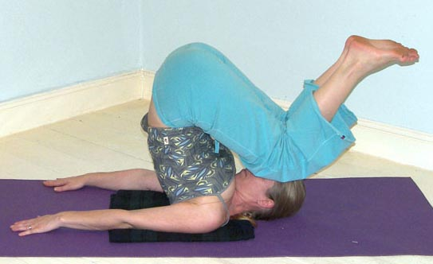

* **To exit the pose** bend the knees so the centre of gravity is low then straighten one arm along the ground then the other arm along the ground. Gradually curl the spine to the floor whilst pressing down with both arms and hands to curl down with absolute control.



* After releasing down take a few moments of stillness in a position which feels right, this could be Savasana (Corpse Pose), Supta Baddha Konasana (Supine Cobblers Pose) or whatever feels the right thing to do.

**Drishti:** gaze towards the toes.

**Preparation:**This pose requires good long term preparation to be done with real integrity and an increased sense of ease.

*Longer term preparation can include:*

* Developing flexibility of wrists
* Increasing ROM of external rotation of arms at shoulders, and opening of chest muscles
* Strengthening of muscles of the shoulder girdle especially the rhomboids which help to adduct the scapulae giving stability
* Strengthening of upper arm muscles, especially the triceps to stabilise the pose
* Strengthening of back muscles
* Strengthening of abdominal muscles

Ideally students will be able to perform Salamba Setu Bandhasana (Supported Bridge Pose) where the neck is relaxed and does not touch the ground. This tells us a student is ready to perform shoulderstand, i.e. they are able to produce a firm foundation for the pose.

**Benefits:**

* Promotes proper functioning of the thyroid and parathyroid glands and therefore the functioning of the hormonal system
* Aids the venous return to the heart promoting the circulation of blood to the chest and head
* Promotes the functioning of the parasympathetic nervous system so calming our mind and nervous system and releasing tension, being very good for all ailments where stress is a central factor
* Increases the action of the bowels, so alleviating constipation and releasing toxins from the body
* Reactivates the proper functioning of the abdominal organs
* Assists in alleviating insomnia
* Can be therapeutic for asthma and sinusitis
* Can be therapeutic for infertility
* Increases energy levels
* Invigorates the brain

**Cautions & possible modifications**

There are different cautions given by various authorities and this may be a little confusing, especially when one authority states we must avoid the shoulderstand if we have a particular condition whereas another authority states the same pose will actually help that condition. So as always we must note the available advice and then apply our knowledge and commonsense; in addition we must always teach our students to observe their reaction to a pose both during the asana and afterwards.

It is also very helpful to practice softer modified versions of the shoulderstand and over time make our way to the stronger versions of the shoulderstand, staying at first for a few seconds only then gradually building up the time spent. In this way we can monitor our responses to the pose.

This pose is prohibited if a student has:

* heart conditions, un-medicated HBP, medicated HBP if beyond 30 years, mature diabetic
* severe eye conditions such as detached retina or glaucoma
* ear or nose problems
* overactive thyroid
* un-medicated epilepsy
* severe kyphosis

Also avoid this pose if currently experiencing:

* migraine or headache
* high temperature
* flu or cold symptoms
* excessive gas or mucous
* pregnancy (unless very well practiced and able)
* heaviest days of menstruation

For any of these conditions we can adopt a version of **viparita karani** (reversed position pose) as shown above in stage one, if blocks are unavailable placing palms or fists beneath thighs can work well. Alternatively we can place legs up against a wall, if available. For pregnancy where lying supine is not possible, we can give a helpful alternative pose.

We also need to take care for the following conditions:

* diabetes
* lower back conditions
* osteoporosis
* neck problems
* mild kyphosis
* wrist problems
* vertigo

For all of these conditions we must monitor how a student responds and they can if necessary adopt viparita karani as shown above or only stay within the pose for a few moments.

#### Staging

Ideally we will teach shoulderstand in a progressive manner:

1. Starting by working with Salamba Setu Bandha (Supported Bridge) so a good foundation is established.
2. Then we can introduce Viparita Karani for everyone so students begin to experience partial inversions.
3. Introduce the use of padding beneath upper back and shoulders
4. Now students can learn to lift the hips off the blocks from viparita karani into Ardha Sarvangasana (half shoulderstand) where the legs are positioned at 45º
5. Finally we can teach students how to lift safely into and out of Ardha Sarvangasana and at this point student can, if applicable, straighten legs vertically, drawing a straight line between shoulders, hips and ankles.
6. Once students can perform a well aligned and relaxed version of Salamba Sarvangasana then students can progress to practicing the developments.

**Two useful modifications are:**

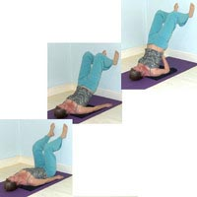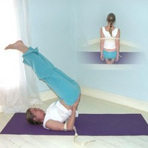

Placing a belt around the upper arms to keep the arms at shoulder width.

Performing a supported shoulderstand against a wall gives a good feeling if being inverted. Although **we should avoid lifting away from the wall as this can cause injury.** If we need to use the wall to lift then we are not ready to work into a support free shoulderstand!

**Variations & Developments**

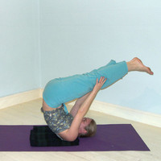There are many different variations and developments we can practice.

***Pose of tranquility***This is a very useful alternative to shoulderstand, especially for those who do not wish to place pressure upon the neck. Here we lift up as for half shoulderstand but then balancing upon the upper back we place hands to legs. This pose calms the mind.

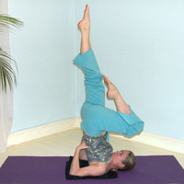

***One leg sarvangasana***

We can alternately lower one knee then the other, although this must be performed slowly so we do not disturb the neck, especially by placing unequal asymmetrical pressure on the cervical spine

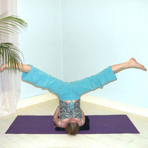

***Spread leg sarvangasana***

We can move into spread leg shoulderstand, although we must ensure the back remains vertical with hips above shoulders.

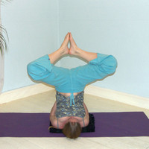

***Cobbler sarvangasana***

We can bend knees and place soles together, keeping knees pointing upwards so the thighs are not parellel to the floor. As before we must ensure the back remains vertical with hips above shoulders.

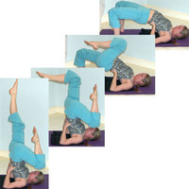***Supported shoulderstand to supported bridge***

Here we can move into supported bridge by lowering one leg to the floor as the other is drawn inwards as a counterbalance. This movement requires flexible wrists and the ability to keep the hips raised as we lower into bridge. We must also be able to keep the elbows aligned with the shoulders, maintaining the lift of the chest. To exit ideally we lift back up to shoulderstand by drawing one knee inwards.

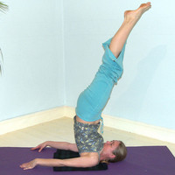

***Nirlamba shoulderstand***

We can release the hands and move into unsupported shoulderstand where muscular effort maintains the posture. Here we endeavour to gradually straighten the legs, drawing ankles above hips, hips above shoulders. We can also hold arms along the body as opposed to along the ground.

**Adjustments**

Always check that students do not have a block or padding beneath the head, remember the padding is for the upper back and back of shoulders. It is certainly worth scanning the whole group to check.

Also check that students do not have elbows splayed, if so then verbally instruct them to draw them in to align with the shoulders and where this is not possible and if asked there is weight upon the upper shoulders and neck then return to stage 1.

Some teachers use physical adjustments but this needs great care because we can inadvertently put more body weight upon the upper back, shoulders and even the neck.

We can, if confident, stand behind the legs, holding the legs with both hands, pressing one knee against the back gently straightening the back as the legs are lifted upwards; as always however we must never work forcefully and this option is only acceptable when a student is considered capable of moving into full candlestand!

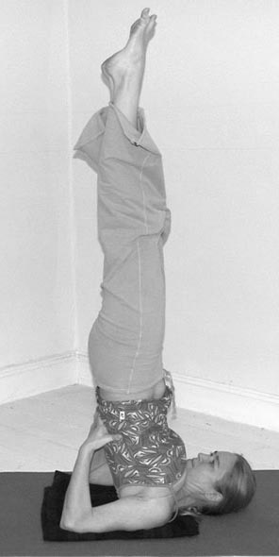

© Sarah Beck August 2021