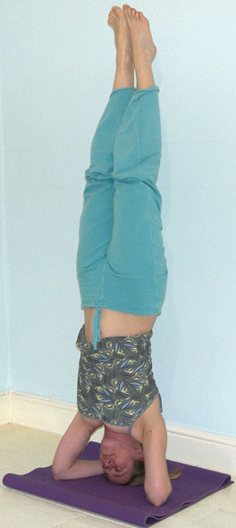**Salamba Sirsasana (Headstand)**

# *The word salamba means supported and sirsa means head in Sanskrit.*

The headstand is known as the king of all asana as the benefits are many however it also requires long preparation. We must also be sure to take account of the contraindications of which there are quite a few. The teaching points will take you step by step into the full pose although of course we can stay at any stage if necessary. At first it is preferable to work with the wall behind so whilst the wall is not supporting the body it is there to instill confidence.

**Note:**

To teach headstand we must check there is enough space between students and inform them if they do fall then the best thing is to tuck the chin in to the chest and relax. The headstand requires suitable padding that is wide enough to pad the arms so a yoga mat folded three times works very well.

**Teaching Points:**

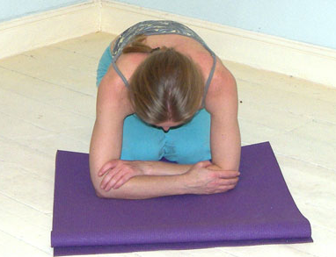

1) Begin by positioning the arms correctly. To do so adopt a kneeling position and hold elbows with opposite hands to measure the correct placement of the elbows at shoulder distance apart.

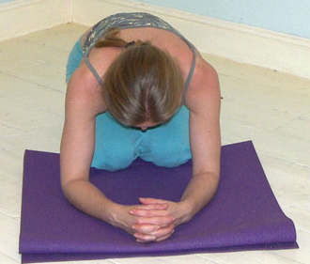

2) Now keeping elbows as they are, clasp hands together, as if holding a small ball, to create a firm support. Check there is symmetry.

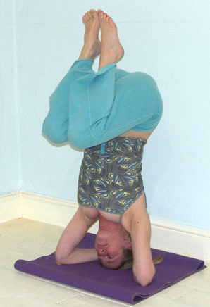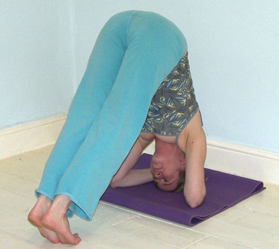3) Place the head in one of two possible positions. The head can be placed so the crown is down against the floor, back of head in hands or we can place the head an inch or so in front of the crown. The second placement is sometimes used because it is harder to tip over backwards. Once the head is placed walk the feet towards the head attempting to align the hips directly above the shoulders. If this is not yet possible we stay working here in a partial inversion. Note that the effort here is largely in the shoulders and arms where we press down into the floor with the arms and lifting the shoulders away from the floor. This releases most if not all of the pressure upon the head and neck!

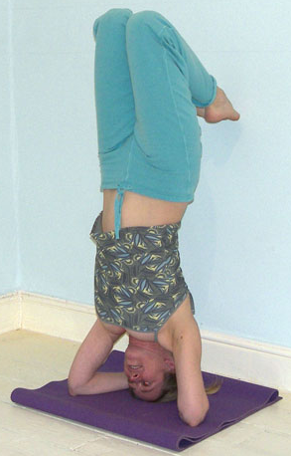4) Once the hips are aligned above the shoulders and we are on tip-toes magically the legs will want to lift of their own accord. Initially keep knees bent thighs parallel to the floor. Keep pressing down into the floor lifting shoulders away from ears. Ideally students will continue to work at this stage until they are able to take around 6 breaths here with ease.

5) Now we can draw the hips open, as we straighten thighs vertically.



6) Finally we can straighten both legs pointing toes up to the ceiling

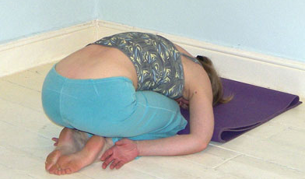7) We must exit the pose as we lifted by coming down in stages.

8) Having released from the pose we must rest in balasana (child’s pose) for at least the same time as we spent in the posture.

**Caution:**

We must avoid compressing the neck so students must check the back of the head is nestled in the curve of the hands where the weight of the body can be directly dropped down without bending or twisting the neck – remember the pressure upon the head and neck is alleviated by lifting shoulders away from ears but we must still find proper alignment. Also as we move through the stages entering and exiting the pose we must ensure the weight remains distributed evenly along the forearms, wrists and hands.

We must discourage students from using momentum to lift up into headstand because by kicking up there is no real control and it can easily lead to instability. It is much preferable to learn to lift and lower using core strength and in this way the body becomes lighter and stronger as will the mind!

Teaching this pose to a mixed ability class may be difficult as students will often want to lift up before their body is capable of it so it is always good to lead students into the first stage where they are learning to raise hips above shoulders and ask them to stay there unless the legs are naturally lifting in which case they can continue into the pose. It is important to thoroughly demonstrate the whole pose, including the lift, stay and the exit. You will certainly need to be in charge when teaching this pose!

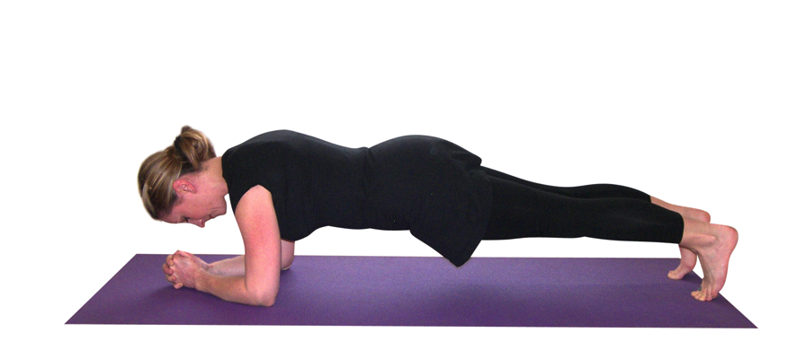

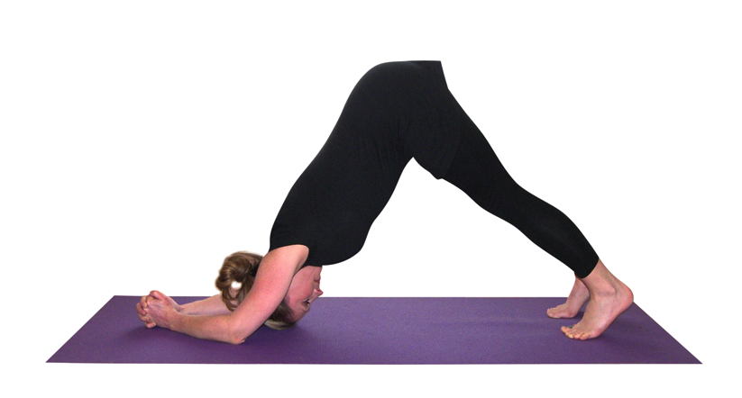Students who should not be performing this pose will need to be given an alternative, here another inversion such as shoulderstand or a simpler inversion may be possible such as viparita karani or alternatively adho mukha svanasana (down facing dog). The dolphin pose as shown here works well as an option because it helps weaker students develop strength in the arms and shoulder.

Often when teaching headstand it is best to divide the class into those who still need to work with shoulderstand or a modification of it and those who are already comfortable in shoulderstand who can now be led into headstand. Remember to work well with asana you will certainly need to offer guidance to your students but one of the most important and challenging aspects of teaching will be instilling right attitude in your students!

**Benefits:**

* Aids brain function
* Increase blood supply to head increasing mental clarity and sensory acuity
* Improves memory
* Helps the regulatory function of the pituitary gland and hypothalamus
* Can alleviate menopausal symptoms
* Stimulates the major marma points upon the head
* Increases exchange of nutrients and waste between capillaries and cells in the lower body
* Assists the venous return to the heart
* Assists the movement of lymph
* Assists digestion
* Releases pressure upon spinal discs
* Develops good posture
* Strengthens arms and shoulders
* Promotes good use of diaphragm and abdominal breathing as the diaphragm as it has to push against the abdominal organs to inhale
* Improves tidal breathing as less residual air is left in the lungs
* Develops concentration
* Increases energy levels & stamina
* Develops confidence
* Gives us a new perspective on the world – helping to change longstanding habits

Note: many of these benefits will be achieved when students have learnt to relax within this posture which of course may take a little practice.

#### Good preparation

Shoulder and arm strengtheners, simpler inversions, hamstring and adductor stretches, abdominal and back strengtheners.

To successfully work with headstand takes long preparation. Note that good hamstring and adductor length is required to be able to lift and lower legs from a stable upper body position otherwise the back will become rounded just as for all forward bends!

**Contra-indications & possible modifications**

* This pose is prohibited for:
  + For heart conditions and high blood pressure
  + For eye problems, epilepsy and headaches
  + For severe cervical degeneration or neck problems
  + For severe spinal degeneration in lumbar region
* For general back conditions and sciatica work very cautiously and this pose may be prohibited if it creates any sense of discomfort
* For low blood pressure work very slowly through the stages
* For shoulder injury or stiffness this pose may be prohibited or it may be possible to work with the first stage where the feet stay to the floor
* For menstruation this pose is best omitted for the first three days
* For bone weakness, asthma, anxiety, sinusitis take care

#### Simple versions and modifications

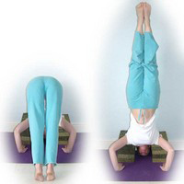

***Blocks beneath shoulders***

A nice option to familiarize students with the feeling of the headstand without the head in hands is to place around 5 blocks in two stacks at shoulder width, close to a wall. Students can lift into headstand from here without placing any pressure upon the top of head. This does however still require good abdominal strength!

***Placing a belt around upper arms***

We can help stabilize the pose by keeping the correct shoulder width using a belt. However students ideally need to strengthen and release shoulder joints and should not rely on this option in the long term.

***Standing behind a student***

As students progress and can work within the room rather than near a wall an intermediary option is to stand behind a student and place your hip or knee to the back, perhaps supporting the legs with hands. This can help to keep the back straight and give the necessary confidence.

**Developments & Variations**

***Lifting and lowering with straight legs***

Once students can work with ease with raising bent legs they can simply lift and lower with straight legs. This does of course require much greater strength.

***Different leg placements***

Once students are comfortable working within the pose they can then adopt different leg positions. For instance it is possible to place soles together as for baddha konasana (cobbler pose), cross legs into padmasana (lotus pose) or the legs can be wound together as for garudasana (eagle pose).

**Note**: in the past a tripod version of headstand was often taught where the head was placed directly to the floor with hands placed in front of the shoulders at the distance of the upper arms. But this has more recently been prohibited as the neck is much more vulnerable and this version does not rely so much upon muscular effort because students often were able to place their knees upon their upper arms meaning students did not possess enough strength to lift with control. It is best not to teach this version!

**Adjustments**

Check that elbows are indeed shoulder width apart, if necessary ask all students to place the arms and scan the room before they attempt to walk feet to the head, if necessary move the arms into the correct position. Again scan the room for any rounded backs once they have walked the feet as close as possible to the head, if necessary stand to the side of a student and place your hand upon the rounded back requesting that they move their spine away from your hand which should help them lengthen the back.

You will have to be very organized to teach sirsasana to your students!