**BWYQ Level 4 Progression to Diploma in Teaching Yoga** 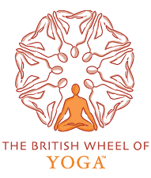

**Student Teacher Record of Teaching**

During the BWYQ L4 Progression Course you must record at least 15 hours of yoga teaching. The 15 hours should be formal class teaching. Details of your teaching during the BWYQ L4 Progression Course should be included below and you must also complete reflective evaluation of your teaching for 3 classes in the form of reflective evaluation sheets (PLREs).

|  |  |  |  |  |  |
| --- | --- | --- | --- | --- | --- |
| **Date** | **Length of Class** | **Venue** | **Own class/**  **cover/other** | **Short description of students – number and level** | **Brief description of content (general/asana/relaxation/**  **breathing/meditation/other)** |
|  |  |  |  |  |  |
|  |  |  |  |  |  |
|  |  |  |  |  |  |
|  |  |  |  |  |  |
|  |  |  |  |  |  |
|  |  |  |  |  |  |
|  |  |  |  |  |  |
|  |  |  |  |  |  |
|  |  |  |  |  |  |
|  |  |  |  |  |  |
|  |  |  |  |  |  |
|  |  |  |  |  |  |
|  |  |  |  |  |  |

**Signature of student teacher:**

**Date:**

The table should be enlarged, and rows added as necessary.

A record should be included in the student teachers’ portfolio together with reflective evaluations of teaching.