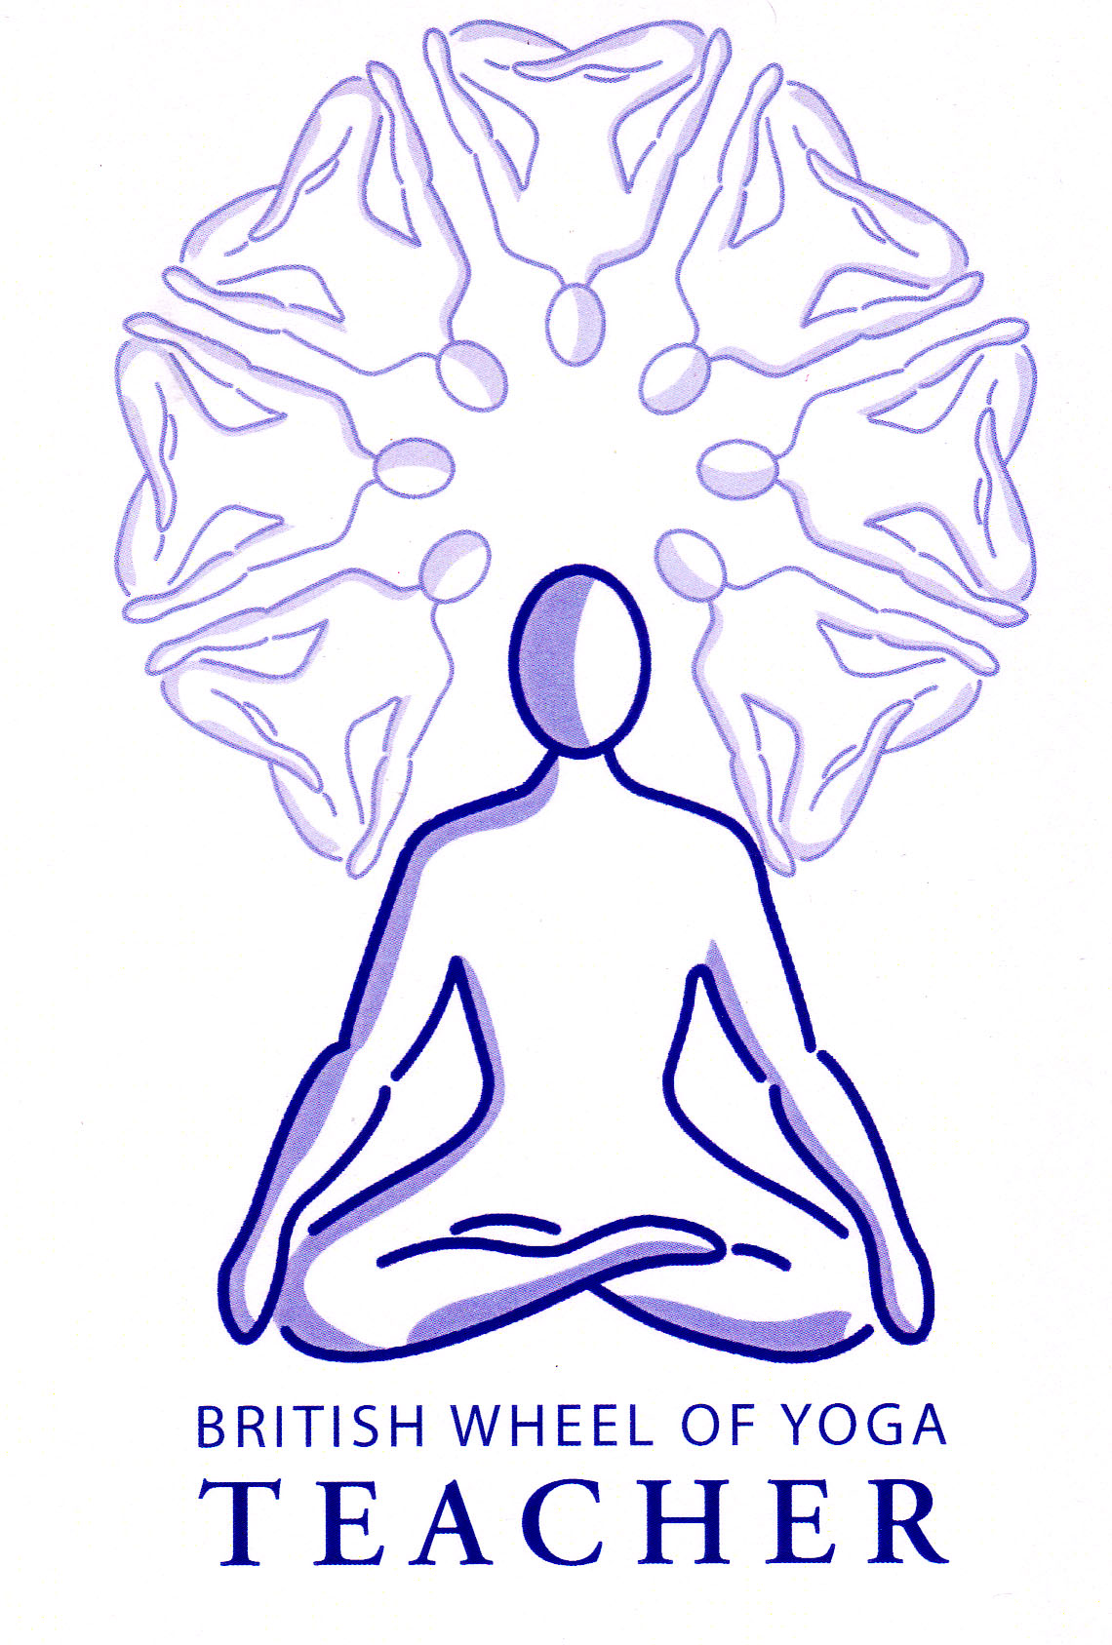**Benefits of inversions**

Generally speaking inversions are considered to be some of the most beneficial of all yoga asana but they also possess the most contraindications of all asana and therefore need to be treated with respect.

In inversions we are reversing our usual relationship to gravity, the upper body becoming the weight bearing part of the body and the head, which is usually free to move, becoming more fixed. This factor makes inversions very rejuvenating and age defying. There is a benefit to the circulatory and lymphatic systems as blood and lymph are drained towards the upper body, helping alleviate fatigue, edema in the lower limbs and stagnant blood such as we find in varicose veins. The cardiac muscles of the heart are worked as the venous return to the heart is increased bringing health to the cardiac muscles, with the increased blood flow to the brain bringing renewed clarity and focus. The spine can be released, alleviating the usual pressure upon the spinal discs as the spinal column lengthens.

We also find inversion helps bring new blood to the lower areas of the lungs which is usually more compressed and less oxygenated giving healthier lung tissue.

With experience inversions bring great relaxation; in fact inversion creates increased pressure within the carotid arteries of the neck meaning the baroreceptors or blood pressure regulators located there slow the blood flow to the brain thus reducing both heart rate and blood pressure. Over time it is suggested the daily practice of inversions lowers the resting blood pressure, as the body gradually rebalances itself.

Psychologically inversions can have a great effect as we are literally seeing the world from a new perspective bringing emotional release and new clarity. They also can bring the feeling of exhilaration and confidence.

Energetically inversions are said to be very powerful at releasing toxins as the apana energy is moved downwards to the central energy of samana literally burning toxins! They are also said to make sexual energy available for other functions, increasing our spiritual energy!

In addition there are a multitude of other more specific benefits we shall discover as we explore different inversions.

The king and queen of asana, the headstand and shoulderstand respectively, are very different in nature; the stay in the headstand is an example of a pure balance and the stay in the shoulderstand is an example of an asana where muscular effort is paramount. There are however some general principles we can apply to all inversions.

General principles for inversions

* We must take the time to prepare the body since we may place excessive pressure upon areas of the body that are unused to carrying the weight of the body. For instance the neck may be placed under excessive pressure in both the headstand and the shoulderstand and we may also find the wrists, arms and shoulder muscles suffer if the body is not strong and flexible enough. Prior preparation is essential so for instance we spend time in poses which increase our ability to stabilize the shoulder blades and which strengthen the muscles of the arms and wrists. We must always ensure we can create a strong stable foundation for our inversion.
* In every inversion we must keep the spine long, especially at the thoracic region where there may be a tendency to slump downwards, the shoulders will rotate slightly outwards (external rotation) and the scapulae will rotate upwards where the arms are overhead as for the headstand. To counteract this slumping effect we must slide shoulder blades down to the waist and keep them against the back, we can also engage the core muscles to maintain a lift through the spine.
* We must also consider the entrance into and exit from an inversion as this requires good abdominal and back strength ensuring a safe and controlled movement into and out of the pose. Here again good prior preparation is essential.
* With inversions of any kind it is always helpful to work with positions that will eventually move the body towards the full position. Here for instance we can first place the head and hands ready for headstand then walk the feet towards the head as the hips are being lifted so they become aligned above the shoulders. This will be the first stage and it is only when the hips are aligned over the shoulders and the back becomes straight that we will naturally find the legs wish to lift, here the legs will be tucked in against the torso as we keep the spine vertical. Only then would we consider lifting and straightening the legs to full headstand, this being the third and final stage. This step-by-step approach means we will always be working within our current capacities.
* Taking a step by step approach also means we can psychologically prepare ourselves since for many students of yoga inversions are at first a little daunting.
* When we are inverted blood pools in the capillaries of the head, neck, arms and shoulders. The baroreceptors in the arteries between the head and heart, which are measuring blood pressure, realize that blood pressure has increased and immediately the body seeks to redress this by constricting the celebral arteries to prevent an increased blood flow within the brain. However when there is already high blood pressure this system of autoregulation means there may be adverse reaction such as oedema or haemorrage as the blood pressure is high and simultaneously the arteries constrict. Potential problems are also possible because inversions are static meaning there will be a lift in both systolic and diastolic blood pressure readings as many muscles are contracted to hold the pose; in essence the blood flow must be increased to force blood through the smallest blood capilliaries.
* For heart conditions where the functioning of the arteries or heart has been compromised the capacity of the body to autoregulate the cranial blood flow is reduced so we must be cautious teaching inversions to these students. We generally avoid inversions with those who have these conditions and this includes those who are over 30 years of age and have medicated hypertension as there is most likley to be arterioscelorosis meaning arteries are damaged.
* Some yoga authorities tell us that when we are practicing inversions this is activating the parasympathetic nervous system (p.n.s) to lower the heart rate and blood pressure as the baroceptors (blood pressure detectors) in the neck detect a lift in blood pressure. And indeed we must always endeavor to be as relaxed as we can in any inversion, avoiding working beyond our capabilities, so this relaxation response is evoked giving us the beneficial effects of inversions. But today we are also told that this blood pressure lowering effect due to the feedback from the baroreceptors is not enough of an effect to offset the elevation of blood pressure when performing inversions.
* This natural activation of the p.n.s is especially important when an individual is liable to low blood pressure and reflexive hypotension, where if there is an increase in blood pressure they automatically experience increased activity within the parasympathetic nervous system and reduced activity in the sympathetic nervous system. In these cases as the body seeks to redress the increase in blood pressure, this creates a quicker drop in blood pressure and if the blood pressure is already low there may be an exaggerated response causing faintness. We must work sensitively into inversions noting our inner experience as we progress step by step.
* Headstands are often taught earlier in a class following the warming up so students are still fresh whereas shoulderstands, being more calming, are usually taught in the later stages of a class.
* Finally we must always spend a reasonable length of time in the counterpose to allow the body to return to balance. Generally we can spend at least the same time within the counterpose as for the inversion.

Good Preparation for inversions

Generally we need to strengthen and mobilize the muscles of the shoulder girdle. We also need to develop strength within the abdominals and back and mobilize the hip joints.

It is best to teach inversions progressively so at first concentrate upon adho mukha savanasana (down dog), viparita karani (inverted pose) and uttanasana (standing forward bend) to enable students to become familiar with taking the head lower than the heart.

For sarvangasana (shoulderstand) we must practice salamba setu bandha (supported bridge pose) to find the perfect foundation and it is generally agreed that unless a student can perform this without strain and can lift into the bridge so the neck lifts from the floor they are not yet ready!

## Areas for caution

We must take great care in the stronger inversions such as sarvangasana (shoulderstand) and sirsasana (headstand) because whilst there may be no immediate pain or discomfort over the long term if they are practiced too soon or insensitively then problems such as cervical degeneration, impaired neck mobility or numbness in shoulders, arms and hands may follow. Therefore as teachers we must teach these asana in stages, slowly over the weeks and months absolutely discouraging competition or end-gaining. We must be able to closely observe our students as they prepare for and practice these asana.

|  |  |
| --- | --- |
| Anxiety | Be extremely cautious gradually developing experience of inversions |
| Back conditions | Be extremely cautious generally if severe working only with partial inversions possible such as legs up a wall or upon a chair seat or possibly with viparita karana (inverted pose) if mild. |
| Diabetes | Only partial inversions possible such as legs up a wall or upon a chair seat, with head on block due to the possible secondary complication of eye and heart problems: indeed it is advised we treat all older diabetics as possessing CAD |
| Eye conditions e.g. glaucoma, detached retina, inflammation | Only partial inversions possible such as legs up a wall or upon a chair seat, with head on block |
| Ear conditions such as middle ear infection | Only partial inversions possible such as legs up a wall or upon a chair seat, possibly with head on block |
| Hiatus hernia | Only partial inversions possible such as legs up a wall or upon a chair seat. Possibly using viparita karani and here the upper body must be raised to avoid any acid reflux |
| High blood pressure & heart conditions (coronary heart disease (CAD), angina) | Only partial inversions possible such as legs up a wall or upon a chair seat. Medicated high blood pressure under age 30 can work as usual maintaining good self observation but when medicated and over age 30 meaning arteriosclerosis is probable, inversions (or keeping head below the heart generally) are prohibited. |
| Injury to joints or muscles of hands, arms or shoulders | Only partial inversions possible such as legs up a wall or upon a chair seat |
| Kyphosis | Extreme caution due to the vulnerable nature of the neck so only partial inversions possible such as legs up a wall or upon a chair seat, possibly working with viparita karana (inverted pose) using padding beneath the head. |
| Low blood pressure | Go very slowly between the heights observing inwardly |
| Menstruation | No inversions on first few days as apana must not be working against gravity |
| Neck problems | Only partial inversions possible such as legs up a wall or upon a chair seat |
| Obesity | Only partial inversions possible such as legs up a wall or upon a chair seat |
| Osteoporosis | Depending upon severity may need to stay at preparatory stage for stronger inversions and perform adho mukha svanasana with support or against the wall. |
| Pregnancy | Only partial inversions possible such as legs up a wall or upon a chair seat, and the upper body must be raised use padding |
| Respiratory problems | Go slowly and cautiously stage by stage, staying comfortable |
| Sinus problems | If severe only partial inversions such as legs raised against a wall, with block under head |

For all strong inversions inner sensitivity and proper preparation is everything.

© S Beck May 2013