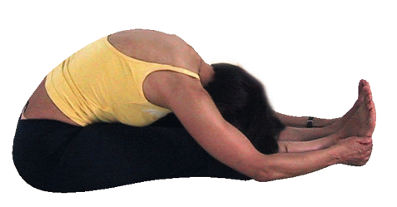**Paschimottanasana – Seated Forward Bend Pose**

# Pronounced puhsh-chee-moht-tuhn-aah-suh-nuh the word paschima means west and uttana means intense in Sanskrit.

This pose is often named the ‘west stretch’ because traditionally asana was practiced facing to the east so the back of the body was considered to be the west side of the body; therefore the literal translation of this asana is the ‘intense stretch of the west side of the body’.

**Teaching Points:**

Stage 1:

* Sit in dandasana, stick pose, could sit on a block if it is challenging to sit erect here whilst maintaining a natural lumbar curve, and may need to bend knees if back is still rounded
* Inhaling lengthen the spine, creating space between the ribcage and pelvis, shoulder blades down the back and tucked into the back
* Exhaling, keep the chest open as fold forwards from the hips feeling the pelvis tilt forwards as try to **draw the pubic bone to the thighs first**, whilst reaching arms forwards at about shoulder height
* Feel both sits bones lifting backwards and upwards
* Allow the body to fold forwards until resistance is experienced in the legs or back, without allowing the lower back to round.
* If necessary allow the knees to bend to enable a connection between the upper body and the thighs, keeping the spine long and open.
* Stay here, as you inhale allow the upper body to gently lift a little & lengthen and then exhaling relax the upper body back down over the thighs.
* Remember there is a sense of slightly arching the lower back as you inhale creating a small backbend each time you inhale

Stage 2:

* When ready stay statically using the breath to evoke the relaxation response; also subtlely draw the ischial tuberosities apart by engaging the adductor muscles as if internally rotating the legs at this hipsas this will increase flexion at the hips

To exit:

* Inhaling engage leg muscles and abdominal muscles lifting arms back up to shoulder height and exhaling lower arms returning to dandasana, the start position

**Benefits:**

Quiets the mind

Calms the systems of the body, especially the cardiovascular and nervous systems

Rejuvenates the spinal nerves

Tonifies internal viscera, especially the liver, spleen, kidneys uterus and ovaries

Alleviates menstrual pain and some menopausal symptoms

Stretches the hamstrings

Can alleviate fatigue and anxiety

#### Good preparation

Hip mobilizers, hamstring and adductor stretches, mobilization of the spine eg. twists

**Cautions & possible modifications**

* Lower back problems and sciatica: bend knees and sit upon a block(s)
* Sacroiliac Strain: stay upright or bend knees/sit on block
* Abdominal conditions & pregnancy: avoid compression, reducing depth of flexion
* Hamstring injury: bend knee/sit on block, enure stretch is in the belly of the hamstrings
* Hip conditions: can stay upright/use belt
* Osteoporosis: caution can bend knee/sit on block/ stay upright/use belt

Take care to:

* Avoid creating strain at the sacroiliac & lumbar regions by bending knees if necessary and sitting upon a block
* Avoid hyper-extending your legs by avoiding pushing back into the knees, instead keep a very slight bend at the knees or contract quads as press hips to the floor
* Avoid placing unnecessary tension within the neck, so do not lead with the head

#### Simpler modifications

**Block beneath buttocks & Bent knees**

As we have seen these simple modifications make this pose very accessible and ensure that flexion can occur at the hips.

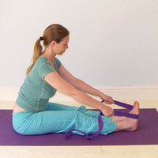**Belt around ball of feet**

Here we can work the legs by placing a belt around the ball of foot. We hinge forwards from the hips keeping the spine long. This primarily focuses upon toning legs

**Variations**

**C- shape**

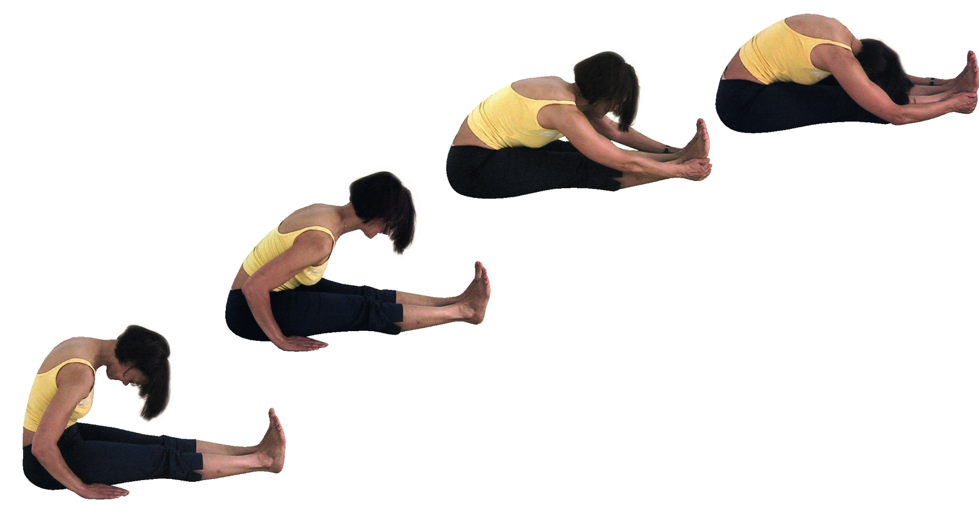A great variation is to start in a very un-yogic manner by relaxing the upper body into a C-shape then inhaling we press the tailbone backwards, creating an anterior tilt of the pelvis as we lengthen the spine, exhaling we fold forwards to our new edge placing hands where they naturally fall. After a few breaths here we place the hands either side of the legs, slumping once again into a C-shape, inhaling as before. In this way it is as if we are climbing along our legs little by little!

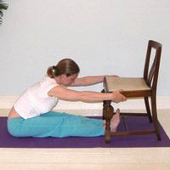

**Using a chair**

A nice variation is to hold the sides of a chair allowing the body to fold forwards from the hips.

**Developments**

**Arms fully flexed**

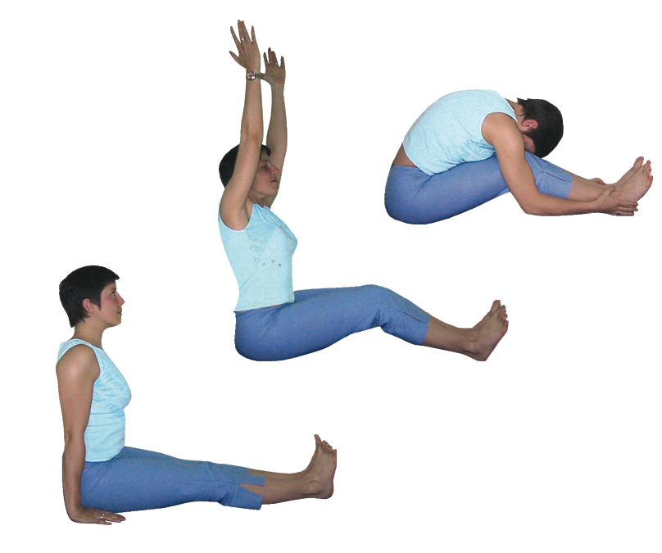When we can work more intensely then we can raise arms up vertically as we inhale and fold forwards as we exhale. Exiting from the pose by inhaling and reaching outwards and upwards and exhaling lower arms.

**Hold one wrist**

When we are able to easily touch the feet with straight legs we can make the pose more challenging by reaching beyond feet and holding one wrist. Here we can also increase the intensity by imagining we are lengthening the lower legs by pressing them down and forwards.

#### Adjustments

Ideally we will verbally instruct for this asana perhaps mirroring or individually demonstrating. We should always avoid placing pressure upon the sacrum or back of the student!

© S Beck June 2021