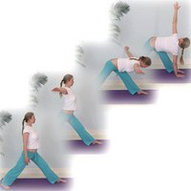**Parvritti Trikonasana – Reverse Triangle Pose**

*Pronounced par-ee-vrt-tee-tree-kohn-aah-suh-nuh parvriti means revolving, tri means three and kona means angle in Sanskrit.*

This pose can be taught with several different foot placements as we shall we see below. We shall take the version shown opposite as the standard version.

**Teaching Points:**

* From tadasana, feet hipth apart step the right foot forwards, externally rotating the back left leg a few degrees so the toes point out to the side.
* **Keep hips facing forwards.**
* Inhaling lift both arms out to sides at shoulder height, stretching outwards from heart to fingertips, engaging the core
* Exhaling **folding forwards from the hips**, look downwards to keep the neck aligned with the spine as the sitting bones are pressed back, **keep the whole spine lengthened,** bending the front knee if necessary.
* Make sure the **front leg hip is drawn backwards, to keep hips facing forwards** and **equalise the weight between both feet so the weight is not increased into the front foot.** Do not let outer edge of rear foot lift
* As the torso is aligned with the height of the hips continue by rotating at the thoracic region of the spine taking the lower hand to the instep of the front leg, placing the hand on a block/brick if needed.
* Press down into the floor with the lower hand **lifting up into fingers of the upper hand, opening the chest and shoulders** as the neck rotates to look at the upper hand, if possible, otherwise keep looking forwards or down
* Stay, rotating the top shoulder back, keeping the shoulders down away from ears.
* Try to **lengthen between the crown of the head and the tailbone**, drawing the hip of the lead leg backwards, **creating space between hips and the ribcage.**
* To exit lower upper arm to release from the twist and inhaling raise both arms out to the sides at shoulder height, chest over floor, spine parallel to the floor, bending the front knee if needed; and using the internal muscles of the torso and leg muscles lift the upper body vertically with the whole spine working as one long unit.
* Then exhaling lower arms to sides and work to the opposite side.

**Benefits:**

Tones both legs significantly

Tones spinal musculature

Opens chest and shoulder muscles

Mobilizes thoracic and cervical vertebrae

Increases circulation to lower back

#### Good preparation

Teach anterior tilt of pelvis, i.e. flexion from hips; pada bandha; mula bandha; hamstring and adductor stretches, shoulder, chest and back mobilizers, simpler twists:

**Cautions**

* **Un-medicated high blood pressure & heart conditions:** if necessary place lower hand on to blocks to avoid head lower than heart & keep the upper hand to the top hip; work for short briefer periods, without strain.
* **Lower back conditions and sciatica:** work cautiously using modifications such as bent front knee, lower hand to a block.
* **Neck problems:** keep the head turned forwards
* **Hyperextension of front knee:** keep weight equal between feet, pressing into ball of lead foot, engaging quadriceps
* **Pregnancy:** feet parallel, lower hand to chair to minimise twist & pressure on rectus sheath & SI Joints

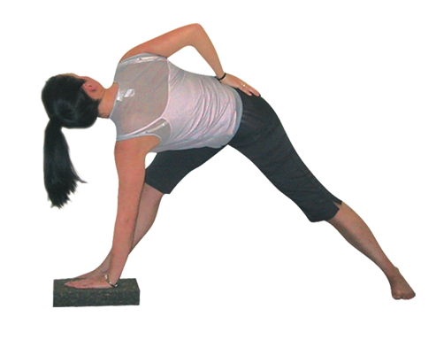

Note:

* Can direct the primary work into the thoracic spine by bending the front knee if necessary and/or placing a hand upon a block or brick
* Keep the rear arch lifted, outer side of foot rooted to floor.
* Sometimes students have a smaller length of arms proportionate to the length of legs so here students may benefit from keeping the lower arm at a higher point, perhaps on a block or brick placed on the floor to the inside of the front foot. If this is not addressed then the spine will curve rather than be lengthened.

**Variations**

#### ::30-4-557-602-563_resized.tifFeet forwards

Just as with trikonasana we can work with feet facing forwards so the hips cannot rotate externally or internally. This is a good option for beginner students and where we would like to work dynamically in time with the breath. To modify the pose students can bend the knee they are working towards, inhaling to centre and exhaling into the twist, moving from side to side.

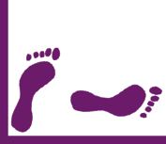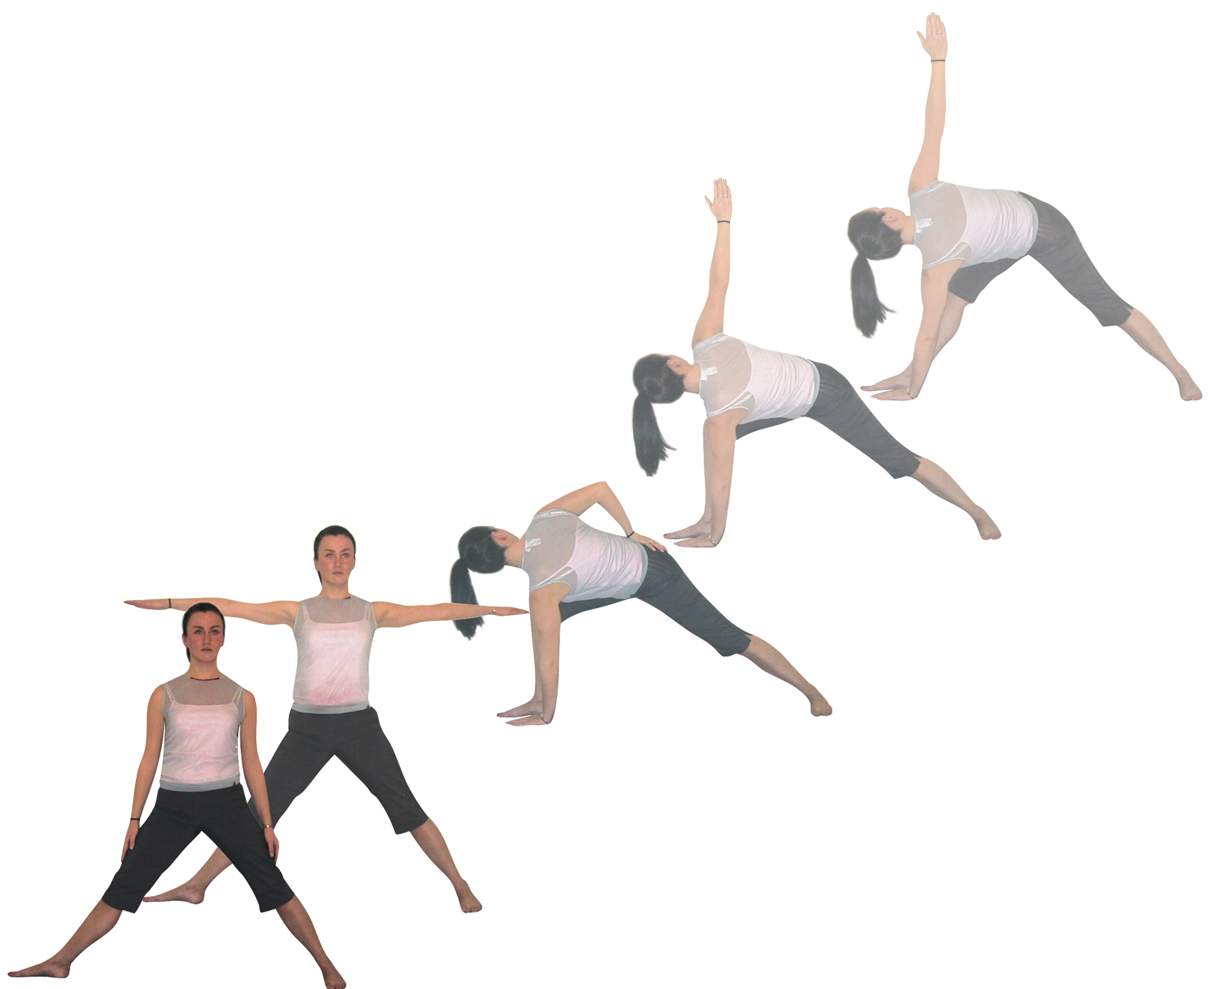

**Feet aligned 90º and 45º**

This version has a different foot placement where the front foot is externally rotated 90º and the back foot internally rotated to 45º. As we twist towards the front leg we can keep the front knee bent, hand to floor or block enabling a good opening of the chest as we draw the top shoulder back.

This asana can also form an important part of many sequences

#### Adjustments

Students must avoid rounding the spine so when the hamstrings or lower back are tight using blocks and/or bending the front knee can be very helpful to keep the spine long. It can also be helpful to stand behind the student’s upper back keeping their balance by placing a hip against their back. Then with one hand draw the top shoulder back and/or with the other hand draw the front hip backwards.

© S Beck December 2014