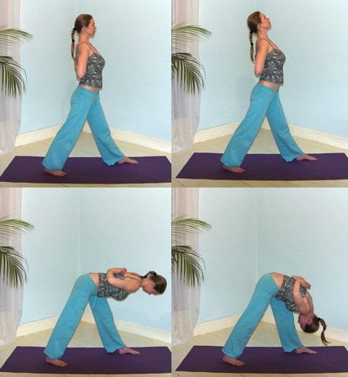***Pronounced paarsh-voht-taahn-aah-suh-nuh the word parshva means side or flank in Sanskrit***

**Parsvottanasana (flank stretch)**

It is rather like uttanasana, the standing forward bend but it is an asymmetrical posture where the intensity of the pose is much stronger at the hips and along the side of the body. It also requires much more balance to perform!

**Teaching Points:**

* From tadasana step the left foot forwards for the length of approximately one leg’s length turning the right foot out 45º if necessary. **Turn your hips to face forwards.**
* Place hands in reverse prayer position drawing shoulders back and down, lifting and opening the chest without flaring at the lower ribs. If reverse prayer position is not possible touch fingertips together or if necessary hold your elbows with the opposite hands.
* Ensure your **weight is equally distributed between both feet**, engaging both quadriceps, both soles of feet snuggled into the ground using pada bandha.
* Inhaling look up 45º, keeping the neck long and open, as you contract abdominals, lift the sternum and draw your shoulders back and down, creating a gentle, long backbend within your spine.
* Exhaling look downwards as you fold forwards from your hips, with the chest leading; **the left hip moving gently backwards**, to keep pelvis aligned. Keep your chest open, shoulders back, **lifting your tailbone & sits bones as you reach forwards through your crown**. Ensure both shoulders stay aligned since it is possible the left shoulder will lift. Descend in this way keeping the spine long and open the top of the head moving away from you.
* You may need to bend the front knee a little if you are experiencing any strain in the back or legs otherwise front leg straight with the left hip being drawn backwards, the **right frontal bone being drawn forwards to keep the sacrum level.**
* Keep the shoulder blades down away from the head, your shoulders away from your ears, lifting the elbows upwards towards the ceiling.
* You may prefer to descend with the breath, with each exhalation you lower a little, on each inhalation you stay lengthening the spine.
* Once in the full position see if you can relax here, lengthening the spine, staying grounded down into the floor keep the breath smooth and easy.
* To exit, press down firmly into both feet equally and looking down elongate the back inhaling, lifting up at the chest, keeping shoulders open. Can bend front knee to assist the movemnet out of the pose.
* Stepping out of the pose then work to the other side in just the same way.

Note: if feet are aligned from front heel to back arch or heel then it becomes very difficult to draw both hips forwards. As a result there is likely to be a twist within the spine exerting uneven pressure upon spinal discs and musculature, and also upon the sacroiliac joints. We should always therefore teach the foot placement where feet are hip width part, and only use this version for more experienced students, especially when used in a sequence.

**Contra-indications & possible modifications**

* Heart conditions, high blood pressure, mature diabetic: work dynamically, if staying still then keep head at heart level only descending into a half forward bend
* Shoulder or wrist problems: hands to hold opposite elbows only, or hands to hips
* Hamstring problems or low back conditions, sacroiliac problems and sciatica: bend front knee a little, staying halfway only if needed.
* Low blood pressure, vertigo & pregnancy: go slowly through the levels, could place hands on the top of chair
* Loose ligaments: check front knee is not hyperextended, softening knee if needed.
* General inflexibility & weakness: lift & lower with hands to hips, bend front knee, or place blocks at either side of front foot

#### Possible Staging:-

1. Hands to hips, lift and lower to hip height, ensuring flexion at the hips is occuring and that the back is straight, shoulders even (bend front knee if needed)

2. Hands to hips, lower the whole way, check alignment is maintained

3. Lifting arms to ceiling and lowering arms to chair, checking weight distribution between feet is still equal and body is still aligned

4. Lifting arms to ceiling and lowering arms to the floor, lifting arms up to ceiling, lowering to side

5. Having worked dynamically, stay for several breaths, using correct entrance Note: can lift and lower arms in a different way.

#### :attachments_09_11_2009 Folder:flank-stretch-var-5_resized.jpg

#### Variations

**Modifications:**

Bent front knee

Hands to hips

Halfway - hands to chair

Halfway – hands to blocks

#### :attachments_09_11_2009 Folder:flank-stretch-var-1_resized.jpg

#### *Asymmetrical arms*

#### *Hands linked beyond the body*

#### Adjustments

Here we can help students by placing a hand lightly upon the neck or shoulders to remind them to relax them. In particular if hips are misaligned then we can stand behind the student holding each side of the hips drawing them gently backwards, so they are both facing directly forwards. Remember for the lead leg side the buttock must move backwards and for the back leg side the hips may need to be turned forwards. Ideally we would be able to balance a tea tray upon the buttocks!

**Benefits:**

Mobilises wrist joints releasing stiffness

Mobilises shoulder joints releasing stiffness & rounded shoulders

Mobilises hip joints releasing stiffness

Gives strength and flexibility to the spinal column

Rejuvenates the spinal nerves

Tones the legs giving strength and flexibility

Tonifies internal viscera

Increases circulation throughout the body including the head

© S. Beck January 2014