Parighasana (gate pose)

# *Pronounced par-eegh-aah-suh-nuh the word parigha means the cross-bar we use to close a gate in Sanskrit.*:gate pose.tif

This pose is named the gate pose because the pose resembles the shape of the closing mechanism we often find upon gates.

**Teaching Points:**

* Adopt a raised kneeling position, keep the right knee bent and perpendicular to the ground as the left leg is rotated out to the left, knee stacked over ankle in alignment with the left foot.
* Stay here keeping the pelvis level, the groin open, ensuring the left knee does not fall inwards as you roll the top of the left thigh outwards.
* **If this is enough we could stay here.**
* To go more deeply inhaling lift arms out to shoulder height keeping shoulders down away from ears and exhaling laterally bend to the left side placing the lower hand to the inside of the lower shin and the top arm vertical. It is important the top shoulder stays back and the groin remains open, so no sitting down! **We could stay working here.**
* To go more deeply we can begin again with the left leg place straight out to the left side, the thigh rolled outwards so the knee is facing upwards, the left foot can be flat or if necessary the toes can point upwards.
* Again we inhale raising arms out to shoulder height and exhaling keeping the top shoulder back, the chest open and the groin open we laterally fold to the left side placing the lower hand wherever it naturally falls upon the left leg, the right arm lifted vertically. **We could stay working here.**
* If we wish to make the pose more intense we can inhale and exhale lower the top arm over the top ear, palm facing downwards, looking up across the armpit.
* Keep the torso in alignment with the extended leg, the body open rather than compressed.
* When we are ready to exit, we take the top arm back to the vertical position and inhaling lifting arms back to shoulder height and exhaling lower arms to sides.

Note: for this posture there will be a wide range of natural ability to abduct the legs and externally rotate at the hips and as always students must honour that.

**Drishti**: gaze across armpit

**Benefits:**

* Frees ribcage & intercostal muscles, promoting free breathing
* Intensely tones abdominal muscles and organs
* Releases stiffness in chest and shoulders
* Tones the waist
* Releases stuckness with the spinal column
* Increases circulation of prana, bringing vitality to body

#### Good preparation

Hip mobilisers, adductor & hip flexor stretches, twists, back mobilisers, chest openers

**Contra-indications & possible modifications**

* For knee problems we can place padding beneath the bent knee or if necessary we can work in a standing pose such as parsvakonsana, giving similar benefits.
* For high blood pressure and heart conditions we can keep the upper arm to the hip.
* For shoulder injuries we can take the arms just as far as is comfortable.

#### Simple versions and modifications

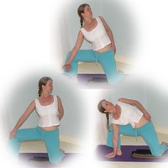

#### *Keep upper arm to side*

Here we work keeping the top arm to the top hip, working to keep the bent knee back as we draw the top shoulder back. We can work at the level of thigh or take the lower hand to a block or the floor. This is great as preparation to the full posture, helping to open tight groin muscles and hip flexors.

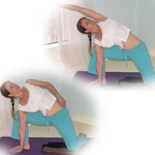We can then if we wish take the upper arm overhead to increase the intensity of the stretch into the side of the body.

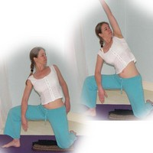

#### *Arm to thigh*

Remember if necessary students can stay in a more upright position and even here they will working the correct muscles!

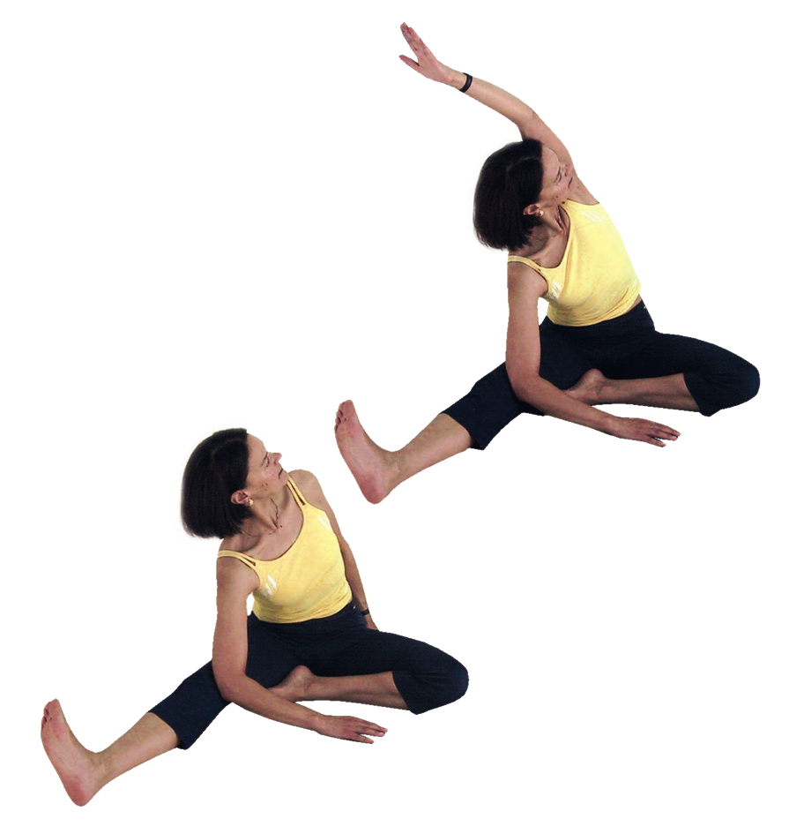

***Revolving head to knee pose***

If a student cannot kneel directly upon the floor then we can work with trikonasana (triangle pose) or parsvakonasana. As an alternative we could also teach parvritti janusirsasana (revolving head to knee pose) as shown opposite as this will work the body similarly.

**Developments & Variations**

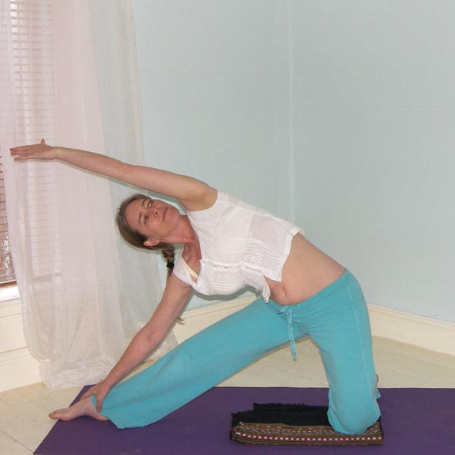

We can work more deeply into the lateral stretch but here it is likely we will need to flex at the hips rather than having the bent leg perpendicular to the ground.

**Adjustments**

For this asana verbal instruction is ideal however we can alter the position of the upper arm if the hand is facing in the wrong direction or if the arm is not connecting down through the side of the body. We can also place a hand lightly upon the lower shoulder blade and the other hand upon the top shoulder gently helping to rotate the torso and the top shoulder backwards.