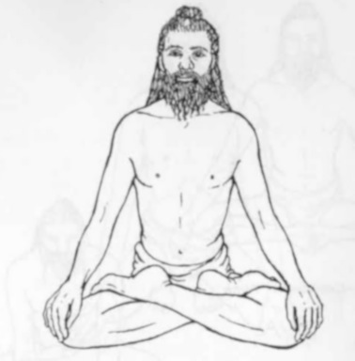Pronounced puhd-maah-suh-nuh the word padma means lotus in Sanskrit.

Padmasana (Lotus pose)

This is perhaps the best known of all yoga asana and is used for the quieter more meditative aspects of a yoga practice. It requires extremely good hip flexibility and for many students an alternative will be required. It is important to realize that some students possess hip sockets and femur heads which do not naturally allow for maximum hip rotation and also that sometimes bone length and bulky muscles will also make this pose inaccessible. We can always however teach students to reach their optimal position taking a less challenging option as needed.

From:

www.surajamrita.com

**Teaching Points:**

As we move through the stages students must be asked to ensure the work is primarily occurring within the hips and **there should be no discomfort within the ankles or knees.** If the ankles or knees are overstretching structural damage can follow so instruct student to remain aware and stay at the correct level. It is therefore very important students are advised to not to end-gain.

**Stage one**

Sit in a simple sukhasana pose with legs crossed and lean forwards with a slight anterior pelvic tilt, nestling the sitting bones into the ground. Once the sits bones are placed then slowly sit up drawing the belly to the spine creating a level balanced pelvis. Lift the top front of throat to engage the hyoid bone so the crown feels to be rising easily upwards and the muscles of the front of the body are engaged. Ideally there is now the feeling of simultaneously being grounded downwards and rising upwards through the spine, feeling almost weightless.

**Stage two**

If possible move into ankle to knee pose where the right ankle is positioned upon the left knee with the left ankle stacked beneath the right knee. The shinbones will form a triangular shape with the thighs. Now activate both feet by flexing the heels to avoid overly twisting at the knees or ankles.

**Stage three**

If we can progress then move into half lotus pose where we place the top of the outside of the right ankle across the crease at the top of the left thigh allowing the right knee to drop, the lower foot drawn in towards the right buttock. We must however check the right ankle amd knee are not being excessively compressed and rotated by ensuring the right foot is hanging over the left thigh, if necessary flex the right foot to help prevent the ankle being twisted. We may also need to place padding under the right knee if the knee does not touch the ground.

**Stage four**

To move into the final position of full lotus then from half lotus move the lower leg away so the knee drops and pick up the left leg and lift the leg so the heel is positioned towards the navel, then drawing the outer ankle of the left foot into the crease at the top of the right thigh. Ensure the ankle is fully over the thigh or stress to the ankle ligaments & tendons will be experienced. Stay here relaxing all effort as the upper body remains erect. As always check both ankles and knees remain comfortable. No end-gaining!

To release from these poses simply stretch out the top leg and then the bottom leg rolling the legs from side to side on the heels

Always work on both sides so we do not favour one hip.

**Benefits:**

Increases energy available to upper body

Facilitates balanced functioning of visceral organs & has a balancing effect upon the metabolism in general

Tones lower nerves

Balances mind and emotions as nervous system is balanced (i.e. balances mental and pranic forces)

Provides a stable seated position, increasing capacity for concentration

**Good preparation:**

Knee warming, hip mobilisers, ankle mobilisers, leg stretches, iliopsoas stretches, back mobilisers & strengtheners.

This pose requires good long term preparation for the full pose to be achieved with structural integrity. Whilst students may like the idea of adopting the full pose it can potentially cause injury through use especially over the longer term.

Image taken from L.Kaminoff, Yoga Anatomy, 2007, Human Kinetics: Ilinois, page 81

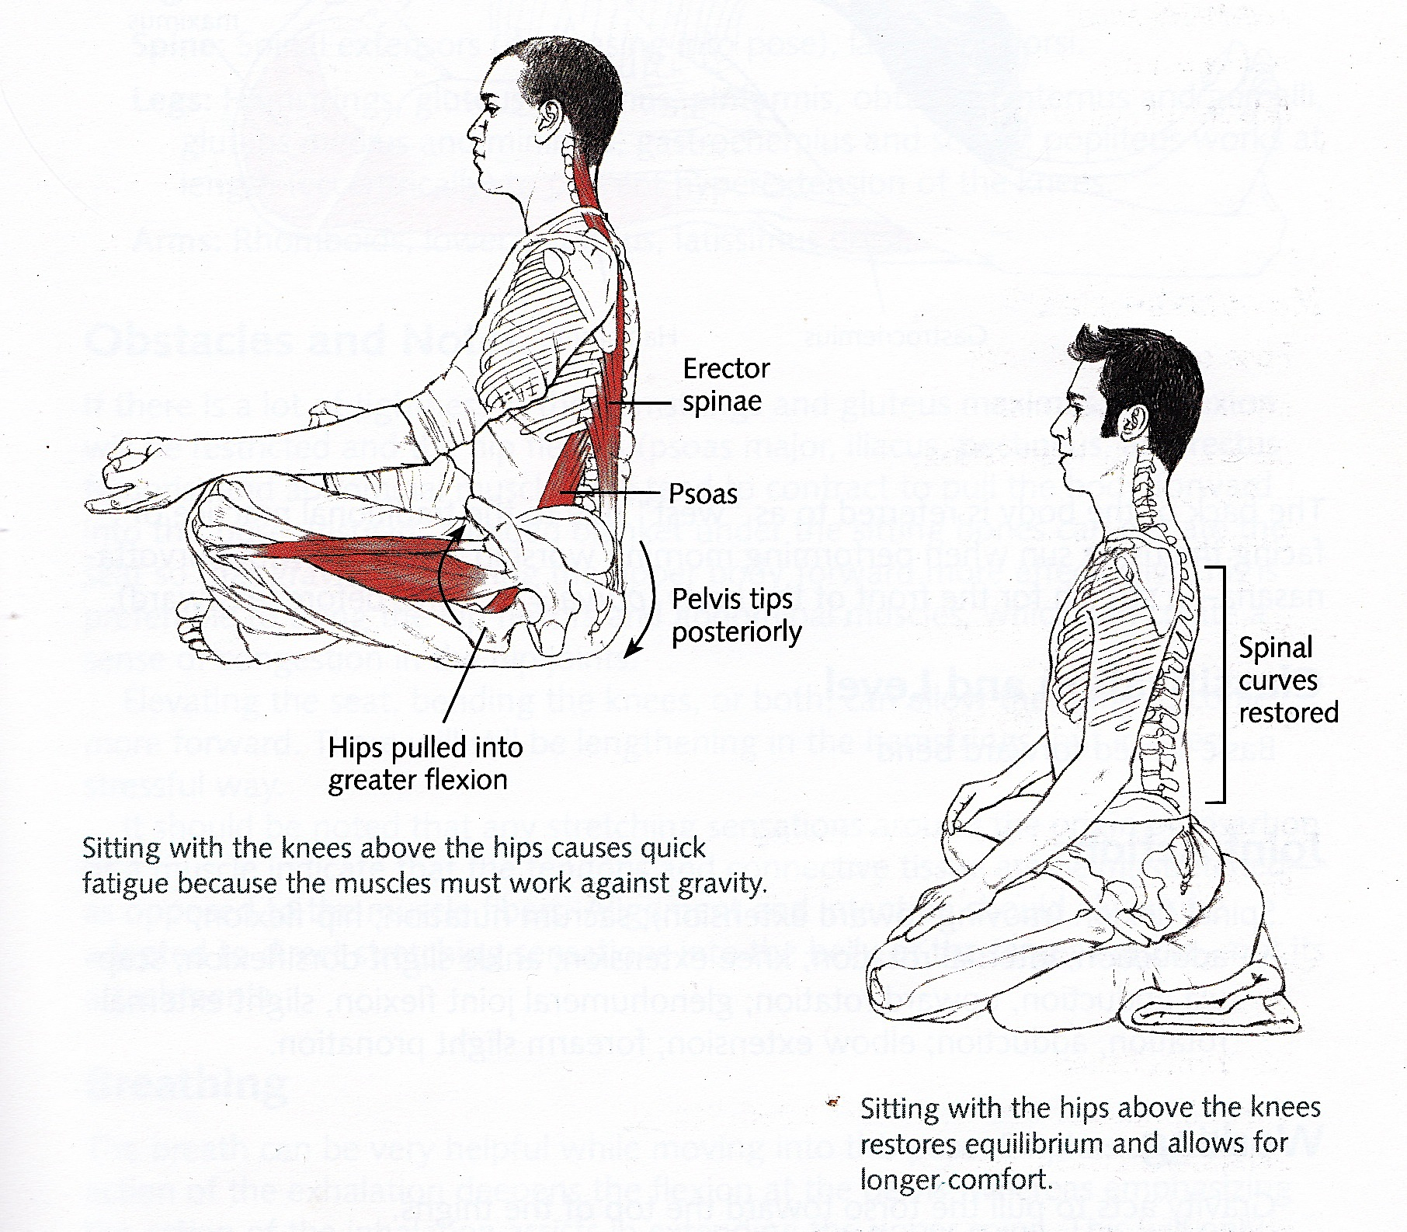**Note:** Whichever cross-legged pose we adopt we must ensure the natural lumbar curves are maintained and for many people this requires sitting in a simpler pose with padding beneath buttocks to lift hips higher than knees. If knees are positioned above hips then the pelvis tilts posteriorly (backwards) and the spine moves into more flexion, losing the natural spinal curves. This means there will be too much effort exerted to work against gravity to stay here for the quiet practices.

Also, along with the errector spinae muscles, we contract the iliopsoas muscle to sit upright with a natural lumbar curve, however if the iliopsoas is tight this can pull the thighs up as the hip is drawn into flexion, again reinforcing the posterior tilt; this is because the illiopsoas is attached to the lumbar spine and down into the medial part of the femur bone so it can perform flexion of the leg at the hip. Again this creates excessive effort as other muscles are contracted to compensate.

Always check that the natural spinal curves are present for seated poses, and that knees are lower than hips, offering padding for buttocks to aid the anterior tilt if needed.

**Cautions:**

**Use a more comfortable alternative such as sukhasana or burmese pose for:**

General inflexibility

Knee injuries and knee conditions

Ankle discomfort

Varicose veins

Sacral problems & sciatica

Or use another alternative such as *vajrasana,* kneeling pose or *dandasana* or a *chair*

**Simple versions and modifications:**

*Sukhasana* can be used and blocks can be placed beneath the buttocks where necessary, padding can be placed under thighs and a blanket can be wrapped around ankles.

*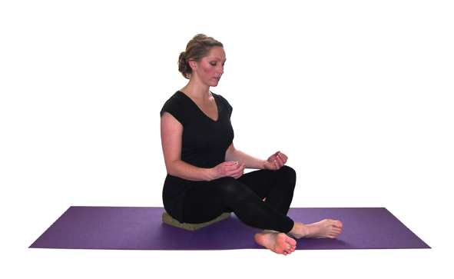Adopt baby lotus*

Here we simply cross the ankle only, drawing the feet as close as possible. This can be used when the body is extremely tight or there are knee or hip issues.

**Developments & Variations:**

*Bound lotus*

Wrap the arms behind the back and grasp the big toes with the opposite fingers.

*Tolasana (scales pose)*

We place hands to the ground beside the hips and inhaling press down into hands as we raise the hips from the floor. If arms are short relative to the length of the torso we can place hands upon blocks.

We can also practice *Siddhasana/Siddha Yoni Asana (lower heel to perineum & upper foot between lower calf & thigh)* or *Swastikasana (toes of both feet between either calf and thigh).*

**Adjustments:**

For all seated poses if the body is not upright we can place one hand lightly just below shoulder blades and the other just to the front of the shoulder, indicating a lift is needed by gently lifting the lower hand up a little.

© S Beck November 2014