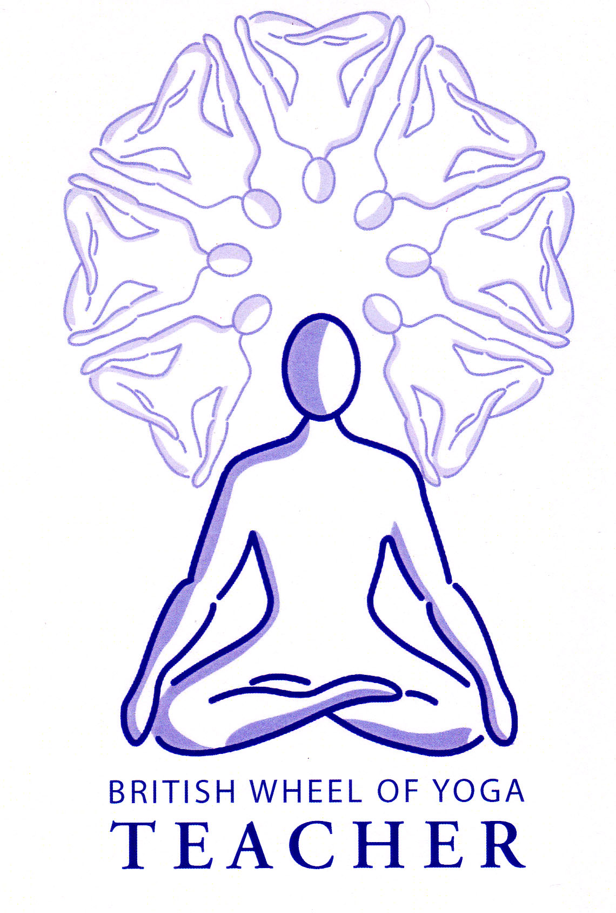**PYS 7.2a Guidelines**

**The whole assignment question to be cut and pasted into the start of your assignment is:**

## Assignment Task 7.2: The Yogasutra of Patanjali (Student)

With reference to the text and informed commentary

a) Discuss the purpose of Patanjali’s System of Yoga with specific reference to the first four Sutras.

1. Describe the yamas and niyamas and discuss their relevance to you and your teaching.
2. Explain the meanings of dharana, dhyana and Samadhi. Identify and discuss possible objects of meditation suitable for a general yoga class.
3. Discuss one of the following :

* Abhyasa and Vairagya.
* Klesha.
* Kriya Yoga.
* Vikshepa.
* Significance of Ishwara.

Guideline word count: 3,000 to 4,000 words. Suggested weighting 25% on each part, meaning each part is around 1000 words.

**NB: Please add each part i.e. a), b) etc. to the same document so it is gradually completed over the next few months.**

**Guidelines for part a): Discuss the purpose of Patanjali’s System of Yoga with specific reference to the first four Sutras.**

Please refer to our course handout ‘An Introduction to the Sutras’ to help you with part a) and within your part a) of this assignment you must include the following terms/ideas written below in bold:

* Classical Yoga is one of the **Astika Darshana**, the six traditional viewpoints of reality of Indian Philosophy, where we go beyond the intellect to experience reality as it really is beyond the projections of the mind.
* The Sutras is based on **Samkhyan Philosophy**. Where according to Samkhya existence is divided into two fundamental divisions meaning it is based on a **dualistic** philosophy:
  + **Purusha:** Spirit, Pure Consciousness, Witness
  + **Prakriti:** Nature, i.e. all manifestations, everything differentiated, including our body, mind and senses.
* **Gunas:** Samkhya is useful as it tells us that on a cosmic, grand scale the gunas of sattva, rajas and tamas are the forces that create, sustain and disintegrate everything respectively, so that all of nature is in constant movement and nothing lasts forever. This has implications for us as our body, mind and senses, as part of Nature or Prakriti, are also subject to the gunas and as such will always be subject to creation, maintenance and dissolution.
* Yoga **experientially** helps us realize that we are the neverchanging Purusha, so we can release our complete identification with being the body, mind & senses, that are always changing.
* When we have fully experienced the difference between Purusha & Prakriti we will have achieved Liberation i.e. **Kaivalya** where we identify with our inner essence of being, the Purusha.
* PYS is concerned with our **state of identification**, i.e. who we think we fundamentally are so that through its practices we can remove **avidya**, our innate existential ignorance, that is we don’t know who or what we really are.
* It is also concerned with our **abilitity to perceive** with absolute clarity, so that through its practices we no longer see through our lense of our conditioning, where we colour everything we see with our previous assumptions, bias etc.
* The **first four verses** **of book one** **give us the overall aim of the Sutras**. Please examine this in some depth as it is central to this assignment question.
* We find that PYS gives us information on **yoga psychology** so we can understand what the mind is, and how it functions so that our perception is normally clouded. You may want to look at this in some depth if you choose to look at the Kleshas for part d) but can mention the following psychological concepts in part a) to some degree if you wish.
  + Five kinds of vrittis (thoughts) which can be aklishta (painless) or klishta (painful)
  + Our conditioning i.e. Samskaras, our habitual subliminal thoughts/feelings and our Vasanas, the patterns of thoughts/feelings making specific traits
  + The influnce of the Gunas (sattva, rajas and tamas) on thought/feeling which can be seen through the lense of the Chitta Bhumis, the five states of mind
  + The significance of the Kleshas, the five fundamental afflictions of the mind which are the underlying motivations beind our thoughts and emotions, i.e. the background beliefs and desires, which collectively cloud our perception and ultimately cause suffering or duhkha.

* We are given the need for abhyasa (practice), the use of vairagya (dispassion or non-attachment, and the growth of viveka (discrimination).

The practices of classical yoga essentially **cover all paths** (i.e. Karma Yoga, Bhakti Yoga and Jnana Yoga) found within the Gita & Upanishads, which is why it is often known as Raja Yoga or Royal Yoga, but it is **primarily the yoga of meditation and is an inwardly focused path.**

Famously is it also known as **Asthanga Yoga** because it is focused on the eight limbed path of: **1) Yamas 2) Niyamas 3) Asana 4) Pranayama 5) Pratyahara 6) Dharana 7) Dhyana 8) Samadhi** where the aim is to achieve the state of Samadhi or absorption into the object of our focus, thereby directly experiencing the outer or inner world, or indeed the Self (Pure Consciousness).

Ultimately as the aim of the Sutras we will have experientially realised that the mind is also an object – and have aligned with that which can watch the mind. We will have become identified with the Watcher, Pure Consciousness i.e. the Purusha, which is never changing and eternal – our True Self.

**Referencing and Bibliography:**

Always write everything in your own words and when you refer to an idea or give a direct quote please acknowledge this in the body of the assignment e.g. Beck. S says that…. or “Ultimately we will have experientially realised that the mind is also an object” (Beck, S. May 2020)

For your bibliography simply build it up as you complete each part of the assignment remembering to list your sources in alphabetical order according to surname.