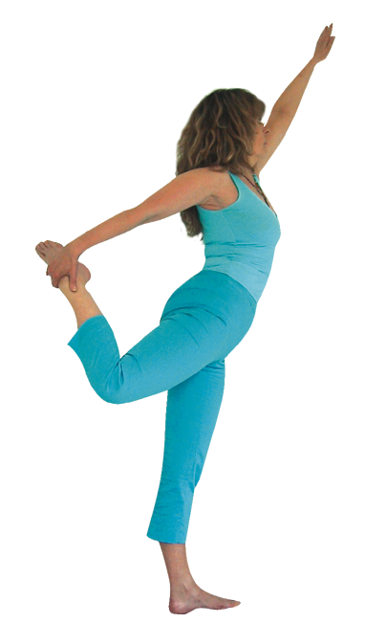**Natarajasana (dancer pose)**

# *Pronounced nut- tuh- raahj-aah-suh-nuh the word nata means dancer and raja means royal in Sanskrit.*

This pose is often called the royal dancer as it represents Lord Shiva in his role as the Lord of the Dance. In Hindu mythology Brahma the creator and Vishnu the preserver work together with Shiva, the destroyer, to create the trinity which controls the cycle of life; Lila the dance of creation. In its fullest form natarajasana is performed by placing the back foot to the back of the head however this is not possible for the vast majority of students, therefore we shall take the version as illustrated here to be the classic version and for those who can take the foot to head we shall see that as a development for those who are structurally able to do so with integrity.

**Teaching Points:**

***Stage one***

* Stand in tadasana (mountain pose), shifting the weight to the standing left foot, pada bandha. Focusing the eyes with a soft gaze at 45º
* Bend the right knee, taking hold of the outside right ankle if possible.
* Start by drawing both hips forwards, thighs together, making sure the bent knee remains aligned and the knee joint is not overly compressed.
* You could stay here, raising the left arm to the vertical position, lengthen spine as lift sternum

## **Stage two**

* If it is possible to go more deeply into the asana, inhaling stretch the left arm out at 45º as you sensitively raise the right leg so the thigh is lifting towards being parallel to the floor as the torso moves forwards to an angle of approximately 45º. **Ensure both hips stay facing forwards** so the right leg does not rotate out to the sides and **keep the sternum raised**.
* Keep length throughout the entire spine, maintaining the reach outwards with the left arm.
* Keep shoulders down away from ears drawing the ribcage away from the pelvis.
* To exit inhaling lift the left arm to the vertical as the knee is drawn back so thighs are together and exhaling lower the arm and leg back to the start position.
* Now work to the other side.

Note: Sometimes students will lower the torso so it is parallel to the ground like ‘superman’ but this can be problematic because it means the weight distribution at the front of the body becomes too great, and the potential arch of the back is diminshed as it becomes more challenging to lift the back heel away.

Also it is sometimes very beneficial to teach natarajasana whilst placing the raised hand against the wall, this is great when students are learning the posture and helps them to refine the position without having to consider balance.

**Drishti**: gaze at fingers of lead hand (can place front hand in gyana mudra)

**Benefits:**

Establishes mental calm and concentration

Develops the ability to balance

Stretches the hip flexors, especially the quadriceps and iliopsoas muscles

Strengthens leg muscles

Enhances flexibility of back muscles

Tones the abdominal organs

Stretches chest and shoulder muscles

#### Good preparation

Twists, back mobilisers, abdominal and back strengtheners, hip flexor releasers.

**Contra-indications & possible modifications**

* For back conditions such as disc injuries, sacroiliac problems and sciatica gentle backbends are generally therapeutic but we must offer gentler versions when the rest of the class is working more intensely.
* For spondylosis where the discs have degenerated or thinned then backbends can aggravate the condition so we must proceed carefully, starting by offering flamingo may work very well, then we can follow this by teaching the gentler modified forms of the dancer.
* For pregnancy caution with backbends, modified versions & supports often helpful
* For knee problems we can place a belt around the ankle or work with the ankle free.
* For balance problems we can use a support such as a chair or wall.

***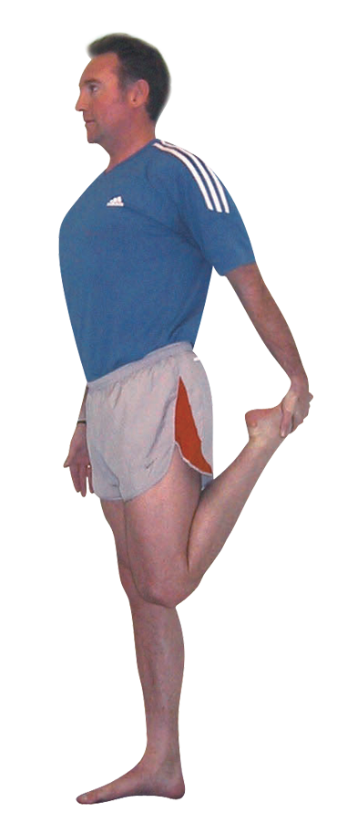*Simpler versions and modifications**

#### *Keep upper arm to side, knees together*

A good way to start working with the dancer is to hold one leg in hand drawing hips forwards. We must ensure we do not overly compress the bent knee by forcing the heel to the buttocks but rather focus upon working the hips forwards. If we cannot reach the foot we can **place a belt** around the bent leg ankle instead. We can of course place a hand to a wall for support if necessary.

**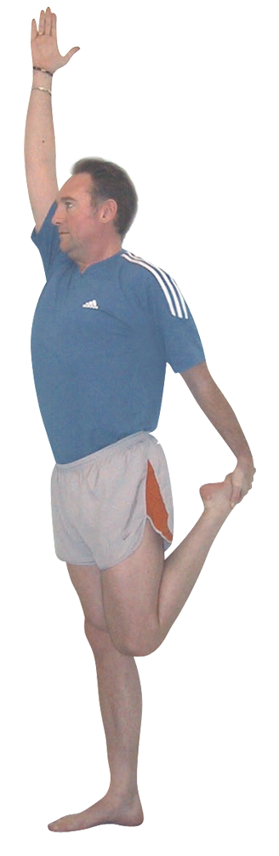*Raise upper arm, knees together***

We can then if wished raise the arm vertically, palm facing inwards to create a line of effort through the side of the body.

*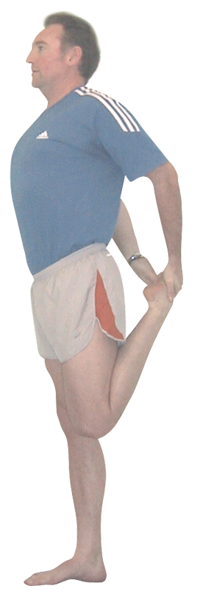****Both hands to back foot***

Another way to way with the dancer in the early stages is to lower the hand from the vertical and place the hands either side of the back foot. Here we keep the hips pressing forwards as we encourage the ribcage away from the pelvis. Drop the tailbone if needed.

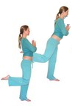

***Flamingo balance***

A good alternative which can also be used as a preparatory posture is the flamingo pose where we place hands in the prayer position at the heart and the thighs are place together. Here we lift the back leg, allowing the back leg to tilt the torso forwards. This pose teaches us to keep the hips pressing forwards. It is a good alternative when the student should not perform backbends.

**Developments & Variations**

The main development is, as mentioned previously, to take both arms overhead in order to reach for the back foot, although this is only possible if the shoulders are very flexible and the spine is capable of excellent extension.

**Adjustments**

For this asana verbal instruction or one to one demonstration is ideal since any physical adjustment can easily unbalance a student. However we can alter the position of the upper arm, especially when it has been lowered too much. We can also with care place one hand lightly upon the bent leg hip and the other hand at the raised arm shoulder, encouraging the hip downwards and the ribcage forwards.