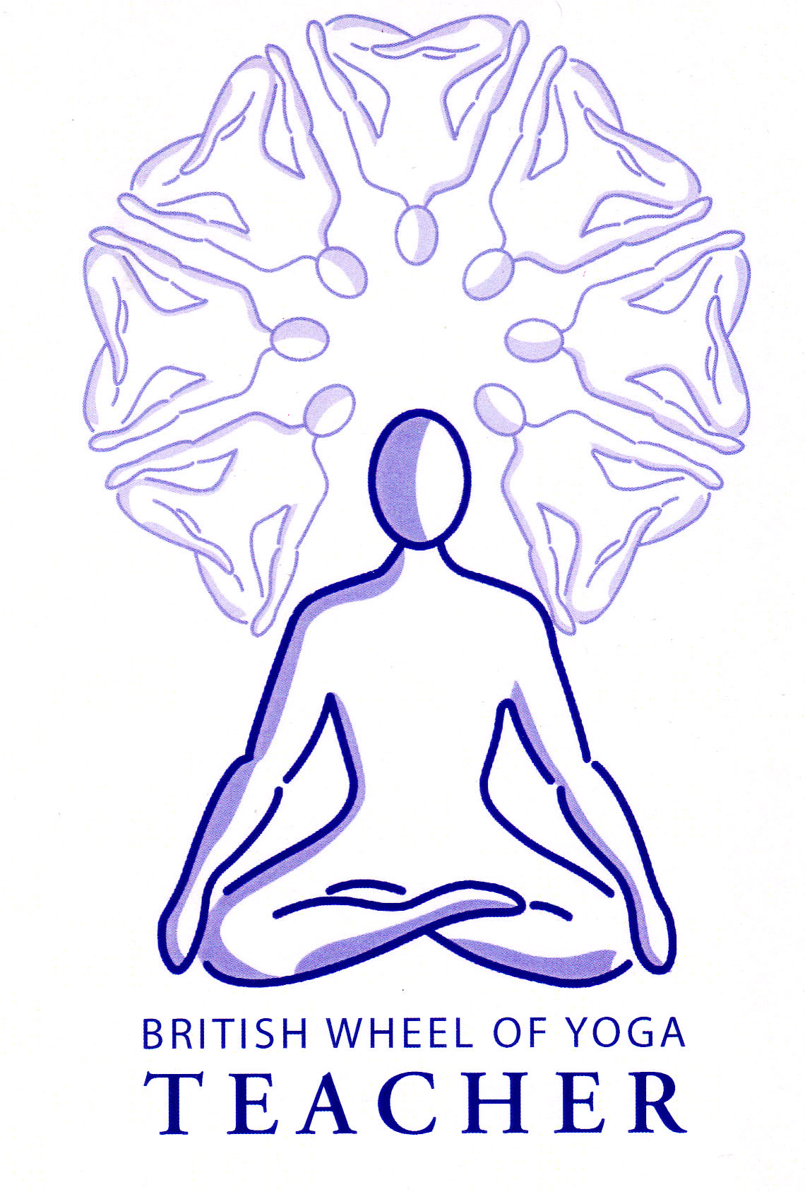
Mudras

Mudra translates as seal or gesture. It comes from the root ‘mud’ meaning to delight or protect. Another translation is ‘Giver of Joy’ implying a wonderful reward or protection from harm, perhaps from the ceaseless activities and distractions of thought by harnessing consciousness.

Mudras can be of the body (kaya), of the hands (hasta), of the feet (pada), of the eyes (chaksu) and the mind itself (mana). We can use mudras in meditation and pranayama to enhance their effects and we can also incorporate mudras into asana by using specific gestures and mantras.

Benefits
Mudras:
- Harmonize and revitalize systems of the body
- Give ability to control involuntary physiological processes
- Invoke a specific emotional response
- Give an awareness of prana & the ability to use it to heal oneself and others
- Cleanse, strengthen and calm the mind
- Represent or transform the psyche
- Develop pratyahara the ability to control the senses so very good prior to meditation where we need ekagrata, a one pointed mind
- Give siddhis or powers and can help to arouse kundalini

As you can see from the list above there is primarily a spiritual aim but also many mental and physical benefits. Do note that as always there are some variations in the descriptions of particular mudras and often there are different ways in which to develop them by for example adding points for mental focus.

Important mudras within Hatha Yoga you may consider teaching:

Hasta Mudras / hand seals

So how do hasta mudras work? In essence we have to see the hand as containing reflex zones for associated parts of the body and brain and indeed many traditional medical systems use this knowledge such as Traditional Chinese Medicine and Ayurveda, where both possess a five element system whereby different points upon the hands have designated correspondences with areas of the body and brain. So in a way the hand becomes a mirror for our body and for our mind and by changing the positioning of the hands we alter the functioning of our body and mind.

An interesting example is Chin Mudra where the tip of the index finger and thumb lightly touch. In yoga the thumb represents divine consciousness and the index finger represents human consciousness so when they are placed together to create a circle they represent the union of individual human consciousness with divine cosmic consciousness, with the three outstretched fingers representing the tri-gunas of embodied existence.. This mudra is therefore often used in meditation practices to both express this desire for union and help to create this union. Interestingly both the thumb and index finger belong to the metal element within Chinese five element theory where metal is considered to be by far the best conductor, having the ability to help us become more intuitive, helping us to create connections with the cosmic world!

To use hasta mudras we simply need to place the fingers together lightly but firmly whilst keeping the hands relaxed and where the hand is not flexible enough to create the position this is usually indicative that the corresponding area of the body or brain is not functioning optimally so we can always in the beginning use the other hand to help us create the position.

Here we can see some hasta mudras we can use, although there are many others we can perform.

Chin Mudra (gesture of knowledge)
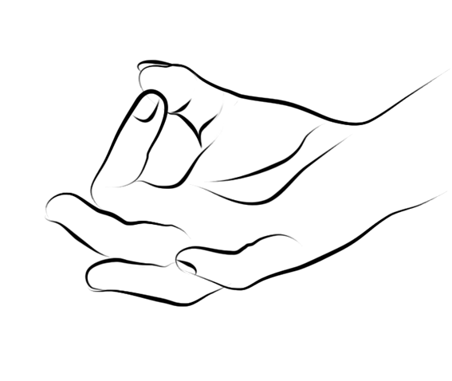
Here the tip of the index finger and the thumb are place together, although sometimes the thumb covers nail of index finger. Hands are placed on knees palms facing upwards.
This mudra draws attention inwardly so it is good for concentration and meditation techniques. It is said to represent the goal of yoga, the union of atman and brahman. It releases mental tension and develops good concentration and memory. Good for insomnia, depression and high blood pressure.
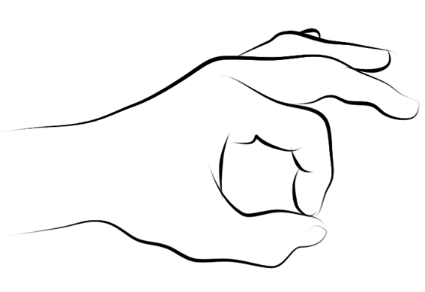

Jnana Mudra (gesture of consciousness)
The fingers are placed as for Chin Mudra except here the palms face downwards.

Benefits are as for Chin Mudra.

These two hasta mudra are used primarily within pranayama and meditation but can also be used within asana to help keep prana from escaping and create concentration.

Dhyani Mudra (seal of submission)
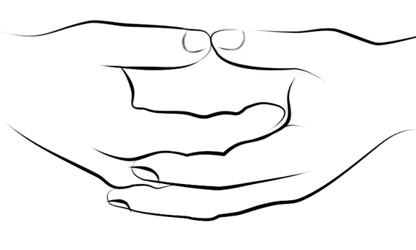
For this mudra the left hand lies in the right hand and the thumbs touch each other, palms facing upwards.

This is classic mudra for meditation where the bowl represents the emptiness of surrendering to receive the divine. When we employ this mudra there is no special intention but rather the feeling that ‘Thy will be done’ i.e. of surrender.

There are also many hasta mudra to create very specific effects, especially therapeutic effects. Some useful examples to include here are:

Padmasana Mudra (lotus seal)
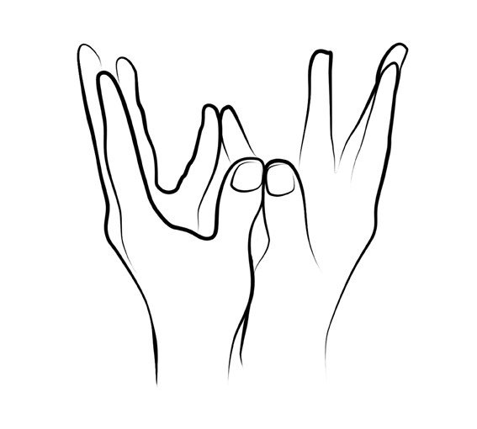
Here we bring the hands to a vertical position then touch the pads of the thumbs and little fingers together. Now we spread the fingers of both hands wide apart representing the open lotus flower. After a few breaths with the open flower we can close the lotus flower by placing the fingernails of the fingers of both hands on top of each other and joining the backs of the fingers, the backs of the hands and allow the hands to hang down for a while. So with awareness within the breath we can work by opening and closed the lotus.

This Mudra stimulates the heart and can be used to good effect when we are feeling lonely, misunderstood or exploited.

Prithvi Mudra (earth seal)
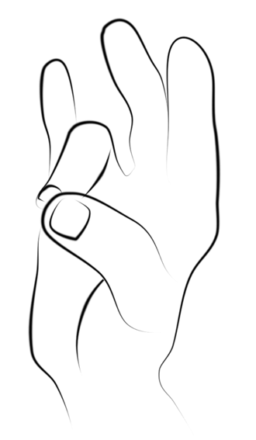
Here we place the tips of the thumb and ring finger together and extend the other fingers away. We apply this to both hands simultaneously.

This mudra is great to use when we feel we need stability or security. It can also be employed when we wish to increase the health of the skin, bones, teeth and nails, helping us to absorb nutrients.
Garuda Mudra (eagle seal)
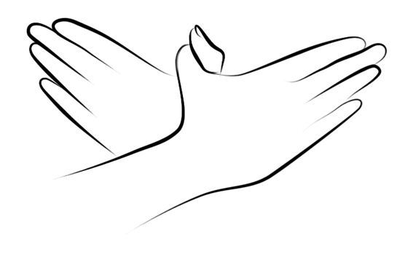
Here we clasp the thumbs and place hands, the right on top of the left, palms facing inwards, spreading fingers wide apart. Initially we place the hands at the level of the lower abdomen, staying here for around 10 breaths, then we position the mudra to the navel, staying here for around 10 breaths, then the stomach and finally at the sternum, with fingers pointing towards the shoulders each time staying for approximately 10 breaths.

Garuda mudra increases circulation and so caution is necessary for high blood pressure sufferers. It relieves fatigue can also relax and alleviate pain.

Kubera Mudra (god of wealth seal)
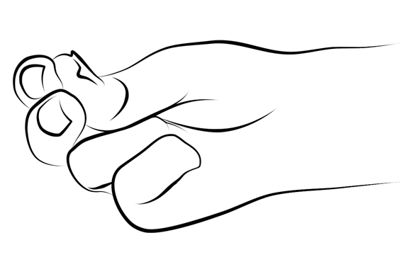
Here we place the tips of thumbs, index finger and middle fingers together with the other fingers folded inwards.

This mudra can be used when we wish to reach a goal, whether it is a wish to find a parking place or fulfill a deeper desire. It gives the mind serenity and confidence. It also opens sinuses.

Pran Mudra (life seal)
Here for both hands we place the tips of the thumb against the tip of the ring finger and little finger, with the other fingers out stretched.

This mudra activates muladhara chakra increasing vitality and removing anxiety, giving a sense of quiet confidence and inner stability. It is also good for improving the health of eyes.

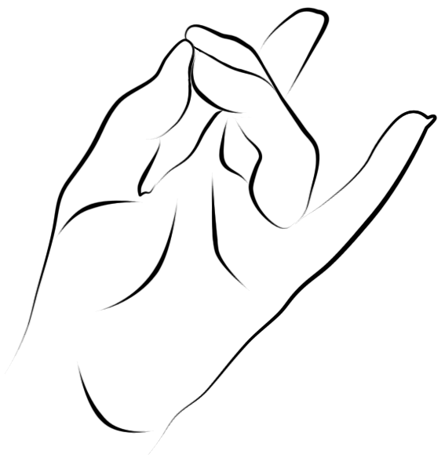
Apana Mudra (energy seal)
Here for both hands we place the tips of the thumb, middle finger and ring finger together, with remaining fingers out stretched.

This mudra aids elimination and the removal of toxins. It has a balancing effect upon the liver, which consequently has a balancing effect upon the mind. It helps to create qualities such a patience and serenity and helps us to have clarity in our internal vision & imagination.

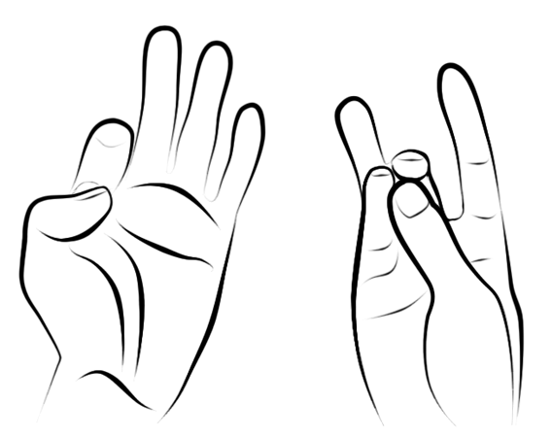
Back Mudra
For the right hand place the thumb, middle finger and little finger together. Index finger and ring finger outstretched. For the left hand place the thumb on the nail of the index finger.

This mudra helps to release backache. It can be done in a position that releases the back such as lying flat to floor with legs raised

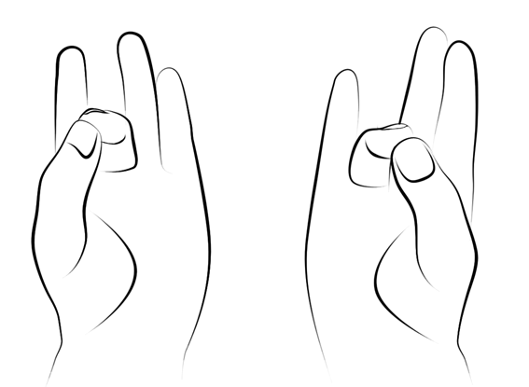
Joint Mudra
For the right hand we place the thumb and ring finger together, other fingers out stretched and for the left hand we place the thumb and middle finger together, other fingers out stretched.

This mudra balances energy in joints

Chaksu Mudras
There are many positions for the eyes we can use but here we shall study the most important ones we can practice and teach.

Shambavi mudra
This is a very well used mudra, particularly in pranayama and meditation. To perform this mudra we simply keep the head straight as if to look forward then without moving the head we focus the eyes upon the area of ajna chakra, i.e. at the midpoint between the eyebrows. It can be performed with open eyes or closed eyes, or indeed half closed eyes. Initially we must only adopt the mudra for a few minutes without strain but as the eye muscles become stronger we can hold it for longer periods. This mudra strengthens eye muscles, calms the mind and develops concentration. It also awakens ajna chakra.

Agochari mudra
Here we position the head in a neutral position then focus the eyes upon the tip of the nose. This mudra creates pratyahara, the withdrawal of the senses and develops concentration. It also awakens muladhara chakra.

Kaki Mudra / Crow Beak
This is the crow beak mudra where we purse the lips to make a tube. Focus eyes on the tip of the nose. Continuing to inhale through mouth and exhale through nose. This mudra cools the body and mind. Helps proper digestion by stimulating digestive secretions. Said to increase longevity.

Bhoochari mudra
This is the gaze into nothingness where we sit facing a blank wall placing the right hand to the knee and the left forearm parallel to the floor at the height of the mouth where with the palm turned downwards the right thumb rests between the top lip and the bottom of the nose. For a few minutes we gaze at the little finger intensely then removing the hand we continue to gaze at the point where the little finger was. This mudra calms the mind and develops memory and concentration.

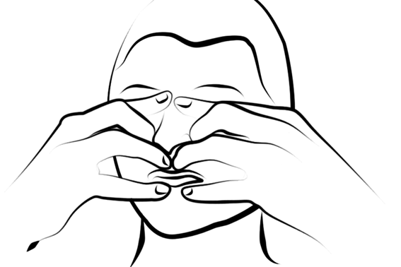
Yoni Mudra
Adopt a seated pose, whilst retaining the breath close ears with thumbs, eyes with index fingers, nostrils with middle fingers, lips with ring fingers on top of lips and little fingers on lower lips then inhale by releasing middle fingers, retain the mudra again as before, and then exhale by releasing middle fingers etc.

Excellent for reducing sensory input so sensitizing the sensory organs. Great for developing control of the senses, pratyahara. Ideal preparation for meditation. It is said to also stimulate an awareness of the psychic sound, nada.

The use of drishtis
Whilst these mudras are classic mudras found within hatha yoga we must not forget that we can also incorporate drishtis or mental focal points within the practices of yoga asana. These can be used once an asana is familiar to create an excellent quality of concentration.

Kaya Mudras (whole body mudras)
We have already explored the three bandhas that can be used within pranayama and we have looked at Maha Mudra I (M.B. & J.B) and Maha Mudra II (M.B., J.B. & U.B.) there are however other classical combinations of the three bandhas which are techniques in themselves. They are generally practiced after general pranayama and before meditation. Inevitably because they require excellent physical control and breath control they are more advanced practices.

Maha Bandha “The Great Lock”
The word ‘maha’ means great in Sanskrit. This practice is taught a little differently in different hatha yoga texts.

Method
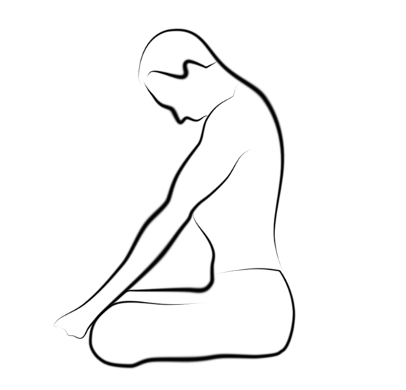
Ideally we sit cross-legged in ardha padmasana (half lotus) where the right foot is place upon the left thigh and the left heel is positioned so it presses against the perineum or vagina. The hands are placed within chin mudra. We breathe naturally and when we are ready on an inhalation we retain the breath, adopting jalandhara bandha, mula bandha and shambavi mudra. The eyes can be closed or open but we gently gaze up to ajna chakra between the eyebrows. Then having held the breath retention for as long as is comfortable we release shambavi mudra, mula bandha and then jalandhara bandha, exhaling through the right nostril. We then work again in just the same way but this time we exhale through the left nostril. Finally we continue sitting in half lotus, hands on knees in chin mudra. Inhale and hold whilst adopting JB. Then pull up MB. Release bandhas smoothly then breathe out through both nostrils with control. At first we practice for only three rounds and build this up to five rounds.

Sometimes maha bandha is also practiced using uddiyana bandha where we exhale through the mouth, adopting J.B., U.B. and then M.B. but this time our focus is rotated between the three chakras, the muladhara chakra (root), the manipura chakra (solar plexus) and vishuddhi chakra (throat). Again we build the number of rounds up to nine rounds over time.

We can also practice maha bandha between rounds of bhastrika (bellows breath) and this works very well indeed but is clearly a development.

Purpose
This practice increases prana and is rejuvenating. Ultimately in yogic terms it is said to defeat death, affect the unification of the three nadis and give siddhis (supersensory powers). However for the movement of prana through the sushumna nadi this practice must be followed by maha vedha mudra (the great piercing attitude) where the legs are placed in full padmasana (lotus), hands placed to the floor, either side of the thighs and jalanadhara bandha is adopted on an internal breath retention. Then we proceed to lift and lower the buttocks from the floor slowly beating the buttocks. (Remember how hatha yoga is sometimes known as the yoga of violence). This however, whilst interesting, is beyond the scope of this course and should only be practiced at specific times, in an ashram situation under the guidance of a personal guru as energy may become wild and agitated, overly stimulating the body and mind.

Precautions & Prohibitions
Maha bandha should only be practiced by those in good health and who already are proficient with the three bandhas.

Viparita karani mudra (the inverted attitude)
We move into viparita karani mudra and relax, closing eyes. Viparita karani is the reverse position asana where we lift our legs up against a wall or we can place blocks beneath the sacrum and lift both legs. We then practice ujjayi and perform khechari mudra where the tongue is rolled backwards, so the back of tongue is placed against the upper roof of the mouth. As we inhale we feel the breath (prana and consciousness) moving from manipura chakra to vishuddhi chakra and as we slowly exhale we hold awareness at vishuddhi chakra. Then as we inhale we continue in the same way. At first we only work for a few seconds building this up gradually.

This improves circulation having a purifying effect on lungs, bladder and the intestines. It helps to purify the subtle body by moving prana from manipura chakra to vishuddhi chakra. Jalanadhara bandha is not implicit here due to the position of the head where unlike the shoulderstand the chin is not pressed against the chest. Traditionally khechari mudra, where the underneath part of the tongue is placed against the upper palate, is used along with ujjayi breathing; this helps to stimulate nerve centres within the brain.

Generally this mudra is performed after asana practice but before meditation.

Precautions and prohibitions
This technique should not be practiced by those with un-medicated high blood pressure, heart conditions or an enlarged thyroid.

Yoga Mudra (the psychic union)
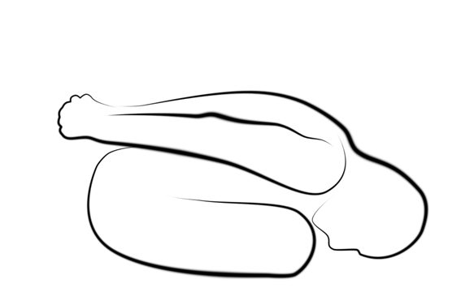
Here we sit in padmasana (lotus) if possible, otherwise virasana (hero pose) or another cross-legged position can be adopted. One hand holds the opposite wrist, arms are held behind the back. We slowly exhale and retain the breath whilst focusing upon muladhara chakra. Then slowly inhaling we feel the breath rising from muladhara to ajna chakra and retain the breath whilst focusing upon ajna chakra. Work with this for several times. We then exhale slowly as we fold forwards until the forehead touches the floor, feeling the breath moving from ajna chakra to muladhara chakra, retaining the breath as we focus upon muladhara chakra. Finally we slowly inhale as we return to the upright position, feeling the breath moving from muladhara to ajna chakra, retaining the breath focusing upon ajna chakra. We then begin again.

At first we only perform this mudra for a few minutes and gradually build it up. It is best to start with exhaling forwards and inhaling lifting upwards, simply naturally pausing at the end of the inhalation and exhalation as feels appropriate.

The full mudra is not for beginners as it requires great control of the breath with the ability to be very relaxed in the position. It creates a calm peaceful mind and develops concentration. It also develops an awareness and control of prana.

It massages lower abdominal organs so good for any complaints in lower abdominal organs: stretches and tones spinal vertebrae and spinal nerves so revitalising energy; increases peace inside; stimulates the solar plexus.

Precautions and prohibitions
Students with back conditions or sciatica must take great care with the forwards movement and it may be they can slightly modify the posture by placing hands to the floor in front of the legs or place a stack of blocks in front of the legs to rest the head upon. Although it may be necessary to work with legs out in front, knees bent. When working in the full mudra all the contraindications for breath retention apply.

Additional Note:
Finally within the HYP, our classical hatha yoga text, there are two additional mudras which are explored in some detail, although in their fullness it is unlikely we would perfom them. The first is maha vedha mudra (great piercing attitude) where in padmasana we lift and lower our whole body by raising up on to our palms, essentially beating buttocks to the ground to initiate the lift of prana through sushumna nadi. Secondly kechari mudra (attitude of dwelling in supreme consciousness) where the tip of the tongue is inserted into the back of the throat, and eventually to the internal portion of ajna to stimulate the pineal gland; this has far reaching effects to include controlling the entire hormonal system and the autonomic nervous system but requires the stretching and cutting of the tongue!

Using mudra and bandha in asana, pranayama and meditation

We can make good use of mudra and bandha in the other practices of yoga so for instance if we know the energetic effect of a hasta mudra then it can be practiced within pranayama and meditation where we feel it would be helpful, and certainly chin and gyana mudras are used extensively but others could also be used to good effect.

Regarding asana, some asana naturally incorporate one of the bandhas for example in sarvangasana (shoulderstand), setu bandha (bridge) etc. jalandhara bandha is naturally engaged. Also as you may have already noticed many asana benefit from engaging mula bandha, these include those asana where we need to ground downwards as well as lift upwards such as vrksasana (tree) and utkatasana (squat) because mula bandha helps us energetically to do this. In addition it is very helpful when we need to protect the lower back so is especially useful in any backbends and also twists.

It is also possible to be creative and adopt different hasta mudras within asana so for example we could perform a spread leg boat pose with knees bent and wrap arms around the outside of the legs performing lotus mudra with our hands placed in front of the heart area or in a pose such as warrior 2 we could adopt chin mudra to help contain energy within the body. Please feel free to experiment with using mudras within asana, inwardly observing what aids the experience of the asana.

Lastly we can use chaksu mudras within asana and these are usually called drishtis where the eyes gently gaze towards a specified point. Many yoga traditions do not use drishti points in asana but others use them extensively so it is certainly something we can consider once a student has become familiar with an asana and will bring a new level of concentration to the asana. There is no absolute point of focus for each asana but we can choose a point of focus upon the body that can be where the eyes physically focus or alternatively where the mind focuses, for instance often the tip of the nose is used but here we must not physically focus the eyes but rather mentally focus the mind upon this point or we might physically gaze softly at the thumbs.

During pranayama if you recall there must be a point for mental focus and here using a mudra can be helpful in achieving a calm, concentrated mind. It is also of course possible to incorporate mudras or bandhas into a specific pranayama technique so for instance nadi sodhana and all other alternate nostril breaths use (deer mudra) and we can use jalanadhara bandha with sitali. It is also possible to use mudra during basic breathing, and you may remember how we all worked with several different hasta mudras in order to appreciate the inner energetic changes as the position of our hands moved slowly from one mudra to another. There are many ways in which mudra and bandha can be slowly incorporated.

With concentration or meditation exercises we will usually adopt a mudra as these are very helpful to the process of concentration and internalization.

Do experiment yourself in your own personal practice and see if there are times when you can incorporate mudra or bandha to increase mental focus and concentrate prana then once you have experienced the benefits you will be able to teach these to your own students. Remember to always practice techniques yourself and never completely trust what is written (possibly with the exception of the classic texts!) without first experimenting with your own body, breath and mind, this holds true for asana, pranayama, dharana etc. and of course also holds true for mudra and bandha. You must also always ensure what you teach is the right next step for your own students and where necessary you can offer modifications and alternatives. Certainly mudra and bandha provide us with an excellent way to add finesse to our teaching and you can be creative but they must also be taught intelligently!

For further reading:

A very useful book to buy is Mudras Yoga in your hands by Gertrud Hirschi, 2000, Red Wheel / Weiser
I can highly recommend this book if you are interested in using and teaching hasta mudras.

Asana, Pranayama, Mudra, Bandha by Swami Satyananda Saraswati, 1969, Bihar School of Yoga

Hatha Yoga Pradipika, Swami Muktibodhananda Saraswati, 1985, Bihar School of Yoga

